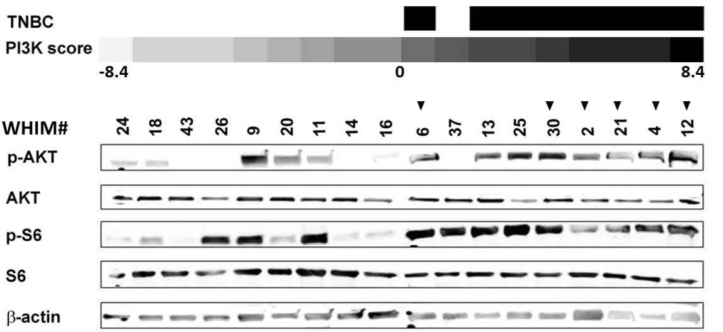

Supplementary figure 1. PI3K activity in a larger cohort of WHIM models. Triple Negative Breast Cancer (TNBC) status (indicated by black squares) and PI3K activity by the PI3K score are indicated for each model. The PI3K score refers to the CMAP PI3K mRNA signature score calculated based on the transcriptome data as previously described [Reference]. Vertical numbers denote WHIM model. Western blots for a set of selected PI3K markers are aligned for each WHIM for comparison. Black triangles indicate patient derived xenograft/WHIM models used in this study (WHIM#).
Reference:
Creighton, C.J., X. Fu, B.T. Hennessy, A.J. Casa, Y. Zhang, A.M. Gonzalez-Angulo, et al., Proteomic and transcriptomic profiling reveals a link between the PI3K pathway and lower estrogen-receptor (ER) levels and activity in ER+ breast cancer. Breast Cancer Res, 2010. 12(3): p. R40.

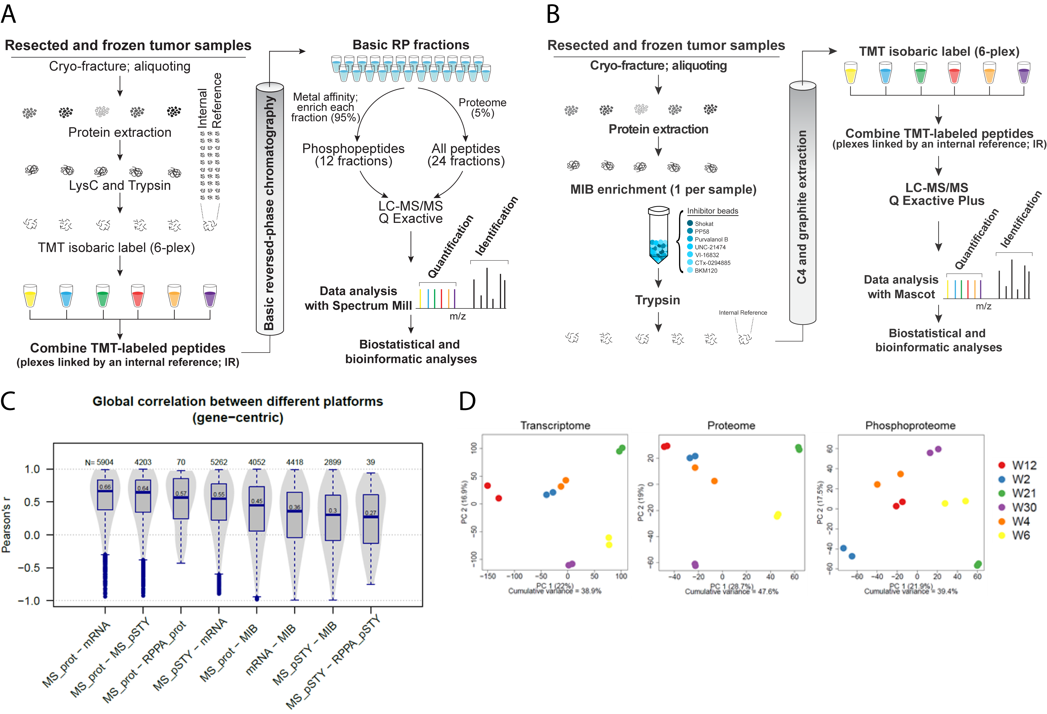
Supplementary figure 2. Workflows, global correlations and heterogeneity. A, TMT6-plex global proteome and phosphoproteome analysis workflow. 30 samples were analyzed in 6 TMT6-plexes, each containing 5 samples from a single PDX model and a common internal reference. The internal reference was comprised of equal amounts of material from all 30 samples and served as an internal standard for all proteins and phosphoproteins quantified in the global liquid-chromatography tandem mass spectrometry (LC-MS/MS) analyses. B, TMT6-plex MIB proteome workflow. Samples were extracted and enriched for kinases using a mixture of 7 kinase inhibitors immobilized to beads. Digested, TMT6-labeled samples were analyzed using a Q Exactive Plus instrument, and peptides were identified and quantified using Mascot. C, Results from the various platforms are moderately to highly correlated to each other, indicating overlap as well as possible complementarity of the -omics methods. _prot = proteome; _pSTY = phosphoproteome. The lowest correlation is measured between the global phosphoproteome and the RPPA phosphoproteins. Factors that could account for these differences include higher sensitivity of the phospho-antibodies for certain phosphosites relative to the MS analyses or cross-reactivity of the antibodies leading to false positive identification by RPPA. Furthermore, the RPPA data is not normalized to the proteome, while the global phosphoproteome is. D, Samples from the same PDX model clustered together, showing less intra-tumor heterogeneity compared to inter-tumor heterogeneity. Each PDX tumor has two vehicle treatments (1 dose 2 hours and 3 doses 50 hours) that are shown as replicates. Only human markers were considered for the analyses and no missing values were allowed. PC = principal component; % = percentage variance explained by each component as well as the cumulative variance explained.
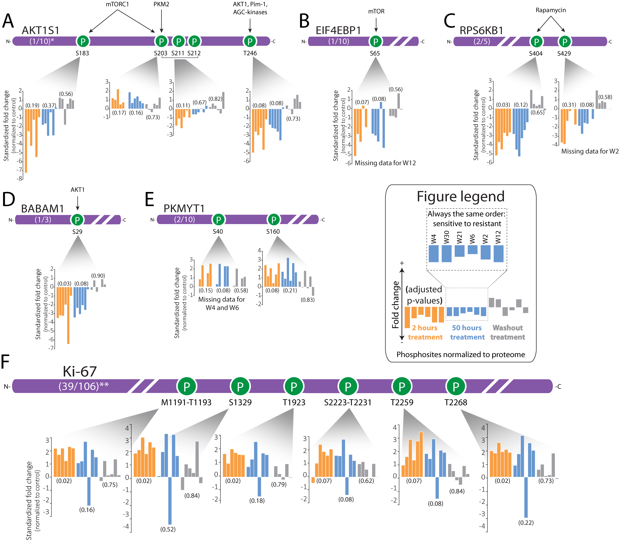
Supplementary Figure 3. Known and new pharmacodynamic phosphosites. Pharmacodynamically-regulated phosphopeptides across all six WHIM tumors include A, AKT1S1. The T246 site on AKT1S1 is well known to be regulated by AKT; its phosphorylation is lost after buparlisib treatment in our study. B, EIF4BP1, and C, RPS6KB1, both central to PI3K signaling. D, BABAM1, and E, PKMYT1, both associated with PLK1 signaling. F, Ki-67, one of the most regulated pharmacodynamic markers in our study. Probability values are based on one-sample moderated t-tests, and adjusted by the Benjamini-Hochberg method. *AKT1S1 shows sites with an adjusted p-value ≤ 0.2. **Six selected sites are shown as representatives for Ki-67.

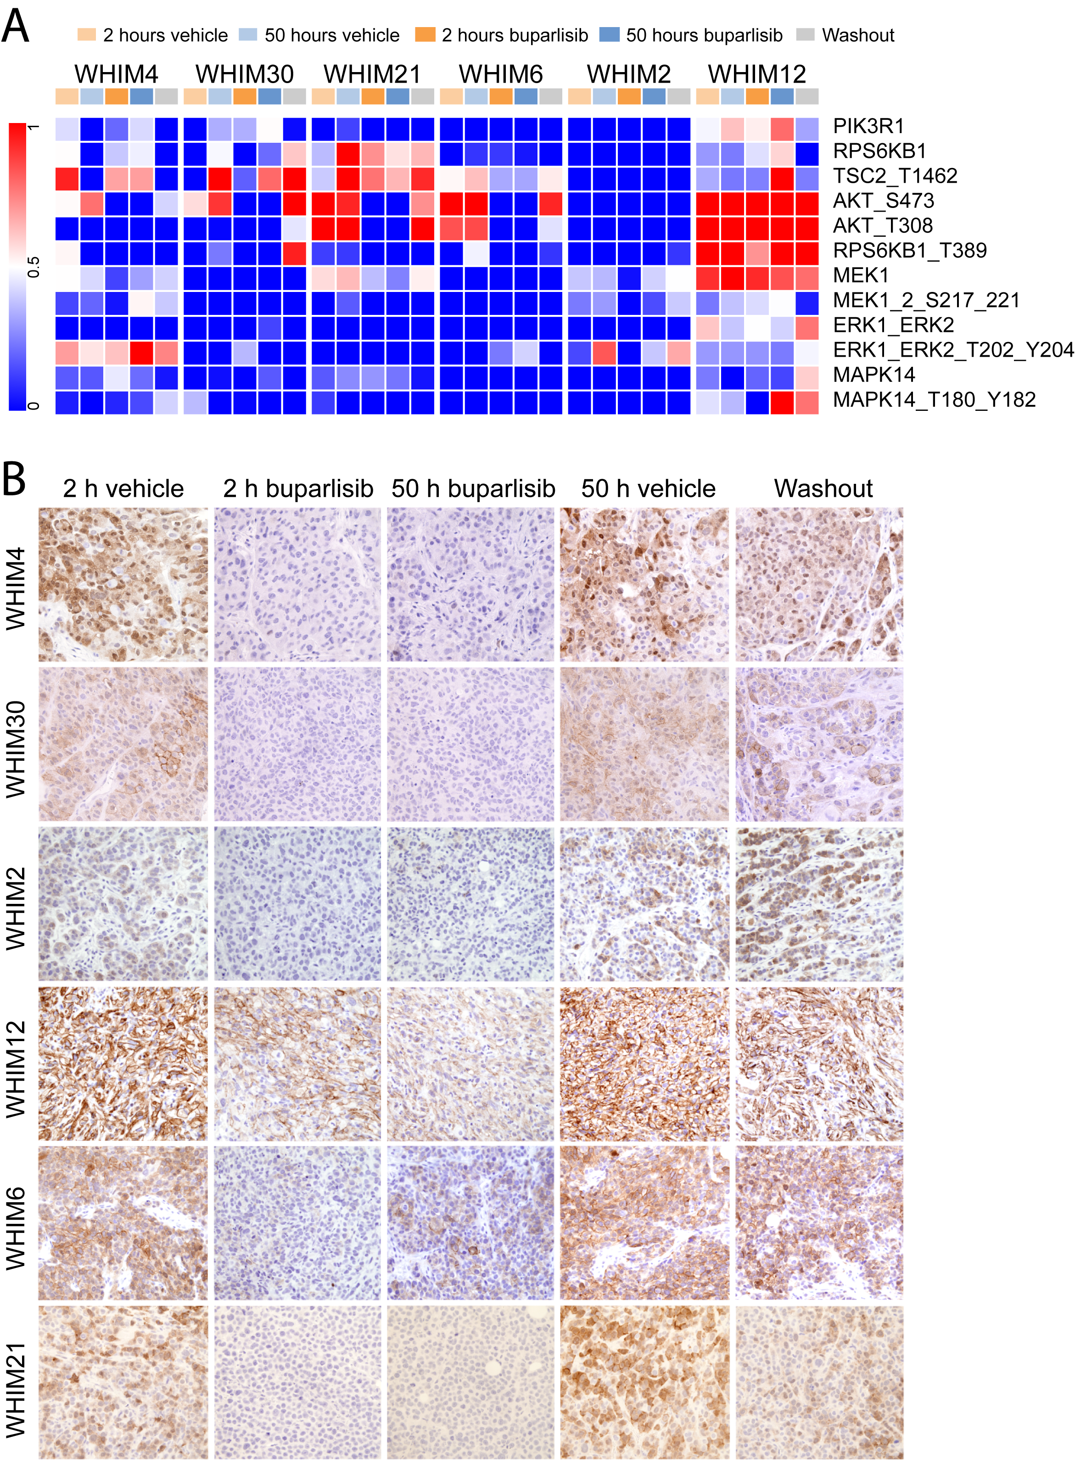
Supplementary figure 4. RPPA of selected markers and representative images of immunohistochemistry of pAKT (S473) on TNBC PDX models post-treatment with buparlisib or vehicle. A, vehicle treatment for all WHIM tumors show a strong baseline difference of selected PI3K members in the RPPA assay. B, buparlisib treatment reduced the levels of pAKT (S473) as early as 2 hours after one dose of buparlisib treatment. pAKT level remained suppressed after 3 days of buparlisib, but recovered to baseline after one day washout. Note the presence of residual pAKT level post treatment with buparlisib in WHIM12 and WHIM6 compared to other PDX models.
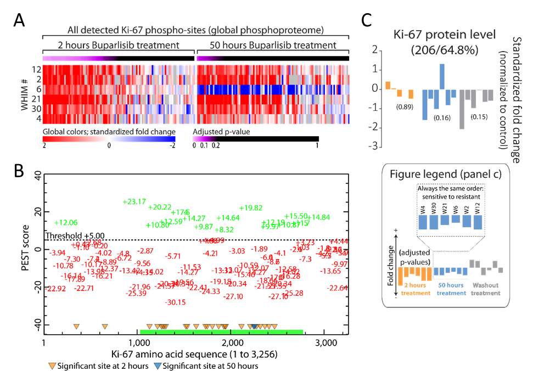 Supplementary figure 5. Predicted PEST motifs of Ki-67 and significant phosphosites after buparlisib treatment across all WHIM tumors. A, heat map of all Ki-67 sites quantified in the global phosphoproteome across all WHIMS. Out of its 106 identified phosphopeptides, 39 had significantly increased phosphorylation with an adjusted p-value ≤ 0.1 after 2 hours buparlisib treatment, with two sites being significantly increased after 50 hours treatment. Significance at the 50 hours time point seemed to be lost due to an opposite decreased overall phosphorylation in WHIM6, with all other tumors still exhibiting increased phosphorylation of multiple Ki-67 sites. B, predicted PEST motif scores (http://emboss.bioinformatics.nl/cgi-bin/emboss/epestfind) are plotted on the y-axis across the amino acid sequence of Ki-67. The majority of highly predicted PEST motifs (≥ 5 PEST score; threshold) are found approx. between amino acids 1,000 and 2,800 (green numbers and green stretch on x-axis). Phosphosites with an adjusted p-value (one sample moderated t-test after buparlisib treatment) equal to or less than 0.1 are marked as triangles along the amino acid sequence. Yellow triangles = 2 hours buparlisib treatment normalized to vehicle control; blue triangles = 50 hours buparlisib treatment normalized to vehicle control. C, hyperphosphorylation of the Ki-67 PEST region correlates with decreased Ki-67 protein abundance (number of peptides/percentage sequence coverage). Probability values are based on a one-sample moderated t-tests, and adjusted by the Benjamini-Hochberg method. W = WHIM.

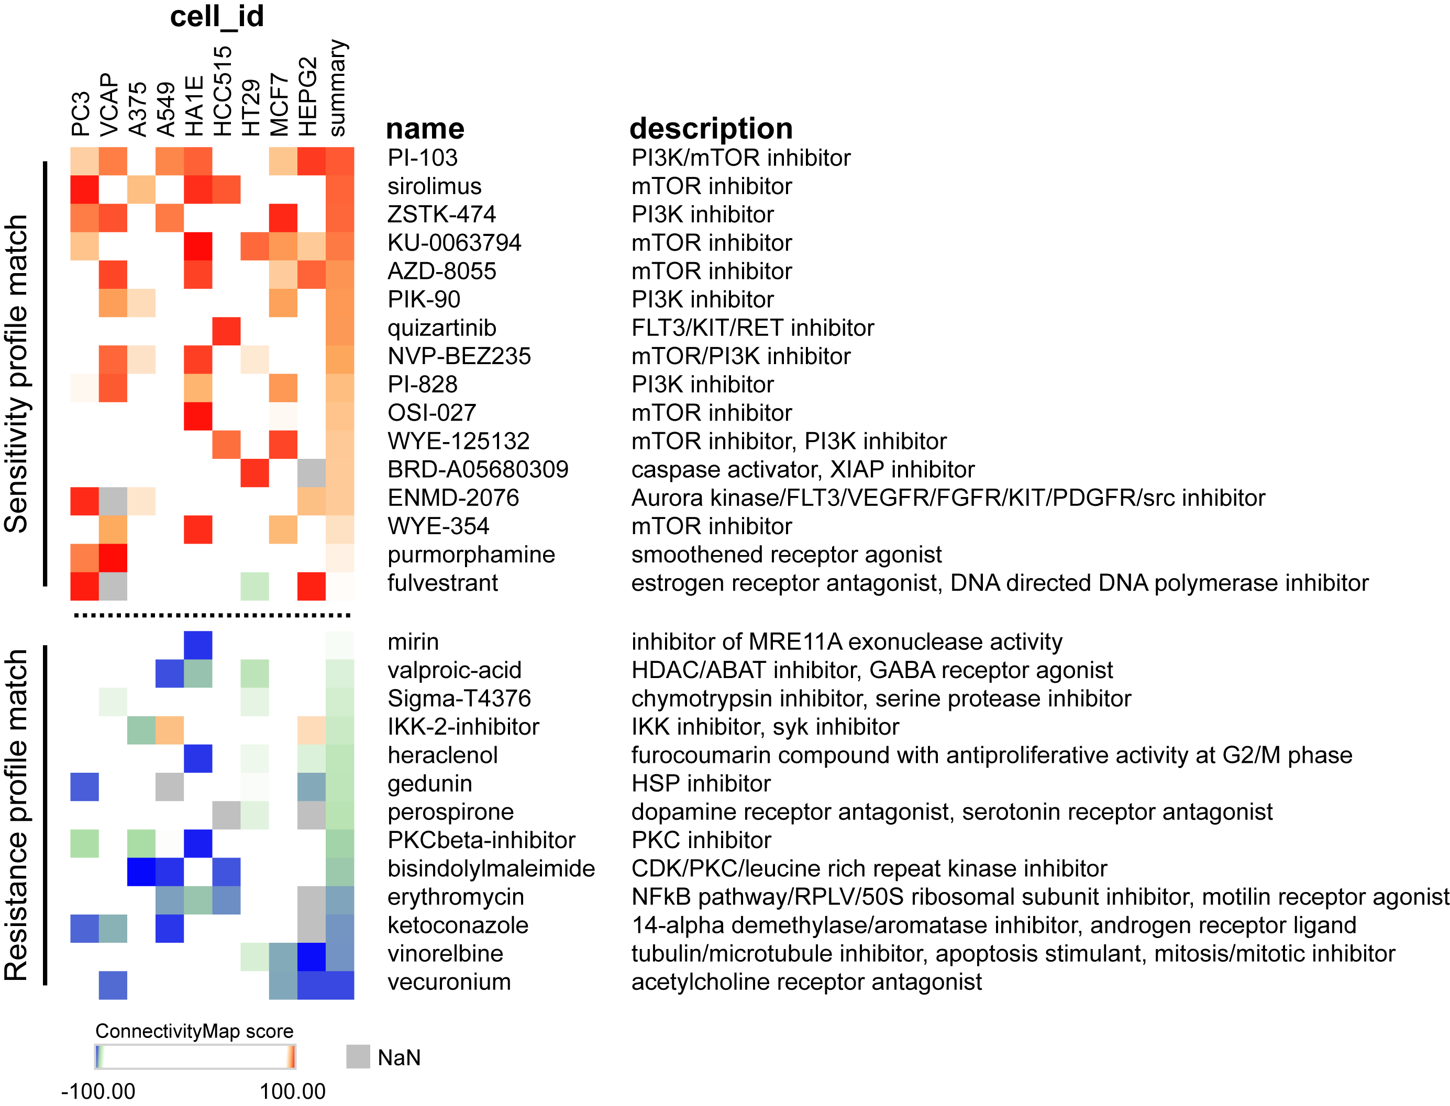
Supplementary figure 6. ConnectivityMap analyses. CMAP analyses (https://clue.io/cmap) using the proteins that are relatively high in the sensitive tumors compared to the resistant tumors after buparlisib treatment (normalized to vehicle controls) show a clear connection to treatments with PI3K and mTOR inhibitors (above the dotted line). In contrast, proteins that are relatively high in the resistant tumors compared to the sensitive tumors after buparlisib treatment (normalized to vehicle controls) show similarities to a wide range of inhibitors (below the dotted line), possibly indicating a general resistance mechanism or mechanisms.

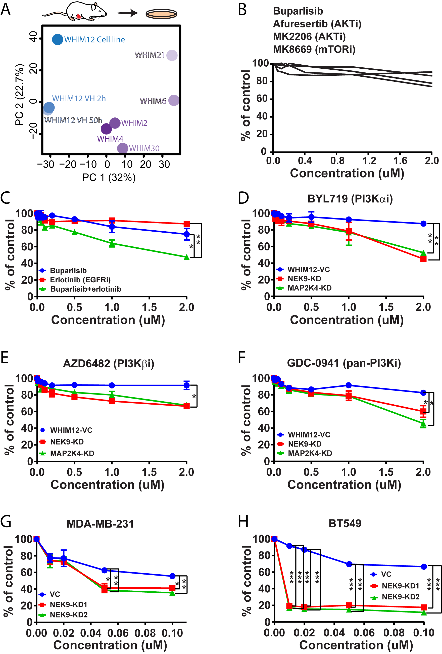
Supplementary figure 7. A WHIM12-derived cell line resembles its parental tumor and NEK9 and MAP2K4 knockdown increases sensitivity to PI3K inhibitors and to buparlisib in several triple negative breast cancer cell lines. A, a cell line derived from the most resistant PDX tumor (WHIM12) shows strong similarities to its parental origin. Single-shot MS of all tumors treated with vehicle control (VH) and cell line lysate shows high similarity between the WHIM12-derived cell line and its parental tumor. However, cell line-specific features are also evident in the second principal component. B, importantly, the WHIM12 cell line carries over its resistance to buparlisib as well as several other PI3K, AKT and mTOR inhibitors (Alamar Blue assay, 6 days treatment). C, Erlotinib synergizes with buparlisib in inhibiting cell proliferation in WHIM12. Cell were treated with DMSO, erlotinib, buparlisib or combination with concentration ranging from (0-2uM) followed by measurement of cell viability after 6 days (Alamar blue assay). D to F, Alamar blue assay in WHIM12 (vector control and NEK9-knockdown) cells in the presence of DMSO or BYL719, AZD6482, GDC-0941. Cell were treated with DMSO or Pi3K inhibitor (0-2uM) followed by measurement of cell viability after 6 days. Alamar blue assay in (G) and MDA-MB-231 (H) BT549 (vector control and NEK9-knockdown) cells in the presence of DMSO or buparlisib. Cell were treated with DMSO or buparlisib (0-2uM) followed by measurement of cell viability after 6 days. < 0.05, **< 0.001 and ***<0.001.
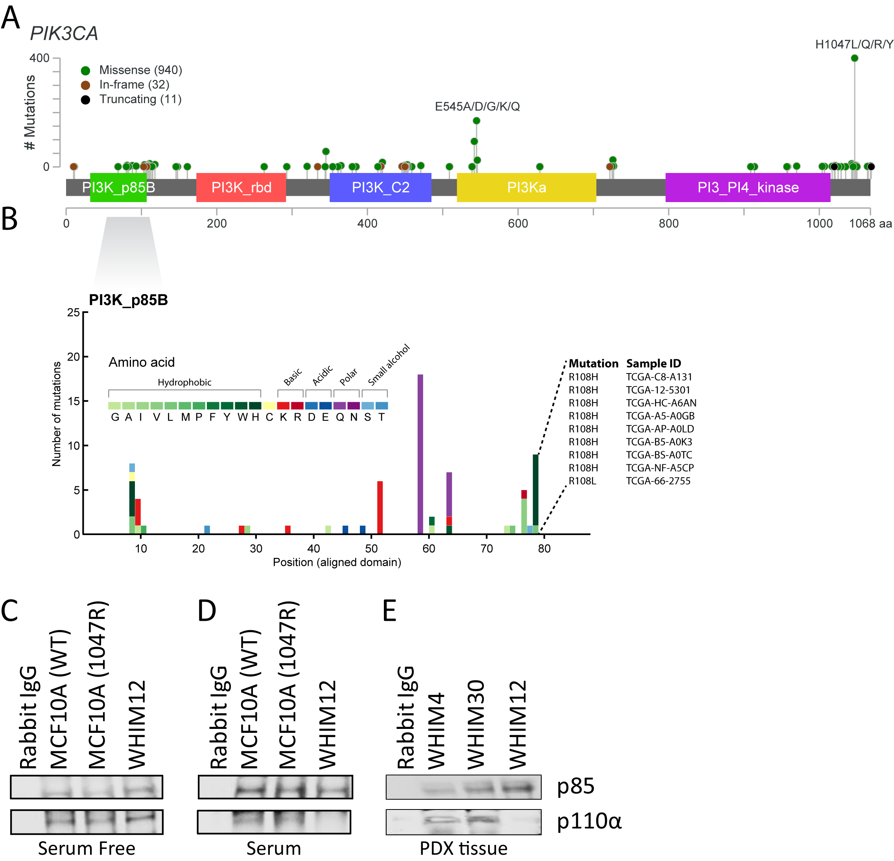
Supplementary figure 8. Overview of PIK3CA mutations and p85 binding domain mutations in detail, and loss of binding between the complex in/del mutant PIK3CA and p85 in WHIM12. A, common mutations of PIK3CA plotted along the protein sequence. The most common cancer-related mutations are indicated (E545A/D/G/K/Q and H1047L/Q/R/Y). An additional mutational hot-spot is evident N-terminally in the p85 binding domain of PIK3CA. A detailed view of the p85 binding domain-related mutations is seen in panel B. In this study, WHIM12 has a complex in/del frameshift deletion resulting in a 4-amino acid deletion and change of E109 to T105 in the p85 binding region of PIK3CA (recorded nonsynonymous mutations at amino acid 108 are listed in panel B for reference). C, Western blots analyzing the expression of p110α and p85 in cell lysates of MCF10A (WT-PIK3CA), MCF10A (H1047R-PIK3CA-mutant), and WHIM12 (mutant PIK3CA) cells under serum free and D, serum conditions after co-immunoprecipitation with p85 antibody. E, Western blots analyzing the expression of p110α and p85 in tumor lysates from WHIM4 (WT-PIK3CA), WHIM30 (WT-PIK3CA) and WHIM12 (mutant PIK3CA) PDXs after co-immunoprecipitation with p85 antibody. Rabbit IgG was used as a negative control for the co-immunoprecipitation experiments.
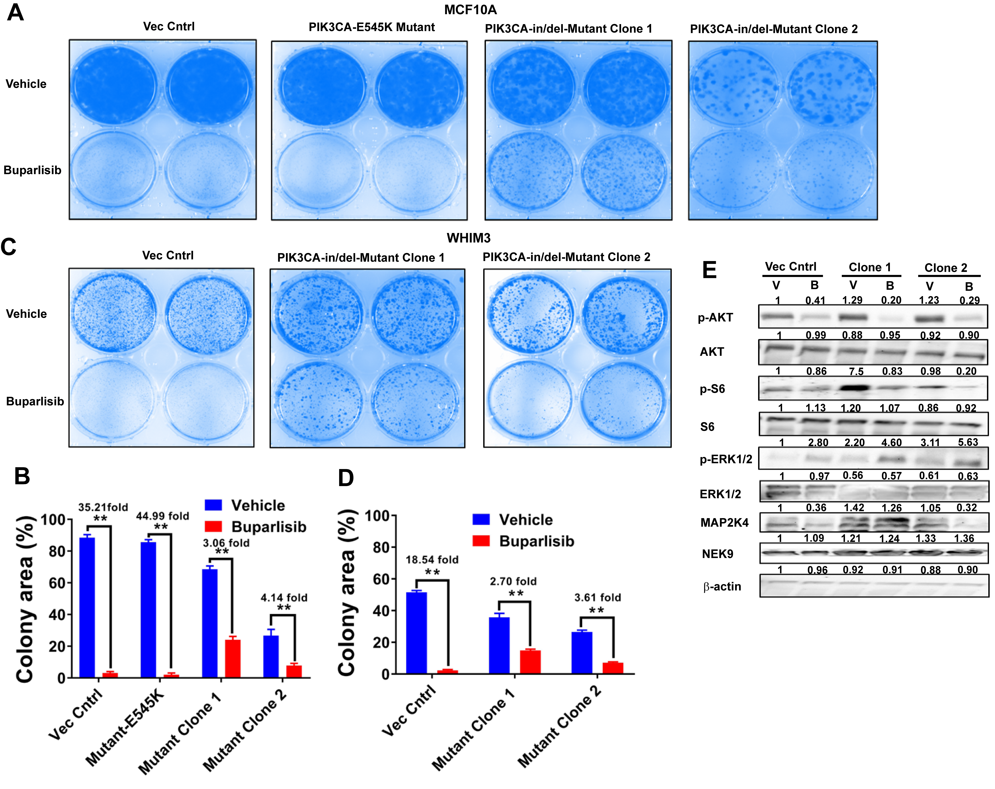 Supplementary figure 9. The mutated form of PIK3CA found in WHIM12 infers partial resistance to buparlisib in sensitive cell lines. A, colony formation assays of MCF10A stably transfected with either vector control or with PIK3CA carrying either the E545K or the complex in/del mutations observed in WHIM12 (Clones 1 and 2 are two different mutant cell clones) following treatment with either vehicle or buparlisib. B, quantified growth of colony formation assays in panel A. C, colony formation assays of WHIM3-derived cell line stably transfected with vector control or the WHIM12-specific mutant form of PIK3CA (two different mutant cell clones are shown) following treatment with either vehicle or buparlisib. D, quantified growth of the colony formation assays in panel C. E, Western blot of selected targets after transfection of the WHIM12 specific mutant form of PIK3CA into the WHIM3 cell line. Numbers are quantifications of Western blot bands. ** = p ≤ 0.01.

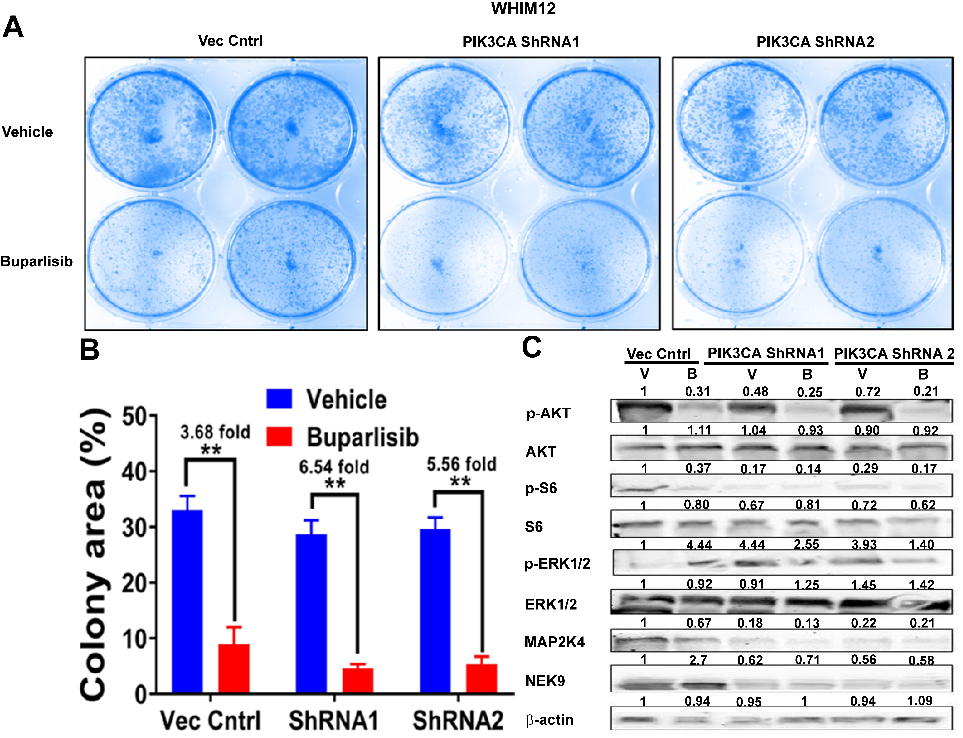
Supplementary figure 10. PIK3CA confers part of the buparlisib resistance, in concert with NEK9 and MAP2K4, in the WHIM12 cell line. A, WHIM12 cell line colony formation assay after PIK3CA knock-down. B, quantified colonies from panel A. ** = p ≤ 0.01. C, Western blots of various proteins after PIK3CA knockdown, with or without buparlisib treatment. Numbers are quantifications of Western blot bands.

