Supplementary Fig 7

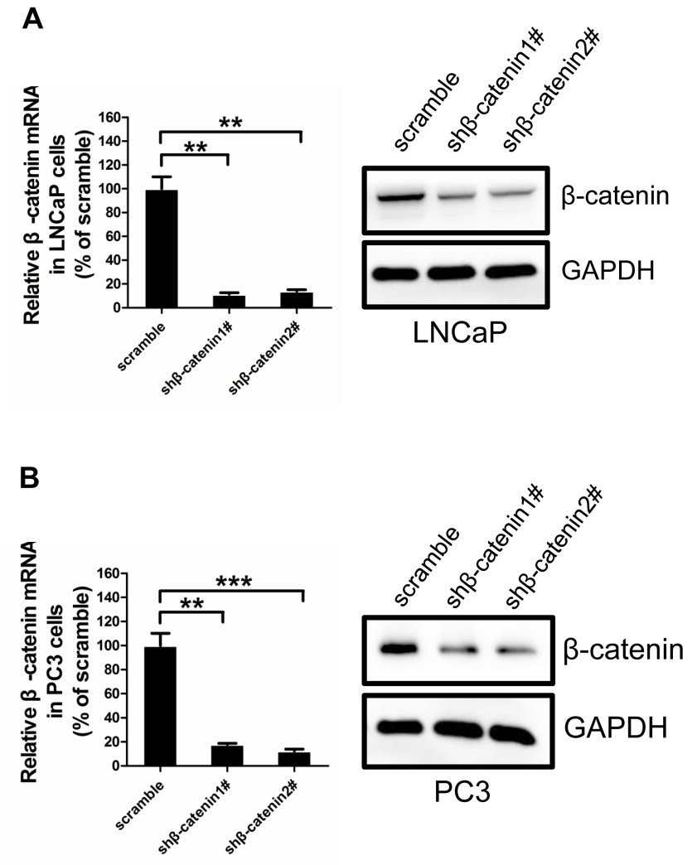
Supplementary Fig 7. Validation of β-catenin knockdown efficiency in PCa cells
(A, B) Two independent shRNA targeting human β-catenin were transfected into LNCaP (A) or PC3 (B) cells.
shβ-catenin 1#: 5'-AAACTACTGTGGACCACAAGC-3'
shβ-catenin 2#: 5'-GCAGCTGGAATTCTTTCTAAC-3'
q-PCR and immunoblotting results show efficient β-catenin knockdown in both cell lines. (Student’s t-test, ***P＜0.001,**P＜0.01, error bars = s.e.m.)

