Supplementary Fig 6
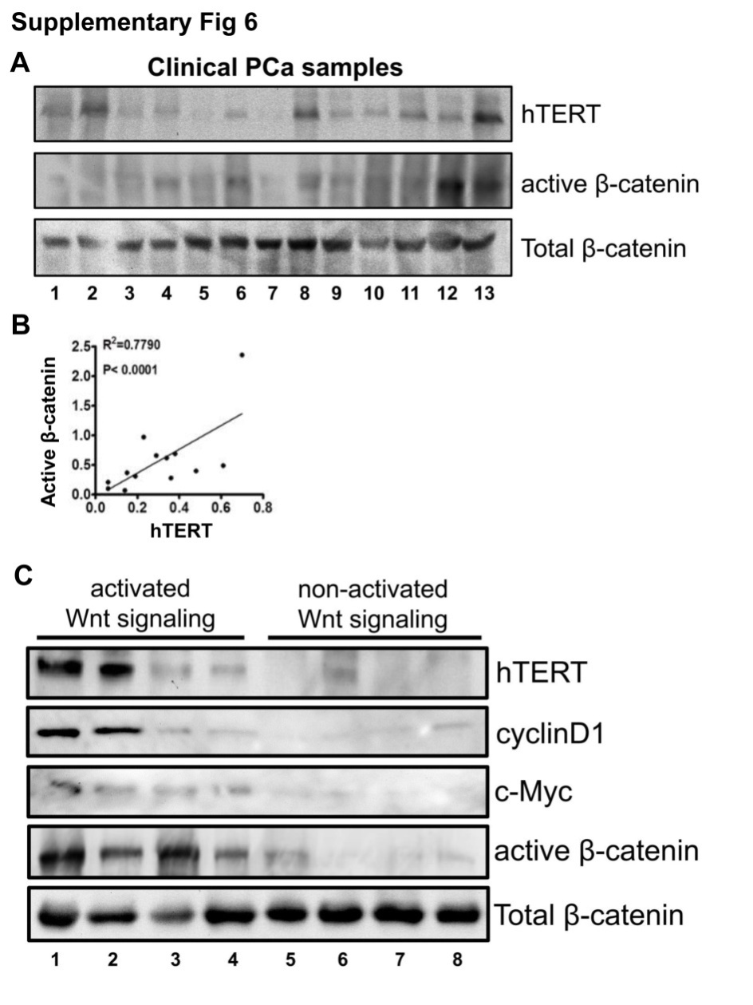
Supplementary Fig 6. PCa tissues with elevated WNT signaling activation express higher level of hTERT
(A) Immunoblotting analysis shows that expression levels of hTERT are positively correlated with active form of β-catenin in a total of 13 cases of PCa specimens. Total β-catenin protein levels were normalized as an internal control. Representative immunoblotting pictures were shown.
(B) A linear relationship between hTERT and active β-catenin protein was evaluated with a regression analysis.
(C) Immunoblotting analysis shows that PCa tissues associated with higher level of active β-catenin and other WNT downstream targets c-Myc and cyclinD1 exhibited increased hTERT expression. Over 30 cases of clinical samples were carefully determined and representative immunoblotting pictures were shown.

