Supplementary Fig 4
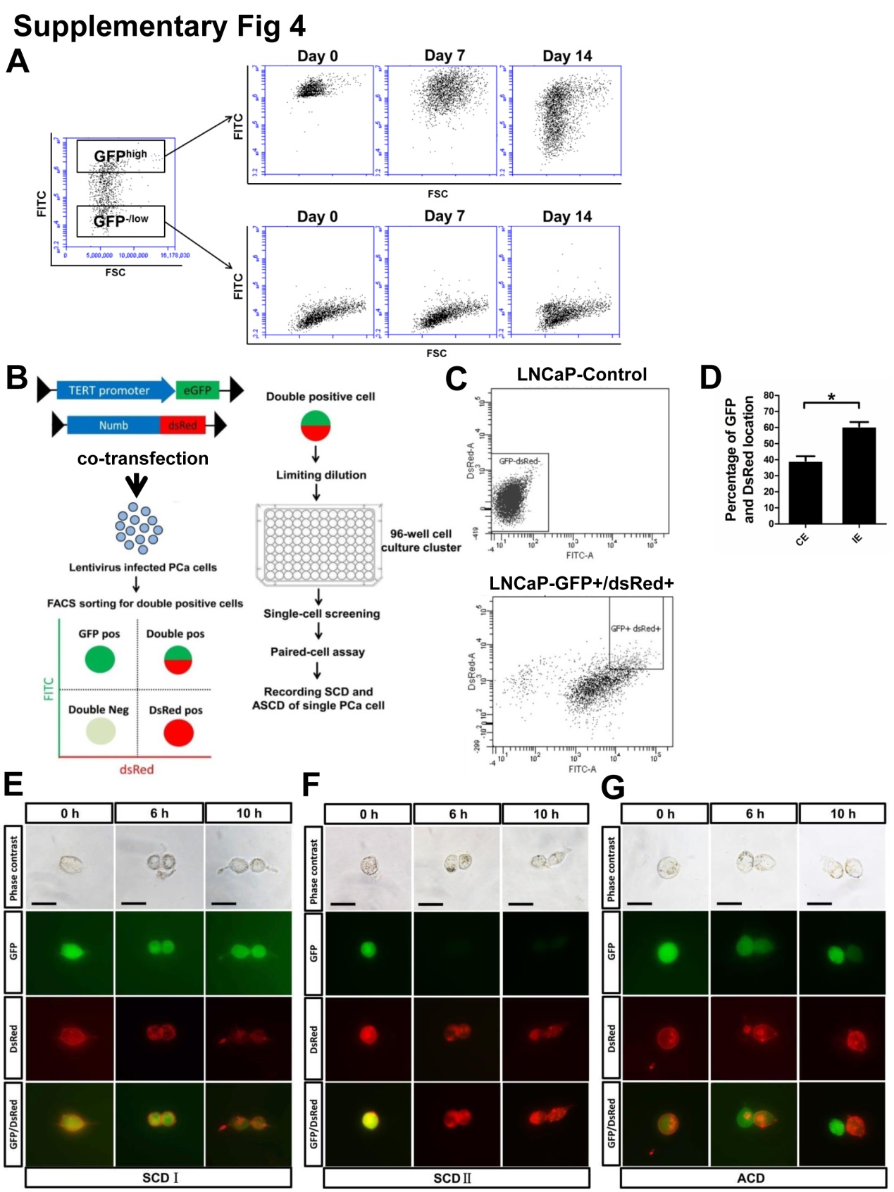
Supplementary Fig 4. hTERT^{high} PCa cells exhibit three distinct cell division modes in a Numb-dsRed segregation context
(A) Top ~15% GFP^{high} and bottom ~10% GFP^{-/low} cells were isolated from the bulk LNCaP cells that are stably expressing hTERT-promoter-GFP respectively. Post-sorting analysis indicated ~98% purity of freshly sorted GFP^{high} cells while the GFP^{-/low} cells showed ~99% purity at Day 0. Cells were cultured in conventional conditions. GFP expression status was determined by flow cytometry at Day 7 and Day 14. Dot plots showed that purity of the GFP^{high} cells started to decrease at Day 7 and decreased even more significantly at Day 14, which indicated GFP^{high} cells were capable to generate GFP^{-/low} cells. Unlike GFP^{high} cells, the purity of GFP^{-/low} cells were stably maintained at least for 14 days, for they mostly remained GFP negative state. (B) LNCaP cells were infected simultaneously with Lv-hTERT-promoter-GFP and Numb-dsRed lentiviruses. Double positive LNCaP cells were sorted by FACS and seeded at single cell level in 96-well-plate. Paired cell assay was performed to record the distribution of GFP and numb-dsRed protein during mitosis of hTERT^{high} cells. (C) Nearly 11.3% of double positive LNCaP cells are sorted out and plated into a 96-well-plate at the density of 10~100 cells per well for the subsequent paired cell assay. (D) Quantified percentage of GFP and dsRed segregations in the daughter cells after cell division. CE represents co-expression; IE represents inverse expression. (Student’s t-test, *P＜0.05, error bars = s.e.m.) (E-G) Images of a GFP/dsRed double positive cell was captured at the indicated time points. In SCDI (E), GFP and dsRed were equally distributed into two daughter cells after mitosis. GFP intensity in two daughter cells retained relatively strong but dsRed in the daughter cells became dimmer compared with their parental cell. Scale bars = 15μm. In SCD II (F), GFP and dsRed were equally segregated into two daughter cells after mitosis. GFP intensity in two daughter cells became extremely weak while dsRed remained strong compared with their parental cell. Scale bars = 15μm. In ACD (G), GFP and dsRed were exclusively segregated into one daughter cell and left the other daughter cell either GFP negative or dsRed negative after mitosis. After mitosis, one GFP/dsRed cell gave rise to two daughter cells: one was GFP⁺/dsRed⁻, the other is GFP⁻/dsRed⁺. Scale bars= 15μm. Over 200 GFP/dsRed double positive LNCaP cells division mode were carefully examined and categorized. Representative pictures were shown.

