Supplementary Fig 2
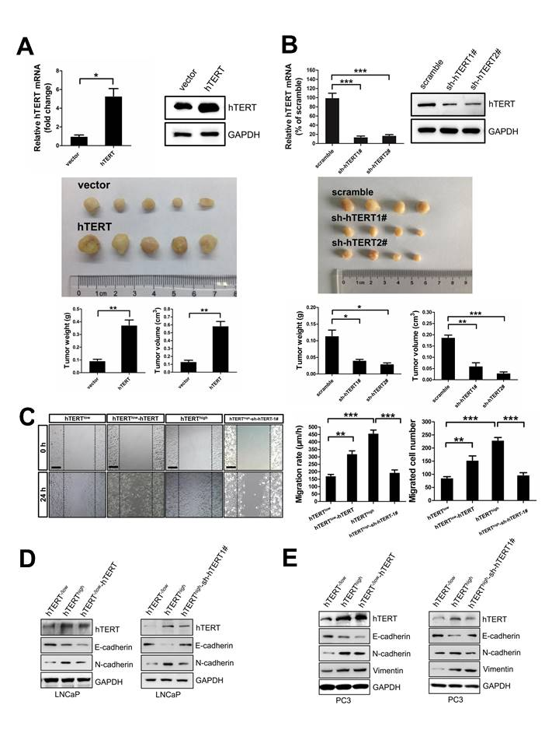
Supplementary Fig 2. hTERT promotes xenograft tumor growth and EMT of PCa cells
(A) Overexpression of hTERT significantly promotes xenograft tumor growth of PCa cells. Ectopic expression of full length hTERT in lentiviral-transfected PC3 cells is verified by q-PCR and immunoblotting analysis (upper panel). 1×10⁵ PC3-vector and PC3-hTERT cells were subcutaneously injected into 6-week male nude mice respectively. At 5 weeks after inoculation, mice were sacrificed and the tumors were collected and imaged (middle panel). Tumor weight and tumor volume at the end point were calculated (lower panel). Five nude mice were used in each experimental group. (Student’s t-test, **P＜0.01, *P＜0.05, error bars = s.e.m.) (B) Knockdown of hTERT dramatically reduces xenograft tumor growth of PCa cells. Two independent shRNA targeting hTERT were used to transfect PC3 cells. Efficient hTERT knockdown are confirmed by q-PCR and immunoblotting analysis (upper panel).
sh-hTERT 1# sequence is 5’-TTTCATCAGCAAGTTTGGA-3’. sh-hTERT 2# sequence is 5’-TGGTGGATGATTTCTTGTT-3’. 1×10⁵ PC3-scramble, PC3-sh-hTERT1#, and PC3-sh-hTERT2# cells were subcutaneously implanted into 6-week male nude mice respectively. At 5 weeks after inoculation, mice were sacrificed and the tumors were collected and imaged (middle panel). Tumor weight and tumor volume at the end point were calculated (lower panel). Four nude mice were used in each experimental group. ( Student’s t-test, ***P＜0.001, **P＜0.01, *P＜0.05, error bars = s.e.m.) (C) hTERT overexpression upregulates the cell mobility of hTERT^{-/low} PCa cells, whereas hTERT knockdown impairs the cell mobility of hTERT^{high} cells. Scale bars = 200μm. Number of migrated cells and cell migration rate were quantified. (Student’s t-test, ***P＜0.001, **P＜0.01, error bars = s.e.m.) (D, E) hTERT overexpression promotes EMT of hTERT^{-/low} PCa cells, whereas sh-hTERT1# mediated hTERT knockdown attenuates EMT of hTERT^{high} cells. Experiments were repeated three times and representative pictures were shown.

