Cell-Specific Computational Modeling of the PIM pathway in Acute Myeloid Leukemia

Supplemental Figures and Tables

Dana Silverbush^{1,2}^, Shaun Grosskurth³^, Dennis Wang⁴, Francoise Powell³, Bertie Gottgens⁵, Jonathan Dry³* and Jasmin Fisher^{2,6}*

¹Department of Computer Science, Tel-Aviv University, Tel-Aviv, Israel;
²Microsoft Research, Cambridge, UK;
³AstraZeneca Oncology IMED, Waltham MA;
⁴AstraZeneca Oncology IMED, Cambridge UK;
⁵Department of Haematology, Cambridge Institute for Medical Research & Wellcome Trust and MRC Stem Cell Institute, University of Cambridge, UK;
⁶Department of Biochemistry, University of Cambridge, UK

^ These authors contributed equally to this work
*To whom correspondence should be addressed:
jf416@cam.ac.uk and jonathan.dry@astrazeneca.com
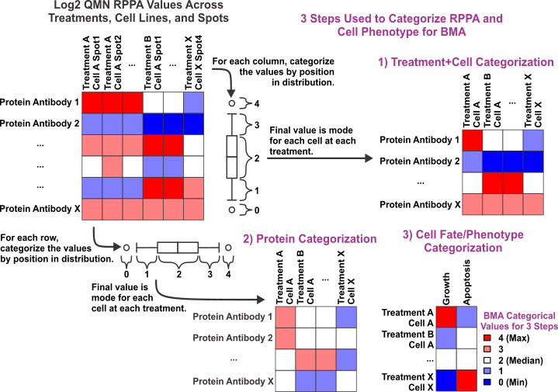

Figure S1. A schematic representation for the method of transforming the log2 linear RPPA values to a 5 point categorical scale suitable for BMA modeling. The RPPA data was categorized by two methods 1) within cell and treatment dynamics of response and 2) within protein antibody measure across cell and treatment. This 5 point scale was also used to categorize the cell line fate (phenotypic response) at each cell line, treatment, and time point condition.
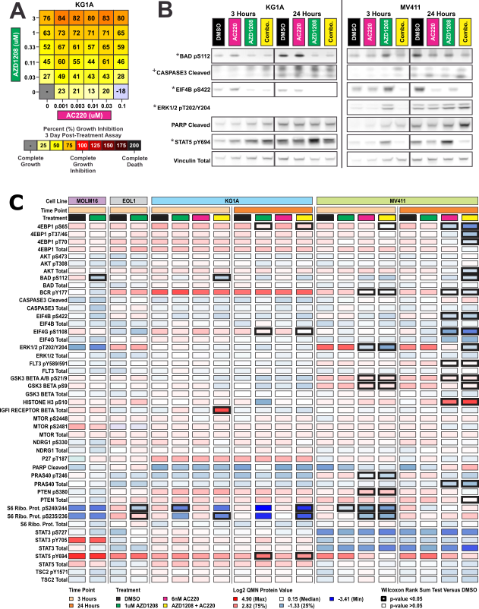
Figure S2. Differential AML signaling responses to single agent PIM inhibition with AZD1208 and combination with FLT3 inhibitor AC220 (A) Growth inhibition of AML cell lines cultured with the indicated concentrations of AZD1208 and/or AC220 for 72 hours. The number of viable cells were determined by Alamar Blue measurements where the values represent percent growth inhibition. (B) Western blot analysis of AML cells prepared at 3 and 24 hours validate many of the RPPA changes identified. An asterix (*) by phospho-signaling change on the Western blot indicate statistical significance in RPPA, while a plus (+) indicate trend holds true between assays. (C) Extending Fig1B: protein expression measured by reverse-phase protein array (RPPA) in treated and untreated cell lines show heterogeneity in signaling responses through various pathways.
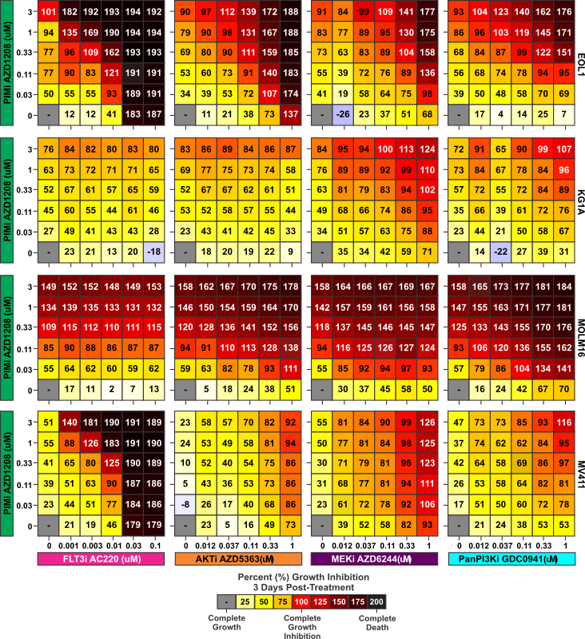
Figure S3. Synergic combinations of drugs are sought to increase sensitivity. Growth inhibition of AML cell lines cultured with the indicated concentrations of AZD1208 and/or tested combined inhibitor for 72 hours. Expanding figure 4.
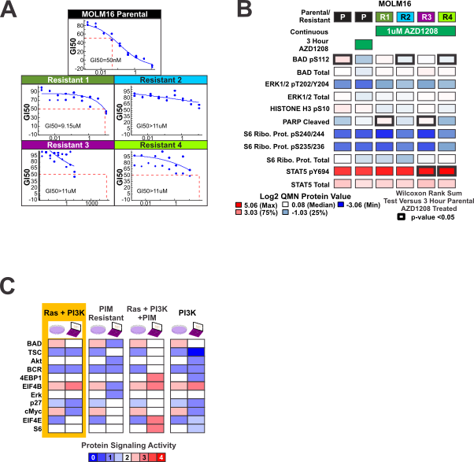

Figure S4. Susceptibility identified in AZD1208 Resistant Cells. (A) Growth inhibition curves and uM GI50 of four independent AZD1208 resistant MOLM16 pools versus the sensitivity of the parental MOLM16 cell line. (B) Significant RPPA signaling changes determined by a Wilcoxon Rank Sum Test with raw p-values < 0.05 and log2 differences greater than or equal to 0.5 from parental cell lines are marked by thick boxes. (C) The model is used to infer most likely mutated genes to derive matching phosphorylation activity as observed in-vitro. The best fit model is chosen according to ability to infer phosphorylation activity compared to measured RPPA. Showing here top four model candidates for source of resistance in R1. The first model, predicting mutation in RAS and PI3K, showing the best correlation.
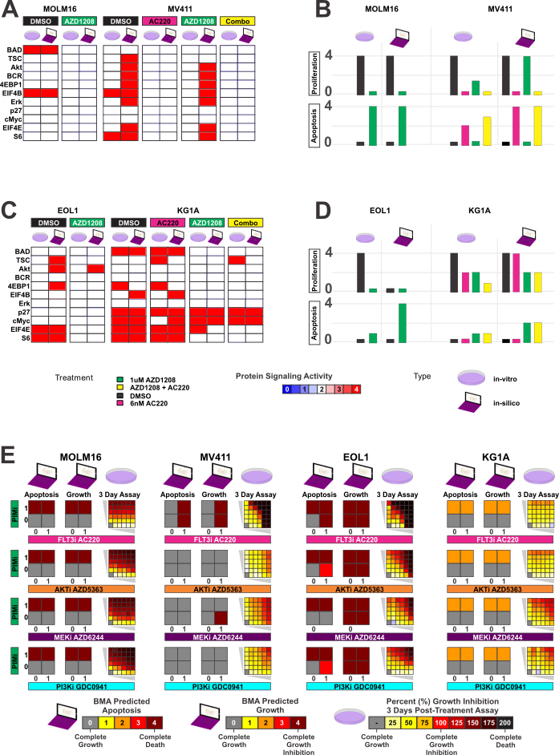Figure S5. Generation of a Boolean model to predict phosphorylation events, responses to single treatment and synergistic combinations of treatments. Activity of proteins was relaxed to binary (ON or OFF) and a new model was generated using the same methodology as described in the main text for the cell-specific AML model: MOLM16 and MV411 cell lines were used as training sets and EOL1 and KG1a were used as test sets. As for treatments we trained with AZD1208 and AC220, and tested with MEK inhibitor, AKT inhibitor, PI3K inhibitor and their combination with PIM inhibitor. (A) Protein signaling activity (phosphorylation) levels inferred in-silico using the Boolean model (laptop icon) capturing levels of phosphorylation activity as measured in-vitro (petri-dish). (B) Cell apoptosis and proliferation as inferred in-silico by the Boolean model compared to levels as observed in-vitro. (C) Unseen cell lines EOL1 and KG1A are incorporated to the executable Boolean model. The robustness of the model is tested via the ability of the model to capture the phosphorylation activity unseen at the time of model construction, and (D) Cell behavior as a result of different perturbations. (E) Predicted cell behavior of apoptosis and proliferations is validated via growth inhibition of AML cell lines cultured with the indicated concentration ranges of AZD1208 and/or tested combined inhibitor after 72 hours.
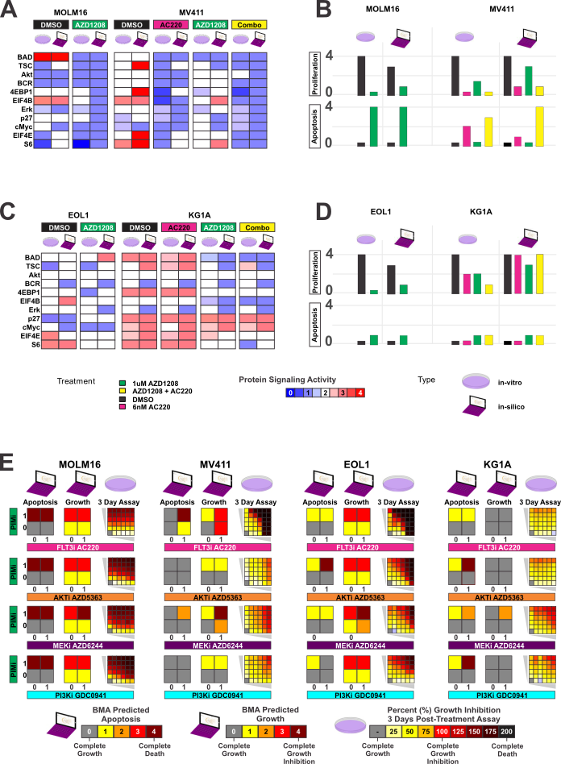Figure S6. Generation of an AND/OR model to predict phosphorylation events, responses to single treatment and synergistic combinations of treatments. Activity of relations is limited to AND/OR/NOT gates only and a new model was generated using the same methodology as described in the main text for the cell-specific AML model: MOLM16 and MV411 cell lines were used as training sets and EOL1 and KG1a were used as test sets. As for treatments we trained with AZD1208 and AC220, and tested with MEK inhibitor, AKT inhibitor, PI3K inhibitor and their combination with PIM inhibitor. (A) Protein signaling activity (phosphorylation) levels inferred in-silico using the AND/OR gates model (laptop icon) capturing levels of phosphorylation activity as measured in-vitro (petri-dish). (B) Cell apoptosis and proliferation as inferred in-silico by the AND/OR gates model compared to levels as observed in-vitro. (C) Unseen cell lines EOL1 and KG1A are incorporated to the AND/OR gates model. The robustness of the model is tested via the ability of the model to capture the phosphorylation activity unseen at the time of model construction, and (D) Cell behavior as a result of different perturbations. (E) Predicted cell behavior of apoptosis and proliferations is validated via growth inhibition of AML cell lines cultured with the indicated concentration ranges of AZD1208 and/or tested combined inhibitor after 72 hours.

Table S8. Target functions for AML general model and cell specific calibrated AML model. The general model is constructed by integrating prior knowledge from literature. Building on this model, the target function in the cell specific model are iteratively refined: the target function for each internal node is designed to reflect the level of phosphorylation activity as measured by the transformed RPPA data for a specific cell as well as the qualitative activity reported in the literature. MOLM16, TYK2, PDGFRA and FGFR1 represent driver mutations. MAX function corresponds to independent activation by upstream proteins, while MIN corresponds to dependant activation, such that the effect is governed by the lower expression of the two upstream proteins. + corresponded to additive effect, and * is used to assign magnitude of effect.
Protein/Node | GeneralModel | Cell Specific Model | Literature and Experimental Supporting Evidences
PIM1 | AVG(STAT3, STAT5) | max(3/4*FltITD,TYK2,3/4*PDGFRA,FGFR1) | PIM1 is activated via STATs by FLT-ITD, TYK2, FIP1L1-PDGFRα and FGFR1 fusion ([1], [2]). The effect of TYK2 on PIM1 is stronger, as implied by the RPPA measurements (Fig 1A) and previous western blot experiments on cell lines [2].
PIM2 | AVG(STAT5) | max(FltITD,1/2*TYK2,1/2*PDGFRA) | PIM2 is activated via STATs by FLT-ITD, TYK2 and FIP1L1-PDGFRα ([1], [2]). PIM2 is over dominanted by FLT-ITD induced expression as was implied previously by western blot experiments [2].
BAD | AVG(RAF, RSK, AKT, PIM1, PIM2) | 1/2*RSK+1/2*PIM1 | BAD accumulates activity from MAPK pathway and from PIM1 direct phosphorylation of all three sites [3]. PIM1 induced over expression is likely to be the main deriving cause for the anti-apoptotic behavior observed in TYK2 mutated cell lines.  From the MAPK pathway, activated ERK phosphorylates cytoplasmic signaling proteins, including RSK [4], which phosphorylates BAD on Ser112 and Ser155 [5], [6].
Table S8 Continue. Target functions for AML general model and cell specific calibrated AML model.
Protein/Node | GeneralModel | Cell Specific Model | Literature and Experimental Supporting Evidences
EIF4B | AVG(RSK, S6, 4EBP1) | min(3,RSK+1/2*PIM1) | PIM1 regulates the phosphorylation of EIF4B on Ser406, required for the binding of EIF4B to the eIF3 translation initiation complex [7]. In concurance, EIF4B is over-expressed in MOLM16 and MV411 cell lines, as was evident in our RPPA data (Fig 3B), and is responsive to PIMs inhibitor.  Zoncu et al. [8] show that in addition EIF4B is phosphorylated and activated by RSK.
EIF3 | AVG(EIF4B/ EIF4E, PIM1) | min(EIF4E,EIF4B) | Phosphorelated EIF4B binds to the eIF3 translation initiation complex [7]. EIF4E bridges the ribosome to the mRNA via eIF3 [9].
4EBP1 | AVG(PIM2, PIM1, mTORC1, EIF3) | 2/3*mTORC1+1/6*EIF3+1/6*PIM2 | Released from PRAS40 inhibition [3] mTORC1 phosphorylates 4EBP1 [10] and p70S6 [6], [8], [11]. eIF3 binds mTORC1 and recruits it to untranslated mRnAs so that it is optimally placed to phosphorylate s6K1 and 4EBP1 [8]. Independiently, PIM2 directly phosphorylate 4EBP1 [12].  In concurance, 4EBP1 responses moderately on S65 site to the PIMs inhibition, and with a stable consistent response to PIM and FLT3 inhibitors combination (Fig 1B). We attribute the later to FLT3 regulation of 4EBP1 through mTORC1. This finding was supported by a new study very recently, illustrating this mechanism to explain FLT-ITD patients' resistance to Bortezomib treatment [13].
EIF4E | AVG(RSK, S6, 4EBP1) | max(1/2*4EBP1,S6) | Unphosphorylated 4EBP1 suppresses mRnA translation; however, when phosphorylated by mTORC1, 4EBP1 dissociates from eIF4E, allowing eIF4E to recruit the translation initiation factor eIF4G to the 5′ end of most mRnAs22,23 [4]. Yellen et al. found that independently of 4EBP1, S6 inhibition is required in order to achieve the full complete G1 cell cycle arrest induced by repressed EIF4E [14].
Table S8 Continue. Target functions for AML general model and cell specific calibrated AML model.
Protein/Node | GeneralModel | Cell Specific Model | Literature and Experimental Supporting Evidences
S6 | AVG(RSK, EIF3, mTORC1) | 1/8*RSK+3/4*mTORC1+1/8*EIF3 | Released from PRAS40 inhibition [3] mTORC1 if able to phosphorylat the key translation regulator p70S6 [6], [8], [11], which in turn phosphorylates S6. eIF3 binds mTORC1 and recruits it to untranslated mRnAs so that it is optimally placed to phosphorylate s6K1 and 4EBP1 [8]. Roux et al. speculated that an mTOR-independent pathway that requires RSK activity promotes S6 phosphorylation at Ser235/236 [15]. Our theranostic results support the hypothesis, showing consistent inhibition of S6 for cell lines treated with Pim and FLT3 inhibitos comnbination, inhibitong simoltanously both MAPK and mTORC1 pathways (Fig 1B and S1C).
BCR | AVG(FLT-ITD) | max(1, 1/2*FltITD) | We observed high levels of phosphorylation activity on BCR Y177 in EOL1, KG1a and MV411, reduced by the FLT3 inhibitor, yet no change after PIM inhibition as a single treatment (Fig 1B). We hypothesize that BCR plays a role in resistance to PIM inhibitor, yet is activated downstream of FLT3 and is sensitive to FLT3 inhibitor aiding to inhibit the MAPk pathway (Fig 3B and 3D). Kazi et al. provided evidence that SLAP directly associates with Flt3 and BCR to modulate downstream signaling of FLT3-induced Akt, Erk and p38 activation  [16] . In their survey of activated FLT3 signaling in leukemia, Gy et al. [17] showed that oncogenic FLT3 affects BCR signaling pathway in human leukemia.
Table S8 Continue. Target functions for AML general model and cell specific calibrated AML model.
Protein/Node | GeneralModel | Cell Specific Model | Literature and Experimental Supporting Evidences
Grb2/SOS | AVG(BCR, FGFR1) | max(BCR,1/2*FGFR1) | BCR initiates three major signalling pathways: the Ras pathway, leading to ERK activation; the phospholipase C-γ pathway; and the PI3K pathway [18].  Ma et al. [19] and Million et al. [20] researched the effect of BCR/Abl fusion and suggest that when BCR is phosphorylated on site 177 it activates Ras through binding GRB2, leading to over expression of ERK and PI3K [18].  Our RPPA reports highlight the correlated respons of BCR and downstream ERK in the MAPK pathway (BCR pY177 and ERK1/2 pT202/Y204 for MOLM16, EOL1 and MV411 through the single and combination treatments Fig 1B). PI3K was not measured directly, yet its target AKT was observed, and sowhs the expected correlation to BCR activity (Fig 3B and 3D).
RAS | AVG(BCR,Grb2/SOS) | min(Grb2/SOS,BCR)
PI3K | AVG(Grb2/SOS, !RAS) | max(BCR,Grb2/SOS,1/2*PDGFRA)
RAF | AVG(RAS) | AVG(RAS) | MAPK signaling cascade [21] characterizes the RAS-RAF-MEK-ERK-RSK cascade. FIP1L1–PDGFR fusion is required to stimulate proliferation and mediate survival of the eosinophils in CEL patients, through activation of several signaling pathways including PI3K, ERK 1/2 and STAT5 [22].
MEK | AVG(RAF) | AVG(RAF)
ERK | AVG(MEK, PDGFRA) | max(MEK,1/2*PDGFRA)
RSK | AVG(ERK) | AVG(ERK)
AKT | AVG(PI3K, PDK1, mTORC2, !S6, !PRAS40) | max(PI3K,mTORC2) | PI3K generates PIP3, which recruits the protein kinase AKT to the plasma membrane where it is activated by PDK1 and mTORC2 [4], [23].  AKT is consistently high in MV411 cells (Fig 3B), and it responses to FLT3 inhibitor and the combination of FLT3 and PIMs inhibitors, as would be expected of mTORC2 target, downstream of PI3K. We hypothesize that the mechanism described above of FLT-ITD trigering PI3K and TSC2-mTORC to activate AKT, is a key factor in MV411 resistance to PIM inhibitors.
Table S8 Continue. Target functions for AML general model and cell specific calibrated AML model
Protein/Node | GeneralModel | Cell Specific Model | Literature and Experimental Supporting Evidences
mTORC2 | AVG(PI3K, !TSC2) | AVG(PI3K) | mTORC2 is knwon to be activated by PI3K [4]. It was also found that TSC2 is defective in cells lacking the TSC1-TSC2 complex, thus believed that TSC2 has a feed back inhibitory effect on mTORC2 [24]. However our RPPA results do not show this to effect mTORC2 (Fig S1), consistent with the claim that this effect on mTORC2 can be separated from the inhibitory effects of the TSC1-TSC2 complex on Rheb and mTORC1 [24].  mTORC2 measured on site Ser2481 of mTOR [11] was sensitive to FLT3 inhibitor as well as the combination (Dataset S1), as expected of PI3K target, triggred by FLT-ITD.  We there fore speculate that in the context of modeling the signaling events in AML leading to prolifiration and apoptosis, the inhibitory effect of TSC2 on mTORC2 should be excluded.
mTORC1 | AVG(TSC2, !mTORC1PRAS40complex) | 1/2*PRAS40+TSC2 | Phosphorylation of PRAS40 by AKT and PIM1 no longer inhibits mTORC1 [25], leading to its dissociation and the subsequent activation of mTORC1, independently of TSC2 [26]. Lu et al. [27] studied mRNA expression in Multiple Myeloma cell lines to show that combinational inhibition of both PIMs and PI3K/Akt leads to more pronounced reduction of mTORC1 activity than inhibiting PIMs or PI3K/Akt alone.
TSC2 | AVG(PIM2, !ERK, !RSK) | 1/2*((PIM2-1)+1/2*Akt) | PIM2 is reported to directly phosphorylate TSC2 on Ser1798 [28]. Akt phosphorylates TSC2 on sites Ser1798 and Ser939/Thr1462 [28]. Both events independently can release TSC inhibition of RHEB, which directly activates mTORC1 [4], [29].
Table S8 Continue. Target functions for AML general model and cell specific calibrated AML model.
Protein/Node | GeneralModel | Cell Specific Model | Literature and Experimental Supporting Evidences
PRAS40 | AVG(AKT, PIM1, PIM2) | 1/4*PIM1+5/4*Akt | Both AKT and PIM1 phosphorylate PRAS40 on Thr-246 site, leading to its dissociation and the subsequent activation of mTORC1 [26].Our RPPA results support the evidences accumulating for AKT/mTOR pathway role in AML[2], presenting elevated levels of PRAS40 phosphorylation in EOL1, MV411 and KG1a (Fig 1B). A key difference of the cell lines we modelled points to MOLM16, harboring a TYK2 mutation, averting from hitting the AKT/mTOR. We suggest that while TYK2-mutated cell lines preserve healthy level of regulation of PRAS40 and mTORC1 binding [25], [26], FLT-ITD, PDGFRA and FGFR1 fusion over activate PRAS40, which reduces their sensitivity to PIM inhibition (Fig 1A).
CHK | AVG(PIM1, PIM2) | max(PIM1,PIM2) | Yuan et al. Found that Pim kinases phosphorylate Chk1 and regulate its functions in acute myeloid leukemia [3]
H3 | AVG(CHK) | AVG(CHK) | Chk phosphorylation on histone H3 derives cell survival [30]
Table S8 Continue. Target functions for AML general model and cell specific calibrated AML model.
Protein/Node | GeneralModel | Cell Specific Model | Literature and Experimental Supporting Evidences
cMyc | AVG(FGFR1, PIM1, PIM2, H3) | max(3/4*FGFR1,max(1,1/4*(max(PIM1,PIM2) + H3)) | cMyc is a traditional PIM kinase target [31], [32]. It showed an expected consistent decrease in MOLM16, EOL1 and MV411 cell lines in response to PIM and FLT3 inhibiting treatments, as well as a synergic decrease for the combination of treatments (Fig 3B and 3D). Chen et al. [31] suggested that cMyc driven transcription is disrupted by PIMs inhibition, this may be because of decreased c-Myc phosphorylation and decreased histone H3 on Ser10 phosphorylation that is required for binding of Myc/Max dimers to the E-box31 and initiation of Myc-driven transcription. Yang et al. agree that PIM1 phosphorylation of Histone H3 at Ser10 is a necessary event for cMyc– driven transcription [32].  For KG1a the abnoarmal high phophrylation level of cMyc remains so even in presence of the various treatmnets (Fig 3D). We hypothesise that the high levels of cMyc derive the persistant insensitivity of KG1A to the treatments. The critical role of cMyc in AML was charcterized alreqady in 2011 [33], yet not its connection to FGFR1 fusion, harboured in KG1A. In a study done on stem cells it was found that wild type FGFR1 stimulates cMyc [34]. Very recently, subsequent of writing this paper, an independant study by Ozretic et al. [35] demonstrated the interplay of FGFR1 and cMyc overexpression in Head and neck squamous cell carcinoma. Recently, Malchers et al. [36] suggested the expression of cMyc in FGFR1 amplified squamous cell lung cancer cell lines is a good predictor of therapy response to FGFR1 inhibitors, which could suggest that expression of cMyc in AML patients harbouring FGFR1 fusion may serve as a good indicator to response to FGFR1 inhibition.
Table S8 Continue. Target functions for AML general model and cell specific calibrated AML model.
Protein/Node | GeneralModel | Cell Specific Model | Literature and Experimental Supporting Evidences
P27 | AVG(PIM1, PIM2, FOXO3) | max(1,cMyc*(cMyc-2)+1/2*max(PIM1,PIM2)) | Several evidnces suport the finding that p27 is phospohorylated by PIMs [2], [7]. Independintly p27 was shown to be upregulated by cMyc [37] findings that were repeated specifically in AML [38].
FOXO3 | AVG(STAT3, FLT-ITD) | Merged to other complexes
STAT3 | AVG(TYK2)
STAT5 | AVG(FLT-ITD, PIM1)
cyclinD1 | AVG(AKT, STAT5)
mTORC1PRAS40complex | AVG(PARS40, !AKT)
Proliferation | AVG(ERK, RSK, cyclinD1, cMyc, p27, 4EBP1) | (EIF4B-2)+1/2*ERK+2/3*p27+2/3*cMyc | EIF4B regulates translation of proliferative mRNAs [39], and Shahbazian et al. show that its silencing led to decreased proliferation rates [40]. EIF4B is overexpressed in all four cell lines (Fig 3B and 3D) and responses to PIM inhibition with correlation to proliferation level. Interesting to note EIF4B resistance to FLT3 inhibition in KG1A cell line, which could suggest a cause to the resistance expressed in proliferation. An addative effect of proliferation may be due to allevated levels of cMyc in KG1A, its deriving effect on proliferation was widely explored [41].  MV411 cell line shows decreased response in proliferation in response to PIM inhibition compared to FLT3 inhibiton, which we attribute to addative ERK phosphorylaion (Fig 3B), its role in cell proliferation was validated in primary cell cultures and various mouse models [42].  Finally, the phosphorylation of p27 was shown to lead to cell proliferation [31] and may be deriving proliferaion in both MOLM16 and KG1A.
Table S8 Continue. Target functions for AML general model and cell specific calibrated AML model.
Protein/Node | GeneralModel | Cell Specific Model | Literature and Experimental Supporting Evidences
Apoptosis | AVG(!BAD, !S6, !cMyc, !EIF4) | !MAX(BAD, S6, 1/2*BAD + cMyc + S6 + 2*EIF4E))  *range expnanded by 2 for FGFR1 | MV411 exhibits high levels of S6 phosphorylation, S6 levels predicted by reverse correlation level of apoptosis in response to FLT3 inhibition, PIM inhibition and the combination. These results are in concurance with Recher et al. [43] research exploring the use of rapamycin in AML to find that inhibiting the phosphorylation of p70S6K led to cell cycle arrest or apoptosis.  MOLM16 exhibits extremly high levels of BAD phosphorylation, predicting in reverse correlation level of apoptosis in response to PIM inhibition. Phosphorylation of BAD leads to apoptosis [31] by disrupting its binding to the Bcl-XL, allowing BAD to bind scaffold protein 14-3-3 to sequester its proapoptotic function, thereby activating a cell survival pathway [32].  While high levels of either S6 or BAD dominantly protect the cell from apoptosis, even lower levels may synergically effect cell survival. eIF4E also mediates cell survival and apoptosis (reviewed in [44], [45]).  EIF4E levels suggest an addative effect with S6 in EOL1 to prevent cell apoptosis.  In KG1A cMyc persistant high levels may derive the cell suravial, adding to the effect of S6, and perhaps also EIF4E. Concomitant with promoting  cell growth and proliferation, cMyc  sensitizes cells to apoptosis [41].

Table S9. AML genotype state. Modeled by setting the nodes for the driver mutations found in that cell to 1, while all other proteins with mutations that were assessed as non-driver are set to 0. The model was calibrated using MOLM16 and MV411 cell-lines and validated to EOL1 and KG1A cell-lines. To incorporate an unseen cell-line, its respected mutation is added to the model (if it does not exist) and connected to its downstream proteins.
 | Training cell-lines |  | Validation cell-lines
 | MOLM16 | MV411 | EOL1 | KG1A
TYK2 | 1 | 0 | 0 | 0
FLT-ITD | 0 | 1 | 0 | 0
FIP1L1-PDGFRA | 0 | 0 | 1
FGFR1 | 0 | 0 | 0 | 1

Table S10. Immediate downstream effect of modelled AML genotypes. A cell line is modelled by linking its mutations/fusions to their immediate downstream over/under-activated proteins, from which the signal cascade will activate the appropriate AML pathway. Each mutation may activate different proteins to different levels, which we calibrates using the RPPA measurements. Each cell in the table represents the percentage of over-activity level of the immediate downstream protein (rows) triggered by the respected mutation/fusion (columns), empty cell represents normal levels.
 | Training cell-lines |  | Validation cell-lines
 | MOLM16 (TYK2) | MV411  (FLT-ITD) | EOL1  (FIP1L1-PDGFRA) | KG1A  (FGFR1)
PIM1 | 1 | 3/4 | 3/4 | 1
PIM2 | 1/2 | 1 | 1/2
BCR |  | 1/2
ERK |  |  | 1/2
Grb2/SOS complex |  |  |  | 1/2
PI3K |  |  | 1/2
cMyc |  |  |  | 3/4

Table S11. Cell-specific AML network model replicates response to treatments reported in external publications. Summary of experimental conclusions are given in in-vitro, and model predictions are given in in-silico.
Paper | Cell Line | Perturbations | In-Vitro | In-Silico | Check.
[46] | MV411 | FLT3-ITD inhibitor | Moderate effect on viable cell number (especially compared to MOLM13 and MOLM14 FLT-ITD positive) | Proliferation reduced to 0 | V
 |  |  |  | Apoptosis increased to 1
 |  | PI3K inhibitor | Neglectable effect on viable cell number (especially compared to MOLM13 and MOLM14 FLT-ITD positive) | Proliferation remains 4 | V
 |  |  |  | Apoptosis remains 0
[46] | MV411 | FLT3-ITD + PI3K inhibitor | induced more apoptosis than each of the agents alone in all samples tested | Apoptosis increased to 4 | V
[47] | KG1A | AKT, PDK1, and FLT3 inhibitor | showed resistant to the inhibitors | Proliferation remains 4 | V
 |  |  |  | Apoptosis remains 0
[48] | MV411 | mTORC inhibitor | Decreased cell proliferation | Proliferation remains 4 | X
 |  |  | Induced apoptosis | Apoptosis increased to 4 | V
 |  |  | AZD8055 fully inhibited multisite eIF4E-binding protein 1 phosphorylation | Phosphorylation activity of eIF4E (3->1) | V
 |  |  | induced a dephosphorylation of 4EBP1 on T37/46, S65 and T70 residues | Phosphorylation activity of 4EBP1 (3->1) | V
Table S11 Continue. Cell-specific AML network model replicates response to treatments reported in external publications.
Paper | Cell Line | Perturbations | In-Vitro | In-Silico | Check.
[49] | EOL1 | MEK inhibitor | Failed to induce apoptosis | Apoptosis remains 0 | V
 |  |  | Level of p-4E-BP1 were not down-regulated | Phosphorylation activity of 4EBP1 remains 3
[50] | EOL1 | PIM inhibitor | 4EBP1 is hardly effected | 4EBP1 slightly affected (3 -> 2) | V
 |  |  | S6 very slightly affected | S6 slightly affected (3 -> 2)
 |  |  | Induced apoptosis, yet not as sensitively as MOLM16 | Apoptosis induced (0 -> 1), yet profoundly less senstitive than MOLM16 (0 -> 4)
[50] | EOL1 | AKT inhibitor | Effect on S6 in more profound than with PIM inhibition | S6 (3 -> 1) | ~V
 |  |  | Effect on 4EBP1 is as PIM inhibition | Phosphorylatyion of 4EBP1 decreased (3 -> 1)
 |  |  | Significant amount of inhibitor had induces apoptosis | Apoptosis induced (0 -> 3)
[50] | EOL1 | PIM and AKT inhibitors | S6 reflectes synergic effect | S6 reflectes synergic effect | V
 |  |  | Significant effect on apoptosis | Significant effect on apoptosis (0 -> 4)
Table S12. Combination strategy showing predicted activity for combinations of PI3K inhibitor, AKT inhibitor, MEK inhibitor, and AKT inhibitor with the PIM inhibitor AZD1208 across the 4 AML cell lines.
Cell line | Inhibitors |  |  | In-Silico Predictions |  |  |  |  |  | Supporting Literature
 |  |  |  | Phosphorylation activity |  | Proliferation |  | Apoptosis
MV411 | PI3K |  |  | AKT might show some decreased activity |  | Unchanged levels of proliferation |  | Unchanged levels of apoptosis |  | [46]
MV411 | PI3K+PIMs |  |  | AKT should show decreased activity |  | Decreased proliferation |  | Increased apoptosis (even with respect to PIMs as single agent) |  | No experimental data found in literature
MV411 | AKT |  |  | The model shows no change in PRAS40 and S6 |  | Unchanged levels of proliferation |  | None to slight increased apoptosis, depending on S6 activity |  | [50]
MV411 | AKT+PIMs |  |  | PRAS40 and S6 activity shut down |  | Decreased proliferation |  | Increased apoptosis |  | [50]
MV411 | MEK |  |  | Reduced ERK and RSK activity |  | Decreased proliferation |  | Unable to induce apoptosis |  | No experimental data found in literature, [49] supports the claim for MOLM13, also harbouring FLT-ITD
MV411 | MEK + PIMs |  |  | Decreased BAD and S6 activity |  | Decreased proliferation |  | Moderately increased apoptosis |  | No experimental data found in literature
Table S12 Continue. Combination strategy
Cell line |  | Inhibitors |  |  | In-Silico Predictions |  |  |  | Supporting Literature
 |  |  |  |  | Phosphorylation activity | Proliferation |  | Apoptosis
MOLM16 |  | PIMs |  |  | Decreased BAD activity | significant effect on proliferation |  | significant effect on apoptosis | [50]
MOLM16 |  | PI3K |  |  |  | Unchanged levels of proliferation |  | Unchanged levels of apoptosis | No experimental data found in literature
MOLM16 |  | PI3K+PIMs |  |  |  | Decreased proliferation |  | Increased apoptosis | No experimental data found in literature
MOLM16 |  | AKT |  |  |  | Unchanged levels of proliferation |  | Unchanged levels of apoptosis | [50]
MOLM16 |  | AKT+PIMs |  |  |  | Decreased proliferation |  | Increased apoptosis | [50]
MOLM16 |  | MEK |  |  | Reduced ERK and RSK activity | Decreased proliferation |  | Unable to induce apoptosis | No experimental data found in literature
MOLM16 |  | MEK + PIMs |  |  |  | Decreased proliferation |  | Increased apoptosis | No experimental data found in literature
EOL1 |  | PIMs |  |  |  | Decreased proliferation |  | Very slightly increased apoptosis | [50]
EOL1 |  | PI3K |  |  |  | Unchanged levels of proliferation |  | Increased apoptosis | No experimental data found in literature
EOL1 |  | PI3K+PIMs |  |  | Phosphorylation of S6 decreased | Decreased proliferation |  | Increased apoptosis | No experimental data found in literature
EOL1 |  | AKT |  |  |  | Unchanged levels of proliferation |  | Increased apoptosis | [50]
Table S12 Continue. Combination strategy
Cell line | Inhibitors |  |  | In-Silico Predictions |  |  |  |  | Supporting Literature
 |  |  |  | Phosphorylation activity |  | Proliferation | Apoptosis
EOL1 | AKT+PIMs |  |  | Phosphorylation of Bad slightly decreased, S6 decreased |  | Decreased proliferation | Increased apoptosis |  | [50]
EOL1 | MEK |  |  |  |  | No change | Unchanged levels of apoptosis |  | Apoptosis was concurred with [49], proliferation verification was not found
EOL1 | MEK + PIMs |  |  |  |  | Decreased proliferation | Very slightly increased apoptosis |  | No experimental data found in literature
KG1a | PIMs |  |  | Phosphorylation of Bad decreased, S6 slightly decreased |  | Moderately decreased proliferation | Very slightly increased apoptosis |  | Internal experiments conducted verified response (Fig 5C)
KG1a | PI3K |  |  | Phosphorylation of Bad unchanged, S6 decreased |  | Unchanged levels of proliferation | Moderately increased apoptosis |  | [51]  demonstrated apoptotic signal in response to LY335979
KG1a | PI3K+PIMs |  |  | Phosphorylation of Bad decreased, S6 decreased |  | Moderately decreased proliferation | Increased  apoptosis |  | No experimental data found in literature
KG1a | AKT |  |  |  |  | Unchanged levels of proliferation | Moderately increased apoptosis |  | No experimental data found in literature
Table S12 Continue. Combination strategy
Cell line | Inhibitors |  | In-Silico Predictions |  |  |  |  |  | Supporting Literature
 |  |  | Phosphorylation activity |  |  | Proliferation | Apoptosis
KG1a | AKT+PIMs |  | Phosphorylation of Bad decreased, S6 decreased |  |  | Moderately decreased proliferation | Increased  apoptosis |  | No experimental data found in literature
KG1a | MEK |  | Phosphorylation of ERK decreased |  |  | Very slightly decreased | Unchanged levels of apoptosis |  | No experimental data found in literature
KG1a | MEK + PIMs |  | Phosphorylation of ERK decreased, BAD decreased |  |  | Decreased proliferation | Moderately increased apoptosis |  | No experimental data found in literature
References

[1] M. Ku et al., “Src family kinases and their role in hematological malignancies,” Leuk. Lymphoma, vol. 56, no. 3, pp. 577–586, Mar. 2015.
[2] E. K. Keeton et al., “AZD1208, a potent and selective pan-Pim kinase inhibitor, demonstrates efficacy in preclinical models of acute myeloid leukemia,” Blood, vol. 123, no. 6, pp. 905–913, Feb. 2014.
[3] L. L. Yuan et al., “Pim kinases phosphorylate Chk1 and regulate its functions in acute myeloid leukemia,” Leukemia, vol. 28, no. 2, pp. 293–301, Feb. 2014.
[4] M. C. Mendoza, E. E. Er, and J. Blenis, “The Ras-ERK and PI3K-mTOR pathways: cross-talk and compensation,” Trends Biochem. Sci., vol. 36, no. 6, pp. 320–328, Jun. 2011.
[5] Y. Tan, M. R. Demeter, H. Ruan, and M. J. Comb, “BAD Ser-155 phosphorylation regulates BAD/Bcl-XL interaction and cell survival,” J. Biol. Chem., vol. 275, no. 33, pp. 25865–25869, Aug. 2000.
[6] F. Zhang et al., “PIM1 protein kinase regulates PRAS40 phosphorylation and mTOR activity in FDCP1 cells,” Cancer Biol. Ther., vol. 8, no. 9, pp. 846–853, May 2009.
[7] B. Cen et al., “The Pim-1 protein kinase is an important regulator of MET receptor tyrosine kinase levels and signaling,” Mol. Cell. Biol., vol. 34, no. 13, pp. 2517–2532, Jul. 2014.
[8] R. Zoncu, A. Efeyan, and D. M. Sabatini, “mTOR: from growth signal integration to cancer, diabetes and ageing,” Nat. Rev. Mol. Cell Biol., vol. 12, no. 1, pp. 21–35, Jan. 2011.
[9] S. Morino, H. Imataka, Y. V. Svitkin, T. V. Pestova, and N. Sonenberg, “Eukaryotic Translation Initiation Factor 4E (eIF4E) Binding Site and the Middle One-Third of eIF4GI Constitute the Core Domain for Cap-Dependent Translation, and the C-Terminal One-Third Functions as a Modulatory Region,” Mol. Cell. Biol., vol. 20, no. 2, pp. 468–477, Jan. 2000.
[10] M. E. Feldman et al., “Active-Site Inhibitors of mTOR Target Rapamycin-Resistant Outputs of mTORC1 and mTORC2,” PLOS Biol, vol. 7, no. 2, p. e1000038, Feb. 2009.
[11] J. Copp, G. Manning, and T. Hunter, “TORC-specific phosphorylation of mammalian target of rapamycin (mTOR): phospho-Ser2481 is a marker for intact mTOR signaling complex 2,” Cancer Res., vol. 69, no. 5, pp. 1821–1827, Mar. 2009.
[12] G. Huot et al., “CHES1/FOXN3 regulates cell proliferation by repressing PIM2 and protein biosynthesis,” Mol. Biol. Cell, vol. 25, no. 5, pp. 554–565, Mar. 2014.
[13] “FLT3-ITD Confers Resistance to Bortezomib By Protecting the mTOR/4EBP1 Pathway through Activation of STAT5 and Induction of Pim-1 Expression | Blood Journal.” [Online]. Available: http://www.bloodjournal.org/content/126/23/1270?sso-checked=true. [Accessed: 10-Sep-2016].
[14] P. Yellen, A. Chatterjee, A. Preda, and D. A. Foster, “Inhibition of S6 kinase suppresses the apoptotic effect of eIF4E ablation by inducing TGF-β-dependent G1 cell cycle arrest,” Cancer Lett., vol. 333, no. 2, pp. 239–243, Jun. 2013.
[15] P. P. Roux et al., “RAS/ERK signaling promotes site-specific ribosomal protein S6 phosphorylation via RSK and stimulates cap-dependent translation,” J. Biol. Chem., vol. 282, no. 19, pp. 14056–14064, May 2007.
[16] J. U. Kazi and L. Rönnstrand, “Src-Like Adaptor Protein (SLAP) Binds to the Receptor Tyrosine Kinase Flt3 and Modulates Receptor Stability and Downstream Signaling,” PLOS ONE, vol. 7, no. 12, p. e53509, Dec. 2012.
[17] T. Gu et al., “Survey of Activated FLT3 Signaling in Leukemia,” PLOS ONE, vol. 6, no. 4, p. e19169, Apr. 2011.
[18] A. Jacob, D. Cooney, M. Pradhan, and K. M. Coggeshall, “Convergence of signaling pathways on the activation of ERK in B cells,” J. Biol. Chem., vol. 277, no. 26, pp. 23420–23426, Jun. 2002.
[19] G. Ma, D. Lu, Y. Wu, J. Liu, and R. B. Arlinghaus, “Bcr phosphorylated on tyrosine 177 binds Grb2,” Oncogene, vol. 14, no. 19, pp. 2367–2372, May 1997.
[20] R. P. Million and R. A. Van Etten, “The Grb2 binding site is required for the induction of chronic myeloid leukemia-like disease in mice by the Bcr/Abl tyrosine kinase,” Blood, vol. 96, no. 2, pp. 664–670, Jul. 2000.
[21] R. Seger and E. G. Krebs, “The MAPK signaling cascade.,” FASEB J., vol. 9, no. 9, pp. 726–735, Jun. 1995.
[22] J. Gotlib and J. Cools, “Five years since the discovery of FIP1L1–PDGFRA: what we have learned about the fusion and other molecularly defined eosinophilias,” Leukemia, vol. 22, no. 11, pp. 1999–2010, Oct. 2008.
[23] Z. Zeng et al., “Rapamycin derivatives reduce mTORC2 signaling and inhibit AKT activation in AML,” Blood, vol. 109, no. 8, pp. 3509–3512, Apr. 2007.
[24] J. Huang and B. D. Manning, “A complex interplay between Akt, TSC2, and the two mTOR complexes,” Biochem. Soc. Trans., vol. 37, no. Pt 1, pp. 217–222, Feb. 2009.
[25] D. M. Gwinn et al., “AMPK phosphorylation of raptor mediates a metabolic checkpoint,” Mol. Cell, vol. 30, no. 2, pp. 214–226, Apr. 2008.
[26] P. T. Bhaskar and N. Hay, “The two TORCs and Akt,” Dev. Cell, vol. 12, no. 4, pp. 487–502, Apr. 2007.
[27] J. Lu et al., “Pim2 is required for maintaining multiple myeloma cell growth through modulating TSC2 phosphorylation,” Blood, vol. 122, no. 9, pp. 1610–1620, Aug. 2013.
[28] P. Neri and N. J. Bahlis, “Pinning down myeloma with Pim2 inhibitors!,” Blood, vol. 122, no. 9, pp. 1534–1536, Aug. 2013.
[29] J. Huang, C. C. Dibble, M. Matsuzaki, and B. D. Manning, “The TSC1-TSC2 Complex Is Required for Proper Activation of mTOR Complex 2,” Mol. Cell. Biol., vol. 28, no. 12, pp. 4104–4115, Jun. 2008.
[30] F. T. M. Chang et al., “CHK1-driven histone H3.3 serine 31 phosphorylation is important for chromatin maintenance and cell survival in human ALT cancer cells,” Nucleic Acids Res., vol. 43, no. 5, pp. 2603–2614, Mar. 2015.
[31] L. S. Chen, S. Redkar, P. Taverna, J. E. Cortes, and V. Gandhi, “Mechanisms of cytotoxicity to Pim kinase inhibitor, SGI-1776, in acute myeloid leukemia,” Blood, vol. 118, no. 3, pp. 693–702, Jul. 2011.
[32] Q. Yang, L. S. Chen, S. S. Neelapu, R. N. Miranda, L. J. Medeiros, and V. Gandhi, “Transcription and translation are primary targets of Pim kinase inhibitor SGI-1776 in mantle cell lymphoma,” Blood, vol. 120, no. 17, pp. 3491–3500, Oct. 2012.
[33] B. Salvatori et al., “Critical Role of c-Myc in Acute Myeloid Leukemia Involving Direct Regulation of miR-26a and Histone Methyltransferase EZH2,” Genes Cancer, vol. 2, no. 5, pp. 585–592, May 2011.
[34] C. Dombrowski et al., “FGFR1 Signaling Stimulates Proliferation of Human Mesenchymal Stem Cells by Inhibiting the Cyclin-Dependent Kinase Inhibitors p21Waf1 and p27Kip1,” STEM CELLS, vol. 31, no. 12, pp. 2724–2736, Dec. 2013.
[35] L. Ozretić et al., “FGFR1 amplification and co-overexpression of c-MYC in oropharyngeal squamous cell carcinoma,” Oral Oncol., vol. 54, pp. e7–e9, Mar. 2016.
[36] F. Malchers et al., “Cell-autonomous and non-cell-autonomous mechanisms of transformation by amplified FGFR1 in lung cancer,” Cancer Discov., vol. 4, no. 2, pp. 246–257, Feb. 2014.
[37] V. Chandramohan et al., “c-Myc represses FOXO3a-mediated transcription of the gene encoding the p27(Kip1) cyclin dependent kinase inhibitor,” J. Cell. Biochem., vol. 104, no. 6, pp. 2091–2106, Aug. 2008.
[38] M.-J. Huang, Y. Cheng, C.-R. Liu, S. Lin, and H. E. Liu, “A small-molecule c-Myc inhibitor, 10058-F4, induces cell-cycle arrest, apoptosis, and myeloid differentiation of human acute myeloid leukemia,” Exp. Hematol., vol. 34, no. 11, pp. 1480–1489, Nov. 2006.
[39] D. Shahbazian, A. Parsyan, E. Petroulakis, J. Hershey, and N. Sonenberg, “eIF4B controls survival and proliferation and is regulated by proto-oncogenic signaling pathways,” Cell Cycle Georget. Tex, vol. 9, no. 20, pp. 4106–4109, Oct. 2010.
[40] D. Shahbazian et al., “Control of cell survival and proliferation by mammalian eukaryotic initiation factor 4B,” Mol. Cell. Biol., vol. 30, no. 6, pp. 1478–1485, Mar. 2010.
[41] S. Pelengaris, M. Khan, and G. Evan, “c-MYC: more than just a matter of life and death,” Nat. Rev. Cancer, vol. 2, no. 10, pp. 764–776, Oct. 2002.
[42] Y. Mebratu and Y. Tesfaigzi, “How ERK1/2 Activation Controls Cell Proliferation and Cell Death Is Subcellular Localization the Answer?,” Cell Cycle Georget. Tex, vol. 8, no. 8, pp. 1168–1175, Apr. 2009.
[43] C. Récher et al., “Antileukemic activity of rapamycin in acute myeloid leukemia,” Blood, vol. 105, no. 6, pp. 2527–2534, Mar. 2005.
[44] M. j. Clemens, “Translational regulation in cell stress and apoptosis. Roles of the eIF4E binding proteins,” J. Cell. Mol. Med., vol. 5, no. 3, pp. 221–239, Jul. 2001.
[45] K. Dua, T. M. Williams, and L. Beretta, “Translational control of the proteome: Relevance to cancer,” PROTEOMICS, vol. 1, no. 10, pp. 1191–1199, Oct. 2001.
[46] L. Jin et al., “Mechanisms of apoptosis induction by simultaneous inhibition of PI3K and FLT3-ITD in AML cells in the hypoxic bone marrow microenvironment,” Cancer Lett., vol. 329, no. 1, pp. 45–58, Feb. 2013.
[47] Z. Zeng et al., “Simultaneous inhibition of PDK1/AKT and Fms-like tyrosine kinase 3 signaling by a small-molecule KP372-1 induces mitochondrial dysfunction and apoptosis in acute myelogenous leukemia,” Cancer Res., vol. 66, no. 7, pp. 3737–3746, Apr. 2006.
[48] L. Willems et al., “The dual mTORC1 and mTORC2 inhibitor AZD8055 has anti-tumor activity in acute myeloid leukemia,” Leukemia, vol. 26, no. 6, pp. 1195–1202, Jun. 2012.
[49] C. Nishioka, T. Ikezoe, J. Yang, and A. Yokoyama, “Inhibition of MEK/ERK signaling induces apoptosis of acute myelogenous leukemia cells via inhibition of eukaryotic initiation factor 4E-binding protein 1 and down-regulation of Mcl-1,” Apoptosis Int. J. Program. Cell Death, vol. 15, no. 7, pp. 795–804, Jul. 2010.
[50] K. Meja et al., “PIM and AKT kinase inhibitors show synergistic cytotoxicity in acute myeloid leukaemia that is associated with convergence on mTOR and MCL1 pathways,” Br. J. Haematol., vol. 167, no. 1, pp. 69–79, Oct. 2014.
[51] G. Lehne, P. De Angelis, M. den Boer, and H. E. Rugstad, “Growth inhibition, cytokinesis failure and apoptosis of multidrug-resistant leukemia cells after treatment with P-glycoprotein inhibitory agents,” Leukemia, vol. 13, no. 5, pp. 768–778, May 1999.

