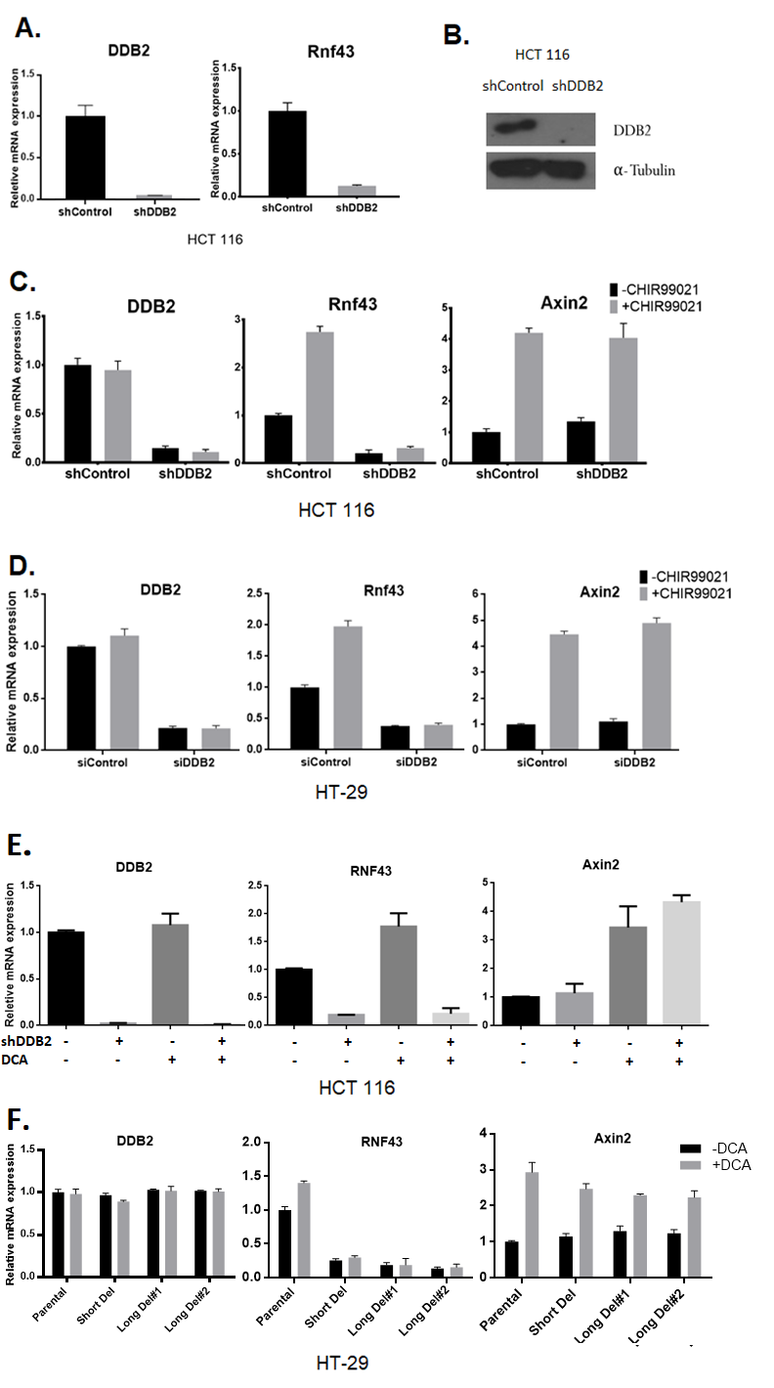
Supplementary Figure S1
Figure S1: DDB2 is required for the activation of Rnf43 mRNA expression (Related to Figure 1).
(A) Total mRNA, extracted from HCT 116 cells stably expressing shRNAs (shControl and shDDB2), was analyzed using qRT-PCR for the mRNA level of Rnf43. (B) Western blotting showing the knockdown of DDB2 in HCT 116 cells. (C) HCT 116 cells stably expressing shRNAs (shControl or shDDB2) were treated with DMSO or CHIR99021 (3.3µM, 16 hrs). The mRNA levels of DDB2, Rnf43 and Axin2 were analyzed using qRT-PCR (Normalized by 18S rRNA). N=3. All error bars indicate SD. (D) HT-29 cells expressing DsiRNAs (siControl or siDDB2) were treated with DMSO or CHIR99021 (6.7µM, 24 hrs). The mRNA levels of DDB2, Rnf43 and Axin2 were measured and analyzed using qRT-PCR (Normalized by 18S rRNA). N=3. All error bars indicate SD. (E) Deoxycholic acid (DCA) was used to activate downstream Wnt signaling as an alternative to CHIR99021. HCT 116 cells stably expressing shControl or shDDB2 were treated with 10µM DCA for 1 hour. The relative mRNA levels of DDB2, RNF43 and Axin2 were analyzed using qRT-PCR. (F) HT-29 parental cells, short deletion cells and two clones of long deletion cells were treated with 10µM DCA for 1 hour; and the relative mRNA levels of DDB2, RNF43 and Axin2 were analyzed using qRT-PCR. N=3. All error bars indicate SD.

Supplementary Figure S2
Figure S2: mRNA expression of RNF43 decreases from Grade 2 to Grade 3 in human patient colon adenocarcinoma samples.
Data of RNF 43 expression are obtained from Oncomine Bittner Colon Dataset. mRNA expression of RNF43 is plotted according to different grades of colon adenocarcinoma. Error bars indicate Min to Max, **** P< 0.0001.

Supplementary Figure S3
Figure S3: DDB2 specifically binds with P2 region on Rnf43 regulatory region. ChIP assay was conducted to analyze the local enrichment of DDB2 and T7 tagged DDB2 at P2 region in HCT 116 cells expressing AdLacZ or AdDDB2-T7. The relative fold enrichment was quantified by normalization to input, and the fold enrichment of IgG is set as 1. N = 5, Error bars indicate SD.

Supplementary Figure S4
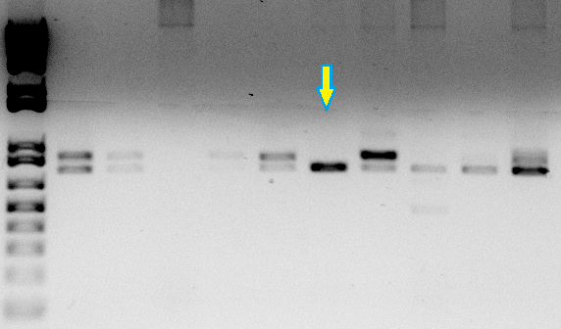
Short Del

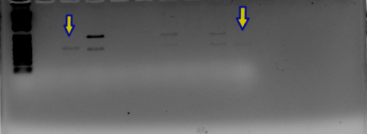
Long Del #1
Long Del #2

ctgaaaagcgacctgtgtggtccctctgattagactagttaatgtctatgtgatgggcatttatttatc
ctgaaaagcgacctgtgtggtccctctgattagactagttaatgtctatgtgatgggcatttatttatc
ctgaaaagcgacct.......................................................

tttattagcaaggtttaaaagagcaaattatcaagacacctatatcttttggccagactatataatatt
tttattagcaaggtttaaaagagcaaattatcaagacacctatatcttttggccagactatataatatt
.....................................................................

ttgtcagagtatgtgaagaggagacccaatttccaaatgaaggaactttgctttttctctgtcatgttg
ttgtcagagtatgtgaagaggagacccaatttccaaa................................
.....................................................................

aagagctaatatactgtgtagattttcccctaaatatggctttcttagctttatagatgttgagataat
.....................................................................
.....................................................................

atcttttgaggaacacatgtcaagcaggaaccttggcatagatttggtttcagttgttttaaggcttaa
..............................ccttggcatagatttggtttcagttgttttaaggcttaa
.....................................................................

ttaatgaaatgccttaatcagctttccaaacatttttatatatgaatacagcagaccaaggagctggat
ttaatgaaatgccttaatcagctttccaaacatttttatatatgaatacagcagaccaaggagctggat
.....................................................................

ctcctgctatccttagacgccttgtatctatcaactaaagctgtcattaatgacttgggcaaaatggca
ctcctgctatccttagacgccttgtatctatcaactaaagctgtcattaatgacttgggcaaaatggca................acgccttgtatctatcaactaaagctgtcattaatgacttgggcaaaatggca

Figure S4: CRISPR/Cas9 system was used to deleted DDB2 binding site on RNF43 upstream regulatory region (Related to Figure 2).
PCR results showing one clone of short deletion cells (Short Del) and two clones of long deletion cells (Long Del #1 and #2) that were selected for the experiments. Sequences of RNF43 upstream regulatory region of the Parental (Black letters), Short Del (Green letters), and Long Del (Orange letters) cells are shown in the lower panel.

Supplementary Figure S5
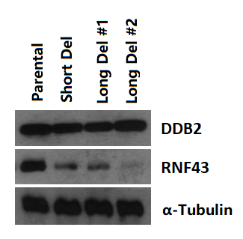
Figure S5: HT-29 cells with deleted DDB2 binding motif showed decreased protein expression of RNF43 (Related to Figure 2).
Western blotting shows decreased expression of the RNF43 protein level in Short Del, Long Del #1 and Long Del #2 cells compared to the Parental HT-29 cells.

