In silico modeling of immunotherapy and
stroma-targeting therapies in human colorectal cancer

Supplementary Data

Table S1
Parameter | Description | Default | Range | Ref
Tupprol | Proliferation probability tumor cells | 0.5055 | 0 to 1 | own data
Tupmig* | Migration probability tumor cells | 0.35 | 0 to 1 | -
Tupdeath | Death probability tumor cells | 1-(1-0.0319)^4 | 0 to 1 | own data
Tupmax | Proliferation capacity tumor cells | 10 | > 0 | (1)
Tups* | Symmetric division probability | 0.7 | 0 to 1 | -
Imkmax | Killing capacity immune cells | 5 | > 0 | (2)
Impmax | Proliferation capacity immune cells | 10 | > 0 | (1)
Impprol | Proliferation prob. immune cells | 0.0449 | 0 to 1 | own data
Impmig* | Migration probability immune cells | 0.8 | 0 to 1 | -
Impkill* | Killing probability immune cells | 0.3 | 0 to 1 | -
Impdeath | Death probability immune cells | 1-(1-0.0037)^4 | 0 to 1 | own data
Imrwalk* | Random influence on immune walk | 0.8 | 0 to 1 | -
Imspeed | Speed of immune cell movement | 97 | >0 | (3)
engagementDuration | Duration of immune cell engagement in tumor cell killing | 48 | >0 | (4)
Iminfluxprob* | Probability of immune cell influx | 0.3 | 0 to 1 | -
IMinflRate* | Number of immune cells per influx | 1 | >0 | -
distMaxNecr | Max. hypoxia-generating distance | 134 | >0 | own data
probSeedNecr* | Probability of necrosis seeding | 0.00004 | 0 to 1 | -
probSeedFibr* | Probability of fibrosis seeding | 0.00025 | 0 to 1 | -
seedFrac* | Scaling of fibrosis / necrosis seed | 0.3 | 0 to 1 | -
defRadius* | Radius of fibrosis / necrosis seed | 4 | >0 | -
stromaPerm* | Stromal permeability | 0.0025 | 0 to 1 | -
Table 2: List of model parameters. For some parameters, a definite value was available in the literature (corresponding reference given). Other parameters were quantitatively measured in our own experiments (“own data”). All remaining parameters were free parameters (*).

Table S2
Pseudonym | Primary tumor / metastasis | Sample source
CRC_UMM_001 | Liver metastasis | UMM
CRC_UMM_002 | Liver metastasis | UMM
CRC_UMM_003 | Liver metastasis | UMM
CRC_UMM_004 | Liver metastasis | UMM
CRC_UMM_005 | Liver metastasis | UMM
CRC_UMM_006 | Primary tumor | UMM
CRC_UMM_007 | Primary tumor | UMM
CRC_UMM_008 | Primary tumor | UMM
CRC_UMM_009 | Primary tumor | UMM
CRC_UMM_010 | Primary tumor | UMM
CRC_UMM_011 | Primary tumor | UMM
CRC_UMM_012 | Primary tumor | UMM
CRC_UMM_013 | Primary tumor | UMM
CRC_UMM_014 | Primary tumor | UMM
CRC_UMM_015 | Primary tumor | UMM
CRC_UMM_016 | Primary tumor | UMM
CRC_UMM_017 | Primary tumor | UMM
CRC_UMM_018 | Primary tumor | UMM
CRC_UMM_019 | Primary tumor | UMM
CRC_UMM_020 | Primary tumor | UMM
Colorectal cancer tissue samples for measurements of basic histomorphological variables (calibration cohort): These N=20 samples were used to measure the fraction of Ki67-positive cells and the fraction of active-Caspase-3-postive cells (in tumor cells and immune cells, three independent regions of interest for each cell types); they were also used to measure the distance from the tumor margin to the necrotic core and the overall cell density used to calibrate the spatial scale. Furthermore, for all samples, a CD3 staining was available that was used as a comparison for spatial patterns generated by the model. UMM = University Medical Center Mannheim, Germany.

Table S3
Pseudonym | Primary tumor / metastasis | Institution / Reference
NCT-Co_001 | Liver metastasis | described in (5)
NCT-Co_002 | Liver metastasis | described in (5)
NCT-Co_003 | Liver metastasis | described in (5)
NCT-Co_004 | Liver metastasis | described in (5)
NCT-Co_005 | Liver metastasis | described in (5)
NCT-Co_006 | Liver metastasis | described in (5)
NCT-Co_007 | Liver metastasis | described in (5)
NCT-Co_008 | Liver metastasis | described in (5)
NCT-Co_009 | Liver metastasis | described in (5)
NCT-Co_010 | Liver metastasis | described in (5)
NCT-Co_011 | Liver metastasis | described in (5)
NCT-Co_012 | Liver metastasis | described in (5)
NCT-Co_013 | Liver metastasis | described in (5)
NCT-Co_014 | Liver metastasis | described in (5)
NCT-Co_015 | Liver metastasis | described in (5)
NCT_15QWK5 | Liver metastasis | NCT Biobank, #2152
NCT_17Z30O | Liver metastasis | NCT Biobank, #2152
NCT_1UUVJF | Liver metastasis | NCT Biobank, #2152
NCT_1UW7FT | Liver metastasis | NCT Biobank, #2152
NCT_BZXONL | Liver metastasis | NCT Biobank, #2152
NCT_GNEY4A | Liver metastasis | NCT Biobank, #2152
NCT_IR13ZE | Liver metastasis | NCT Biobank, #2152
NCT_J5Z6D9 | Liver metastasis | NCT Biobank, #2152
NCT_QNYVRC | Liver metastasis | NCT Biobank, #2152
NCT_1MDI4V | Liver metastasis | NCT Biobank, #2152
NCT_16HJHG | Primary tumor | NCT Biobank, #2152
NCT_16TIQY | Primary tumor | NCT Biobank, #2152
NCT_18YP5I | Primary tumor | NCT Biobank, #2152
NCT_1FJEXB | Primary tumor | NCT Biobank, #2152
NCT_1FKYL9 | Primary tumor | NCT Biobank, #2152
NCT_1OKS15 | Primary tumor | NCT Biobank, #2152
NCT_1PUGA6 | Primary tumor | NCT Biobank, #2152
NCT_1SQOOP | Primary tumor | NCT Biobank, #2152
NCT_22F7YQ | Primary tumor | NCT Biobank, #2152
NCT_5QYVXU | Primary tumor | NCT Biobank, #2152
NCT_LH673K | Primary tumor | NCT Biobank, #2152
NCT_X1E6XI | Primary tumor | NCT Biobank, #2152
Colorectal cancer tissue samples for spatial patterns (morphological validation cohort): tissue samples that were stained for CD3 and used to compare spatial patterns generated by the model. NCT Biobank = National Center for Tumor Diseases, Heidelberg, Germany

Table S4
3L-AA1B | 4N-A93T | 4T-AA8H | 5M-AAT4 | 5M-AAT6 | 5M-AATE | A6-2674
A6-2677 | A6-2684 | A6-3809 | A6-3810 | A6-5656 | A6-5656 | A6-5657
A6-5659 | A6-5659 | A6-5660 | A6-5661 | A6-5662 | A6-5664 | A6-5665
A6-5666 | A6-5667 | A6-6137 | A6-6138 | A6-6140 | A6-6141 | A6-6142
A6-6648 | A6-6649 | A6-6650 | A6-6650 | A6-6651 | A6-6652 | A6-6653
A6-6654 | A6-6780 | A6-6780 | A6-6781 | A6-6782 | A6-A565 | A6-A566
A6-A567 | A6-A56B | A6-A5ZU | AA-3489 | AA-3494 | AA-3521 | AA-3524
AA-3526 | AA-3530 | AA-3662 | AA-3664 | AA-3715 | AA-3977 | AA-3979
AA-3980 | AA-3982 | AA-3984 | AA-A004 | AA-A00A | AA-A00D | AA-A00E
AA-A00F | AA-A00J | AA-A00K | AA-A00L | AA-A00N | AA-A00O | AA-A00Q
AA-A00R | AA-A00U | AA-A00W | AA-A00Z | AA-A010 | AA-A017 | AA-A01C
AA-A01D | AA-A01F | AA-A01G | AA-A01I | AA-A01K | AA-A01P | AA-A01Q
AA-A01R | AA-A01S | AA-A01T | AA-A01V | AA-A01X | AA-A01Z | AA-A022
AA-A024 | AA-A029 | AA-A02E | AA-A02F | AA-A02H | AA-A02J | AA-A02K
AA-A02O | AA-A02R | AA-A02W | AA-A02Y | AA-A03F | AA-A03J | AD-5900
AD-6888 | AD-6889 | AD-6890 | AD-6895 | AD-6899 | AD-6901 | AD-6963
AD-6964 | AD-6965 | AD-A5EJ | AD-A5EK | AF-6136 | AF-6655 | AF-A56K
AF-A56L | AF-A56N | AG-3593 | AG-3594 | AG-3598 | AG-3882 | AG-A002
AG-A008 | AG-A00C | AG-A00H | AG-A00Y | AG-A011 | AG-A014 | AG-A015
AG-A016 | AG-A01J | AG-A01L | AG-A01N | AG-A01W | AG-A01Y | AG-A020
AG-A023 | AG-A025 | AG-A026 | AG-A02G | AG-A02N | AG-A02X | AG-A032
AG-A036 | AH-6544 | AH-6547 | AH-6897 | AY-A54L | AY-A69D | AY-A71X
AY-A8YK | AZ-4308 | AZ-4313 | CA-6715 | CM-5341 | CM-5344 | CM-5348
CM-5349 | CM-5860 | CM-5861 | CM-5862 | CM-5863 | CM-5864 | CM-5868
D5-5538 | D5-5539 | D5-5540 | D5-5541 | D5-6529 | D5-6530 | D5-6531
D5-6532 | D5-6533 | D5-6534 | D5-6535 | D5-6536 | D5-6537 | D5-6538
D5-6539 | D5-6540 | D5-6541 | D5-6920 | D5-6922 | D5-6923 | D5-6924
D5-6926 | D5-6927 | D5-6928 | D5-6930 | D5-6931 | D5-6932 | DC-5337
DC-5869 | DC-6155 | DM-A0X9 | DM-A0XD | DM-A0XF | DM-A1D0 | DM-A1D4
DM-A1D6 | DM-A1D7 | DM-A1D8 | DM-A1D9 | DM-A1DA | DM-A1DB | DM-A1HA
DM-A1HB | DM-A280 | DM-A282 | DM-A285 | DM-A288 | DM-A28A | DM-A28C
DM-A28E | DM-A28F | DM-A28G | DM-A28H | DM-A28K | DM-A28M | DY-A0XA
DY-A1DC | DY-A1DD | DY-A1DE | DY-A1DF | DY-A1DG | DY-A1H8 | EI-6917
F4-6459 | F4-6460 | F4-6461 | F4-6463 | F5-6464 | F5-6465 | F5-6812
G5-6233 | G5-6235 | G5-6641 | NH-A50T | NH-A50U | NH-A50V | NH-A5IV
NH-A6GA | NH-A6GB | NH-A6GC | NH-A8F7 | NH-A8F7 | NH-A8F8 | QG-A5YV
QG-A5YW | QG-A5YX | QG-A5Z1 | QG-A5Z2 | QL-A97D | RU-A8FL | SS-A7HO
T9-A92H | WS-AB45 | - | - | - | - | -
List of TCGA patient pseudonyms included in the survival analysis (clinical validation cohort): A list of all eligible samples from the TCGA (The Cancer Genome Atlas) consortium that were used for survival analyses. Criteria for eligibility were: manual estimation of stromal content and lymphocyte content available and follow-up data available (survival data).

Figure S1
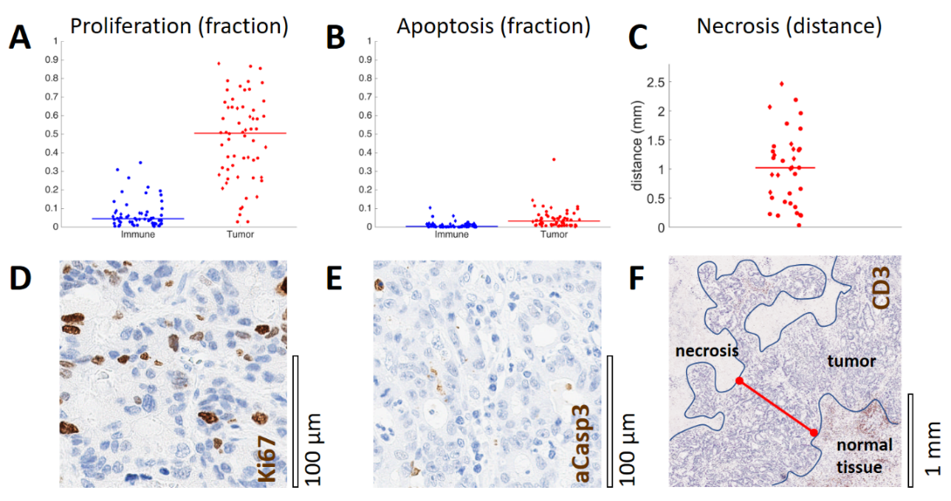
Measurements of proliferation, apoptosis and distance to necrosis in histological samples: a quantitative basis for the agent-based model. Based on morphology, we selected areas of immune cell infiltrates and pure tumor cells in N=20 tissue samples of human colorectal cancer. We quantified Ki67 stained cell fraction (the fraction of proliferating cells, shown in A and active Caspase 3 stained cell fraction (the fraction of dying cells, shown in B. Also, we observed that in colorectal cancer tissue, necrosis occurred at a fixed distance from the surrounding tissue. In 12 of 20 analyzed tissue slides, necrosis was present. The distance between tumor boundary and necrosis in 3 areas in these 12 samples is shown in C. The median is plotted as a straight line for each group. Representative image patches are shown for Ki67 stained tumor tissue (D) and aCasp3 stained tumor tissue (E). In F, the distance to necrosis (red) is demonstrated for a representative CD3 stained section. Median distance of necrosis from the tumor boundary was 1.0215 mm. We used this value as the hypoxia threshold in our model. The boundary between normal tissue (adjacent liver) and tumor tissue as well as the boundary between tumor tissue and necrosis are drawn in blue.

Figure S2

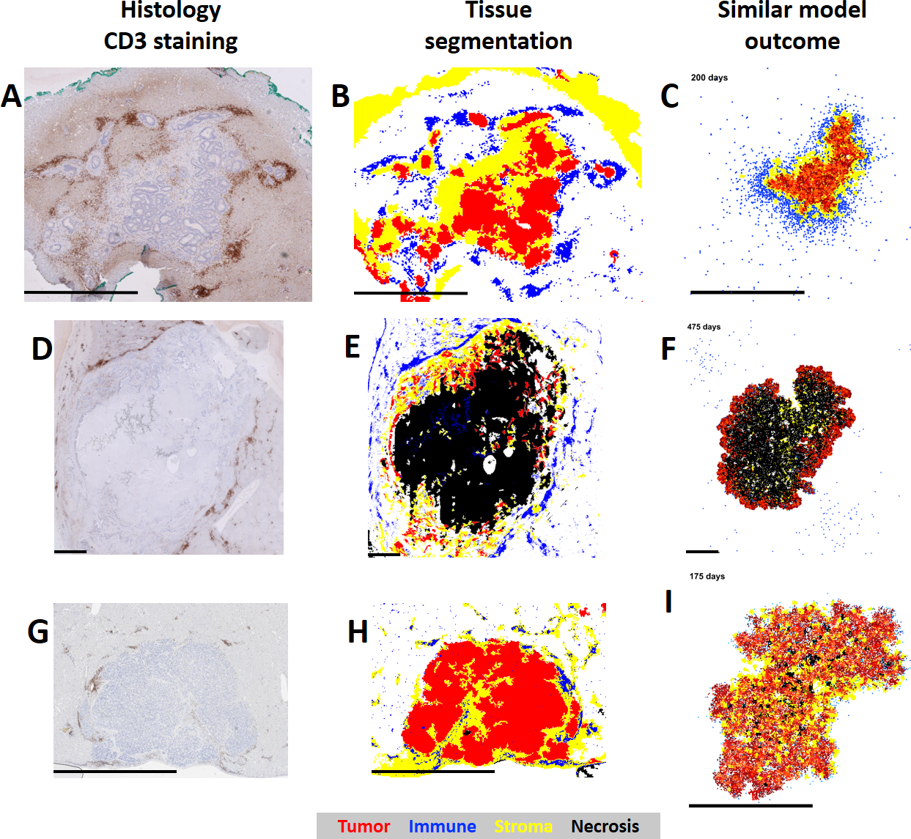
Quantitative histology shows similar patterns in actual tissue samples and simulated spatial patterns on a centimeter scale. (A,D,G) representative histological images of colorectal cancer liver metastases. (B,E,H) Semiautomatic tissue classification of tissue samples. (C,F,I) Results of agent-based simulations are shown. It can be seen that the model can give rise to very different spatial patterns, closely resembling actual histological patterns. All scale bars are 2 mm.

Figure S3

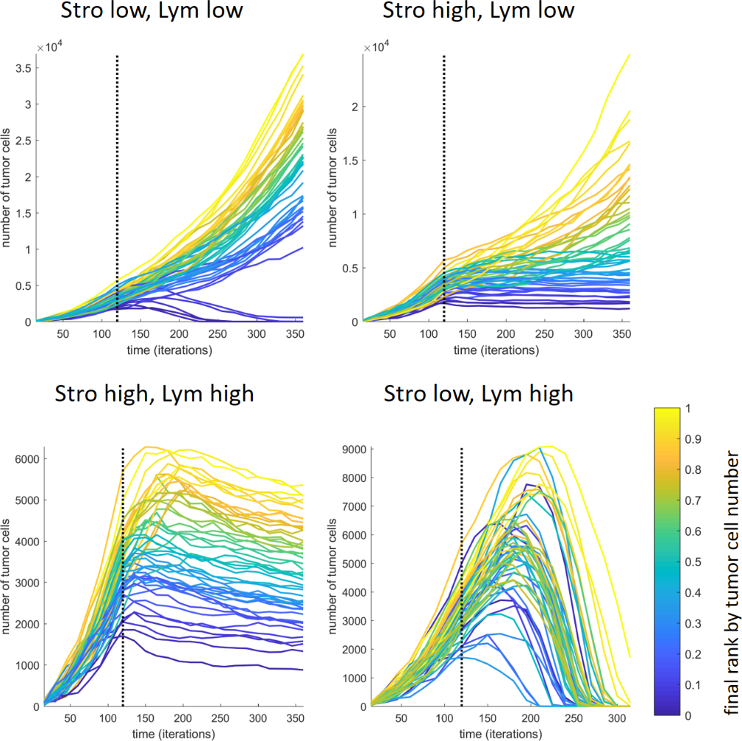
Tumor growth trajectories for varying degrees of stroma induction and lymphocyte influx. Four tumors (A-D) are shown at different time points (from left to right: 30-60-90-120 days before immune boost and 30-60-90-120 days after immune boost; parameters were A-C: 2x immune boost and 4% stroma permeability, D: 4x immune boost and 16% stroma permeability).

Figure S4
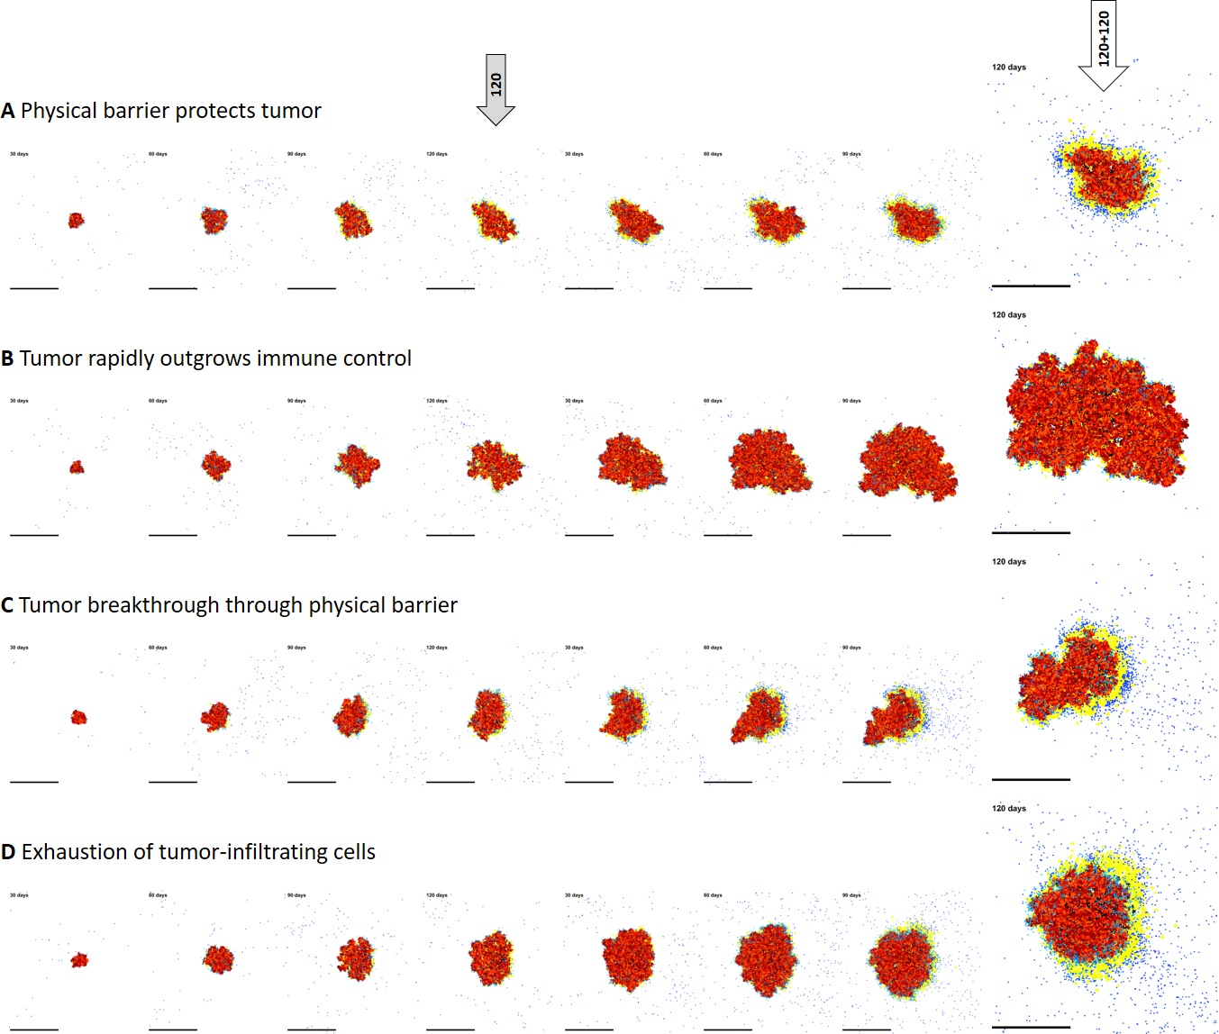
Phenotypes of immune escape in silico. Four tumors (A-D) are shown at different time points (from left to right: 30-60-90-120 days before immune boost and 30-60-90-120 days after immune boost; parameters were A-C: 2x immune boost and 4% stroma permeability, D: 4x immune boost and 16% stroma permeability).

References for supplementary data
1. Poleszczuk J, Macklin P, Enderling H. Agent-Based Modeling of Cancer Stem Cell Driven Solid Tumor Growth. Methods Mol Biol. 2016;1516:335-46.
2. Christophe C, Muller S, Rodrigues M, Petit AE, Cattiaux P, Dupre L, et al. A biased competition theory of cytotoxic T lymphocyte interaction with tumor nodules. PLoS One. 2015;10(3):e0120053.
3. Boldajipour B, Nelson A, Krummel MF. Tumor-infiltrating lymphocytes are dynamically desensitized to antigen but are maintained by homeostatic cytokine. JCI Insight. 2016;1(20):e89289.
4. Breart B, Lemaitre F, Celli S, Bousso P. Two-photon imaging of intratumoral CD8+ T cell cytotoxic activity during adoptive T cell therapy in mice. J Clin Invest. 2008;118(4):1390-7.
5. Halama N, Michel S, Kloor M, Zoernig I, Benner A, Spille A, et al. Localization and density of immune cells in the invasive margin of human colorectal cancer liver metastases are prognostic for response to chemotherapy. Cancer Res. 2011;71(17):5670-7.

