Supplementary figures and legends

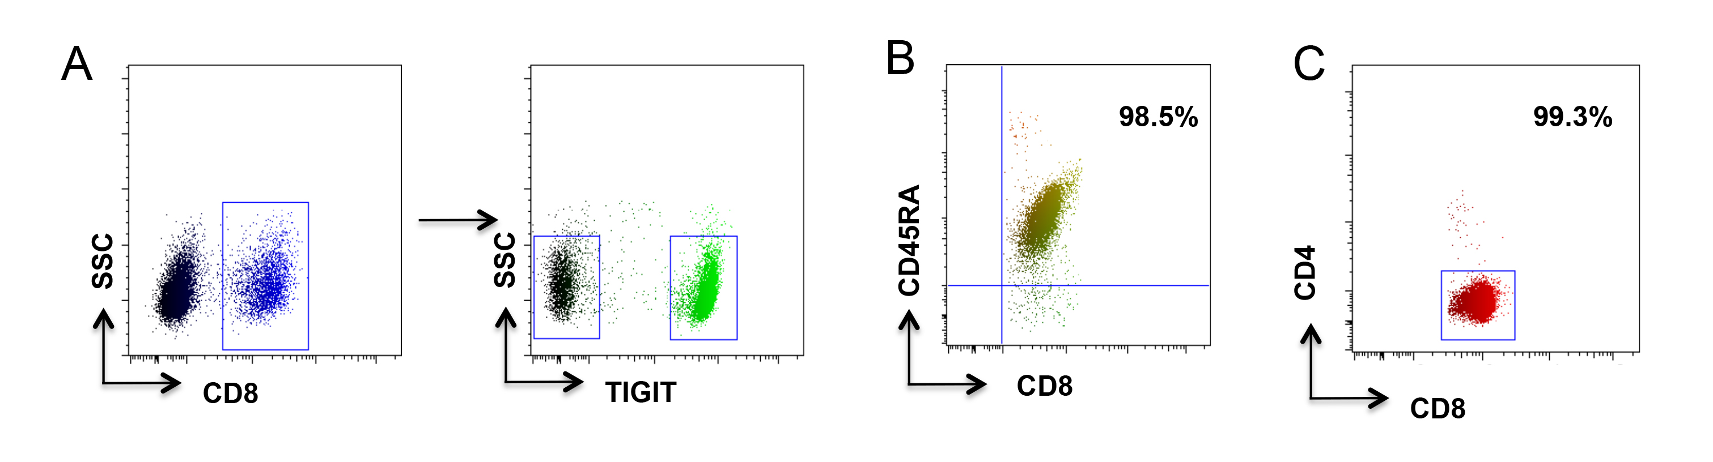

Supplementary Figure 1. Cell isolation by flow cytometry and magnetic beads. (A) Representative flow charts were gated on CD3 cells. Cells were further gated on CD8 T cells. CD8⁺TIGIT⁺ and CD8⁺TIGIT⁻ cells were sorted separately. (B, C) Naïve or total CD8 T cells were isolated using an EasySepTM human CD8⁺ T cell enrichment kit. Purity was confirmed by flow cytometry.

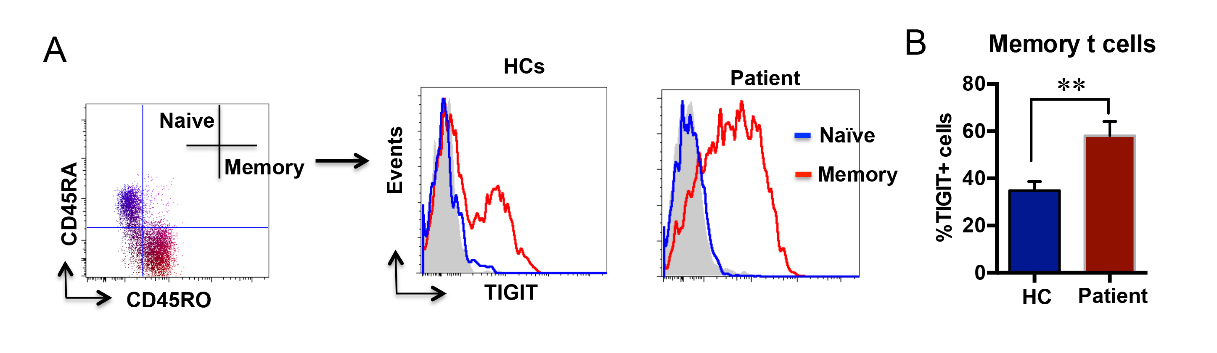

Supplementary Figure 2. TIGIT⁺ T cells have a memory phenotype. (A) PBMCs from gastric cancer patients or healthy controls (HCs) were stained with anti-CD8/CD45RA/CD45RO/TIGIT antibodies. Representative flow chart gated on CD8 T cells. (B) Percentages of TIGIT⁺ memory T cells in HCs or gastric cancer patients. N=12, data was expressed mean±SEM. **P < 0.01.

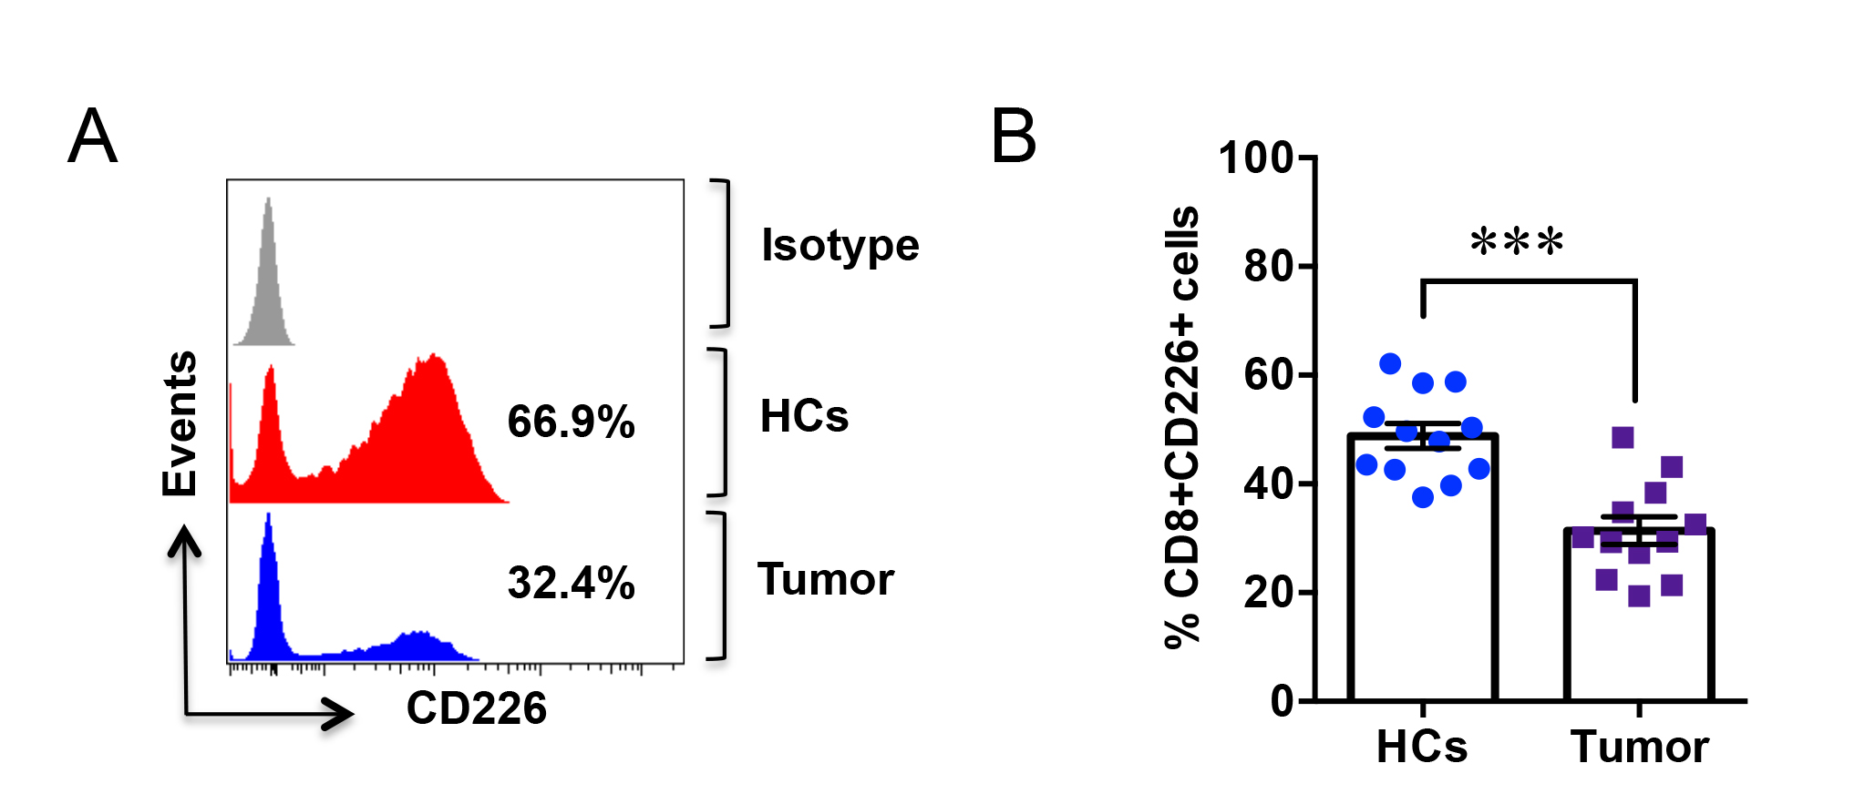
Supplementary Figure 3. CD226 is downregulated in gastric cancer CD8 T cells. PBMCs from gastric cancer patients (tumor) or healthy controls (HCs) were stained with anti-CD8 and anti-CD226 antibodies. (A) Cells were gated on the CD8 T cell population, and representative histograms are shown. (B) Percentages of CD226-positive CD8 T cells in gastric cancer patients or HCs (n = 8). Data was expressed as mean±SEM. **P < 0.01.

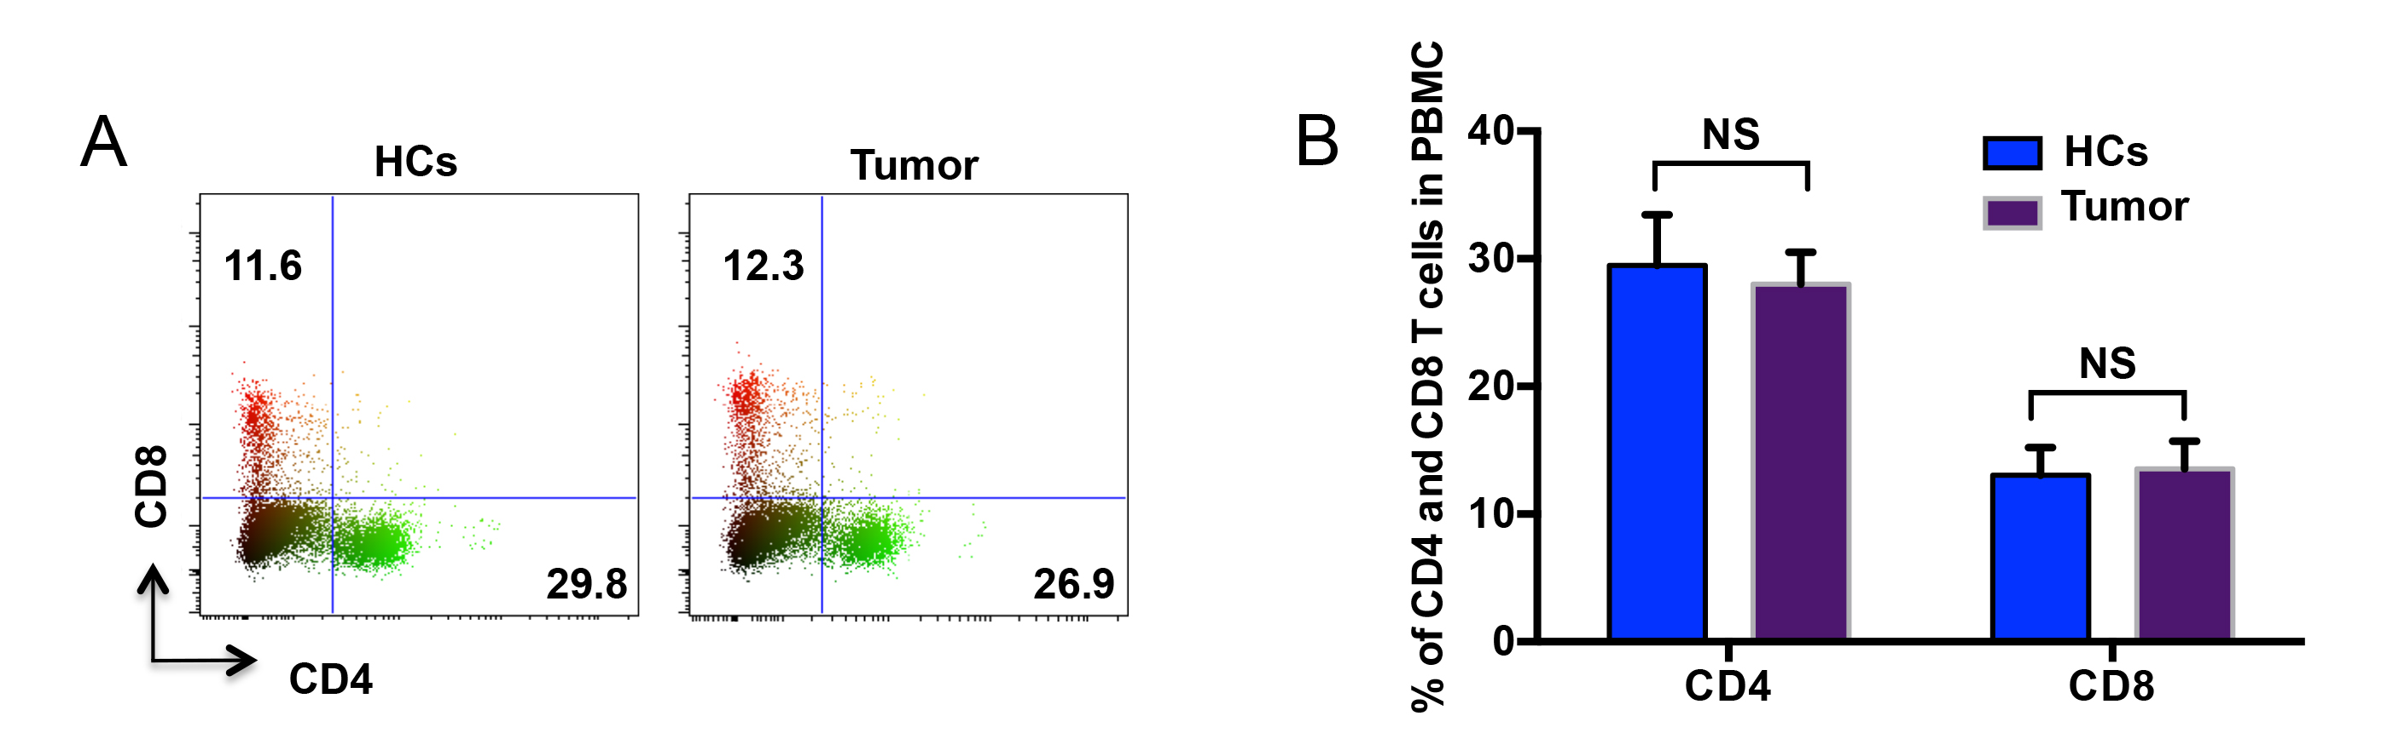
Supplementary Figure 4. CD4 and CD8 compartments from gastric cancer patients are not different from healthy controls. (A) PBMCs from gastric cancer patients (tumor) or healthy controls (HCs) were stained with anti-human CD4 and anti-human CD8 antibodies and analyzed by flow cytometry. (B) CD4 T cell and CD8 T cell percentages in gastric cancer patients or healthy controls (n=8). NS: non-significant

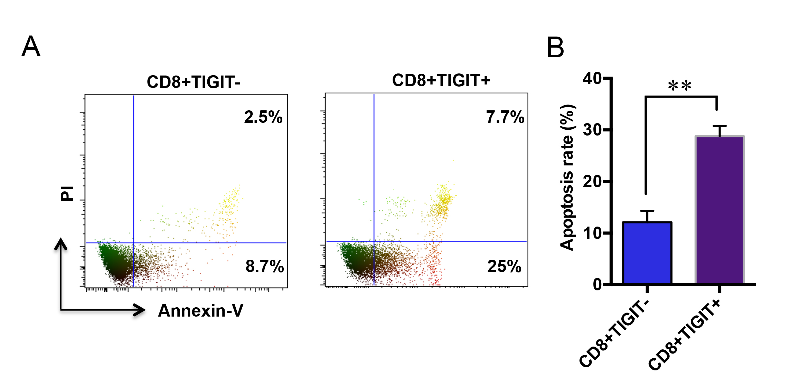
Supplementary Figure 5. TIGIT-positive CD8 T cells have higher apoptosis rates. (A) CD8⁺TIGIT⁺ and CD8⁺TIGIT⁻ cells were isolated from PBMCs of gastric cancer patients. Cells were stimulated with anti-CD3/CD28 Dynabeads for 48 h. Apoptosis was quantified by flow cytometry. Representative flow charts are shown. (B) T cell apoptosis rates in TIGIT⁺ or TIGIT⁻ cells. **P < 0.01.

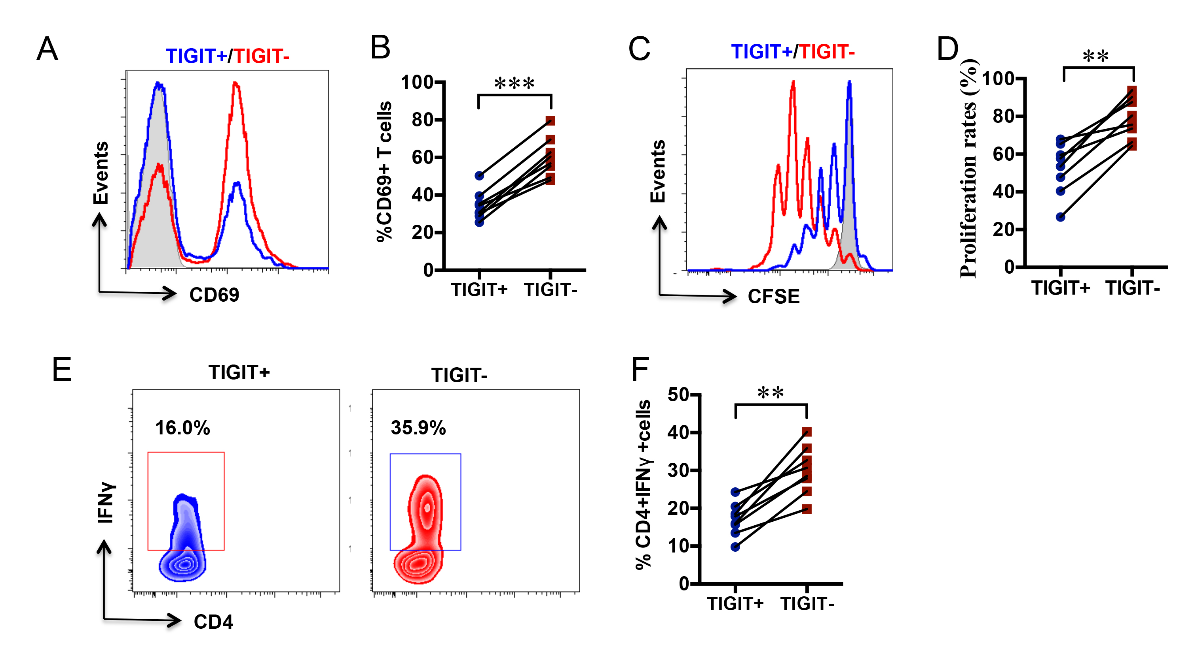
Supplementary Figure 6. TIGIT⁺ CD4 T cells exhibit effector function exhaustion. CD4⁺TIGIT⁺ or CD4⁺TIGIT⁻ cells in PBMCs from gastric cancer patients were sorted by flow cytometry. Cells were stimulated with anti-CD3/CD28 Dynabeads. (A) CD69 expression was determined by flow cytometry after 12 h of stimulation. (B) Summary of CD69-positive rates from 8 samples. (C) Proliferation of CFSE-stained cells was analyzed by flow cytometry. (D) Summary of CD4⁺TIGIT⁺ against CD4⁺TIGIT⁻ cell proliferation rates from 8 independent samples. (E) IFNγ production in CD4 T cells was determined by flow cytometry. Representative flow charts are shown. (F) Percentages of IFNγ-producing CD4⁺TIGIT⁺ or CD4⁺TIGIT⁻ cells (n = 8). **P < 0.01, ***P < 0.001.

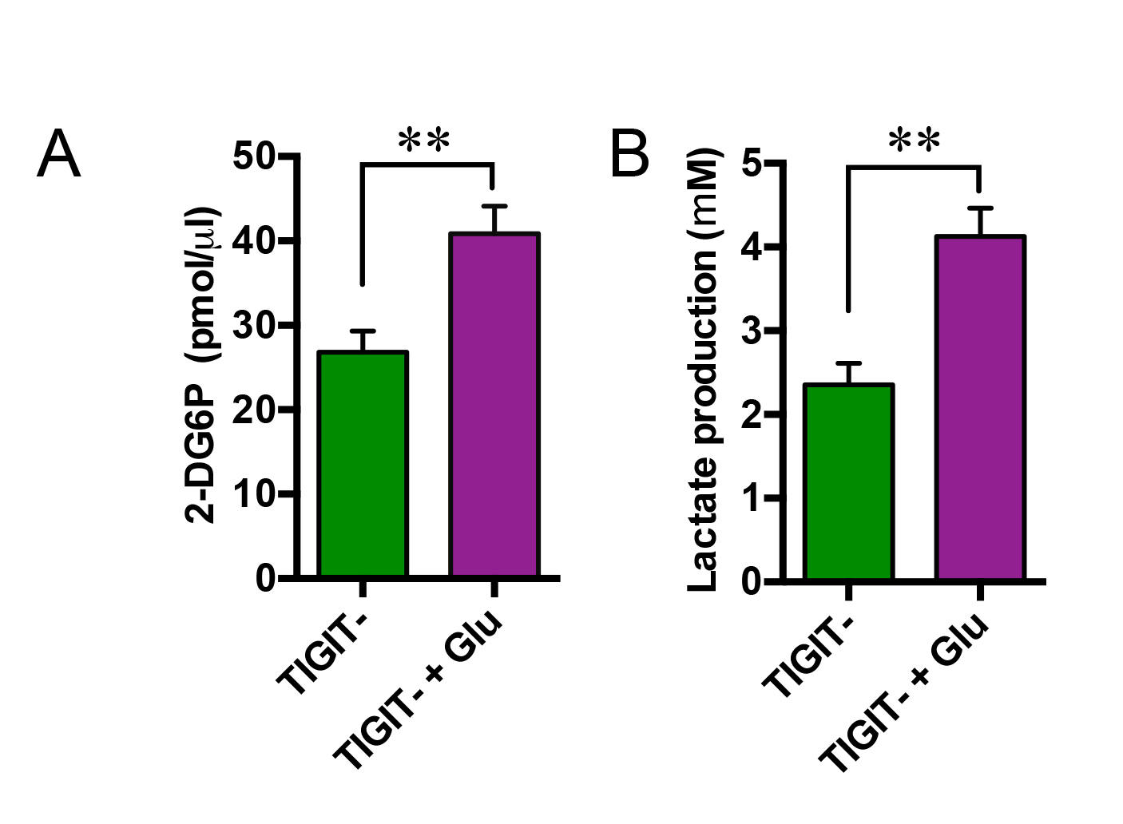
Supplementary Figure 7. Glucose increases metabolic activity of TIGIT⁻ T cells. CD8⁺TIGIT⁻ cells were stimulated with αCD3/CD28 in the presence or absence of 10 mM glucose (Glu) for 24 h. (A) Glucose consumption. (B) Lactate production. **P < 0.01.

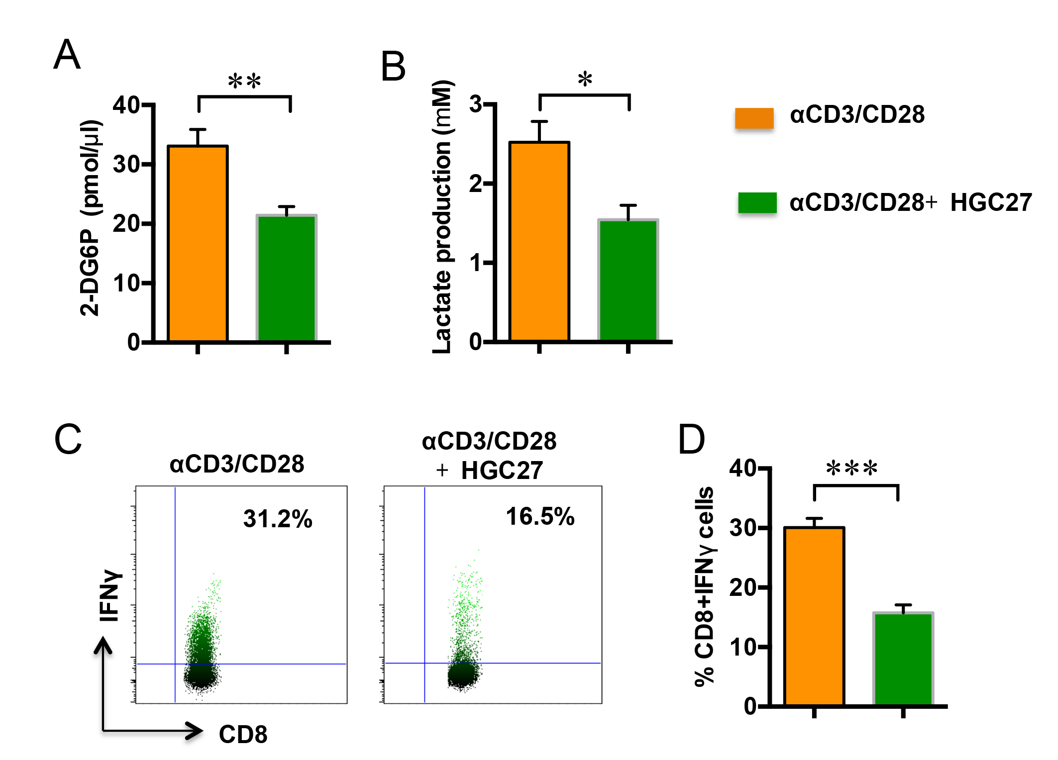
Supplementary Figure 8. Gastric cancer cells outcompete CD8 T cells for glucose uptake. CD8 T cells isolated from healthy controls were stimulated with αCD3/CD28 and co-cultured with gastric cancer cells (HGC27) at a 5:1 ratio. (A) Measurement of glucose consumption in CD8 T cells after 24 h of co-culture. (B) Lactate production in CD8 T cells after 24 h of co-culture. (C) IFNγ production in CD8 T cells stimulated with αCD3/CD28 and co-cultured with HGC27 for 48 h measured by flow cytometry. (D) Percentages of IFNγ-producing CD8 T cells. Data are summarized from six samples. *P < 0.05, ** P < 0.01, *** P < 0.001.

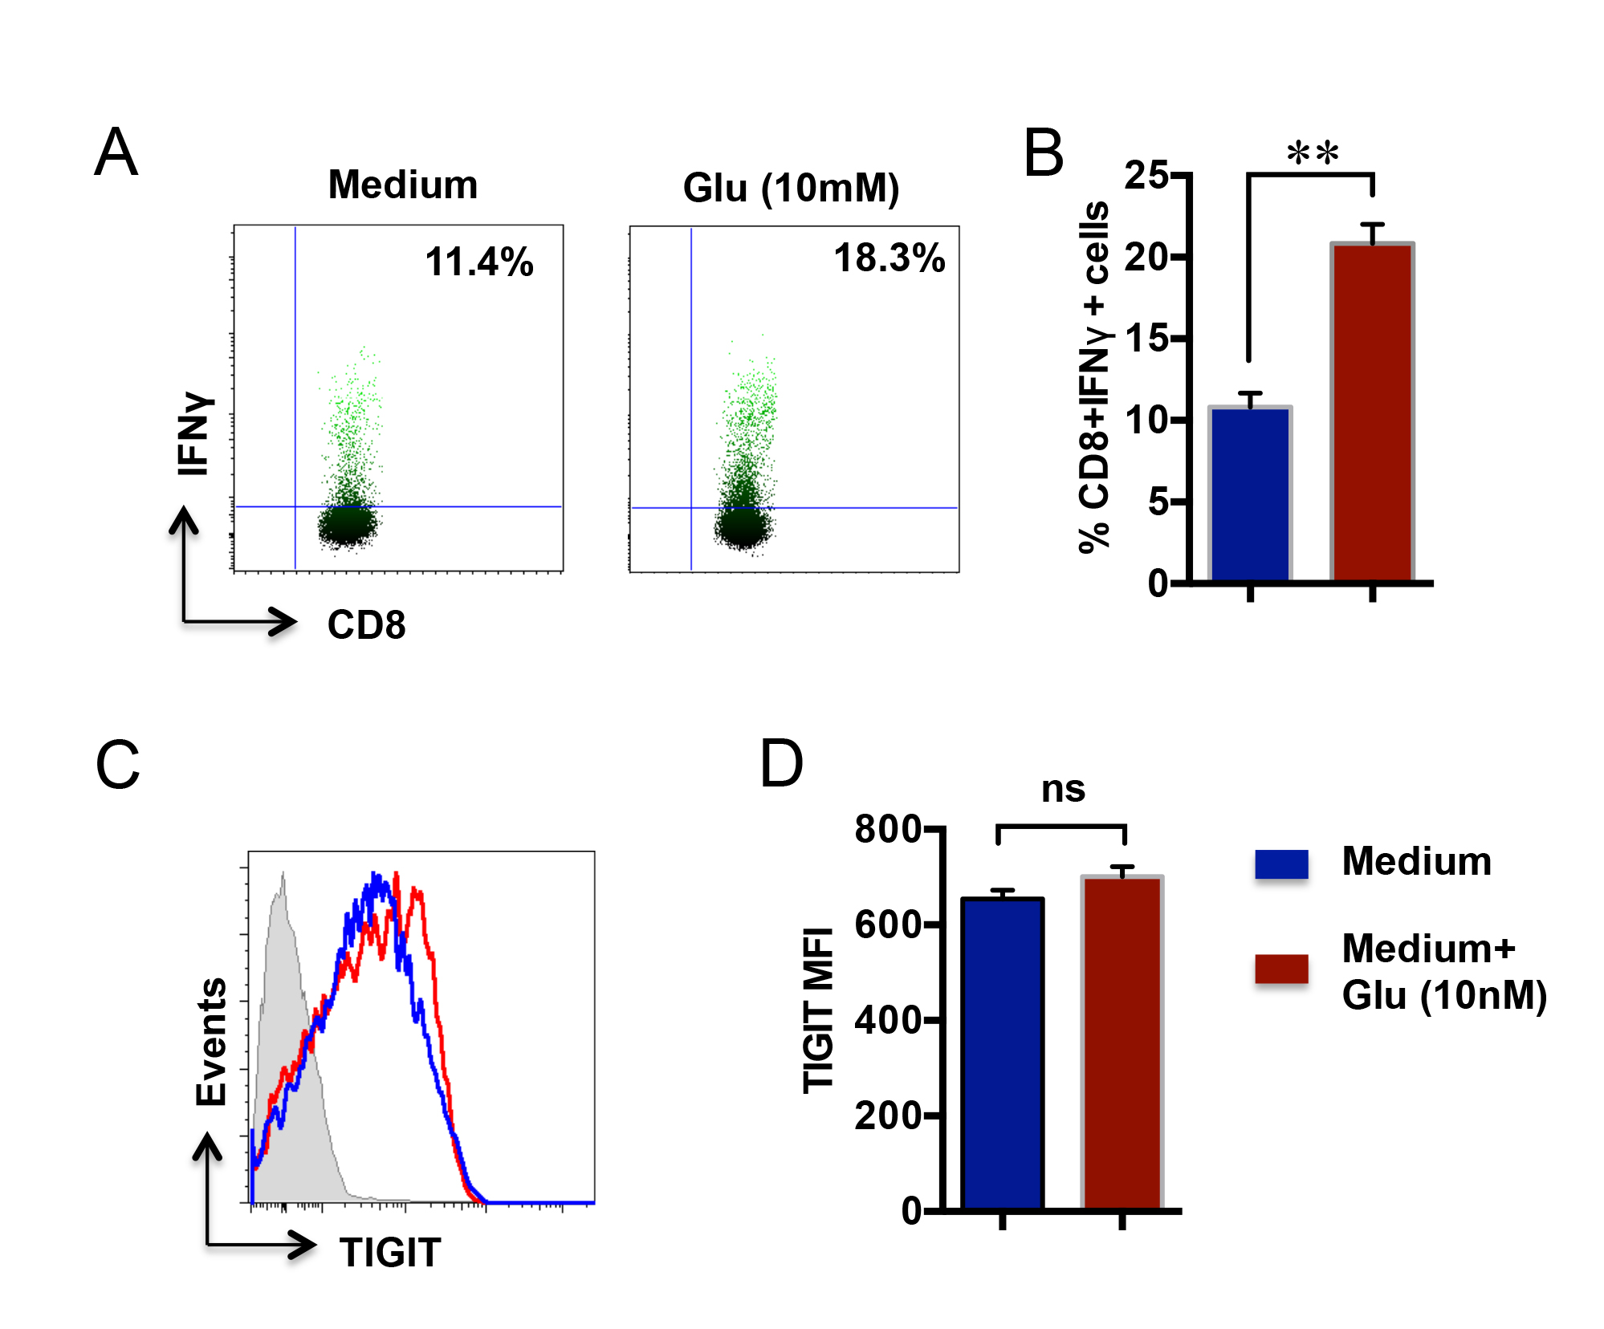
Supplementary Figure 9. Glucose reverses gastric cancer cell-induced T cell inhibition and does not increase TIGIT expression in CD8 T cells. (A) CD8 T cells were stimulated with αCD3/CD28 and co-cultured with SGC7901 for 48 h. Glucose (Glu, 10 mM) was included in some of the experiments. IFNγ production was determined by flow cytometry. Representative flow charts are shown. (B) Percentages of IFNγ-producing CD8 T cells (N=6). (C) Naïve CD8 T cells were isolated from PBMCs obtained from healthy donors. Cells were stimulated with αCD3/CD28 for 3 d, and TIGIT expression was determined by flow cytometry. (D) Summary of TIGIT MFI from six samples. ** P < 0.01, NS: non-significant.

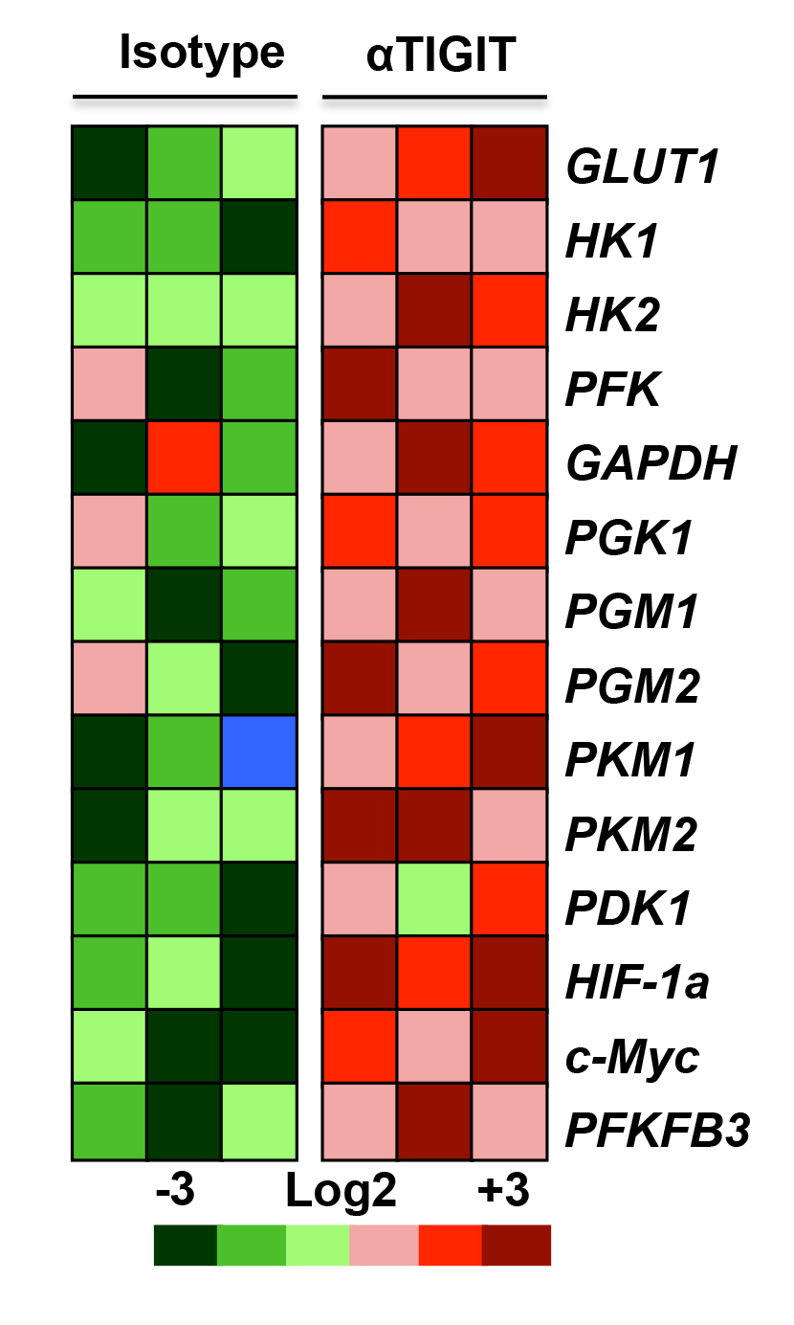
Supplementary Figure 10. TIGIT blockade increases metabolism-associated gene expression. TIGIT⁺ CD8 T cells from healthy controls were stimulated with αCD3/CD28 and co-cultured with SGC7901 at a ratio of 5:1 in the presence of anti-TIGIT blocking antibody (αTIGIT) or isotype control. Metabolism-associated gene expression in CD8 T cells was measured by RT-PCR. Relative gene expression is shown in the heat map.
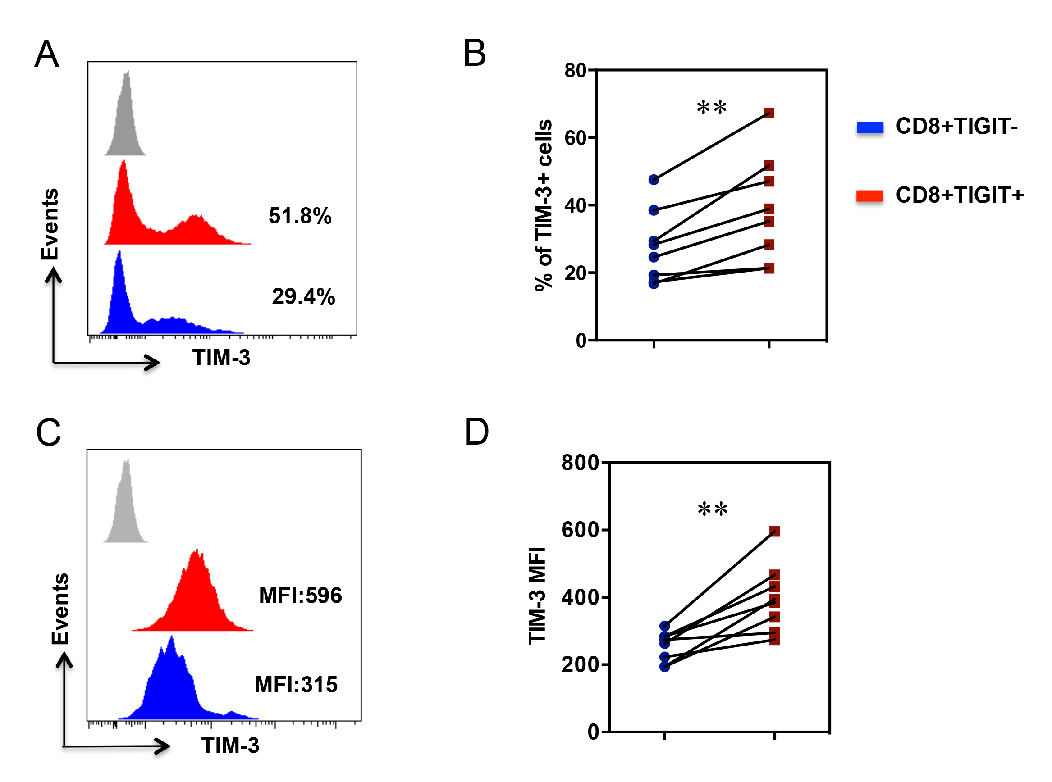

Supplementary Figure 11. CD8⁺TIGIT⁺ T cells co-express TIM-3. PBMCs from gastric cancer patients were stained with anti-human CD8, anti-human TIGIT, and anti-human TIM-3 antibodies. (A) Representative flow charts were gated on CD8⁺TIGIT⁺ or CD8⁺TIGIT⁻ cells. TIM-3 expression by CD8⁺TIGIT⁺ or CD8⁺TIGIT⁻ cells is shown. (B) Percentages of PD-1-positive cells are shown in dot plots. (C) Representative flow charts were further gated on TIM-3 positive cells. (D) TIM-3 MFI in CD8⁺TIGIT⁺ or CD8⁺TIGIT⁻ cells (n = 8). **P < 0.01.

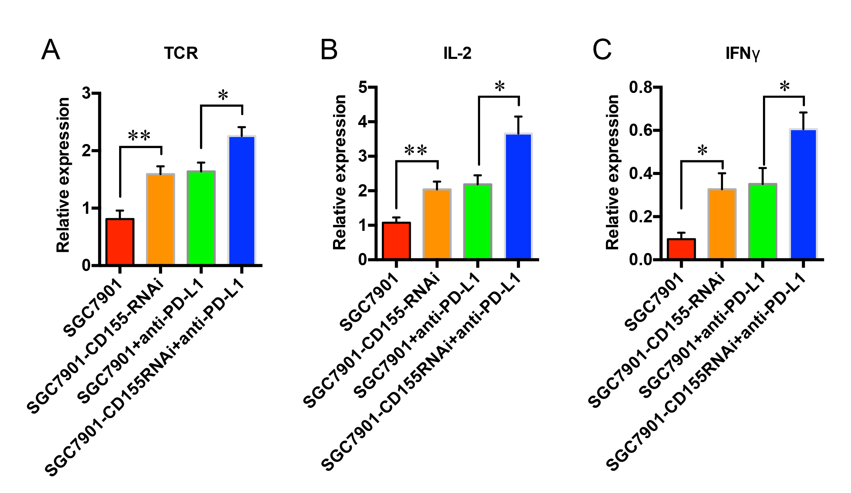
Supplementary Figure 12. Combined blockade of TIGIT and PD-1 signals enhance immune responses in the tumor microenvironment. Tumors were harvested, and TCR, IL-2, and IFNγ expression levels in tumor tissues were quantified by RT-PCR (n = 8). * P < 0.05, ** P < 0.01.

