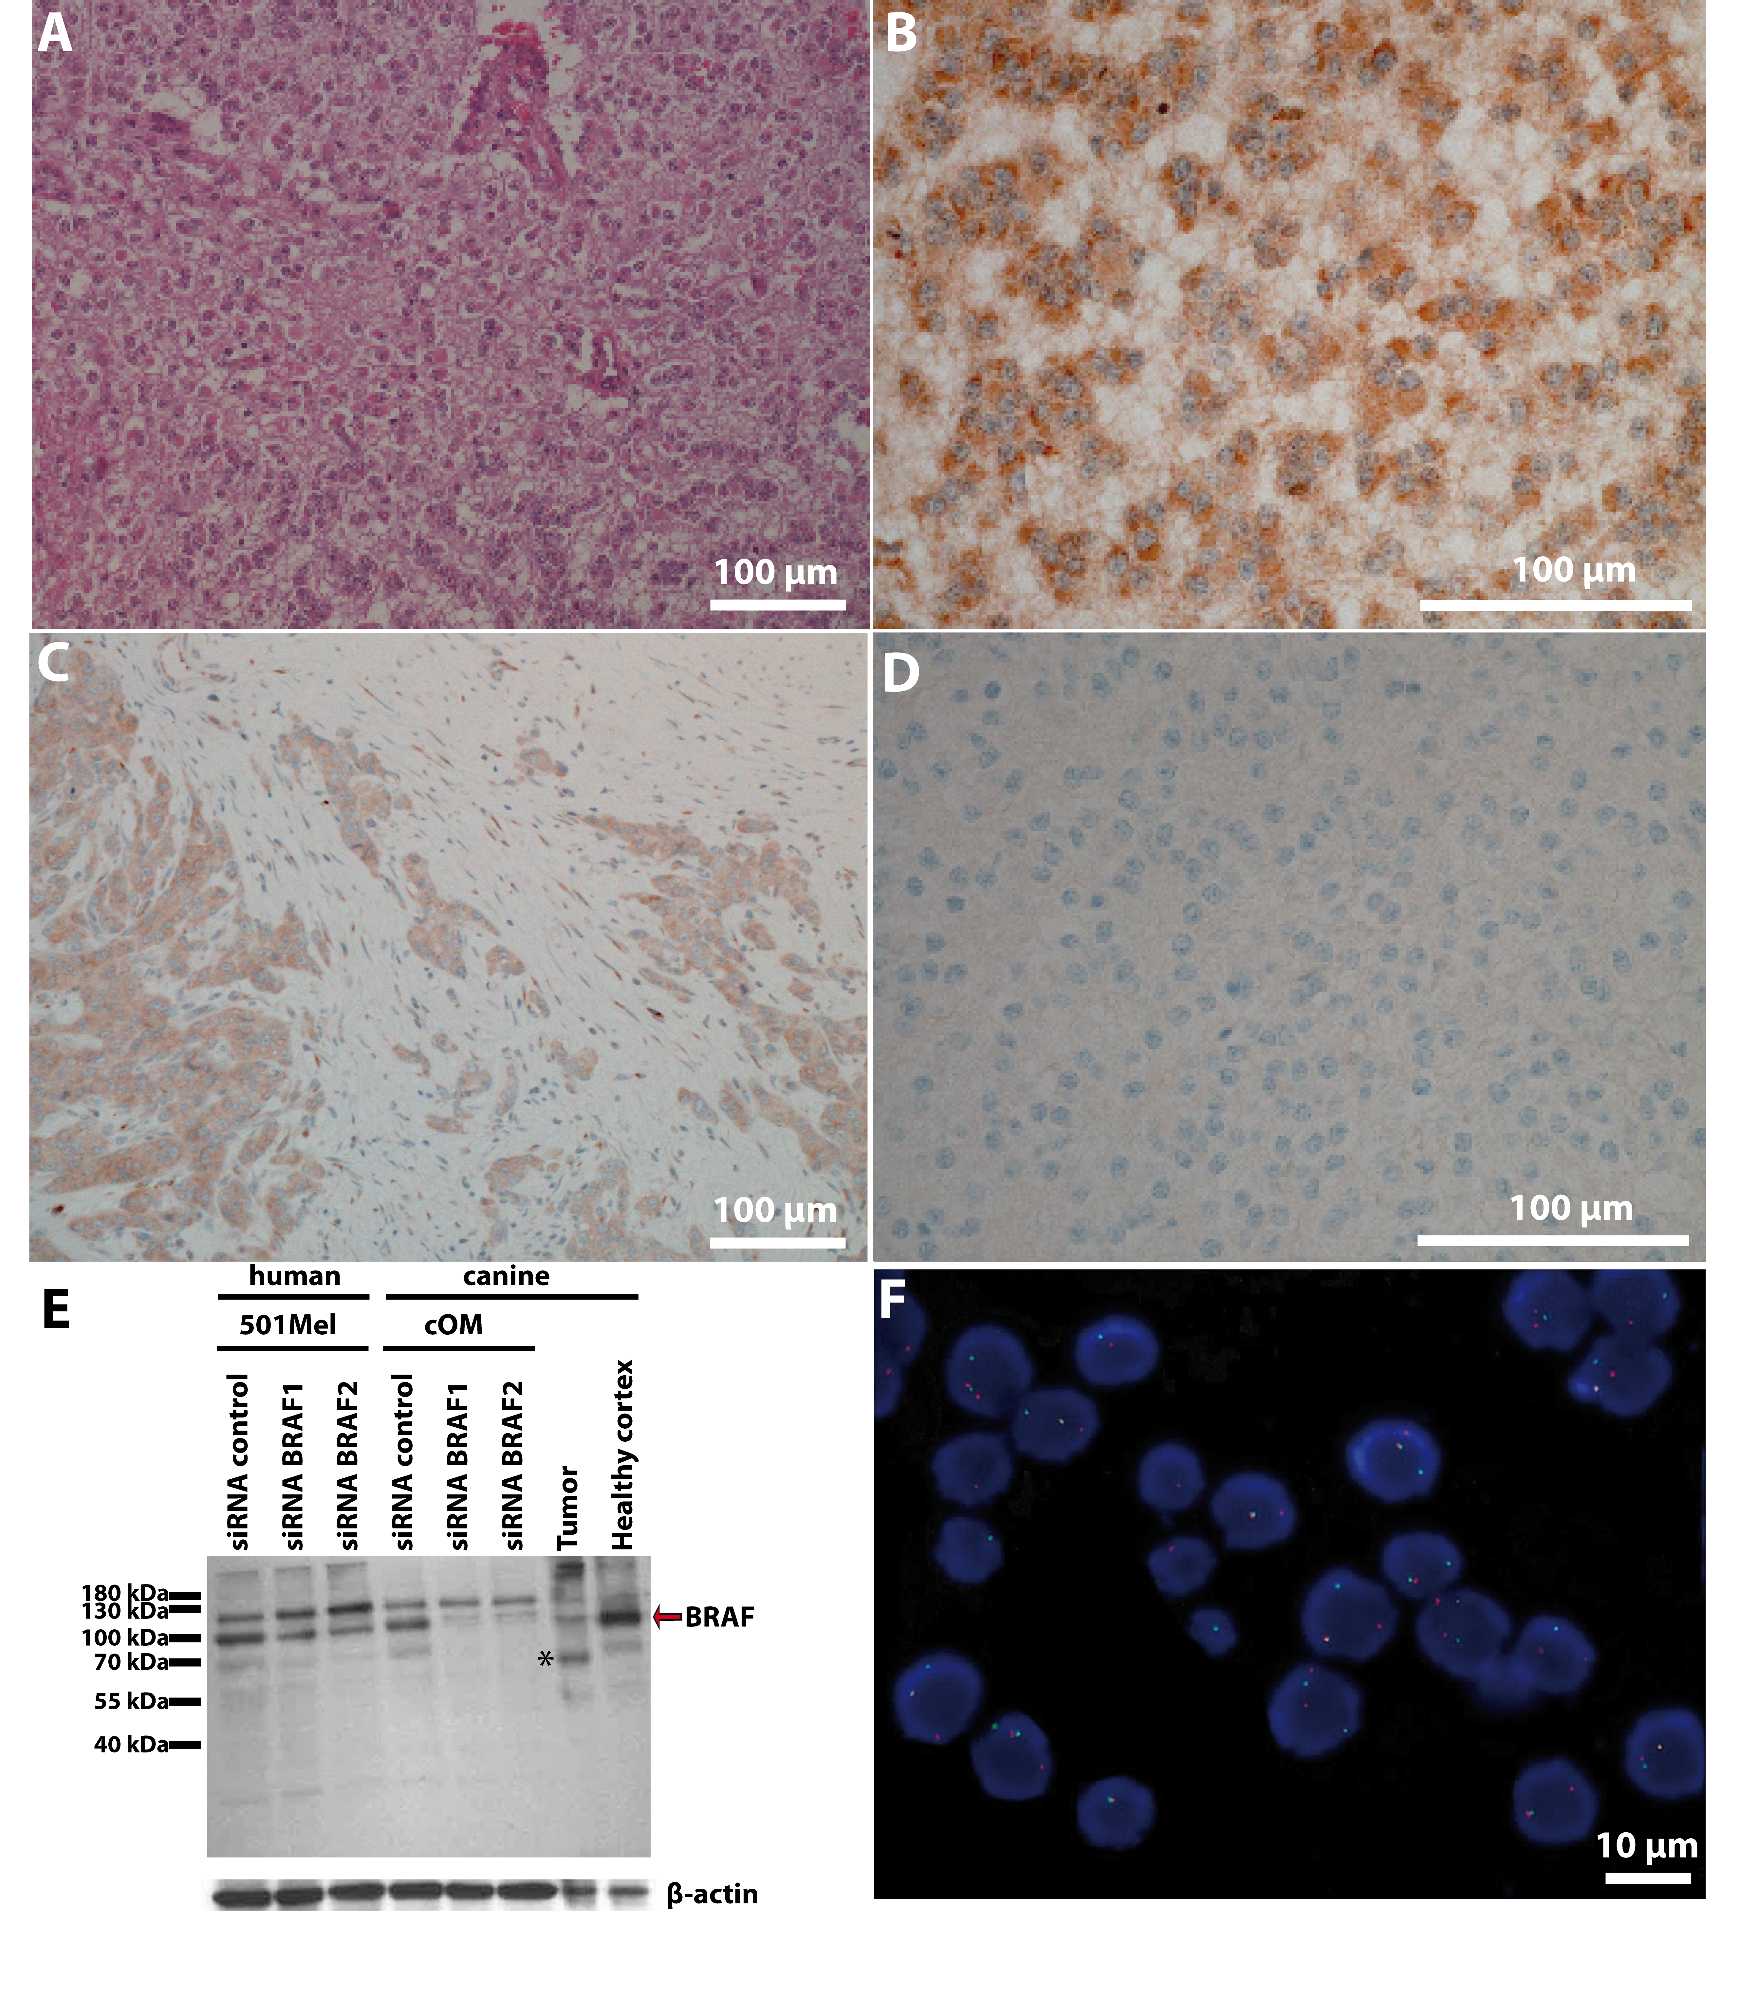
Supplementary Figure 3: Anaplastic oligodendroglioma grade 3 in a German shepherd dog. (A) Hemalun-Eosin-Saffron (x200). The tumor consisted of a homogeneous cell population arranged in sheaths or cords with a fine vascular stroma, areas of multifocal necrosis, hemorrhages, and glomerular-like tufts. The round tumor cells were characterized by a moderate amount of a pale basophilic cytoplasm, a round to slightly oval nucleus with fine-stippled heterochromatin, and an inconspicuous single nucleolus. Rare mitotic figures were observed. At the periphery of the tumor, narrow bands of compressed gray and white matter were observed. (B): immunohistochemical detection of BRAF expression (x400) (immunoperoxidase; DAB chromogen). Immunohistochemical staining of tumor cells reveals a consistent and marked cytoplasmic expression of the BRAF protein as granular to diffuse. (C) Control of the specificity of the BRAF antibody by immunohistochemistry: immunohistochemical detection of BRAF expression in a canine urothelial carcinoma of the urinary bladder, a tumor type reported to commonly express the BRAF protein (immunoperoxidase; DAB chromogen; x200). A consistent marked diffuse cytoplasmic expression of the BRAF protein is detected in tumor cells while the healthy cells (stromal cells) present no significant expression. (D) Negative control with normal rabbit immune serum (x400) (immunoperoxidase; DAB chromogen). (E) Western blot (WB) analysis for BRAF. Protein levels of BRAF were analyzed by WB in 501Mel cell line and a canine Oral Melanoma cell line (cOM) after transfection of a siRNA control, and two siRNA designed against BRAF. The intensity of the main band (at the expected size of ~94kDa) decreased with the two siRNA targeting BRAF in both human and canine cell lines, supporting the fact that the antibody is cross reactive with canine BRAF. Protein levels of BRAF were also analyzed in the tumoral and healthy cortex samples of the glioma case. The tumoral sample showed a decreased expression of wild type BRAF with the detection of a smaller band (*) corresponding to the fused protein (expected size ~68Da). (F): FISH detection of MBP-BRAF fusion (x1000). Signals from probes targeting MBP (green dUTP) and BRAF (Cy3-dCTP) are found close together (arrows) in the formalin fixed tumor.

