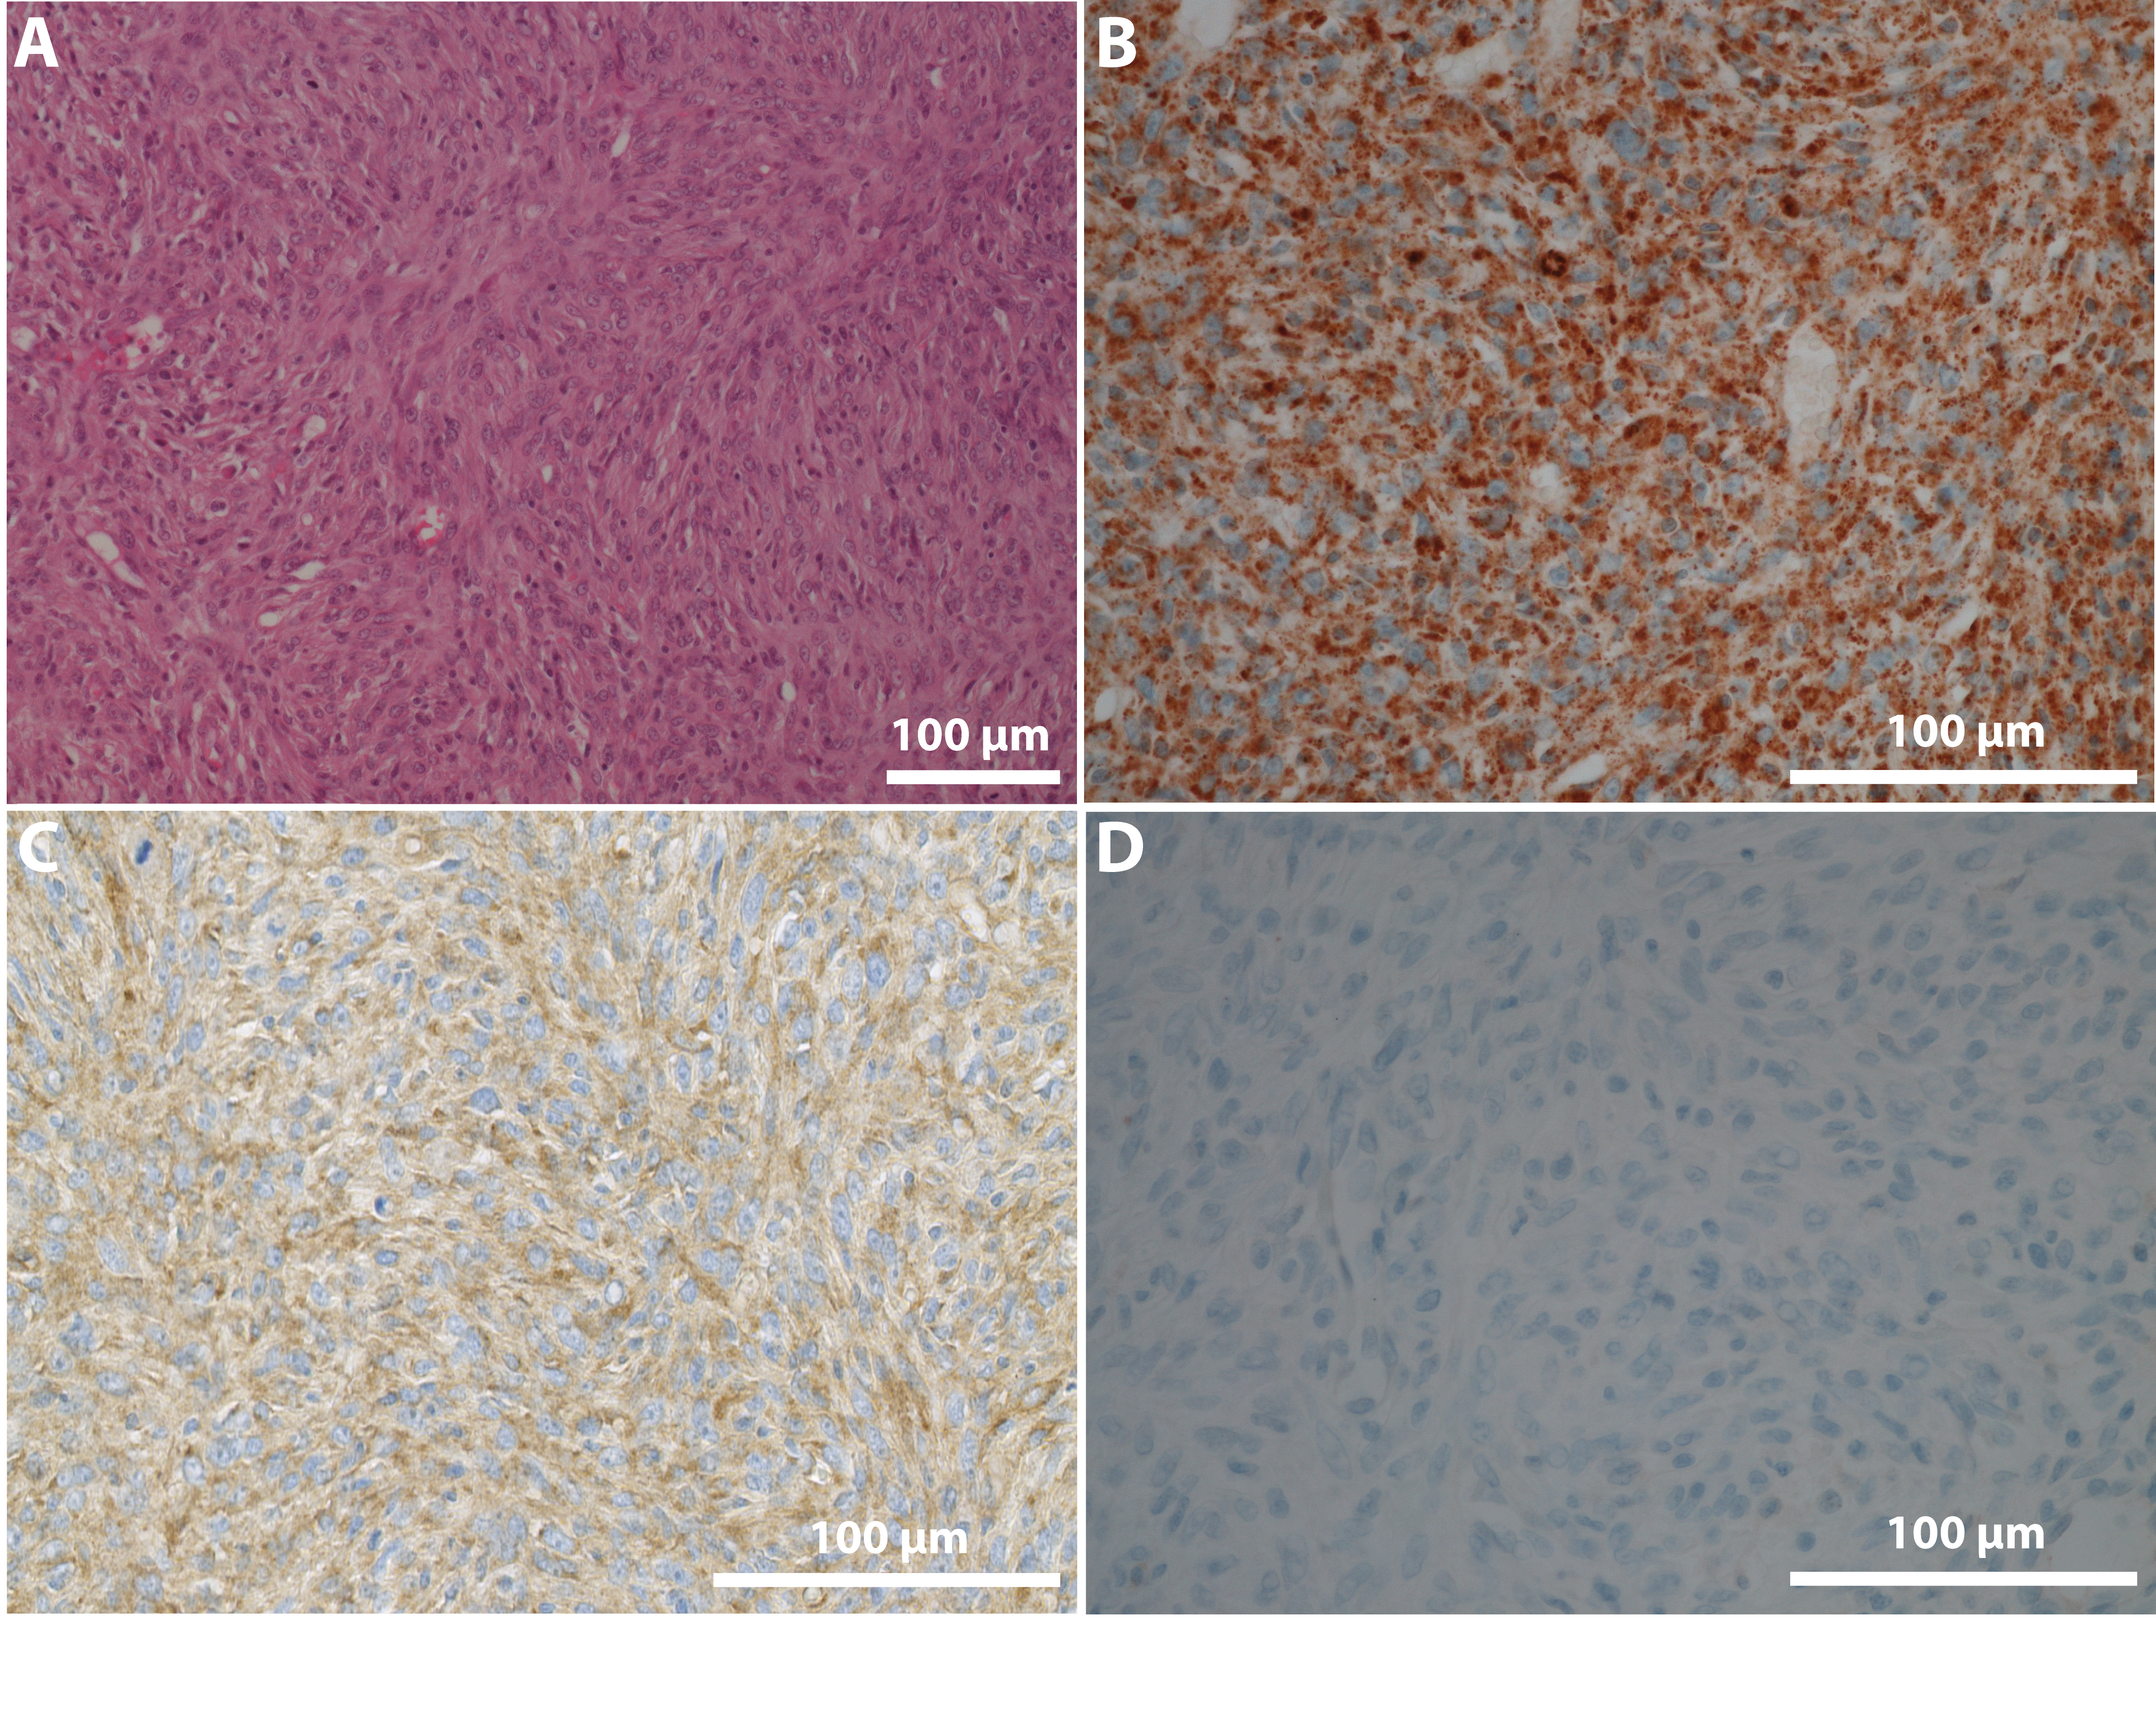
Supplementary Figure 1: Dermatofibrosarcoma protuberans-like lesion in a dog. A dermal spindle cell sarcoma was diagnosed in a Bernese mountain dog, a 5 year-old female with subcutaneous nodules on the lower limb. With no metastasis to the sentinel lymphe node, the treatment of this dog was surgery. Since the tumor was locally aggressive, the tumor recurred and the dog was euthanized one month after diagnosis. Based on the morphological features, the CD34 expression and the dermal localization of the tumor, this spindle cell sarcoma showed similarities with human dermatofibrosarcoma protuberans. (A) Hemalun-Eosin-Saffron (x200). The tumoral proliferation involves cutaneous (dermis) and subcutaneous layers of the skin; it consists of densely-packed uniform spindle-shaped cells with indistinct cell borders arranged in a predominantly storiform pattern with a scant stroma. They display few atypies and mitosis. In the periphery, the tumor cells are arranged in great corrugated and flexuous beams loose parallelism at the surface. In depth, the tumor infiltrates the sub-dermal in tablecloth dissociating the fat lobules and takes the form of interlobular partitions. (B) Immunohistochemical detection of PDFGB expression (x400) (immunoperoxidase; DAB chromogen). The tumor cells show a consistent and marked expression of the PDGFB protein that appears as granular cytoplasmic staining on immunohistochemistry. (C) Immunohistochemical detection of CD34 expression (x400) (immunoperoxidase; DAB chromogen). Membranous and cytoplasmic expression of the CD34 antigen by neoplastic sarcomatous cells and endothelial cells of the stroma. (D) Negative control with normal goat immune serum (x400) (immunoperoxidase; DAB chromogen).

