Label-free Raman spectroscopy detects stromal adaptations in pre-metastatic lungs
Santosh Kumar Paidi^{a,1}, Asif Rizwan^{b,1}, Chao Zheng^{a,c,1}, Menglin Cheng^{b}, Kristine Glunde^{b,d,2} and Ishan Barman^{a,d,2}
ªDepartment of Mechanical Engineering, Johns Hopkins University, Baltimore, Maryland, USA
^{b}Division of Cancer Imaging Research, The Russell H. Morgan Department of Radiology and Radiological Science, The Johns Hopkins University School of Medicine, Baltimore, Maryland, USA
^{c}Department of Breast Surgery, The Second Hospital of Shandong University, Jinan, Shandong, China
^{d}The Sidney Kimmel Comprehensive Cancer Center, The Johns Hopkins University School of Medicine, Baltimore, Maryland, USA
¹These authors contributed equally
²To whom correspondence may be addressed. E-mail: ibarman@jhu.edu or kglunde@mri.jhu.edu

Supplementary Information
Table ST1. Band assignment for spectral features observed in PC loadings derived from the Raman spectra of the mouse lungs.
Observed Raman Peaks in the PC loadings (cm⁻¹) | Raman band assignment from literature
859 | C-C stretch of proline (Collagen)
917 | C-C stretch of proline ring (Collagen)
1003 | C–C stretching vibration of the aromatic ring in the phenylalanine side chain (Collagen)
1061 | OSO₃ symmetric stretching (Proteoglycans)
1304 | In-plane CH₂ twisting modes of lipids
1442 | CH₂ deformation of lipids
1592 | Carbon particles (source of particles unknown)
1653 | Amide I (symmetric C=O stretching mode of proteins) and C=C lipid stretch (Lipids and proteins)
Table ST2. Confusion matrix for PLS-DA derived classification model showing correct classification rates (%) averaged over 1000 iterations.
 |  | Predicted Class Labels
 |  | Control | MCL | MDL
Reference Labels | Control | 90.1 | 0.1 | 9.8
 | MCL | 1.0 | 97.7 | 1.3
 | MDL | 20.9 | 0.7 | 78.4

Table ST3. Correct classification rates (%) of the PLS-DA-derived model using leave-one-mouse-out protocol (MD and MC refer to mouse models with MDA-MB-231 and MCF-7 tumor xenografts, respectively) with background subtracted spectra.
Mouse excluded | Correct classification rate (%) |  |  | Chauvenet’s criterion for MDL  (n = 10; τ_{max} = 1.96)
 | Control | MCL | MDL | τ = |x_{i} - x_{mean}|/σ | Result
None | 95.4 | 95.6 | 75.1 | 0.71 | Retain
MD #1 | 85.7 | 94.2 | 81.5 | 0.04 | Retain
MD #2 | 90.1 | 94.8 | 76.8 | 0.52 | Retain
MD #3 | 100.0 | 96.0 | 100.0 | 2.18 | Eliminate
MC #1 | 88.5 | 96.3 | 83.0 | 0.21 | Retain
MC #2 | 96.3 | 95.5 | 74.5 | 0.77 | Retain
MC #3 | 96.2 | 96.5 | 73.1 | 0.95 | Retain
Control #1 | 96.7 | 93.4 | 73.7 | 0.87 | Retain
Control #2 | 98.0 | 94.0 | 84.8 | 0.42 | Retain
Control #3 | 95.6 | 94.1 | 89.6 | 0.97 | Retain

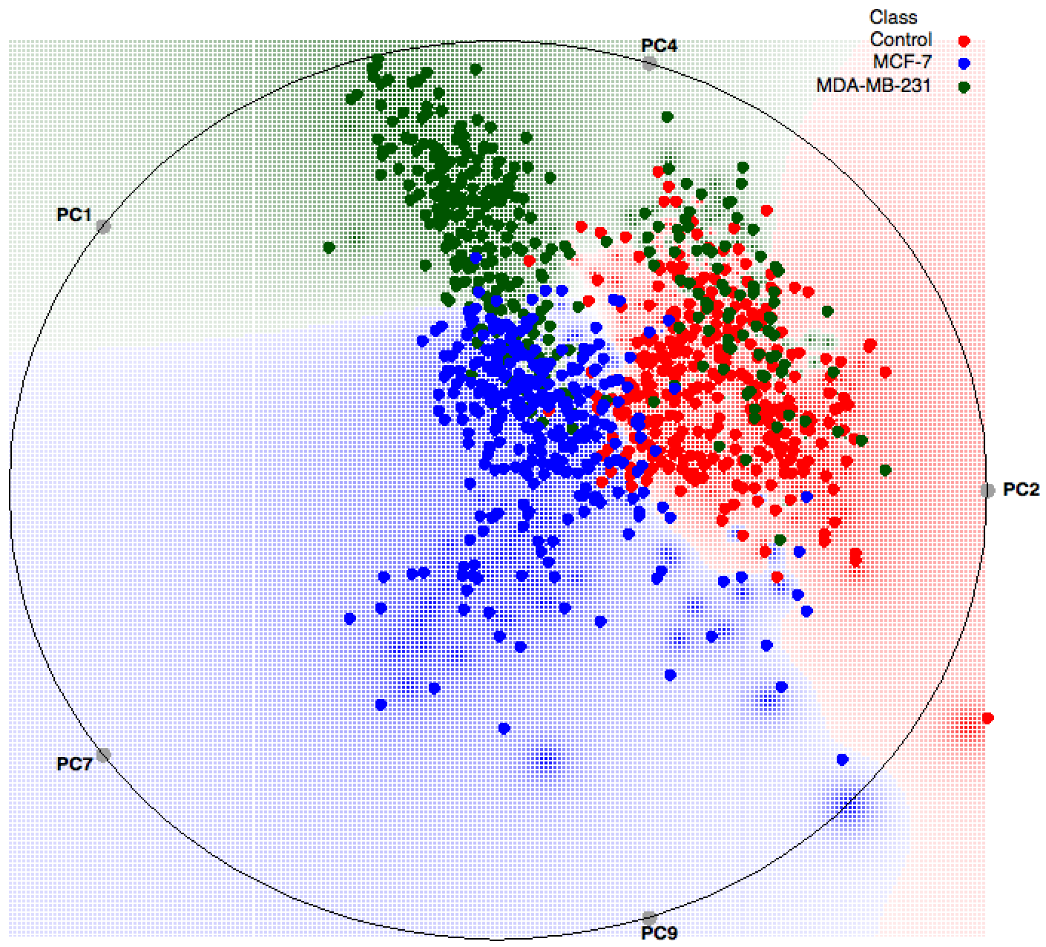
Figure S1. Radial visualization plot showing clusters formed by spectra recorded from lung samples of sacrificed mice bearing MDA-MB-231 and MCF-7 breast cancer xenografts as well as controls without xenografts after autofluorescence background subtraction.

