Supplementary Material

Pathway crosstalk quantification reveals synergistic drug combinations for breast cancer
Samira Jaeger¹, Ana Igea¹, Rodrigo Arroyo¹, Victor Alcalde¹, Begoña Canovas¹, Modesto Orozco^{1, 2}, Angel R. Nebreda^{1, 3} and Patrick Aloy^{1,3*}
S1 Experimental validation of drug combinations in human cancer cell lines
S1.1 Cell lines and culture conditions
The validation of selected drug combinations was conducted in five human cancer cell lines: four breast cancer cell lines, namely MCF-7, MDA-MB-231, SKBR3 and BT-474 representing distinct breast cancer subtypes. In addition, we also included U2OS, as a typical cancer cell line derived from bone osteosarcoma. An overview on molecular characteristics of each cell line is shown in Figure 4A.
MCF-7 and MDA-MB-231 cells were kindly provided by Dr. Violeta Serra (VHIO, Barcelona, Spain). U2OS cells were kindly provided by Dr. Travis Stracker (IRB, Barcelona, Spain). BT-474 cells were kindly provided by Dr. Roger Gomis (IRB, Barcelona, Spain). All cell lines were tested for mycoplasma contamination.
Monolayers of all cell lines were cultured in flasks (VWR Tissue Culture Flask, USA). MCF-7 cells were maintained in DMEM medium (Gibco, Germany) supplemented with 10% (v/v) fetal bovine serum (Gibco, Germany) and 1% of Penicillin-Streptomycin (Gibco, Germany). U2OS and SKBR3 cell lines were maintained in the same conditions, but also incorporated 1% L-glutamine (Sigma-Aldrich, Germany). MDA-MB-231 and BT-474 cells were cultured in DMEM/F12 medium (Gibco, Germany) supplemented with 10% (v/v) fetal bovine serum (Gibco, Germany) and 1% of Penicillin-Streptomycin (Gibco, Germany), and for BT-474 cells 1% L-glutamine (Sigma-Aldrich, Germany) was incorporated.
All cell lines were incubated at 37°C in a humidified atmosphere containing 5% CO2. Cells were passaged using Trypsin/EDTA 1x (Sigma-Aldrich, Germany) either every 3 days (MDA-MB-231, MCF-7 and U2OS) or twice a week (BT-474 and SKBR3).
S1.2 Drugs
Drugs were purchased from Selleckchem (USA), Tocris Bioscience (UK) and Roche (Switzerland) and stock solutions were prepared as indicated by the provider using either DMSO or water as dissolvent. Drug sensitivity was tested at four concentrations, selected according to data from previous studies in which the same compounds have been used in similar conditions. Table S2 shows the specific details for each compound tested (name, supplier and CAS number) as well as the experimental conditions used (solvent, stock solution prepared, the four doses used and the incubation time in which each drug was tested) and the references used to determine the drug doses.
S1.3 Cell viability – MTT assay
To measure drug sensitivity we used the MTT assay, a colorimetric assay which reflects the mitochondrial activity of living cells based on their ability to reduce tetrazolium dye, MTT, to insoluble formazan crystals (1). The concentration of solubilized formazan can be determined by measuring the optical density (OD) using a plate reader. Since the mitochondrial activity is typically constant in viable cells, an increase or decrease in the activity correlates linearly with the number of viable cells. For drug sensitivity measurements, the OD values of cells treated with drugs are commonly compared to the OD of untreated cells.
Prior to the experiments, the optimal cell density was assessed to ensure exponential growth of cells at days 3 or 5 in 96-well micro-culture plates in conditions of low serum culture used for the experiments (see Table S7).
Cells were seeded in 96-well plates at the respective densities in 100 μL per well. After overnight incubation, the corresponding drugs were added to the cell cultures at one of the four doses. In the case of combined treatments, both drugs were added simultaneously and cells were exposed continuously to the drugs. Cells were incubated at 37ºC in a humidified atmosphere with 5% CO2 for the exposure intervals specified in Table S2 (3 or 5 days). At that time, 20 μL of MTT (Sigma; 5 mg/mL in PBS) were added to each well, and the plates were incubated for 3 h at 37°C. Then, the supernatant was aspirated, 100 μL of DMSO was added to each well and absorbance was measured at 570 nm.
Experiments were performed either in triplicates (individual drugs) or quadruplicates (drug combinations) and repeated three independent times. Cell survival is expressed as cell growth relative to the growth of control cells, that is, absorbance of treated well / absorbance of untreated control. Survival values were averaged across the experiments and standard deviation was obtained.
S2 Impact of the residual standard error (RSE)
To determine the IC_{X} values for a given inhibition level X for individual drugs and combinations, we used the drc R package (2). As indicated in the main manuscript, in some instances, the estimated IC_{X} corresponds to a value beyond the tested concentration range. Two cases in which the IC₅₀ is either considerably close or far from the maximum concentration tested are illustrated in Supplementary Fig. S14. The IC₅₀ derived for cabozantinib is 15.27 μM with the maximum concentration being 15 μM (Supplementary Table S2). Given the experimental data and the modeled dose-response curve shown in Supplementary Fig. S14A, the value is likely to present a reliable IC₅₀. In contrast, the IC₅₀ for trastuzumab is 176.72 μg/mL (Supplementary Fig. S14B), which is far beyond the maximum concentration of 40 μg/mL (Table S2). Considering the respective dose-response curve, it is not evident whether a proliferation inhibition of 50% will be reached at all.
If a single agent does not reach a pre-defined inhibition level, we assume that the contribution of this agent to the combination is marginal, i.e., C_{D1,X} = 0 or C_{D2,X} = 0 (3). However, including or omitting an IC₅₀ value might have significant consequences for the drug combination index (DCI), with respect to synergy and antagonism in general, but also on the degree of such a drug interaction. For instance, assuming that the contribution of cabozantinib to the combination is negligible results in a DCI₅₀ of 0.22 indicating strong synergism between the two drugs. However, the drug-response curves show that the effect is at best slightly synergistic or even additive (Supplementary Fig. S14A). In turn, when accepting the IC₅₀ of 15.27 μM, we yield a DCI₅₀ of 0.912 reflecting near additivity as anticipated by visual inspection of the dose-response curves. Note that such an effect might be even more pronounced if the combination reaches the IC₅₀ while the individual agents both have an IC₅₀, which is closely beyond the maximum concentration. In this case, the DCI indicates very strong synergy (DCI₅₀ = 0) but the true drug interaction might even be antagonistic. In the case of trastuzumab in DC09 (Supplementary Fig. S14B), the effect is less distinct. Here, the DCI₅₀ only changes from 0.66 to 0.79 (synergy to modest synergy) when neglecting or considering the IC₅₀ of this agent, respectively.
To obtain more reasonable DCIs, we tried to discriminate IC₅₀ that are outside of the concentration range but provide likely a reliable measure by using the relative standard error (RSE) that can be obtained from the standard error associated with each IC_{X} estimate. We applied a threshold of 0.15 assuming that IC values with a RSE below this value are acceptable. The RSE for cabozantinib in DC06 is 0.04, thus we consider the IC₅₀ to be reliable when calculating the DCI₅₀. In turn, the RSE of trastuzumab is 0.5 indicating that the IC₅₀ estimate is not reliable. Table S5 shows that without considering the RSE when determining the IC₅₀, we are likely to overestimate the degree of synergy of combinations. However, when considering an error margin of 0.15 we yield more realistic DCIs.
S3 In vivo xenograft model
S3.1 Animals
Mice were housed according to national and EU regulation and protocols were approved by the animal care and use committee of Parc Cientific Barcelona.
Five-week-old athymic nude female mice (Harlan Laboratories) were anesthetized using i.p. injections of ketamine (750 mg/kg body weight)/xylazine (50 mg/kg body weight). Six days prior to cell injection a 0.18-mg 17β-estradiol 60-day release pellet (Innovative Research of America, Saratosa, FL) was implanted subcutaneously.
MCF-7 cells were grown in monolayer and were harvested during the exponential growth phase (less than 80% confluence) using trypsin, suspended in a 1:1 PBS:Matrigel (BD Biosciences) mixture and kept on ice. For orthotopic injections, mice were surgically incised and a pocket was created using forceps until the mammary gland was available. Cell suspension was gently agitated to prevent the cells from settling and fifty microliters (1x10⁶ cells) were immediately injected into the mammary gland using a 21G needle. Animals were placed in a clean cage and observed for 10-15 minutes to ensure recovery from the anesthetic. Tumors were observable about 1 month after injection.
S3.2 Treatment Protocol
Tumors were allowed to reach around 120-150 mm³ before the start of the treatment. Animals with tumors in the proper size range were randomly divided into the various treatment groups. We used 39 mice with two tumors per group (3 initial tumors; 9 control; 9 raloxifene; 9 cabozantinib, and 9 combination of raloxifene and cabozantinib).
Animals were treated with compounds once daily by i.p. and/or oral gavage for a total of 15 days. Compounds were administered using as vehicle 30% PEG-400, 20% propylene glycol and 50% distilled water, and were given by exact body weight, with the injection volume being 0.1 ml/10 g body weight. Tumor growth was determined by caliper measurement (mm) and using the formula (LengthxWidth²)/2=mm³. Tumor size and animal weight were determined every two days.
S3.3 Immunohistochemistry assays
Tumors were excised at day 15, fixed in formalin and embedded in paraffin. Five-micron-thick sections of formalin fixed, paraffin embedded tissue were prepared from all tumors.
Sections were deparaffinized, re-hydrated, and then subjected to antigen retrieval using the DAKO citrate retrieval (DAKO; Carpinteria, CA). Hematoxylin and eosin (H&E) stained sections of tumors were compared. To determine cell proliferation, sections were stained with an antibody against Ki67 (Novocastra), using as secondary antibody HRP conjugated anti-rabbit (ImmunoLogic). The signal was visualized with diaminobenzidine peroxidase and counterstained with hematoxylin. Stained sections were analyzed by manually counting cell nuclei positive for Ki67 staining; a minimum of three fields (20x) for each xenograft tumor was counted and the mean count per field was calculated.
To detect apoptosis, sections were deparaffinized, re-hydrated and treated according to the “In situ Cell Death Detection Kit, Fluorescein” (Roche). A minimum of five images per group was taken, the positive area was calculated using ImageJ for each tumor and average values for each group were plotted.
S3.4 PCI assessment at molecular level and Western blot protocol
To assess pathway crosstalk inhibition for DC02 on the molecular level, we identified proteins involved in pathway crosstalk predicted to be modulated predominantly by the combination, including Akt, Src and the nuclear form of the estrogen receptor (nER), and analyzed their activity using western blots in the tumor samples (Fig. 6E/F). Akt and Src modulation were assessed directly by means of their phosphorylation status (phospho-Akt, phospho-Src), which determines the activity of those proteins. Selecting Src and Akt also allows for the evaluation of the modulation of a signaling axis (Src—Pi3k—Akt), which is part of the full pathway crosstalk network (see Fig. 6E). In the case of nER, we measured the total levels of Cyclin D1 as a read out of the activity of nER for which Cyclin D1 is a well-characterized target gene. We focused on nER as it can be activated in a ligand-independent manner through MEK and ERK (4).
Samples from MCF-7 xenografts were lysed in 50 mM Tris–HCl pH 7.5, 150 mM NaCl, 1mM DTT, 1% NP-40, 5 mM EDTA, 5 mM EGTA, 20 mM NaF, 0.1 mM sodium orthovanadate, 1 μM microcystin and the Protease Inhibitor Cocktail Set III from Merck Millipore. Total lysates were centrifuged for 15min at 16,000 × g and 4°C and supernatants were quantified using the Protein Assay kit (Bio-Rad). Proteins (30 μg) were separated by SDS–PAGE and transferred to nitrocellulose membranes (Protran, Schleicher & Schuell) using the Trans-well Blot® system (Bio-Rad). Membranes were blocked with 5% non-fat dry milk in PBS for 1 hour at RT and then incubated with the following antibodies: phospho-AKT (9271 Cell Signaling), BCL2 (2870 Cell Signaling), phospho-SRC (05-677 Millipore), Cyclin D1 (8396 Santa Cruz Biotechnologies) and alpha-Tubulin (T9026 Sigma Aldrich).
All primary antibodies were diluted 1:1000 in 2% BSA, except for tubulin that were diluted 1:5000, and were visualized using the Odyssey Infrared Imaging System (Li-Cor, Biosciences) using with Alexa Fluor 680/800-conjugated secondary antibodies (Molecular Probes).
S4 Functional relationships among KEGG pathways
To assess crosstalk across all pathways in the KEGG database, we obtained 293 human pathways from the KEGG database from which we removed drug metabolism (2) and disease pathways (67), yielding in total a set of 224 pathways. Pathways have been retrieved from KEGG using the REST-style KEGG API.
We assessed the functional relationships among different pathway sets in two ways: (1) all KEGG pathways, as well as (2) pathways from clinical combinations and (3) pathways from predicted drug combinations, by (A) considering shared genes/proteins among pathway pairs as well as by (B) computing pathway crosstalk. Supplementary Fig. S3A shows that pathway pairs from the complete KEGG set have a significantly lower protein overlap than pathway pairs from clinical and predicted combinations (p-value < 2.2e-16). Predicted combinations show a significant higher protein overlap compared to pathway pairs from clinical combinations (p-value = 0.011). Note that a high overlap of genes/proteins denotes not only functional similarity between pathways but might also indicate functional redundancy, which, in turn, may induce alternative signaling and crosstalk.
For assessing pathway crosstalk, we excluded 113 pathways (mostly metabolic pathways), which do not comprise protein-protein interactions, but only protein-compound interactions and enzyme-enzyme relations. When considering crosstalk between pathway pairs in the three pathway sets (Supplementary Fig. S3B), we observe a similar trend as for shared pathway components (Supplementary Fig. S3A). A higher pathway crosstalk can be detected between pairs from clinical (mean: 0.11) and predicted combinations (mean: 0.097) compared to all KEGG pathways (mean: 0.059) with protein interactions (p-value < 2.2e-16). Pathways combined in clinical combinations exhibit a higher crosstalk compared to pathways from predicted combinations with a p-value = 0.0002814.
S5 Efficacy of clinically relevant drug combinations with respect to the PCI
To assess whether there are differences between combinations passing the PCI threshold of 0.34 and those failing it, we collected information regarding efficacy and clinical benefit of each combination, if available, from ClinicalTrials.gov (https://clinicaltrials.gov/) as well as from the literature, to classify each combination with respect to its clinical benefit. Given the available information, we classified the 86 combinations into “with” (32), “without” (22) and “unknown” clinical benefit (32). The number of combinations above (34 of 54) and below (20 of 32) the pathway crosstalk inhibition threshold of 0.34 is shown in Supplementary Fig. S4A. The fraction of combinations with unknown clinical benefit is equally distributed across both sets, with 37% (20/54) and 37.5% (12/32) for PCI ≥ 0.34 and PCI < 0.34, respectively. Given the available clinical annotations, we observe a weak but statistically significant difference (p-value = 0.03215) between the PCI of combinations with and without proven clinical benefit (Supplementary Fig. S4B), indicating that combinations passing the PCI threshold of 0.34 are more likely to be have a clinical benefit compared to combinations failing this threshold.
Note that in general the information regarding the efficacy of a combination is often not easily accessible, difficult to interpret or preliminary as trials are ongoing. Furthermore, trial conditions differ significantly; certain combinations fail for a particular subtype or setting (metastatic vs. early breast cancer, heavily pretreated vs. prevention of recurrence), but might still be effective under different conditions, yet to be tested. On the other hand, a number of combinations is only in early (safety) phases, such as Phase 1/1b trials, lacking information regarding their therapeutic efficacy. Given the challenge of assessing the success of clinical combinations under the distinct trial conditions, we decided to consider the 86 combinations in our analysis.
S6 Enrichment of synergistic combinations in comparison with high-throughput experimental screens
Considering the experimental data from the drug screening performed by Miller et al (3) we assessed the statistical significance of the enrichment of synergistic combinations obtained by our method. This data set presents with 14.3% one of the higher rates of detected synergistic combinations published in the literature. Based on the information of 91 drug combinations obtained among 14 targeted compounds screened in a tumor-derived liposarcoma cell line (DDLS817), we performed a random sampling of a) 50 combinations, b) 40 combinations and c) 10 combinations. Those samplings reflect the 50 drug combinations tested in all five human cancer cell lines, 40 combinations in the four breast cancer cell lines, and 10 combinations in the individual cell lines.
For each sampling we determined the number of synergistic combinations as well as the percentage of synergistic drug combinations. We repeated the sampling N=10,000 times to generate a sampling distribution from which we then computed an empirical p-value to assess the statistical significance of the synergy rates obtained by our method.
Figure S8 illustrates the outcomes of this assessment. Overall, 32% of the drug combinations tested showed synergy (Figure 4B). This number increase up-to 35% when considering only breast cancer cell lines. Sampling 50 combinations 10,00 times from the high-throughput data set, yields on average 14.3% of synergistic drug combinations (median of 14%), while sampling 40 combinations yields a synergy rate of 14.3% (median of 15%). Figure S8A and S8B show that both synergy rates obtained from the random sampling are significantly smaller than the ones obtained by our method (p-value < 1e-04).
Considering the 10 drug combinations for each individual cell line, 50% of the combinations in MCF-7 and SKBR3 and 20% of the combinations in MDA-MB-231, BT-474 and U2OS are synergistic (see Figure 4B). Sampling 10 combinations 10,000 times from Millers data set, results in an average synergy rate of 14.4% (median 10%). Thus, the enrichment of synergistic combinations achieved by means of our method in MCF-7 and SKBR3 is highly significant (p-value = 5e-04, Figure S7C). Although the enrichment of synergistic combinations detected in MDA-MB-231, BT-474 and U2OS is higher than observed for the random sampling (20% vs. 14.4%), this enrichment is not significant (p-value = 0.15, Figure S8C).
This shows that the enrichment of synergistic drug combinations identified by our method compared to the high-throughput screen without computational prioritization of Miller et al. is statistically significant.
SUPPLEMENTARY INFORMATION: TABLES
Supplementary Table S1: Complete list of breast cancer drugs (Excel table).

Supplementary Table S2: Information about the breast cancer drugs tested in combination and the conditions in which the experiments were performed.
 | Name | Supplier | CAS number | Solvent | Stock Solution (nM) | Concentration range | Incubation time (h) | References
D01 | Cabozantinib (XL-184) | Selleckchem | 849217-68-1 | DMSO | 20 | 5 / 7,5 / 10 / 15 μM | 72, 120 | (5)
D02 | Dinaciclib  (SCH727965) | Selleckchem | 779353-01-4 | DMSO | 1 | 0,5 / 5 / 10 / 50 nM | 72 | (6)
D03 | Erlotinib | Selleckchem | 183321-74-6 | DMSO | 5 | 0,5 / 1 / 7,5 / 15 μM | 72 | (7)
D04 | NVP-AEW541  (~Figitumumab) | Selleckchem | 475489-16-8 | DMSO | 20 | 5 / 7,5 / 10 / 15 μM | 72 | (8,9)
D05 | Trastuzumab  (Herceptin) | Roche | 180288-69-1 | Water | 20 mg/ml | 5 / 10 / 20 / 40 μg/mL | 72 | (10-12)
D06 | Paclitaxel  (Taxol) | Selleckchem | 33069-62-4 | DMSO | 20 | 0,1 / 1 / 7,5 / 15 μM | 72 | (13,14)
D07 | Midostaurin  (PKC412) | Tocris | 120685-11-2 | DMSO | 10 | 0,1 / 0,5 / 1 /10 μM | 72 | (15)
D08 | Olaparib  (AZD2281) | Selleckchem | 763113-22-0 | DMSO | 20 | 0,01 / 0,1 / 1 / 5 μM | 72, 120 | (16-18)
D09 | PD-0332991  (Palbociclib) | Selleckchem | 571190-30-2 | Water | 4 | 0,01 / 0,1 / 0,5 / 5 μM | 72, 120 | (19,20)
D10 | Raloxifene | Selleckchem | 84449-90-1 | DMSO | 20 | 0,1 / 1 / 10 / 20 μM | 72 | (21,22)
D11 | Tanespimycin  (17-AAG) | Selleckchem | 75747-14-7 | DMSO | 2 | 0,2 / 2 / 20 / 200 nM | 72 | (23,24)

Supplementary Table S3: Scheme for refining the degrees of synergy or antagonism (25).
Effect type | DCI range | Description
Synergy | < 0.1 | Very strong synergism
 | - – 0.3 | Strong synergism
 | 0.3 – 0.7 | Synergism
 | 0.7 – 0.85 | Moderate synergism
Additivity | 0.85 – 0.9 | Slight synergism
 | 0.9 – 1.1 | Nearly additive
 | 1.1 – 1.2 | Slight antagonism
Antagonism | 1.2 – 1.45 | Moderate antagonism
 | 1.45 – 3.3 | Antagonism
 | 3.3 – 10 | Strong antagonism
 | >10 | Very strong antagonism

Supplementary Table S4: Impact of using the RSE for assessing the reliability of IC₅₀s beyond the maximum concentration on the number of synergistic combinations.
RSE | Synergistic  (DCI ≤ 0.85) | Additive  (0.85 > DCI ≤ 1.2) | Antagonistic  (DCI > 1.2) | Combinations  w/o DCI
0.00 | 40% | 26% | 10% | 24%
0.05 | 38% | 32% | 12% | 18%
0.10 | 34% | 38% | 14% | 14%
0.15 | 32% | 38% | 16% | 14%

Supplementary Table S5: Overview on the predicted drug combinations together with the pathways mainly involved in crosstalk inhibition (Excel table).

Supplementary Table S6: Treatment indication of the individual drugs for a certain breast cancer subtype, if clear treatment details are available. Underline drugs have been approved for breast cancer while the other drugs are under investigation (HR+ Hormone receptor positive breast cancer; HER2+ HER2-overexpressing breast cancer; TN Triple negative breast cancer; SERM Selective estrogen receptor modulator).
 | Drug class | Subtype treatment indication
Cabozantinib | VEGFR inhibitor | HR+ breast cancer
Erlotinib | EGFR inhibitor | TN breast cancer
Raloxifene | SERM | HR+ breast cancer
Olaparib | PARP-1 inhibitor | TN breast cancer
Dinaciclib | CDK inhibitor | ?
Tanespimycin | HSP inhibitor | HER2+ breast cancer
Paclitaxel | Microtubule modulator | Metastatic (all subtypes)
PD-0332991 | CDK inhibitor | HR+ breast cancer
Trastuzumab | HER2 inhibitor | HER2+ breast cancer
Figitumumab | IGF-1R inhibitor | HR+ breast cancer

Supplementary Table S7: Number of cells seeded for each cell line and depending on MTT conditions.
 | MDA-MB-231 | MCF-7 | SKBR3 | BT-474 | U2OS
3-day MTT | 4,000 | 2,500 | 5,000 | 5,000 | 2,500
5-day MTT | 1,500 | 1,000 | 2,500 | 2,500 | 1,000

SUPPLEMENTARY INFORMATION: FIGURES
Supplementary Figure S1:
Overview on currently combined drug classes clinically tested (according to a drug’s therapeutic targets, see Supplementary Table S1). The size of each circle represents the number of combinations between two classes. For instance, instance EGFR inhibitors and microtubule inhibitors are frequently combined with each other, while other drug class combinations are not exploited at all. Drug classes marked with an asterisk are formed by subclasses with differing targets. AI - aromatase inhibitors, CDKi – CDK inhibitors, DI – agents directly interfering with the DNA, EGFRi – EGFR and ERBB2 inhibitors, HSPi – heat shock protein inhibitors, MM – microtubule modulators, MRKi – multiple receptor kinase inhibitors, mTORi – mTOR and PI3K inhibitors, PARPi – PARP inhibitors, SERM – selective estrogen receptor modulators, Various – various inhibitors.
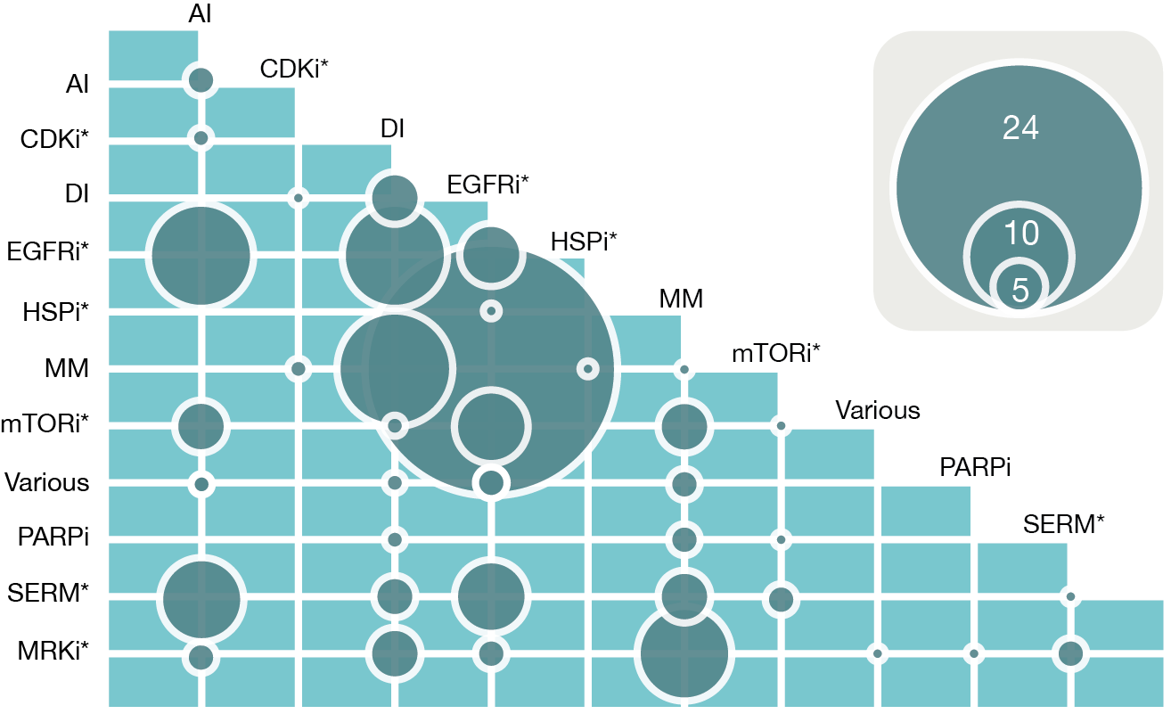

Supplementary Figure S2:
Illustration of the drug combination index (DCI) for an inhibition level of 50%. The dose-response curves for individual drugs, paclitaxel and tanespimycin, are shown in green and blue, respectively. The combination is shown in black. Concentrations of the individual drugs were selected from the literature to hit their activity range (Table S2); see additional PDF S6 for dose-response curves of all ten combinations in the five cell lines.
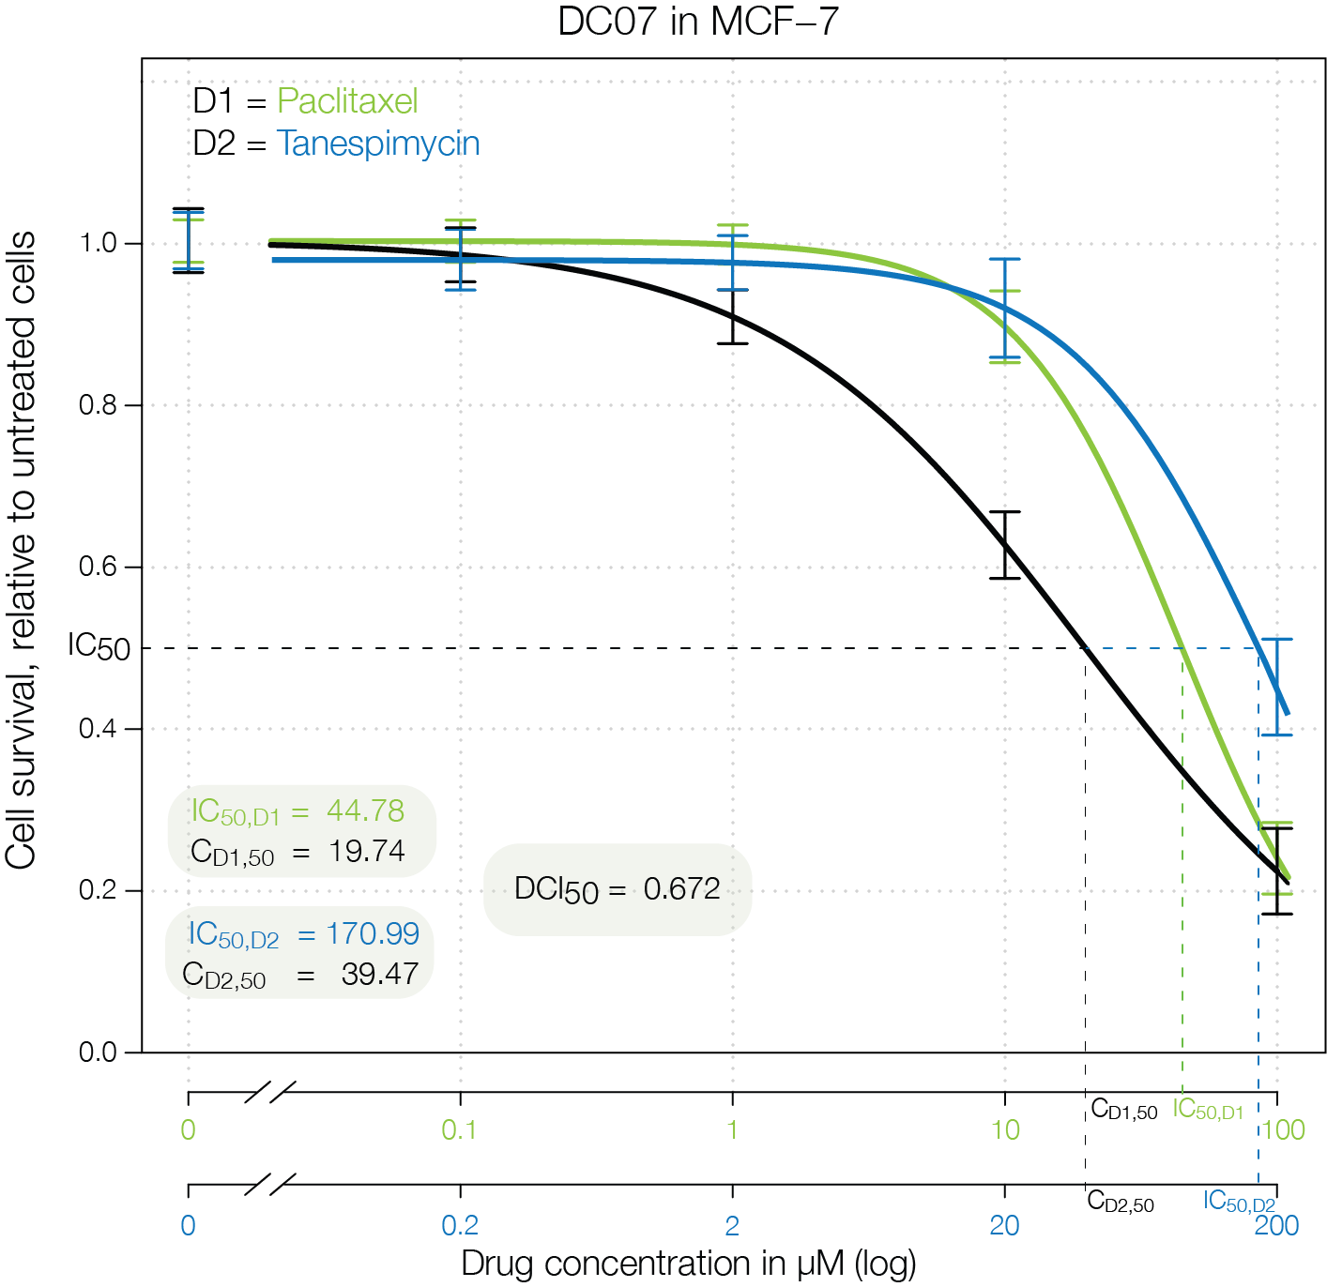

Supplementary Figure S3:
Functional relationships between pathways in terms of (A) shared proteins and (B) pathway crosstalk (using the Jaccard similarity coefficient). All – human pathways from KEGG, CC – pathways from clinical combinations, Predicted – pathways from predicted combinations. Asterisks ‘*’,’**’ and ‘***’ indicate p-values below 0.05, 0.01 and 0.001, respectively.
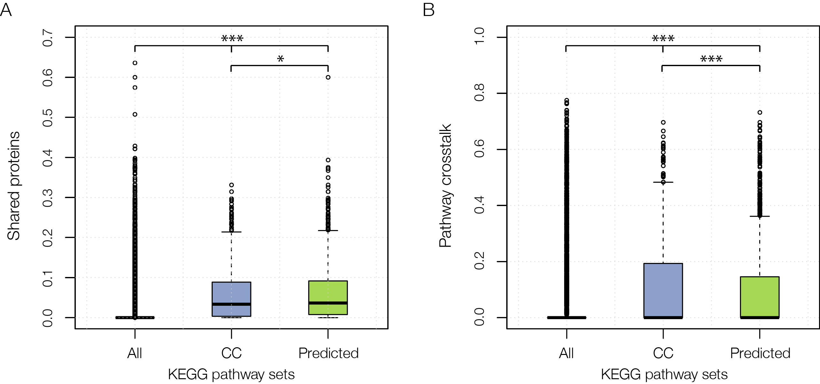

Supplementary Figure S4:
Evaluation of clinical drug combinations with respect to the available clinical annotations indicating improved efficacy and/or clinical benefit. A) Number of combinations above (54) and below (32) the pathway crosstalk inhibition (PCI) threshold, distinguishing between combinations with and without clinical annotations. B) Comparison of the PCI values obtained for combination “with” and “without” confirmed clinical benefit. The ‘*’ indicates a p-value below 0.05, here p-value = 0.03215.
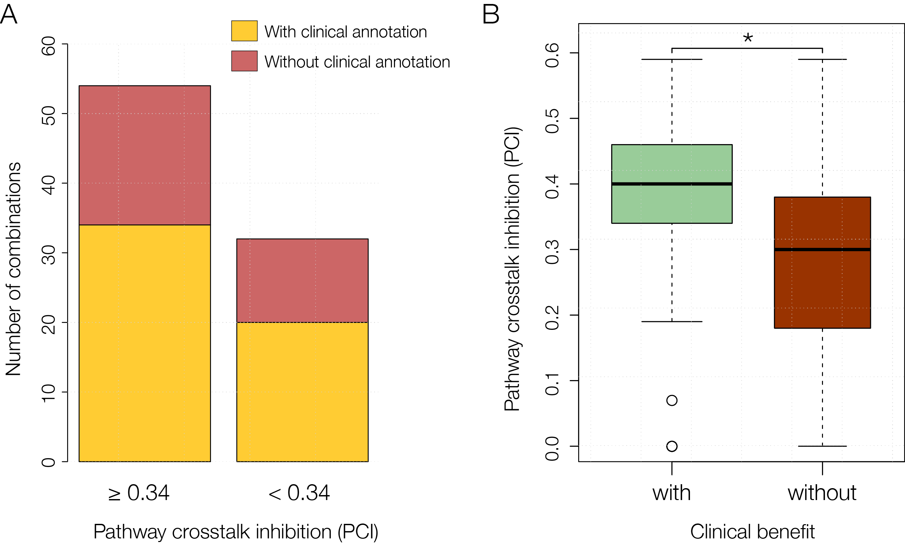

Supplementary Figure S5:
Correlation of the drug combination index (DCI) with the PCI computed for drug combinations between 14 targeted screened in a liposarcoma cell line (3) (Pearson correlation coefficient = -0.439, p-value = 0.0001829).
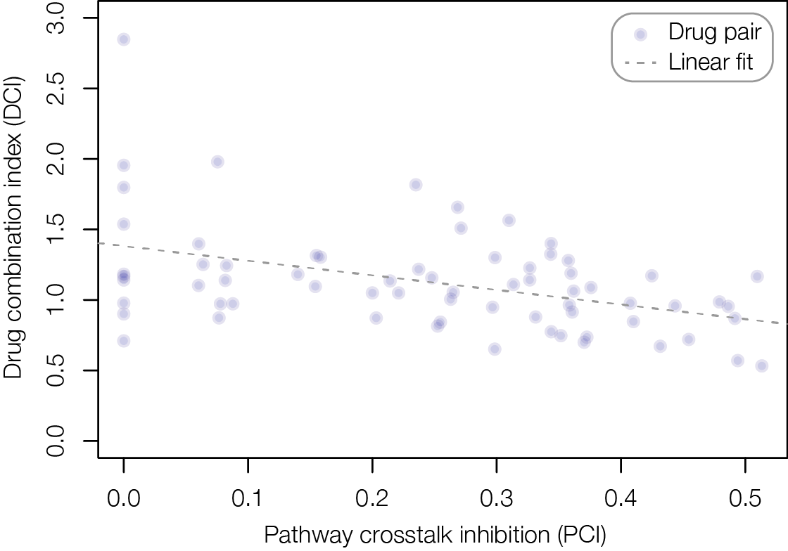

Supplementary Figure S6:
Enrichment of clinically relevant and non-tested combinations at different pathway crosstalk inhibition values. The difference between the two groups of combinations is shown in gray.
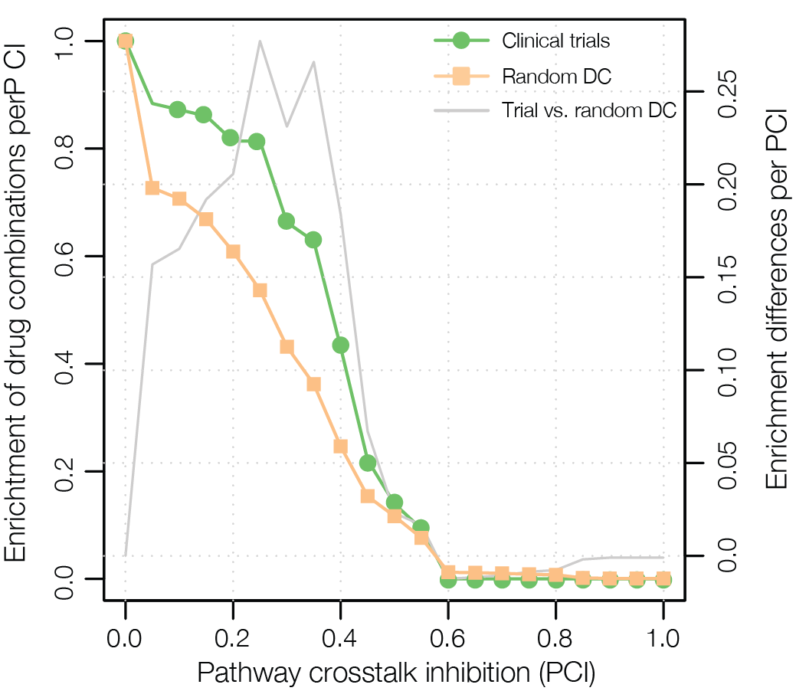

Supplementary Figure S7:
Sigmoid-fitted dose-response curves generated for each of the experimentally validated drug combinations in the five cell lines (additional PDF). Note that for some combinations we could not fit the dose-response curves, thus they are not shown in the additional PDF.

Supplementary Figure S8:
Assessment of the statistical significance of the different synergy rates obtained in (A) five cancer cell lines (32%), (B) four breast cancer cell lines (35%) and (C) each cell line (50% for MCF-7 and SKBR3; and 20% for MDA-MB-231, BT-474, U2OS).
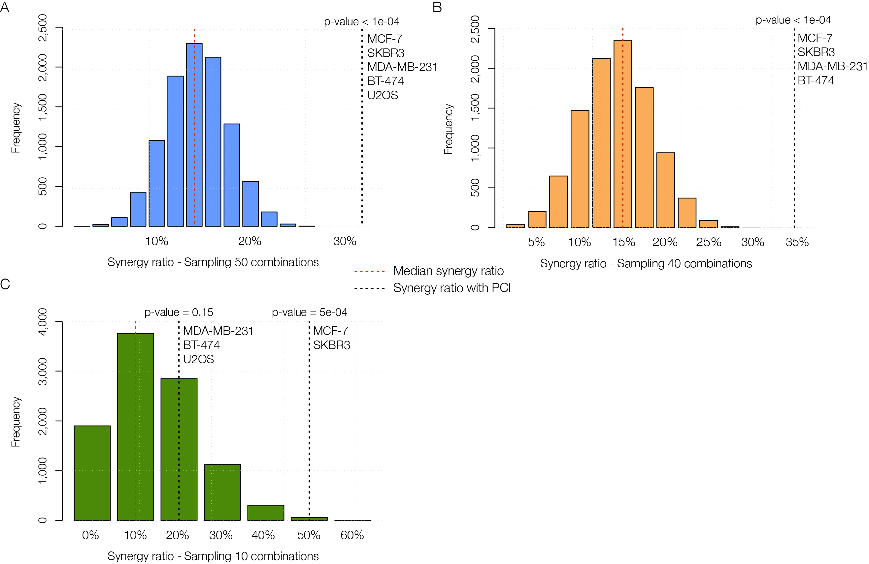
Supplementary Figure S9:
Overview on the DCI₅₀ per drug combination. The green area represents synergy (DCI ≤ 0.85) while yellow indicates additivity (0.85 > DCI ≤ 1.2). Combinations having a DCI above 1.2 are antagonistic. Note that the DCI₅₀ for combination DC08 is 70.27, but we set it to 3.5 for a better visualization.
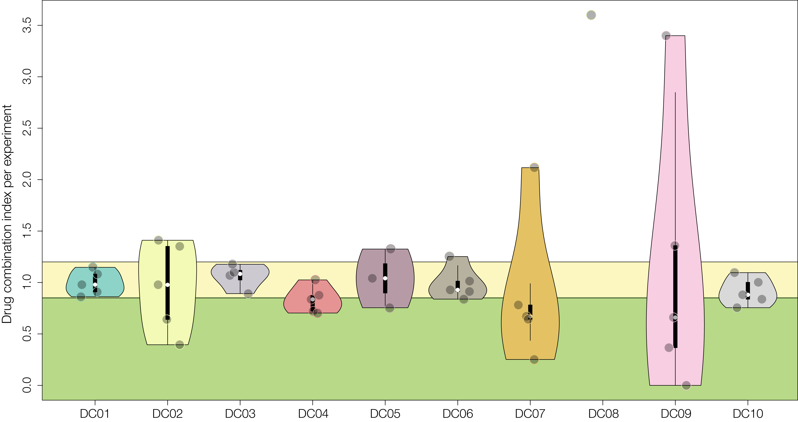

Supplementary Figure S10:
Drug combination index of the combinations summarized per cell line. The green area represents synergy (DCI ≤ 0.85) while yellow indicates additivity (0.85 > DCI ≤ 1.2). Combinations having with a DCI above 1.2 are antagonistic. The DCI₅₀ for combination DC08 in MDA-MB-231 cells is 70.27, but has been set to 3.5 for a better visualization.
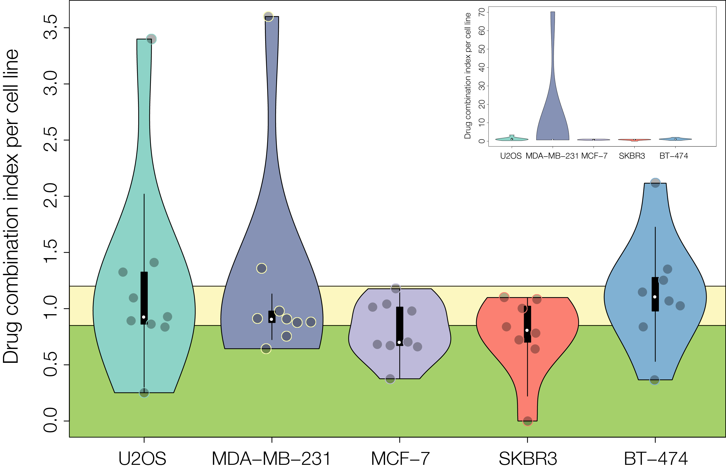
Supplementary Figure S11:
Overview on the interaction behavior of each combination across the five cell lines. (A) Cells are colored according to the median DCI value determined for inhibition levels of 20 to 80%. C indicates consistent behavior (i.e. neither synergistic-antagonistic nor additive-antagonistic shifts). C_{CL} depicts the proportion of consistent combinations per cell line while C_{DC} specifies the percentage of consistent cell lines per combination. (B) Distribution of DCI values ranging from 20 to 80% of proliferation inhibition (IC₂₀ to IC₈₀), illustrated exemplarily for drug combination DC02; see additional PDF S13 for the distribution of DCI20 to DCI80 of all combinations.
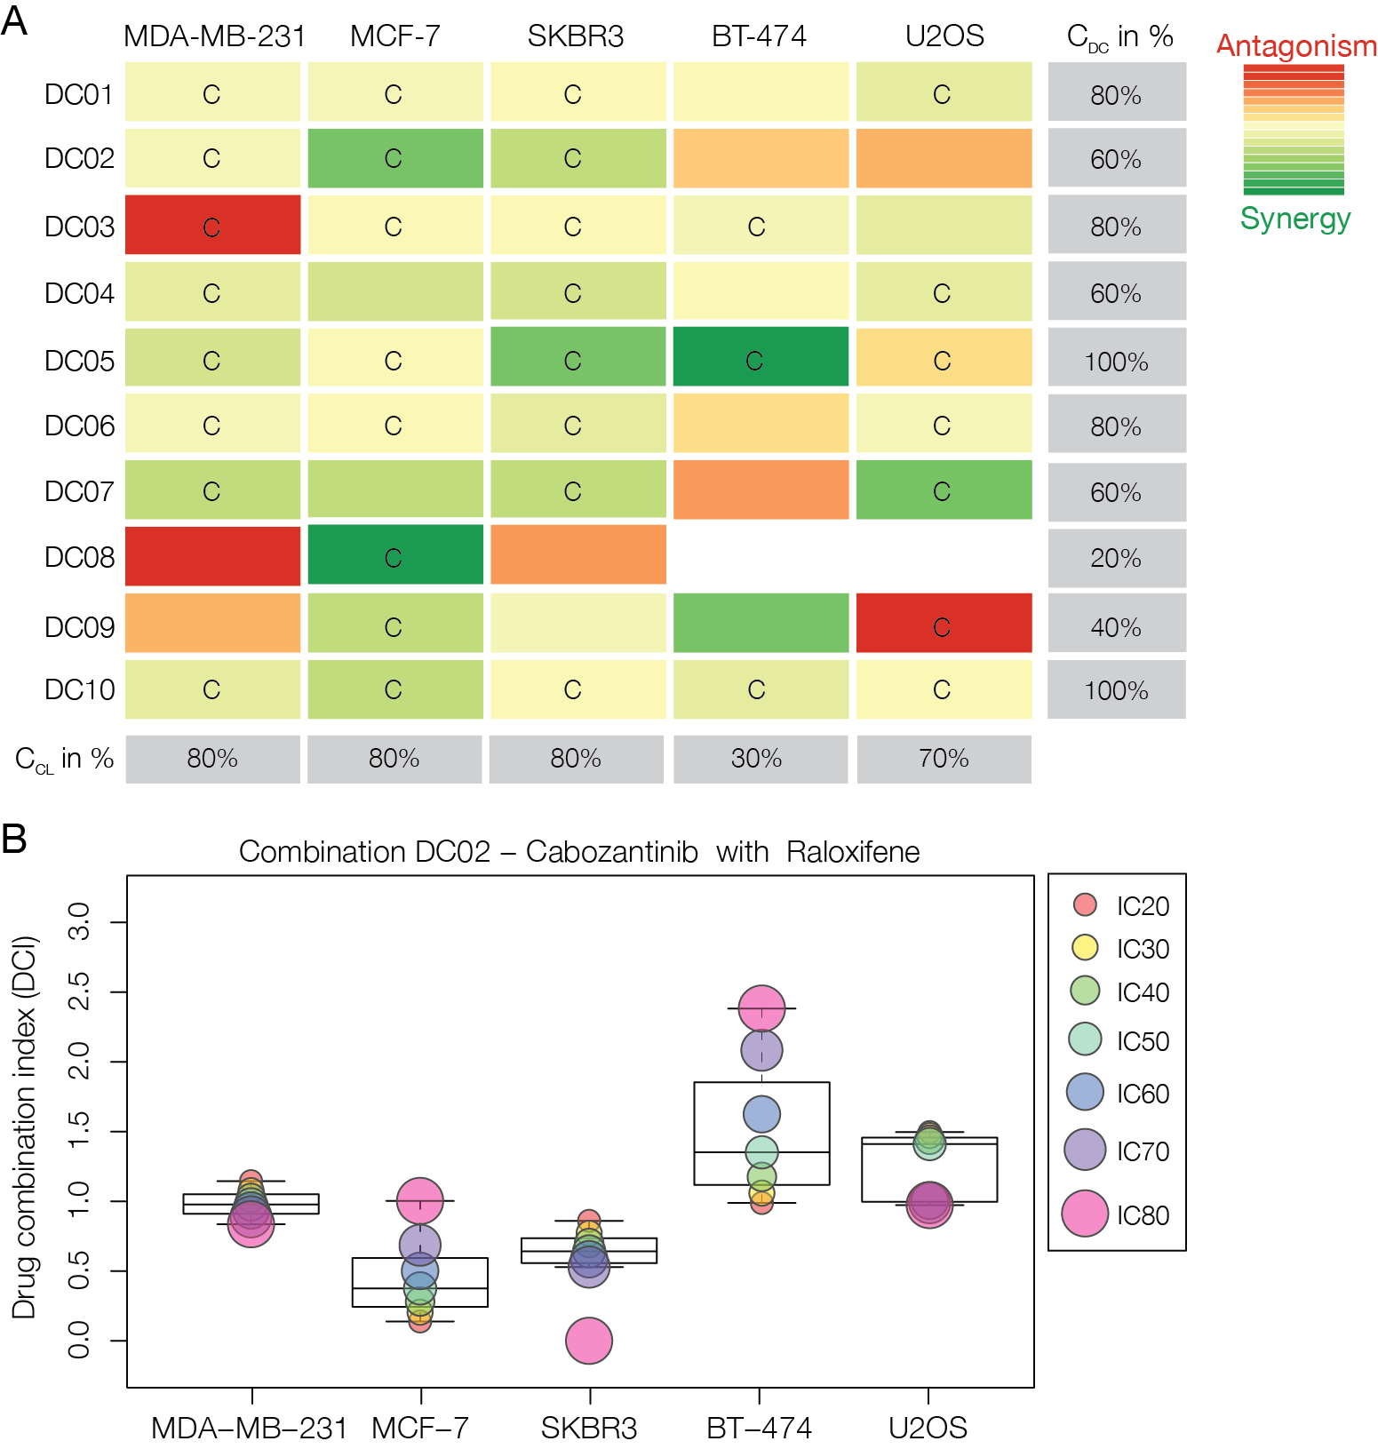

Supplementary Figure S12:
Effects of individual and combinatorial treatment on body weight. Animal weights were recorded every two days.
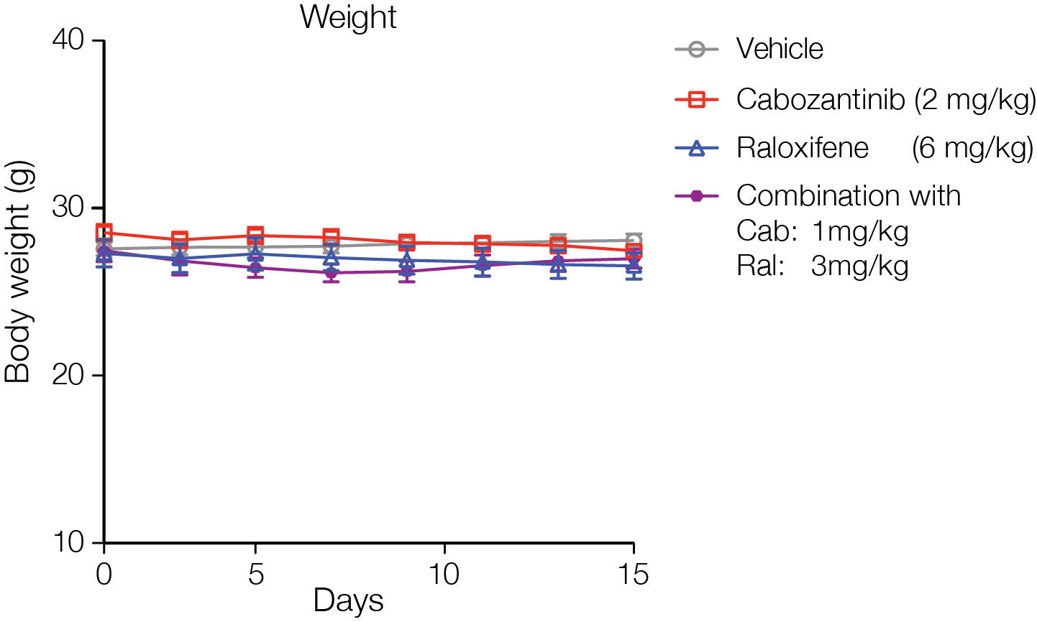

Supplementary Figure S13:
Distribution of DCI values (DCI20 to DCI80) ranging from 20 to 80% of proliferation inhibition (IC₂₀ to IC₈₀) for DC01 to DC10 (additional PDF).

Supplementary Figure S14:
Illustration of two instances in which the estimated IC₅₀ is beyond the maximum concentration tested (indicated with a ‘*’). (A) In the case of cabozantinib in DC06, the IC₅₀ of 15.27 μM is considered to be reliable as it is only slightly larger than the maximum concentration (15 μM) with a low RSE. (B) For trastuzumab in DC09, the IC₅₀ of 176.72 μg/mL is far beyond the highest concentration of 40 μg/mL. The RSE of 0.5 indicates that this estimate is unlikely to be reliable.
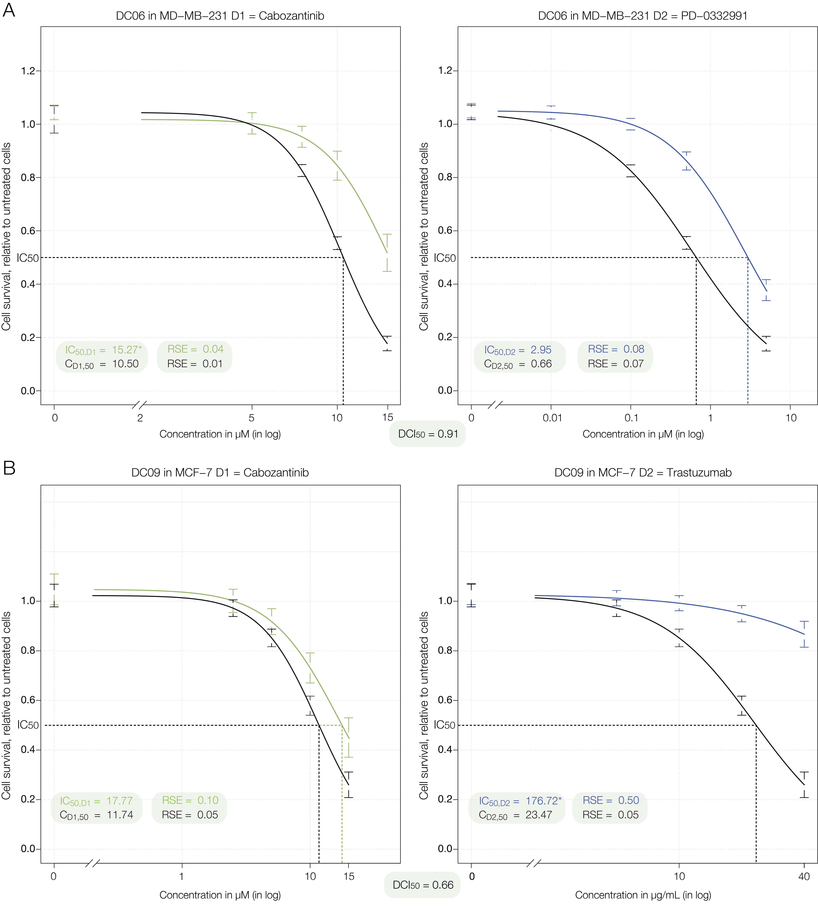

REFERENCES
1. van Meerloo J, Kaspers GJ, Cloos J. Cell sensitivity assays: the MTT assay. Methods Mol Biol 2011;731:237-45.
2. Ritz C, Streibig JC. Bioassay analysis using R. Journal of Statistical Software 2005;12(5).
3. Miller ML, Molinelli EJ, Nair JS, Sheikh T, Samy R, Jing X, et al. Drug synergy screen and network modeling in dedifferentiated liposarcoma identifies CDK4 and IGF1R as synergistic drug targets. Sci Signal 2013;6(294):ra85.
4. Heldring N, Pike A, Andersson S, Matthews J, Cheng G, Hartman J, et al. Estrogen receptors: how do they signal and what are their targets. Physiol Rev 2007;87(3):905-31.
5. Hage C, Rausch V, Giese N, Giese T, Schonsiegel F, Labsch S, et al. The novel c-Met inhibitor cabozantinib overcomes gemcitabine resistance and stem cell signaling in pancreatic cancer. Cell Death Dis 2013;4:e627.
6. Feldmann G, Mishra A, Bisht S, Karikari C, Garrido-Laguna I, Rasheed Z, et al. Cyclin-dependent kinase inhibitor Dinaciclib (SCH727965) inhibits pancreatic cancer growth and progression in murine xenograft models. Cancer Biology & Therapy 2011;12(7):598-609.
7. Yamasaki F, Zhang D, Bartholomeusz C, Sudo T, Hortobagyi GN, Kurisu K, et al. Sensitivity of breast cancer cells to erlotinib depends on cyclin-dependent kinase 2 activity. Molecular Cancer Therapeutics 2007;6(8):2168-77.
8. García-Echeverría C, Pearson MA, Marti A, Meyer T, Mestan J, Zimmermann J, et al. In vivo antitumor activity of NVP-AEW541â€”A novel, potent, and selective inhibitor of the IGF-IR kinase. Cancer Cell 2004;5(3):231-39.
9. Hartog H, Vand Der Graaf WTA, Boezen HM, Wesseling J. Treatment of Breast Cancer Cells by IGF1R Tyrosine Kinase Inhibitor Combined with Conventional Systemic Drugs. Anticancer Research 2012;32(4):1309-18.
10. Lu Y, Zi X, Zhao Y, Mascarenhas D, Pollak M. Insulin-Like Growth Factor-I Receptor Signaling and Resistance to Trastuzumab (Herceptin). Journal of the National Cancer Institute 2001;93(24):1852-57.
11. Barok M, Isola J, Palyi-Krekk Z, Nagy P, Juhasz I, Vereb G, et al. Trastuzumab causes antibody-dependent cellular cytotoxicity-mediated growth inhibition of submacroscopic JIMT-1 breast cancer xenografts despite intrinsic drug resistance. Mol Cancer Ther 2007;6(7):2065-72.
12. Shattuck DL, Miller JK, Carraway KL, Sweeney C. Met Receptor Contributes to Trastuzumab Resistance of Her2-Overexpressing Breast Cancer Cells. Cancer Research 2008;68(5):1471-77.
13. Wang Z, Goulet R, Stanton KJ, Sadaria M, Nakshatri H. Differential Effect of Anti-apoptotic Genes Bcl-xL and c-FLIP on Sensitivity of MCF-7 Breast Cancer Cells to Paclitaxel and Docetaxel. Anticancer Research 2005;25(3C):2367-79.
14. Tabuchi Y, Matsuoka J, Gunduz M, Imada T, Ono R, Ito M, et al. Resistance to paclitaxel therapy is related with Bcl-2 expression through an estrogen receptor mediated pathway in breast cancer. Int J Oncol 2009;34(2):313-9.
15. Tenzer A, Zingg D, Rocha S, Hemmings B, Fabbro D, Glanzmann C, et al. The Phosphatidylinositide 3â€²-Kinase/Akt Survival Pathway Is a Target for the Anticancer and Radiosensitizing Agent PKC412, an Inhibitor of Protein Kinase C. Cancer Research 2001;61(22):8203-10.
16. Hastak K, Alli E, Ford JM. Synergistic Chemosensitivity of Triple-Negative Breast Cancer Cell Lines to Poly(ADP-Ribose) Polymerase Inhibition, Gemcitabine, and Cisplatin. Cancer Research 2010;70(20):7970-80.
17. Min A, Im S-A, Yoon Y-K, Song S-H, Nam H-J, Hur H-S, et al. RAD51C-deficient cancer cells are highly sensitive to the poly (ADP-ribose) polymerase inhibitor, olaparib. Molecular Cancer Therapeutics 2012.
18. Minami D, Takigawa N, Takeda H, Takata M, Ochi N, Ichihara E, et al. Synergistic Effect of Olaparib with Combination of Cisplatin on PTEN-Deficient Lung Cancer Cells. Molecular Cancer Research 2012;11(2):140-48.
19. Liu F, Korc M. Cdk4/6 Inhibition Induces Epithelialâ€“Mesenchymal Transition and Enhances Invasiveness in Pancreatic Cancer Cells. Molecular Cancer Therapeutics 2012;11(10):2138-48.
20. Finn RS, Dering J, Conklin D, Kalous O, Cohen DJ, Desai AJ, et al. PD 0332991, a selective cyclin D kinase 4/6 inhibitor, preferentially inhibits proliferation of luminal estrogen receptor-positive human breast cancer cell lines in vitro. Breast cancer research : BCR 2009;11(5):R77.
21. Fryar EB, Das JR, Davis JH, Desoto JA, Laniyan I, Southerland WM, et al. Raloxifene Attenuation of 5-FU/Methotrexate Cytotoxicity in Human Breast Cancer Cells: The Importance of Sequence in Combination Chemotherapy. Anticancer Research 2006;26(3A):1861-67.
22. Liu H, Lee ES, Gajdos C, Pearce ST, Chen B, Osipo C, et al. Apoptotic action of 17beta-estradiol in raloxifene-resistant MCF-7 cells in vitro and in vivo. J Natl Cancer Inst 2003;95(21):1586-97.
23. Guo W, Reigan P, Siegel D, Zirrolli J, Gustafson D, Ross D. Formation of 17-Allylamino-Demethoxygeldanamycin (17-AAG) Hydroquinone by NAD(P)H:Quinone Oxidoreductase 1: Role of 17-AAG Hydroquinone in Heat Shock Protein 90 Inhibition. Cancer Research 2005;65(21):10006-15.
24. Raja SM, Clubb RJ, Bhattacharyya M, Dimri M, Cheng H, Pan W, et al. A combination of Trastuzumab and 17-AAG induces enhanced ubiquitinylation and lysosomal pathway-dependent ErbB2 degradation and cytotoxicity in ErbB2-overexpressing breast cancer cells. Cancer Biology & Therapy 2008;7(10):1630-40.
25. Chou TC. Theoretical basis, experimental design, and computerized simulation of synergism and antagonism in drug combination studies. Pharmacological reviews 2006;58(3):621-81.

