Integrating Models to Quantify Environment-Mediated Drug Resistance

Noemi Picco, Erik Sahai, Philip K. Maini, Alexander R. A. Anderson

Supplemental Materials and Methods

Analytical solution of ODE model
All parameter estimation routines involve data fitting to the analytical solution of the relevant set of ODEs (Table 1).

Parameter Estimation with Approximate Bayesian Computation
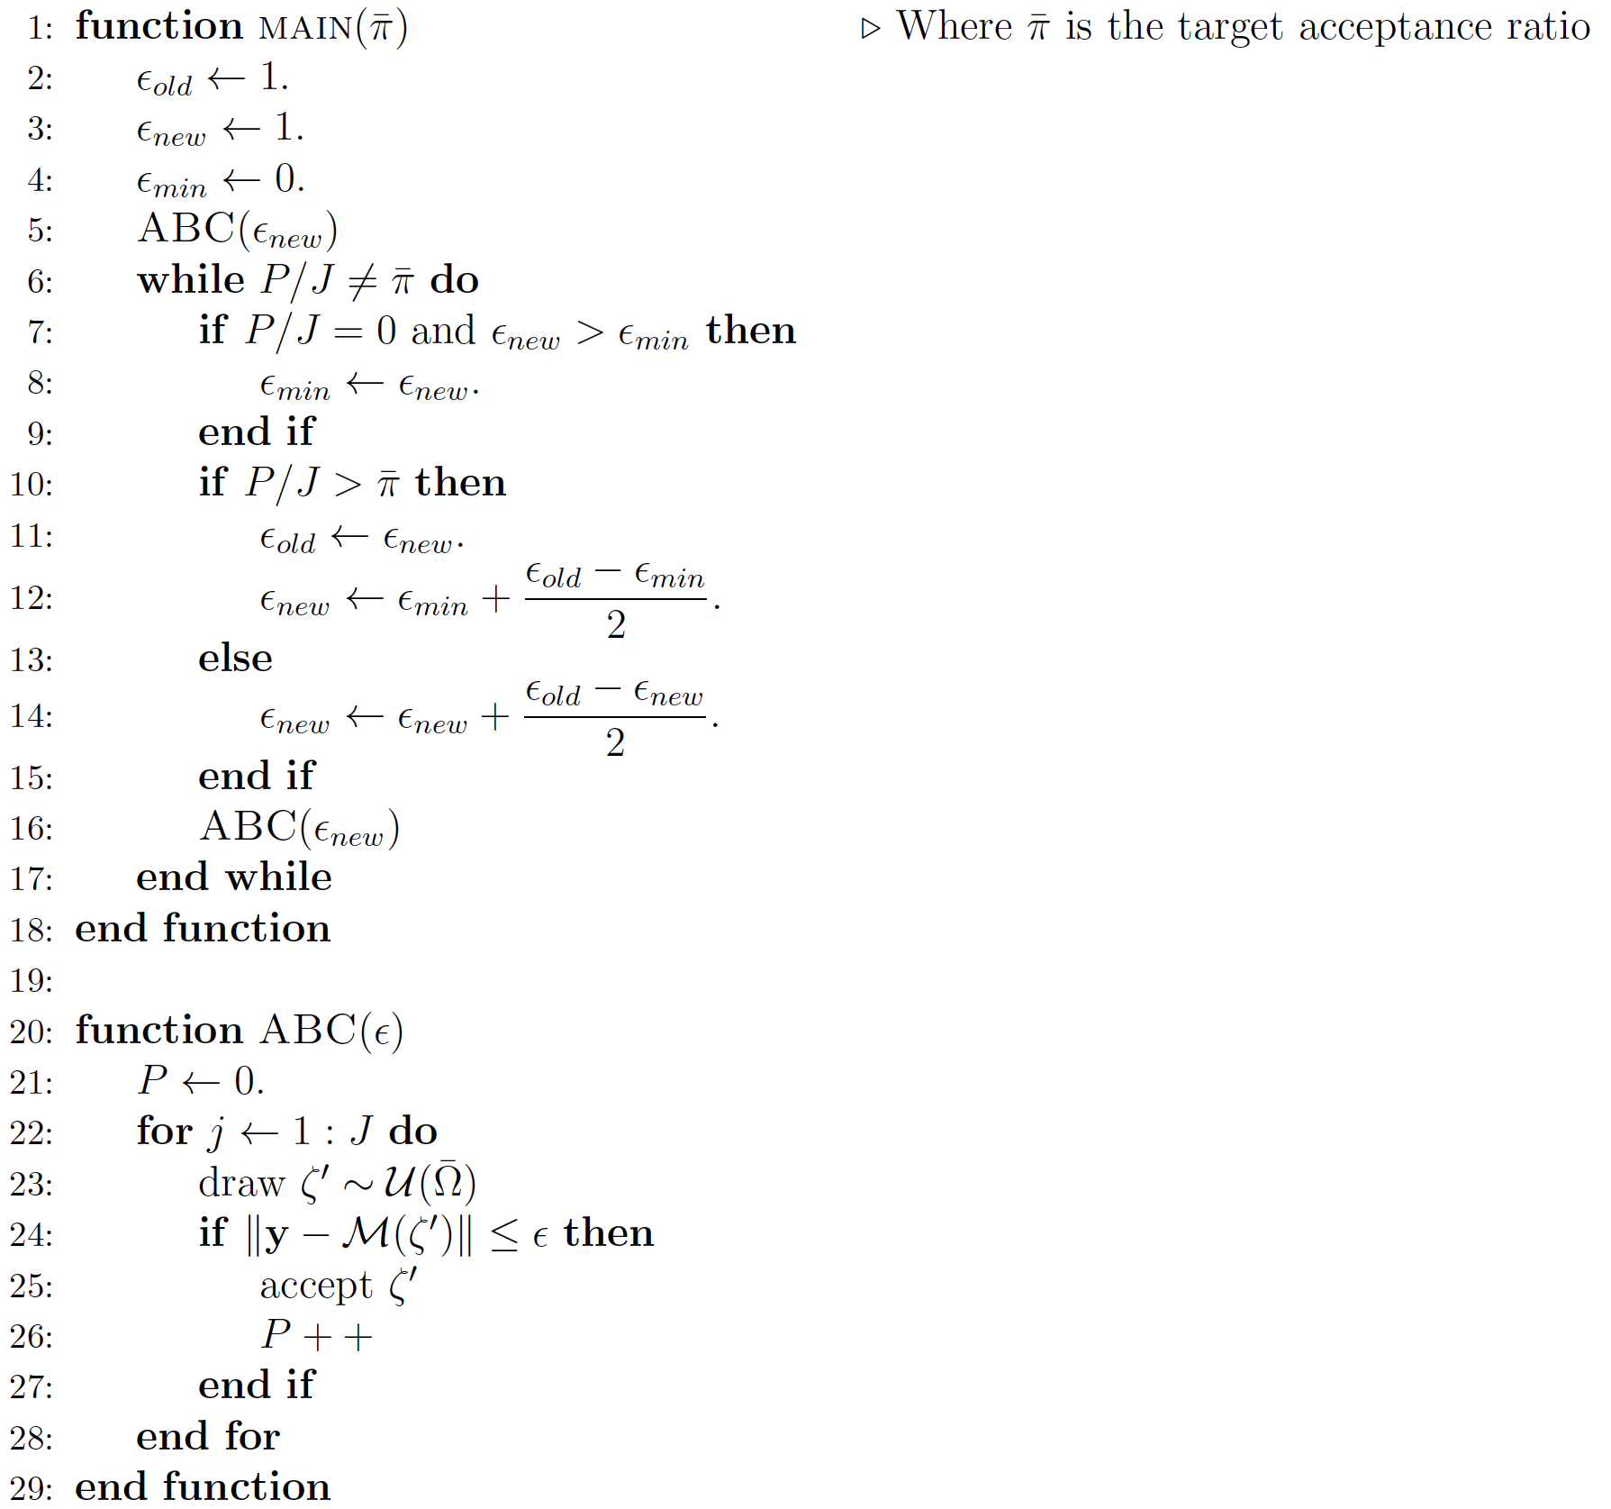
Let $y⊂R_{>0}^{N}$ be a dataset of $N$ temporal observations and $M=M(ζ )$ a model that we chose to explain the observed data, where $ζ$ is the vector of model parameters, taking values in $Ω⊂R^{q}$. We want to estimate values of parameters $ζ$ that best explain the data $y$, with the given model $M$. The Approximate Bayesian Computation (ABC) rejection algorithm allows us to build a discrete approximation of the posterior distribution of $ζ$. Specifically, the algorithm iteratively draws a proposed q-tuple of values for $ζ$ from a uniform prior on some region $\overline{Ω}⊂Ω$. If the model, simulated with the proposed parameter set, falls close to the data within tolerance $ε$, the q-tuple is accepted, otherwise rejected. The collection of all accepted q-tuples constitutes an approximation of the posterior distribution. We chose the sum of squared distances as distance metric, and the temporal sequence of tumor size ($S\left(t\right)+R(t)$) as summary statistic for $M$. The smaller the tolerance $ε$, the more reliable is the approximated posterior distribution. However, too small an $ε$ will result in zero acceptance ratio (defined as number of accepted q-tuples over J). The value of $ε$ giving satisfying results has to be tweaked for every set of data and model. In order to obtain consistent results across estimates, we fix the desired acceptance ratio to $\overline{π}= 0.0002$, and iteratively run the ABC rejection algorithm with increased or decreased $ε$, until the targeted acceptance ratio is reached.
The pseudo-algorithm reads as follows.

Note that for each experimental condition the in vitro data consist of three replicates. We obtained one estimate that best fits all of the replicates at the same time (i.e. in the algorithm the norm-2 is calculated on the vector of concatenated data of length $3N$). On the other hand, in vivo replicates display significant qualitative and quantitative variability. Therefore, the estimation routine for these data is run individually for each mouse replicate, obtaining the set of estimates reported in Table 2.

Simulation of ODE model

Solutions of the ODE systems are obtained using Matlab routine ode45.

