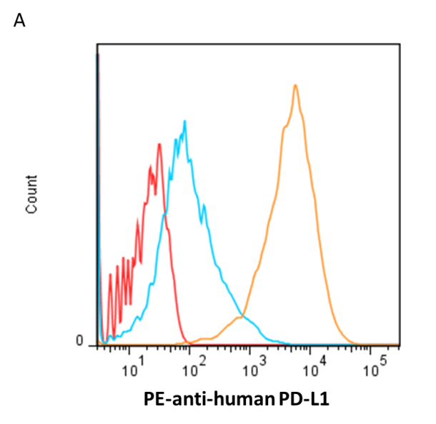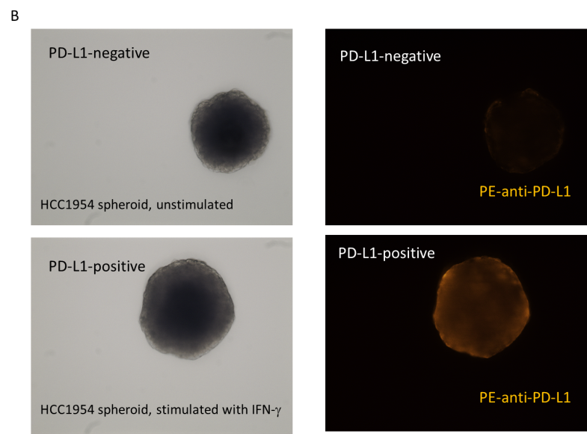

Fig. S8. Upregulation of PD-L1on HCC1954 cells by IFN-γ. (A) HCC1954 cells were stimulated with IFN-γ (20 ng/mL) for 48 h and stained with PE-conjugated anti-human PD-L1 (orange histogram). Unstimulated HCC1954 cells were stained with PE-conjugated anti-human PD-L1 (blue histogram) or PE-conjugated isotype control. (B) Prominent staining of PD-L1 was observed in HCC1954 spheroids following IFN-γ stimulation, with phase-contrast and immunofluorescence images shown in the left and right columns, respectively.

