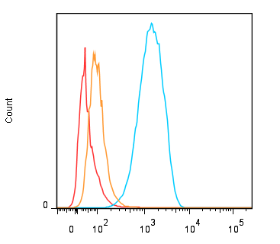
PE-anti-PD-L1
MDA-MB-231
BxPC3
NCI-N87
Cell line | Geometric Mean FI
 | - | PE-Isotype control | PE-anti-PD-L1
MDA-MB-231 | 65 | 65; 65 | 1239; 1259
BxPC-3 | 17 | 21; 23 | 91; 94
MCI-N87 | 11 | 16; 16 | 42; 43

Fig. S7. Expression of PD-L1 on MDA-MB-231, BxPC-3 and NCI-M87, as determined by flow cytometry.

