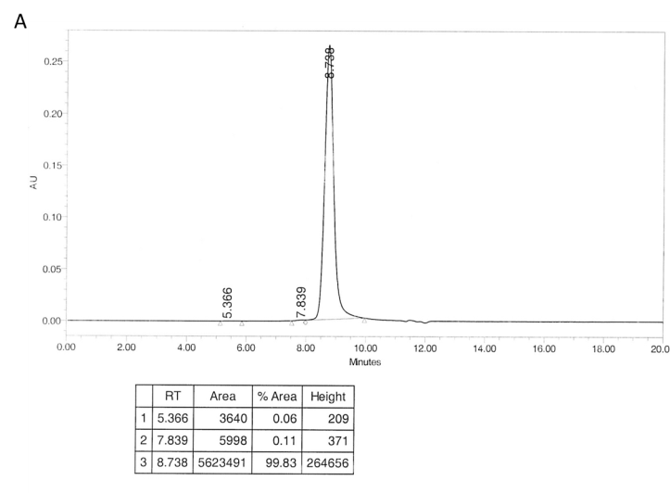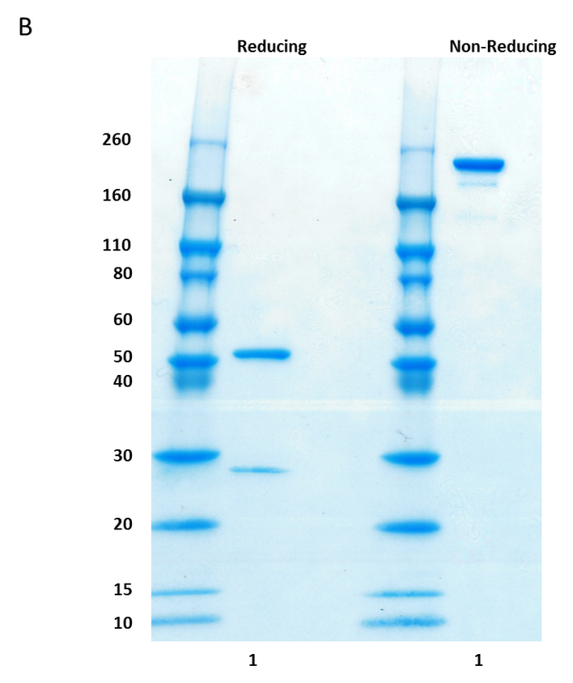
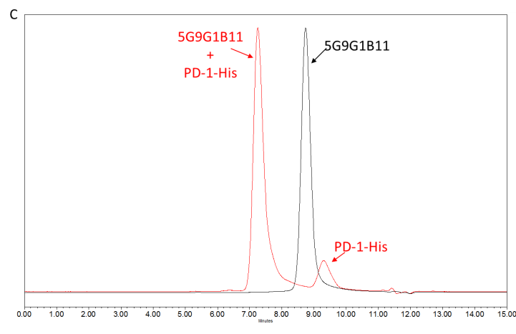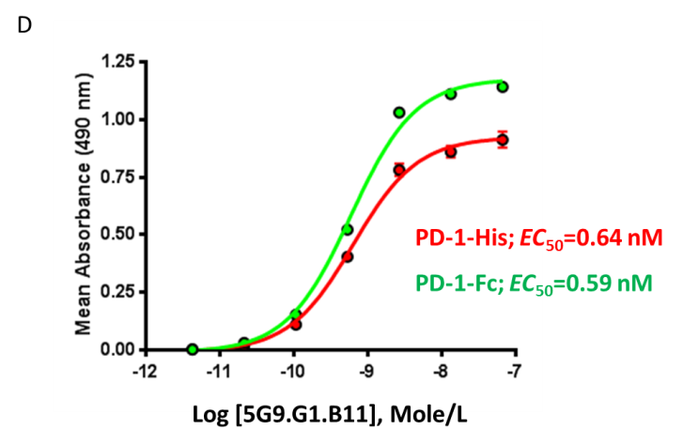
Fig. S1. Biochemical characterization of 5G9.G1.B11. (A) SE-HPLC analysis; (B) SDS-PAGE analysis; (C) reactivity with human PD-1-His by SE-HPLC; (D) binding affinity to human PD-1-His or human PD-1-Fc by ELISA.

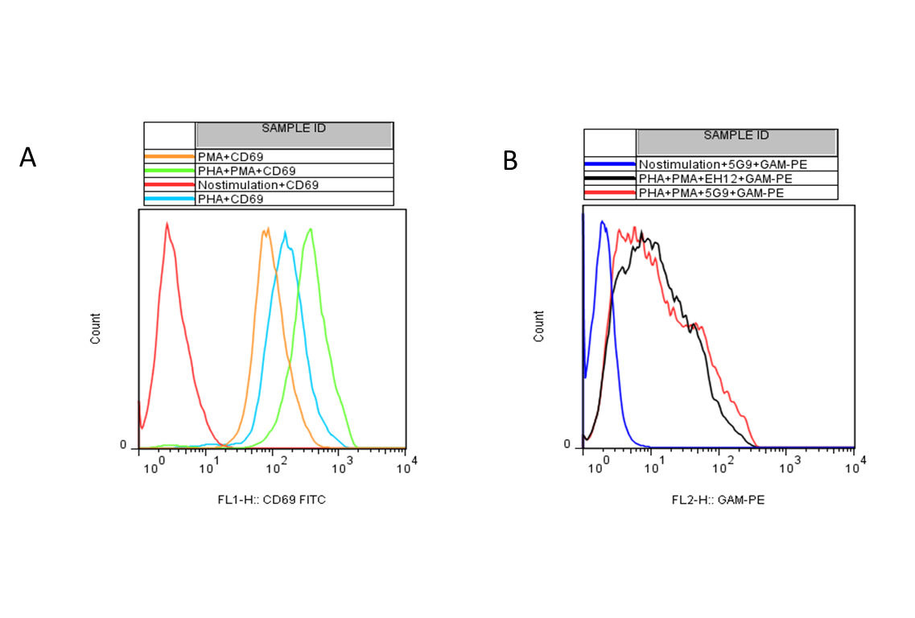
Fig. S2. Binding of 5G9.G1.B11 to native PD-1. Jurkat cells (5 x 10⁵/mL, 5 mL) in T-25 flasks were stimulated with phytohaemagglutinin (PHA;1 μg/mL), phorbol myristate acetate (PMA; 50 ng/mL) or both, for 48 h, stained with anti-CD69 and anti-PD-1 antibodies, and analyzed by flow cytometry. (A) The increased expression of the early T-cell activation marker CD69 was shown for Jurkat cells stimulated with PMA (orange histogram), PHA (blue histogram) and both (green histogram). (B) Binding of PD-1 on Jurkat cells stimulated with both PMA and PHA was shown for 5G9.G1.B11 and a commercial anti-PD-1 (EH12) to a similar extent.

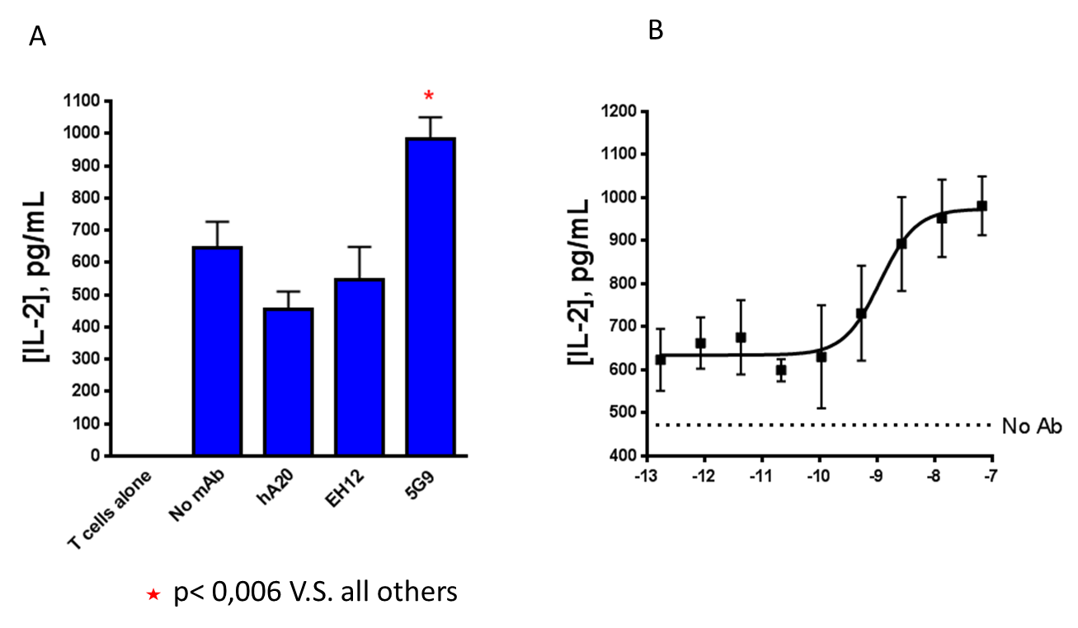
* P<0.006 vs. the three controls (No mAb, hA20, and EH12)
Fig. S3. Blocking activities of 5G9.G1.B11. Dendritic cells (DCs) and T cells from different donors were co-cultured with and without 5G9.G1.B11 in a mixed lymphocyte reaction. (A) 5G9.G1.B11 enhanced IL-2 secretion over the three controls (P< 0.006). (B) The increase of IL-2 by 5G9.G1.B11 was dose-dependent.

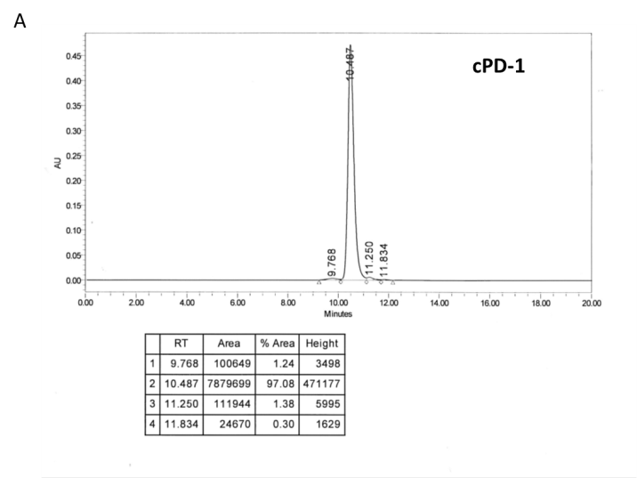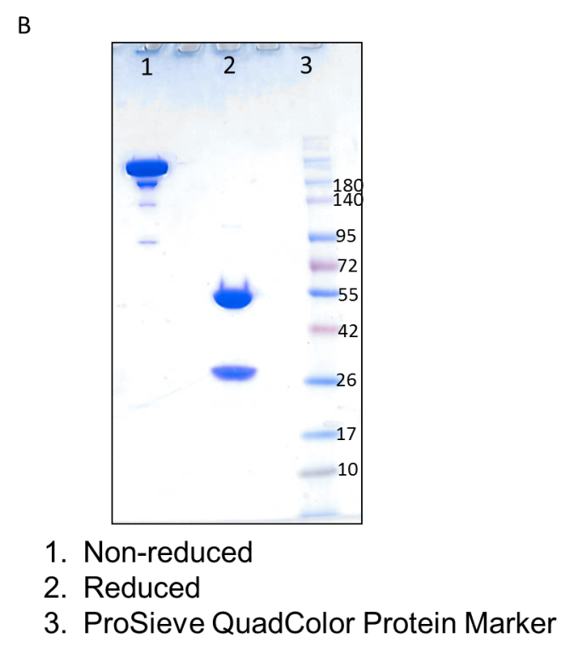
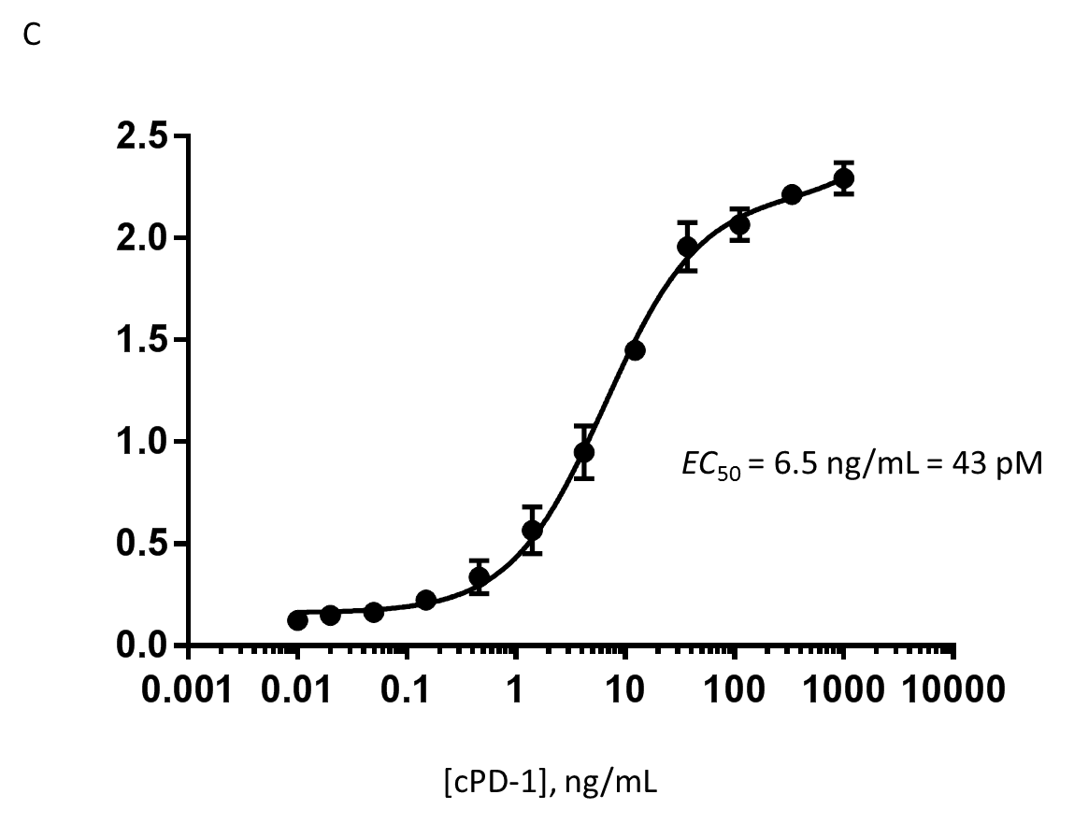

OD490

Fig. S4. Biochemical characterization of cPD-1. (A) SE-HPLC analysis; (B) SDS-PAGE analysis; (C) binding to human PD-1-His by ELISA.

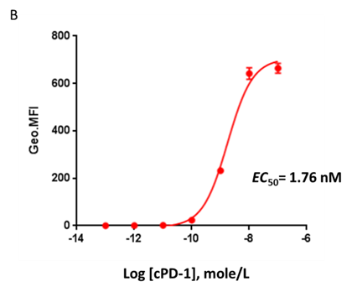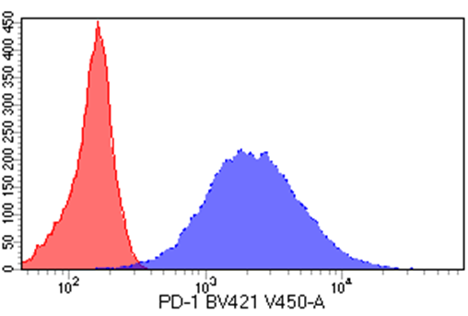
B
A
count
Fig. S5. Binding of cPD-1 to SpESF-X10-2D1 cells transfected to overexpress human PD-1. (A) Affinity of cPD-1 for human PD-1 on the surface of SpESF-X10-2D1; (B) Expression of human PD-1 on SpESF-X10-2D1.

