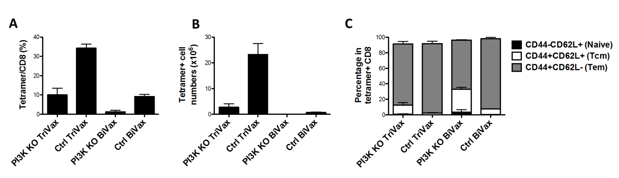
Supplemental Figure 6: WT type and PI3K-δ KO mice were injected with BiVax or TriVax vaccines. (BiVax: peptide + poly-IC, TriVax: peptide + anti-CD40 mAb + poly-IC). The composition of splenic tetramer positive CD8+ T-cells was assessed after 7 days of the injection.
- The percentage of tetramer positive CD8+ T- cells in PI3K-δ KO mice was significantly lower than WT mice
- The number of tetramer positive CD8+ T-cells in PI3K-δ KO mice was significantly lower than WT mice
- The percentages of naïve and T_{CM} CD8+ T-cells were significantly higher in PI3K-δ KO mice when compared to WT mice, while the percentage of T_{EM} and terminally differentiated cells was significantly lower.

