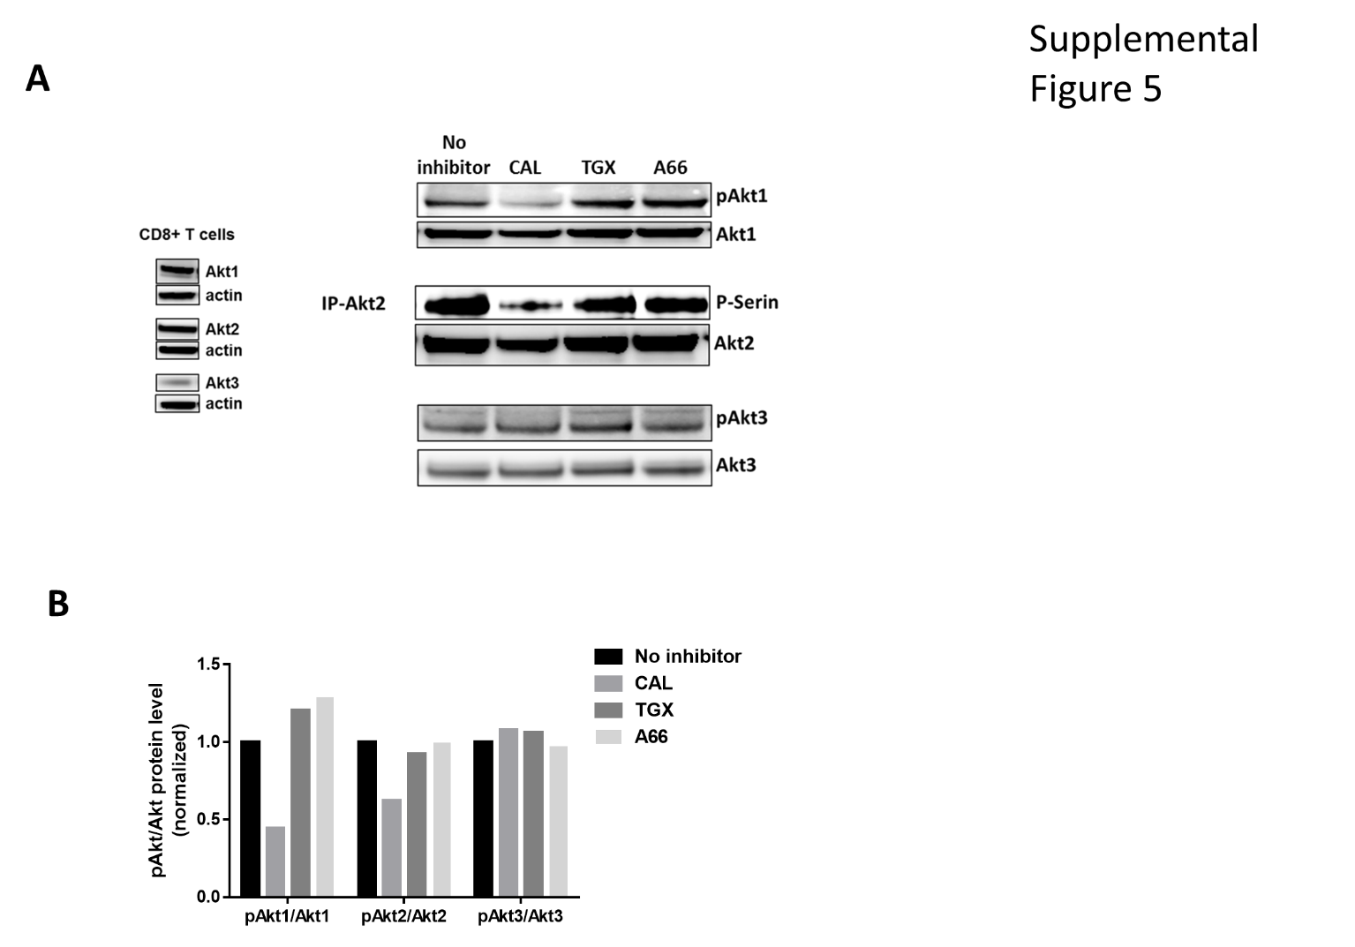
Supplemental Figure 5: PI3K-δ controls the differentiation of CD8 T-cells through the downstream Akt1 and Akt2. FACS sorted CD8 T-cells from WT mice were activated in the presence or absence of A66 (288nM), TGX-221 (45nM) or CAL-101(202.5nM). The expression level of Akt1, Akt2 and Akt3 and the phosphorylation of these isoforms was assessed after three days of activation.
- The phosphorylation of Akt1 and Akt2 was significantly reduced in the presence of PI3K-δ inhibitor, however the inhibition of PI3K-α or PI3K-β had no effect. Akt3 phosphorylation was not affected by the presence of any of the inhibitors.
- Densitometry of phosphorylated Akt isoform levels to the total Akt isoform ratio showed significantly lower levels of Akt1 and Akt 2 in the presence of PI3K-δ inhibitor. Densitometry was performed on the gel in A.

