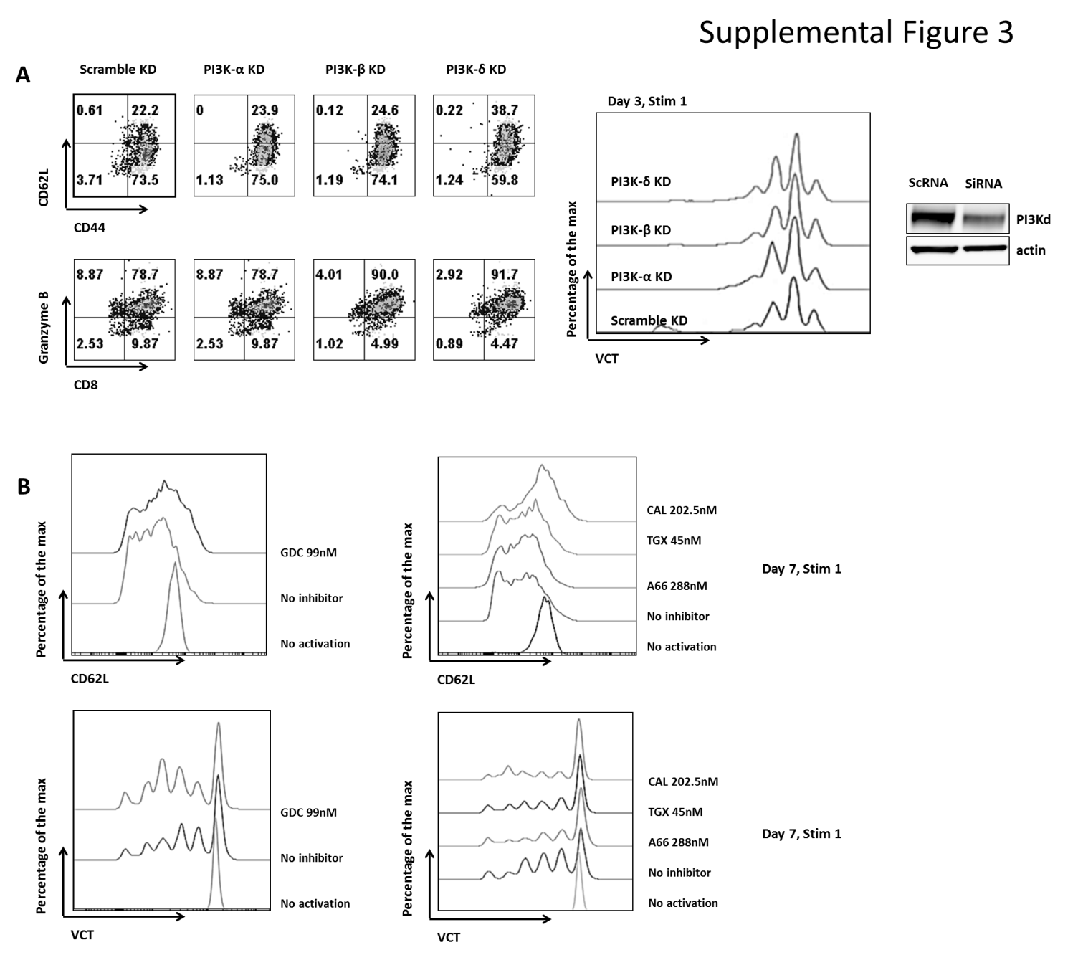
Supplemental Figure 3:
- Individual PI3K isoforms were knocked down (KD) in CD8+ T-Cells using siRNA. Reagents were purchased from GE Dharmacon (Lafayette) and the experiments performed according to the manufacturer’s instructions. CD8+ T-cells were enriched and activated as described in Accell siRNA Delivery Media, 1.5μM Accell siRNA (SC RNA (scramble), P110α, P110β or, P110δ) were added on day 1 of activation. Equal volume of T-cell media with 10% FBS was added on day 2. Cell phenotype, proliferation and Granzyme B production were assessed on Day 3.
Similar to the effect of the inhibitors, KD of PI3K-δ maintained a higher percentage of central memory CD8+ T-cells when compared to the control and to the data from KD other isoforms (top left panel). Very little effect was observed on the proliferation (middle panel) and on Granzyme B production (lower left panel) when any of the isoforms were silenced. Far right panel confirms that the P110δ siRNA knocked down the delta isoform in CD8+ T cells.
- Purified human CD8+ T-cells were activated with plate bound anti-CD3 (0.1μg/ml) and soluble anti-CD28 (0.1μg/ml) antibodies, with or without PI3K inhibitors. GDC was used at 99nM, A66 at 288nM, TGX at 45nM and CAL101 at 202.5nM. Cells were harvested on Day 7 after activation.
The left panel shows the pan inhibition of PI3K using GDC. There is a marked preservation of a high expression level of CD62L in comparison to the untreated cells. GDC did not affect the proliferation of CD8+ T-cells.
The right panel demonstrates the effect of specific isoform inhibition, and clearly shows that the inhibition of PI3K-δ using CAL101 preserves a high level of CD62L following activation. Proliferation was not affected by the inhibitors.

