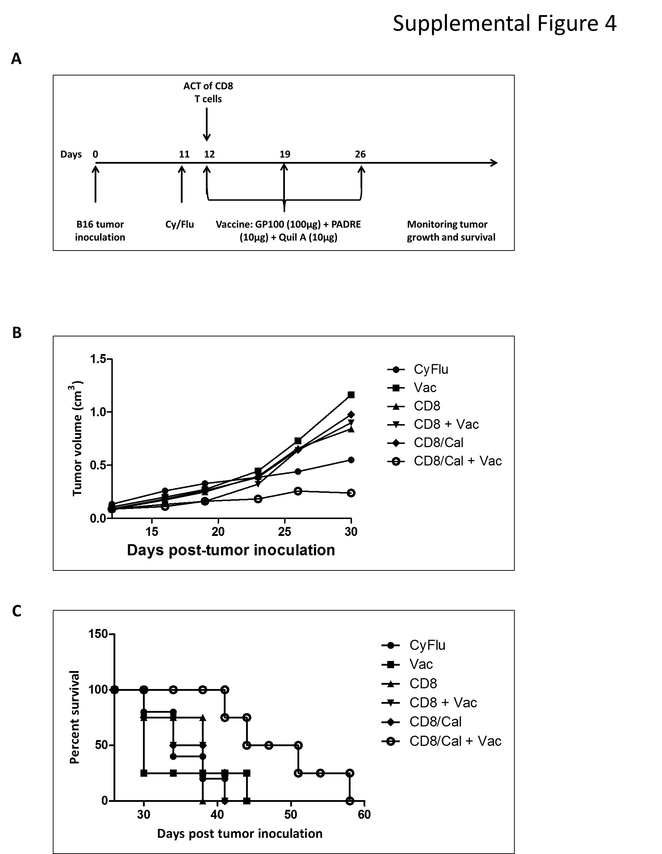
Supplemental Figure 4: The inhibition of PI3K-δ in CD8+ T-cells significantly enhances their anti-tumor therapeutic ability in vivo. Mice were implanted with B16 in the right flank on day 0. On day 11, mice were lymphodepleted with CyFlu and on Day 12, 1 million CD8+ T-cells from pMel-1 mice cultured in the presence or absence of CAL-101 were adoptively transferred. The appropriate groups were vaccinated with gp100/PADRE/Quil A vaccine on day 12, 19 and 26. Animal survival and tumor growth was monitored. Vac-vaccine (n=4), CyFlu-cycophosphamide/fludarabine (n=5), CyFlu + Vac - cycophosphamide/fludarabine + Vaccine (n=4), CD8- ACT of non-treated CD8 (n=4), CD8 + Vac –ACT of non-treated CD8 + vaccine (n=4), CD8/Cal-ACT of CD8+ Treated with CAL-101 (n=4), CD8/Cal + Vac- ACT of CD8+ Treated with CAL-101 + Vaccine (n=4). All mice that received ACT were lymphodepleted with Cy/Flu.
- Treatment Schedule
- Mean tumor volume for different groups. The combination of ACT of CAL-101 treated cells with the vaccine slowed down tumor growth.
- The Kaplan-Meier plot depicts overall survival. The combination of ACT of CAL-101 treated cells with the vaccine significantly prolonged survival.

