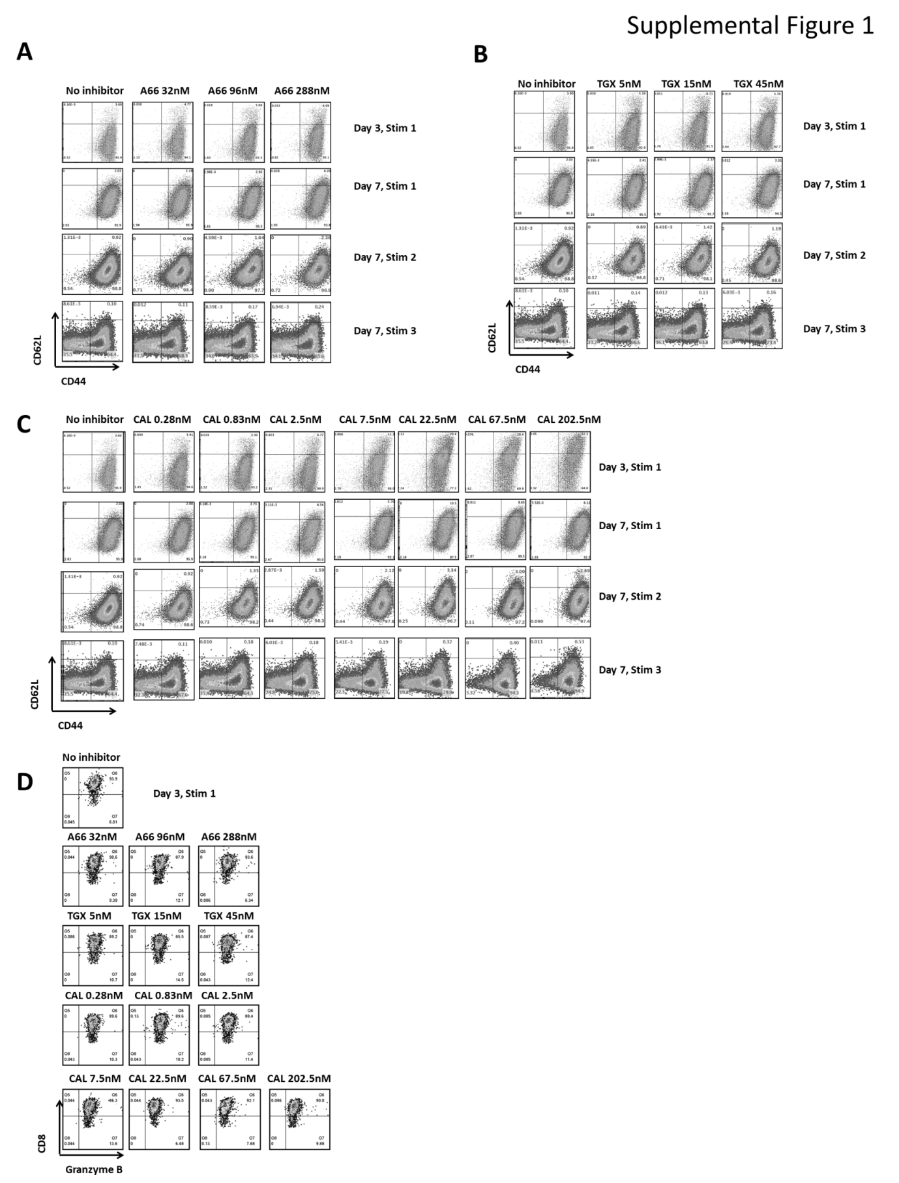
Supplemental Figure 1: PI3K-δ, but not PI3K-α or PI3K-β inhibition preserves the memory phenotype. Non-fractionated splenocytes from pMel-1 mice were activated with gp100₂₅₋₃₃ peptide (1µM) in the presence or absence of A66 (32, 96 and 288nM), TGX-221 (5, 15 and 45nM) or CAL-101(0,28, 0.83, 2.5, 7.5, 22.5, 67.5 or 202.5nM). The gated cells were viable (7AAD-) CD8+Vβ13+.
- PI3K-α inhibition does not affect the CD8+ T-cell phenotype at all the tested concentrations.
- PI3K-β inhibition does not affect the CD8+ T-cell phenotype at all the tested concentrations.
- PI3K-δ inhibition preserves the memory phenotype in a concentration dependent manner.
- The ability of CD8+ T-cells to produce Granzyme B was not affected by the inhibition of any of the PI3K isoforms at any concentration.

