Multifunctional Telodendrimer Nanocarriers Restore Synergy of Bortezomib and Doxorubicin in Ovarian Cancer Treatment
Lili Wang^{1*}, Changying Shi^{1*}, Forrest A. Wright¹, Dandan Guo¹, Xu Wang¹, Dongliang Wang², Richard J.H. Wojcikiewicz^{1,3}, and Juntao Luo^{1,3}
¹Department of Pharmacology, State University of New York Upstate Medical University
²Department of Public Health and Preventive Medicine, State University of New York Upstate Medical University
³Upstate Cancer Center, State University of New York Upstate Medical University
* L. Wang and C. Shi are the co-first authors of this study.

Table of contents
Materials and methods 3
Materials 3
Spectroscopic characterization 3
Telodendrimer synthesis 4
BTZ-telodendrimer formation and dual-drug loading 4
Figure S1.. 6
Figure S2. 7
Figure S3.. 8
Figure S4.. 9
Figure S5.. 10
Figure S6. 11
Figure S7.. 12
Figure S8. 13
Figure S9. 14
Figure S10. 15
Figure S11.. 16
Figure S12.. 17
Figure S13. 18
Figure S14. 19
Figure S15.. 20
Figure S16.. 20
Figure S17. 21
Figure S18.. 22
Figure S19. 23
Figure S20. 24
Figure S21. 25
Figure S22. 25
Figure S23. 26
Figure S24.. 28
Table S1.. 27
Table S2.. 28
References.. 28

Materials and Methods
Materials
All chemicals were used as received. Monomethyl-terminated poly (ethylene glycol) amino (MeO-PEG-NH₂, M_{w} ~5 kDa) was ordered from JenKem Technology USA Inc. (Allen, TX). (Fmoc)-Lys(Boc)-OH, (Fmoc)-Lys(Fmoc)-OH, trifluoroacetic acid (TFA) and chlorogenic acid (ChA) were obtained from Chem-Impex International, Inc. (Wood Dale, IL). 3, 4-Dihydroxycinnamic acid (Caffeic acid, CaA), N,N'-diisopropylcarbodiimide (DIC), N-hydroxybenzotriazole (HOBt) and N,N-dimethylformamide, anhydrous (DMF, 99.8%) were received from Acros Organics (Belglum, NJ). N-hydroxysuccinimide (NHS), gluconic acid (GA), triethylamine (TEA) and all other chemicals were purchased from Sigma-Aldrich (St. Louis, MO). Tetrazolium compound [3-(4,5-dimethylthiazol-2-yl)-5-(3-carboxymethoxyphenyl)-2-(4-sulfophenyl)-2H-tetrazolium, MTS] and phenazine methosulfate were purchased from Promega (Madison, WI). Lipophilic fluorescent dye, 1,1'-Dioctadecyl-3,3,3',3'-tetramethylindodicarbocyanine perchlorate (DiD), was purchased from AAT Bioquest, Inc. (Sunnyvale, CA). Doxorubicin hydrochloride (DOX·HCl), bortezomib and rhein were ordered from AvaChem Scientific LLC (San Antonio, TX). Velcade® (Millennium Pharmaceuticals, Inc., Cambridge, MA) and Doxil® (ALZA Corporation, Bedford, OH) were obtained from the Regional Oncology Center Pharmacy, SUNY Upstate Medical University.
Spectroscopic characterization
¹H NMR spectra were recorded on a 600 MHz Bruker AVANCE NMR spectrometer. Matrix-assisted laser desorption/ionization time-of-flight mass spectrometry (MALDI-TOF MS) spectra were collected on a Bruker Autoflex III system equipped with a Smart beam II laser source. Spectra were acquired in positive, linear mode for co-delivery polymers and positive, reflector mode for model reaction compounds. Samples were prepared by depositing 1 µL aliquots of a premixed solution of sample and matrix (α-Cyano-4-hydroxycinnamic acid for small molecules and 2,5-dihydroxybenzoic acid for polymers) onto a MTP 384 target plate, polished steel TF (Bruker). Transmission electron microscopy (TEM) characterization of nanoparticle was performed on JEOL JEM-2100 HR operated at 200 kV. Samples were prepared by applying aliquots of a nanoparticle solution on a glow discharged carbon-coated copper grids (CF300-CU, 300 mesh, Electron Microscopy Sciences). Negative staining was achieved using uranyl acetate solution (1%). The hydrodynamic sizes of nanoparticles were acquired by dynamic light scattering (DLS) using particle analyzer (Microtrac) equipped with equipped with 780 nm laser diode. Each apparent hydrodynamic size reported is an average of three measurements.

Telodendrimer synthesis
In a typical procedure, telodendrimer synthesis was initiated from methoxy-terminated amino PEG, MeO-PEG-NH₂ (M_{w} = ~5 kDa). N-terminal-protected lysine ((Fmoc)-Lys(Fmoc)-OH or (Fmoc)-Lys(Boc)-OH)) was used to synthesize the branched scaffold of polylysine dendrons using HOBt/DIC as coupling reagents in anhydrous DMF at room temperature. All the reagents are in 3 equiv. stoichiometric excess relative to the primary amine. The completion of the reaction was indicated by the ninhydrin tests, through which the presence or consumption of primary amine yield purple blue (positive) or yellow (negative) color. Fmoc-protecting group was removed by the treatment with 20% 4-methylpiperidine in DMF for 30 min. Boc-protecting group was deprotected in the presence of TFA/DCM (50/50, v/v) for 30 min. The carboxylate group of rhein was activated by NHS (1.1 equiv.)/DIC (1.1 equiv.) and was conjugated at the periphery of polylysine dendrons in the presence of TEA. At last step, BTZ-conjugating molecules (GA, CaA and ChA) were activated using NHS/DIC prior to the attachment to polylysine at intermediate layer. All polymer products were isolated and purified by precipitation in chilled ethyl ether and washed for 3 times. The resulting co-delivery telodendrimers were further purified by dialysis (MWCO 3500) against water followed by lyophilization to give products as powder.

BTZ-telodendrimer formation and dual-drug loading
The BTZ-polymer conjugate was obtained by incubating BTZ at a concentration of 20 mg/mL with cis-diol/catechol-containing polymers at a concentration of 200 mg/mL at 37 °C for 18 h. Subsequently, BTZ-polymer conjugate in DMSO was dialyzed against H₂O for 6 h to remove DMSO solvent and free BTZ residue. The resulting BTZ-polymer prodrug was obtained by lyophilization and stored at -20 °C for further use and the amount of BTZ was quantified using 1H NMR method. The BTZ conversion test in prodrug formation was conducted using ultrafiltration method (Millipore, Amicon Ultra-0.5mL, Ultracel 3.5k). At predetermined time points, 2 µL reaction mixture was withdrawn and diluted with 98 µL PBS. The sampled solutions were placed in microcentrifuge tubes and unreacted BTZ was isolated by spinning the device at 13,000 × g for 15 min. The amount of unreacted BTZ was then analyzed by measuring the UV-Vis absorbance of filtrate at 270 nm using Nanodrop 2000c spectrometer (Thermo Scientific).
BTZ-telodendrimer prodrug, telodendrimer and DOX were prepared separately to produce dual-drug loaded nanocarrier (denoted as NP(BTZ-DOX)) at different drug ratios (BTZ/DOX=1:1, or 1:4, or 1:10, w/w). Typically, 1 mg DOX•HCl was initially dissolved in 900 µL chloroform, 90 µL methanol and 10 µL triethylamine. Appropriate amounts of BTZ-telodendrimer prodrug and telodendrimers were dissolved in CHCl₃ individually. The solutions were mixed together in a 10 mL round flask followed by removal of the solvent to give a homogeneous polymer coating on the flask wall, which was further dried under vacuum for 30 min to remove traces of organic solvents. Then, the polymer film was hydrated with 1 mL PBS followed by sonication to obtain well dispersed nanoparticle solutions. The amount of DOX loaded in the nanoparticle was quantified using fluorescence method by comparing fluorescence intensity of solution before and after being centrifuged at 13,000 × g for 15 min (ex/em=488/590 nm). The drug loading content (DLC%) and drug loading efficiency (DLE%) were calculated as follows:
DLC% = (weight of drug loaded in micelle/total weight of drug-loaded micelle) × 100%
DLE% = (weight of drug in micelle/weight of drug in feed) × 100%

Figure S1. Representative stacked ¹H NMR spectra of BTZ, BTZ-ChA conjugate and ChA, recorded at 600 MHz in DMSO-d₆.

Figure S2. A, Fluorecent profiles of AR-BTZ complex with increasing concentration of BTZ (5×10⁻⁴-1.6×10⁻² M), excitation λ = 490 nm. B, Linear fit of the Benesi-Hildebrand equation for the determination of association constant for AR-BTZ complex (K_{eq[AR-BTZ]}) (1). The K_{eq[AR-BTZ]} is the quotient of the intercept and the slop in a plot of 1/∆RFU vs. 1/[BTZ], while points were obtained from data in (A). C, Representative spectra showing the titration of ChA into a solution of AR (8×10⁻⁵ M) and BTZ (4×10⁻⁴ M). Fluorescence decreases in response to the addition of ChA (0-0.08 M) in DMSO. D-F, Linear fit for the determination of association constant (1, 2). [Diol] is the concentration of target diol used for titrating AR-BTZ solution. P= [BTZ]-1/QK_{eq[AR-BTZ]}-[AR]/(Q+1); Q=Free [AR]/complexed [AR]. Slope of the fitted curve equals to K_{eq[AR-BTZ]/}K_{eq}, where K_{eq} is the association constant of diol and BTZ. The K_{eq} values of diols with BTZ in DMSO were calculated to be 370, 290, and 34 M⁻¹ for ChA, GA and CaA, respectively.

Figure S3. The synthetic schemes of telodendrimer, PEG^{5k}ChA₄-Rh₄, starting from MeO-PEG-NH₂ (~5 kDa). Other two co-codelivery polymers, PEG^{5k}GA₄-Rh₄ and PEG^{5k}CaA₄-Rh₄, were synthesized following the same route by instead attaching gluconic acid (GA) and caffeic acid (CaA) at the final step.
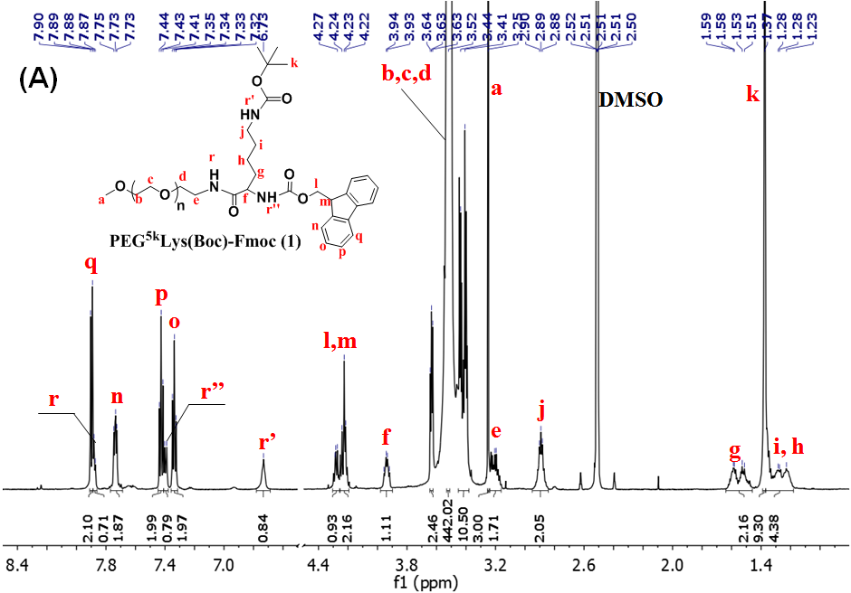
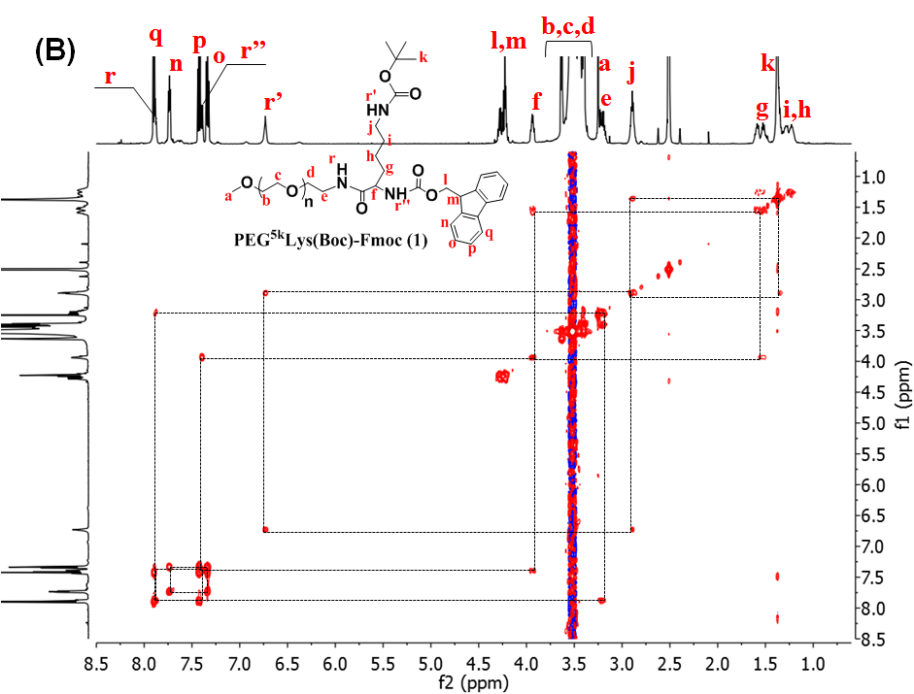
Figure S4. ¹H NMR spectrum (A) and ¹H-¹H 2D COSY spectrum (B) of PEG^{5k}Lys(Boc)-Fmoc (1) recorded at 600 MHz in DMSO-d_{6,} showing correlation of the peaks assigned to neighboring protons. PEG^{5k}Lys(Boc)-Fmoc (1): ¹H NMR (600 MHz, DMSO) δ 7.90 (d, J = 7.6 Hz, 2H), 7.88 (d, J = 5.6 Hz, 1H), 7.79 – 7.69 (m, 2H), 7.43 (t, J = 7.5 Hz, 2H), 7.40 (d, J = 8.2 Hz, 1H), 7.34 (t, J = 7.4 Hz, 2H), 6.78 – 6.69 (m, 1H), 4.28 (dt, J = 12.4, 6.2 Hz, 1H), 4.25 – 4.19 (m, 2H), 3.94 (dd, J = 13.8, 8.6 Hz, 1H), 3.64 – 3.62 (m, 2H), 3.52 (s, 442H), 3.45 – 3.38 (m, 10H), 3.25 (s, 3H), 3.20 (ddd, J = 19.4, 11.5, 5.9 Hz, 2H), 2.89 (dt, J = 12.6, 6.2 Hz, 2H), 1.64 – 1.46 (m, 2H), 1.37 (s, 9H), 1.37 – 1.18 (m, 4H).
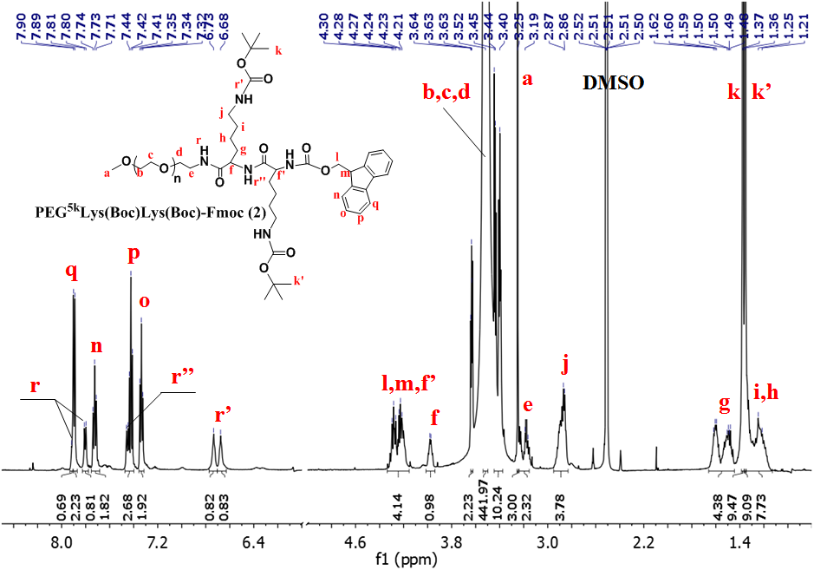

Figure S5. ¹H NMR spectrum of PEG^{5k}Lys(Boc)Lys(Boc)-Fmoc (2) recorded at 600 MHz in DMSO-d₆. PEG^{5k}Lys(Boc)Lys(Boc)-Fmoc(2): ¹H NMR (600 MHz, DMSO) δ 7.92 (d, J = 5.6 Hz, 1H), 7.90 (d, J = 7.6 Hz, 2H), 7.79 (t, J = 10.2 Hz, 1H), 7.72 (q, J = 8.2 Hz, 2H), 7.45 (d, J = 8.1 Hz, 1H), 7.42 (t, J = 7.5 Hz, 2H), 7.34 (t, J = 7.4 Hz, 2H), 6.73 (t, J = 5.0 Hz, 1H), 6.67 (d, J = 5.0 Hz, 1H), 4.34 – 4.15 (m, 4H), 3.98 (dd, J = 13.2, 8.5 Hz, 1H), 3.64 – 3.62 (m, 2H), 3.52 (s, 442H), 3.42 (ddd, J = 22.5, 7.3, 3.5 Hz, 10H), 3.25 (s, 3H), 3.16 (d, J = 6.0 Hz, 2H), 2.95 – 2.83 (m, 4H), 1.66 – 1.45 (m, 4H), 1.37 (s, 9H), 1.36 (s, 9H), 1.35 – 1.13 (m, 8H).

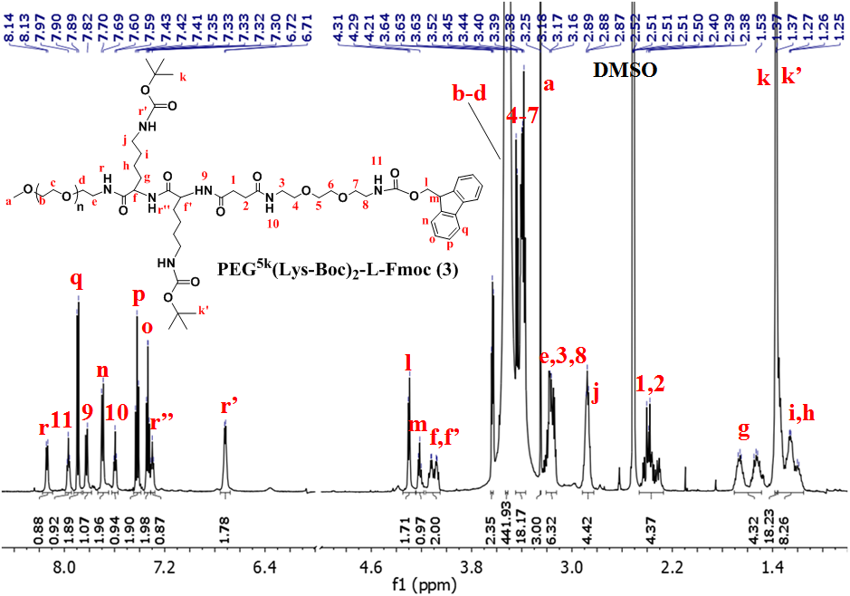

Figure S6. ¹H NMR spectrum of PEG^{5k}(Lys-Boc)₂-L-Fmoc (3) recorded at 600 MHz in DMSO-d₆. PEG^{5k}(Lys-Boc)₂-L-Fmoc (3): ¹H NMR (600 MHz, DMSO) δ 8.14 (d, J = 7.0 Hz, 1H), 7.97 (t, J = 5.5 Hz, 1H), 7.89 (d, J = 7.5 Hz, 2H), 7.82 (d, J = 8.3 Hz, 1H), 7.70 (d, J = 7.4 Hz, 2H), 7.60 (t, J = 5.6 Hz, 1H), 7.45 – 7.39 (m, 2H), 7.33 (dd, J = 7.4, 6.7 Hz, 2H), 7.30 (t, J = 5.7 Hz, 1H), 6.72 (d, J = 5.5 Hz, 2H), 4.31 (t, J = 11.8 Hz, 2H), 4.21 (dd, J = 13.7, 6.6 Hz, 1H), 4.17 – 4.05 (m, 2H), 3.65 – 3.63 (m, 2H), 3.52 (s, 442H), 3.45 – 3.37 (m, 18H), 3.25 (s, 3H), 3.20 – 3.12 (m, 6H), 2.92 – 2.84 (m, 4H), 2.46 – 2.27 (m, 4H), 1.70 – 1.49 (m, 4H), 1.37 (s, 9H), 1.37 (s, 9H), 1.36 – 1.15 (m, 8H).

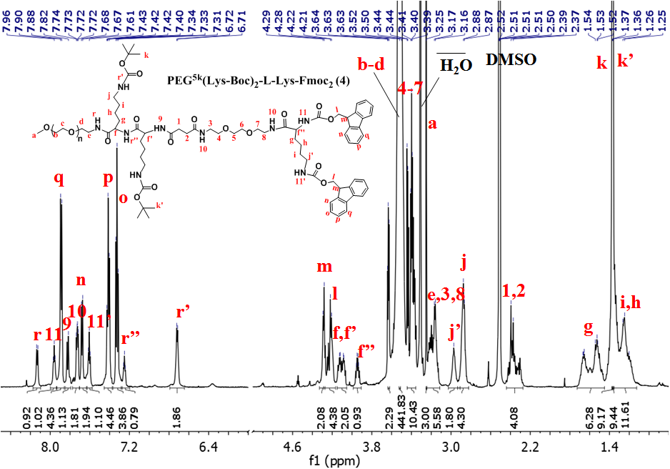

Figure S7. ¹H NMR spectrum of PEG^{5k}(Lys-Boc)₂-L-Lys-Fmoc₂ (4) recorded at 600 MHz in DMSO-d₆. PEG^{5k}(Lys-Boc)₂-L-Lys-Fmoc₂ (4):¹H NMR (600 MHz, DMSO) δ 8.13 (d, J = 6.8 Hz, 1H), 7.96 (t, J = 5.2 Hz, 1H), 7.89 (d, J = 7.4 Hz, 4H), 7.82 (d, J = 8.3 Hz, 1H), 7.73 (dd, J = 7.1, 4.6 Hz, 2H), 7.68 (d, J = 7.4 Hz, 2H), 7.61 (t, J = 5.6 Hz, 1H), 7.46 – 7.37 (m, 4H), 7.33 (t, J = 7.2 Hz, 4H), 7.25 (t, J = 5.5 Hz, 1H), 6.72 (d, J = 5.4 Hz, 2H), 4.29 (d, J = 6.6 Hz, 2H), 4.29 – 4.17 (m, 4H), 4.15 – 4.05 (m, 2H), 3.94 (td, J = 8.6, 5.3 Hz, 1H), 3.31 (s, 22H), 3.25 (s, 3H), 3.24 – 3.11 (m, 6H), 3.03 – 2.92 (m, 2H), 2.88 (dd, J = 29.9, 7.0 Hz, 4H), 2.44 – 2.27 (m, 4H), 1.73 – 1.45 (m, 6H), 1.37 (s, 9H), 1.36 (s, 9H), 1.36 – 1.13 (m, 12H).

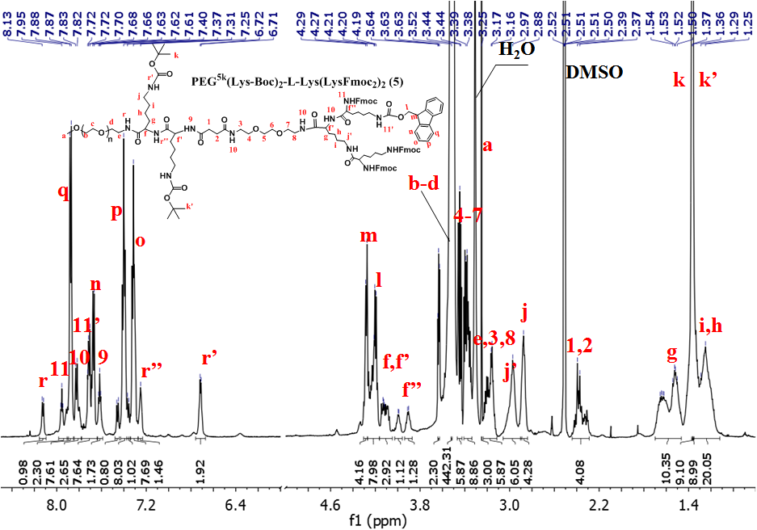
Figure S8. ¹H NMR spectrum of PEG^{5k}(Lys-Boc)₂-L-Lys(LysFmoc₂)₂ (5) recorded at 600 MHz in DMSO-d₆. PEG^{5k}(Lys-Boc)₂-L-Lys(LysFmoc)₂ (5): ¹H NMR (600 MHz, DMSO) δ 8.12 (d, J = 7.0 Hz, 1H), 7.98 – 7.90 (m, 2H), 7.88 (t, J = 9.7 Hz, 8H), 7.85 – 7.78 (m, 3H), 7.78 – 7.64 (m, 8H), 7.62 (t, J = 5.5 Hz, 2H), 7.46 (d, J = 8.1 Hz, 1H), 7.43 – 7.36 (m, 8H), 7.37 – 7.34 (m, 1H), 7.34 – 7.27 (m, 8H), 7.25 (s, 1H), 6.71 (d, J = 5.4 Hz, 2H), 4.30 – 4.27 (m, 4H), 4.27 – 4.16 (m, 8H), 4.11 (ddd, J = 26.1, 12.7, 8.1 Hz, 3H), 4.03 – 3.96 (m, 1H), 3.94 – 3.87 (m, 1H), 3.63 (s, 2H), 3.52 (s, 442H), 3.47 – 3.43 (m, 6H), 3.38 (ddd, J = 15.1, 11.0, 5.5 Hz, 9H), 3.25 (s, 3H), 3.24 – 3.11 (m, 6H), 2.97 (s, 6H), 2.88 (s, 4H), 2.44 – 2.29 (m, 4H), 1.70 – 1.47 (m, 10H), 1.37 (s, 9H), 1.36 (s, 9H), 1.36 – 1.12 (m, 20H).

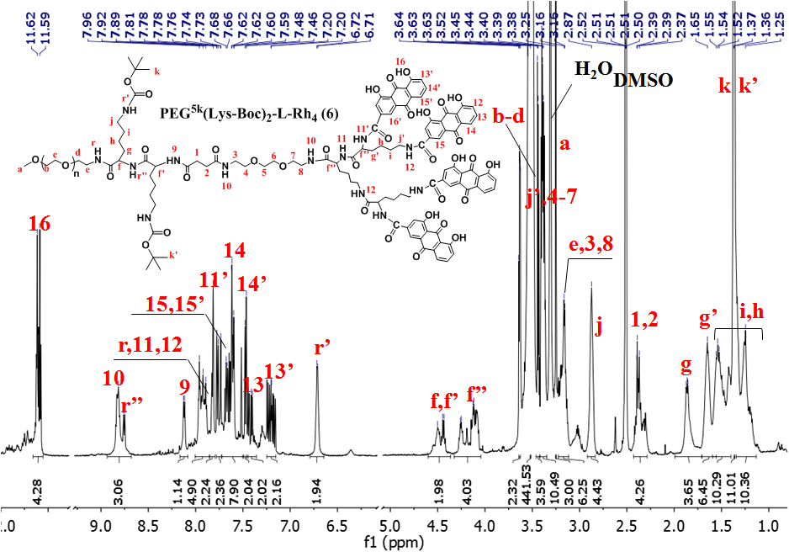

Figure S9. ¹H NMR spectrum of PEG^{5k}(Lys-Boc)₂-L-Rh₄ (6) recorded at 600 MHz in DMSO-d₆. PEG^{5k}(Lys-Boc)₂-L-Rh₄ (6): ¹H NMR (600 MHz, DMSO) δ 11.66 – 11.55 (m, 4H), 8.79 (dd, J = 40.9, 7.9 Hz, 3H), 8.12 (d, J = 7.0 Hz, 1H), 8.00 – 7.85 (m, 5H), 7.82 (d, J = 8.6 Hz, 2H), 7.78 – 7.73 (m, 2H), 7.72 – 7.49 (m, 8H), 7.50 – 7.45 (m, 2H), 7.46 – 7.36 (m, 2H), 7.25 – 7.15 (m, 2H), 6.71 (d, J = 5.1 Hz, 2H), 4.60 – 4.36 (m, 2H), 4.32 – 4.04 (m, 4H), 3.64 – 3.63 (m, 2H), 3.52 (s, 442H), 3.46 – 3.42 (m, 4H), 3.42 – 3.35 (m, 10H), 3.25 (s, 3H), 3.22 – 3.11 (m, 6H), 2.92 – 2.84 (m, 4H), 2.43 – 2.29 (m, 4H), 1.99 – 1.71 (m, 4H), 1.71 – 1.56 (m, 6H), 1.59 – 1.40 (m, 10H), 1.37 (s, 9H), 1.36 (s, 9H), 1.34 – 1.13 (m, 10H).

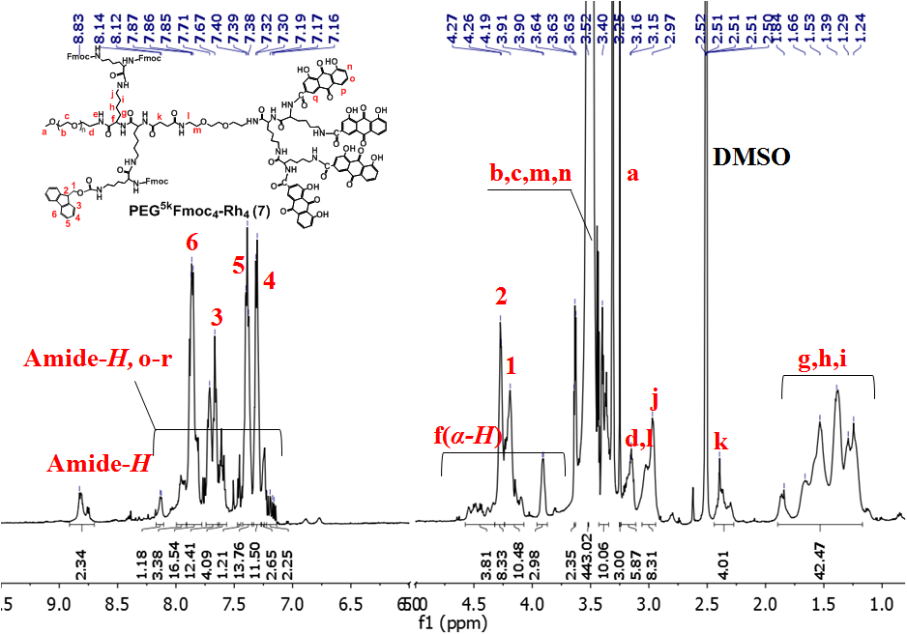
Figure S10. ¹H NMR spectrum of PEG^{5k}Fmoc₄-Rh₄ (7) recorded at 600 MHz in DMSO-d₆. PEG^{5k}Fmoc₄-L-Rh₄ (7): ¹H NMR (600 MHz, DMSO) δ 11.80 – 11.52 (m, 4H), 8.91 – 8.70 (m, 2H), 8.13 (d, J = 6.2 Hz, 1H), 8.00 – 7.91 (m, 3H), 7.91 – 7.78 (m, 17H), 7.68 (m, 12H), 7.64 – 7.57 (m, 4H), 7.47 – 7.44 (m, 1H), 7.43 – 7.33 (m, 14H), 7.31 (d, J = 7.5 Hz, 11H), 7.27 – 7.22 (m, 3H), 7.24 – 7.14 (m, 2H), 4.57 – 4.31 (m, 4H), 4.28 (m, 8H), 4.24 – 4.07 (m, 10H), 3.96 – 3.87 (m, 3H), 3.63 (s, 2H), 3.52 (s, 443H), 3.43 – 3.34 (m, 10H), 3.25 (s, 3H), 3.24 – 3.11 (m, 6H), 3.00 (m, 8H), 2.44 – 2.27 (m, 4H), 1.89 – 1.17 (m, 42H).

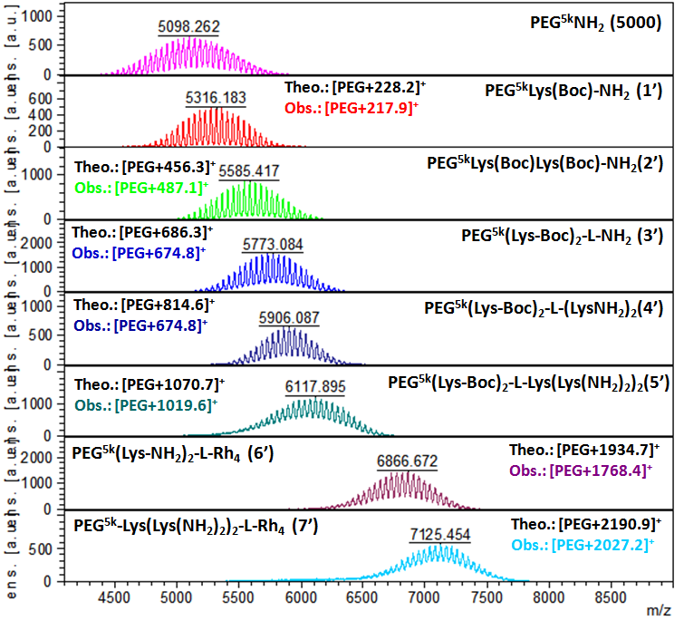
Figure S11. MALDI-TOF spectra of intermediate telodendrimers.

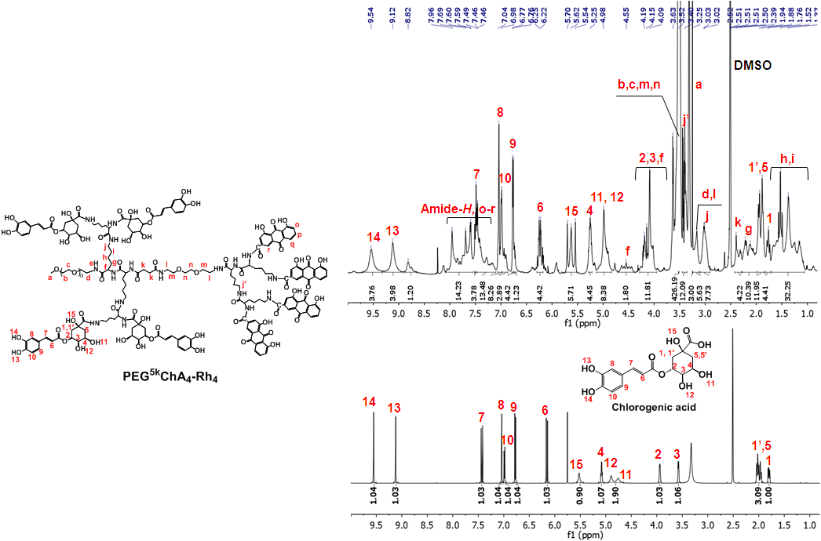
Figure S12. Structural characterization for the co-delivery telodendrimers by ¹H NMR. Stacked ¹H NMR spectra of PEG^{5k}ChA₄-Rh₄ (top) and ChA (bottom).

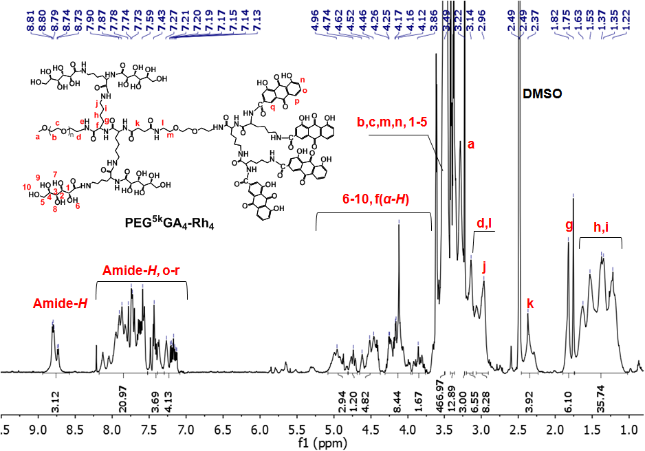

Figure S13. ¹H NMR spectrum of PEG^{5k}GA₄-Rh₄ recorded at 600 MHz in DMSO-d₆.

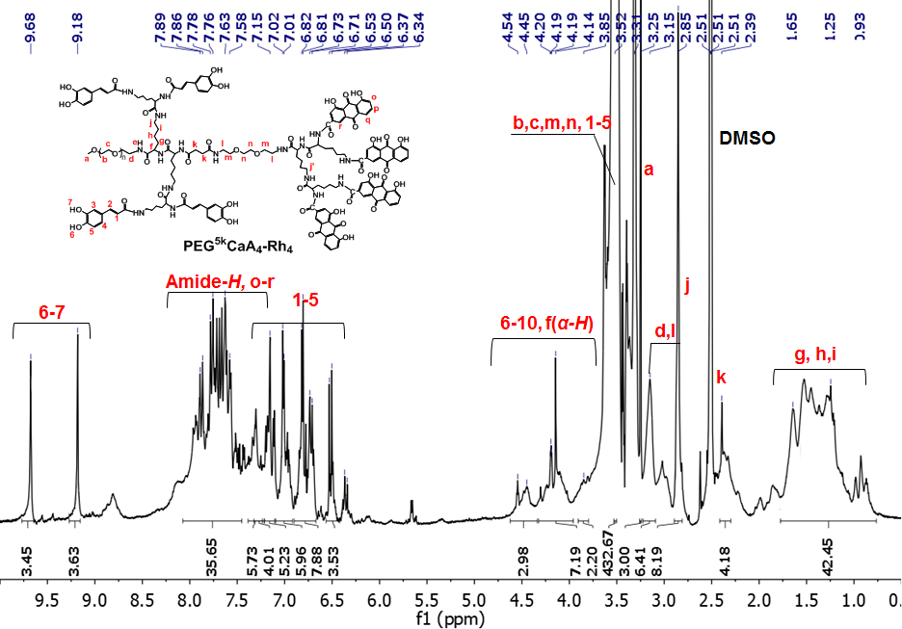
Figure S14. ¹H NMR spectrum of PEG^{5k}CaA₄-Rh₄ recorded at 600 MHz in DMSO-d₆.

Figure S15. A, BTZ conversion over time in conjugation with PEG^{5k}GA₄-Rh₄ , PEG^{5k}CaA₄-Rh₄ and PEG^{5k}ChA₄-Rh₄. B, Standard curve for UV-Vis measurement of BTZ content in conversion test.

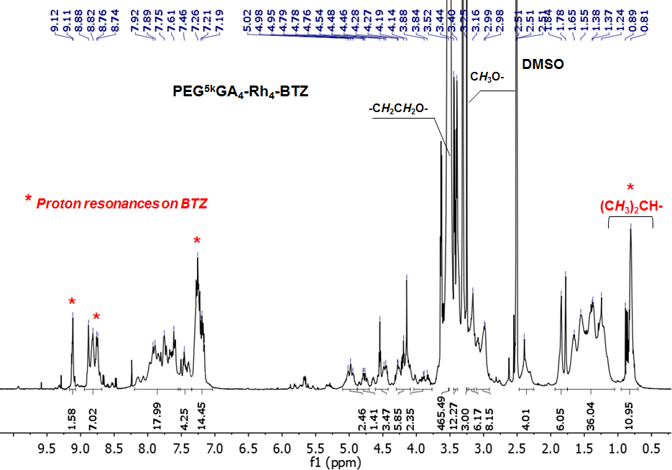
Figure S16. ¹H NMR spectrum of BTZ-PEG^{5k}GA₄-Rh₄ conjugate recorded at 600 MHz in DMSO-d₆.

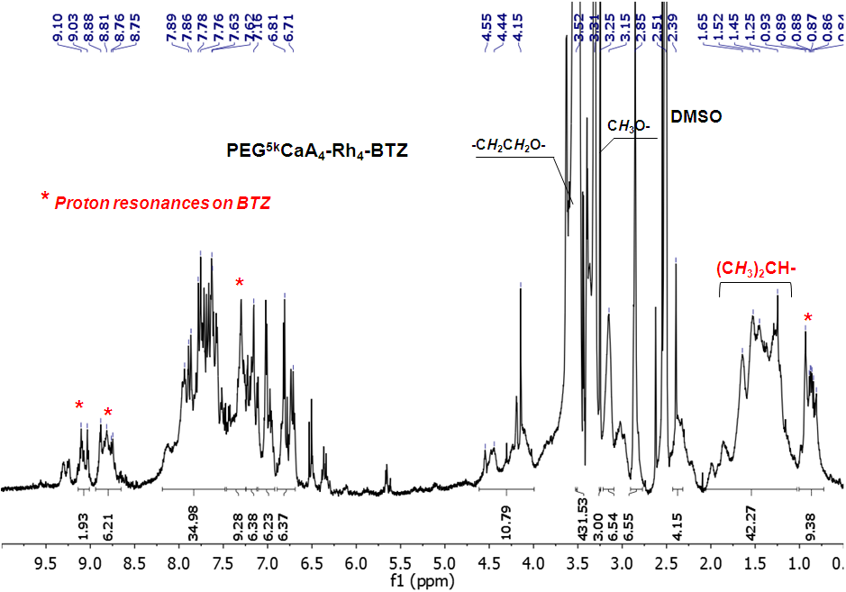
Figure S17. ¹H NMR spectrum of BTZ-PEG^{5k}CaA₄-Rh₄ conjugate recorded at 600 MHz in DMSO-d₆.

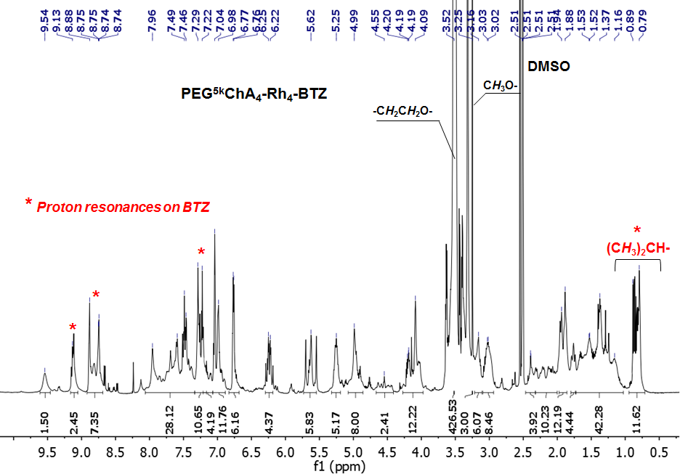
Figure S18. ¹H NMR spectrum of BTZ-PEG^{5k}ChA₄ conjugate recorded at 600 MHz in DMSO-d₆.

Figure S19. BTZ determination by fluorescent method using alizarin as reporter fluorophore. A, Transesterification scheme of alizarin with BTZ-mannitol. B, MALDI-TOF MS spectra of BTZ-mannitol before (top) and after (bottom) the addition of alizarin. C, Fluorescence spectra for alizarin complex with BTZ-mannitol and PBS-mannitol control, excitation wavelength = 485 nm. D, Fluorescence analysis of standard curves for the measurement of BTZ content of BTZ-mannitol, BTZ-PEG^{5k}GA₄-Rh₄, BTZ-PEG^{5k}CaA₄-Rh₄ and BTZ-PEG^{5k}ChA₄-Rh₄, respectively.

Figure S20. Determination of the critical micelle concentration (CMC) of co-delivery telodendrimers using nile red as fluorescence probe.

Figure S21. Cumulative BTZ release from BTZ-mannitol (Velcade mimicking formulation) and indicated BTZ-conjugated nanocarriers in PBS (pH 7.4).

Figure S22. In vitro hemolytic activity and cell viability of co-delivery telodendrimers. A, Homolytic activities of co-delivery telodendrimers in 24 h at 37 °C. B, Cell viabilities of blank telodendrimers and the corresponding BTZ conjugated nanocarriers against H929 after 72 h incubation.
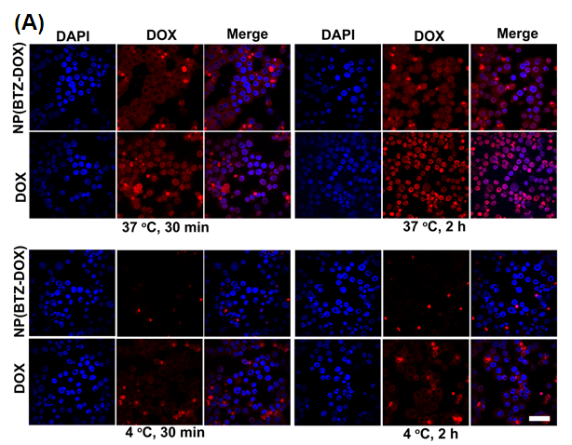
Figure S23. Cellular uptake behavior of free DOX and BTZ-DOX-PEG^{5k}ChA₄-Rh₄. A, The comparison of fluorescence images of H929 cellular uptake at 4 and 37 °C for 30 min and 2 h incubation respectively. Scale bar: 50 µm. Fluorescent analysis of DOX uptake in H929 MM cell lysate after being incubated with free DOX and coloading BTZ-DOX-PEG^{5k}ChA₄-Rh₄ nanoformulation at DOX initial concentration of 1, 3 and 9 μM at 4 °C for 30 min (B) and 2 h (C), and 37 °C for 30 min (C) and 2 h (D).

Table S1. Comparison of the IC₅₀ and CI₅₀ values of various formulations in H929 and SKOV-3 cancer cell lines
Formulationª |  | H929 |  |  | SKOV-3
 | IC₅₀ (ng/mL) |  |  | CI₅₀ ^{b} | IC₅₀ (ng/mL) |  | CI₅₀
 | BTZ |  | DOX |  | BTZ | DOX
BTZ-mannitol | 2.5 |  |  |  | 10.2
NP(BTZ) | 3.1 |  |  |  | 24.5
DOX |  |  | 229.3 |  |  | 57.4
NP(DOX) |  |  | 299.8 |  |  | 66.6
NP(BTZ-DOX)=1:1 | 2.3 |  | 2.3 | 0.40 | 4.9 | 4.9 | 0.55
NP(BTZ-DOX)=1:2 | 2.8 |  | 5.4 | 0.68 | 4.1 | 8.1 | 0.54
NP(BTZ-DOX)=1:4 | 1.8 |  | 7.8 | 0.50 | 4.7 | 18.7 | 0.50
NP(BTZ-DOX)=1:10 | ND^{b} |  | ND | ND | 3.6 | 36.2 | 0.65
ªNanoparticles (NP) were formulated using telodendrimer PEG^{5k}ChA₄-Rh₄. NP(DOX): DOX-encapsulated PEG^{5k}ChA₄-Rh₄; NP(BTZ): BTZ-conjugated PEG^{5k}ChA₄-Rh_{4;} NP(BTZ-DOX): DOX co-loaded with BTZ- PEG^{5k}ChA₄-Rh₄ conjugate at varying BTZ/DOX ratios. ^{b}ND: not detected.
^{b}CI₅₀ is the combination index at 50% cancer cell inhibition.

Figure S24. The body weight changes for animals (BALB/c mice) treated with free BTZ+DOX and NP(BTZ+DOX) at the equivalent BTZ dose of 0.8 mg/kg and DOX dose of 8 mg/kg. After 1st intravenous injection on day 0, one mouse in BTZ+DOX group has a body weight loss more than 20%. Therefore, only one dosage was given to BTZ+DOX group. Three injections on day 0, 4, 8 were given to NP(BTZ-DOX) group.

Table S2. Blood cell counting of blood collected from treated mice 7 days after the third injection.
Groups | WBC  (10³/µL) | RBC  (10⁶/µL) | Hemoglobin  (g/dL) | Platelets  (10³/µL)
Control (PBS) | 8.9 ± 3.6 | 9.3± 0.3 | 17.4 ± 1.4 | 1168.3 ± 216.6
BTZ (0.5 mg/kg × 3) | 12.9 ± 4.6 | 10.0 ± 0.7 | 18.1 ± 0.7 | 1018.3 ± 145.9
BTZ+DOX (0.5/5 mg/kg × 3) | 14.5 ± 4.1 | 8.8 ± 0.2 | 16.4 ± 0.7 | 1562.0 ± 240.7
BTZ+Doxil (0.5/5 mg/kg × 3) | 9.4 ± 2.9 | 7.8 ± 0.6 | 13.8 ± 1.4 | 1748.0 ± 463.4
NP(BTZ-DOX) (0.5/5 mg/kg × 3) | 6.1 ± 1.4 | 8.9 ± 0.8 | 16.6 ± 1.8 | 1254.0 ± 471.2
NP(BTZ-DOX) (0.8/8 mg/kg × 3) | 9.6 ± 2.1 | 7.0 ±0.9 | 12.5 ±1.2 | 1558.4± 606.7
Normal range | 1.8-10.7 | 6.36-9.42 | 11.0-15.1 | 592.0-2972.0

References
1. Springsteen G, Wang B. A detailed examination of boronic acid–diol complexation. Tetrahedron 2002;58:5291-300
2. Springsteen G, Wang B. Alizarin Red S. as a general optical reporter for studying the binding of boronic acids with carbohydrates. Chemical Communications 2001:1608-9

