**SUPPORTING INFORMATION**

***In vitro* and *in vivo* metabolic analysis of mTOR inhibition in sarcoma tumors using multi-nuclear NMR and MRI reveals early metabolic response**

Valentina Di Gialleonardo1, Hannah N. Aldeborgh 1, Vesselin Miloushev1, Kelly M. Folkers1, Kristin Granlund1,William Tap3, Jason S. Lewis1, Wolfgang A. Weber1, Kayvan R. Keshari1,2*.

1Radiology and Molecular Pharmacology Program, Memorial Sloan Kettering Cancer Center, New York, New York 10065, United Sates

2Weill Cornell Medical College, New York, NY 10065, United States

3Medicine Memorial Sloan Kettering Cancer Center, New York, New York 10065, United Sates

**MATERIAL AND METHODS**

*Cell lysate and Western blot*

Each cell line 5 x 106 cells was plated in 10 cc plates. 24 hours before the day of the experiment, the cells were treated with vehicle (6% DMSO) or rapamycin (50 nM).

On the day of the experiment, the cells were washed three times with cold PBS. 1 ml of could PBS was added to each plate and the cells were scraped and collected in 1.5ml eppendorf tubes. The cell suspension was centrifuged at 1300 RPM for 5 minutes. The supernatant was discarded and the cell pellet was resuspended in 500 μl of RIPA buffer (Thermo Scientific Pierce) with protease and phosphatase inhibitors (Thermo scientific Pierce). The cells were kept on ice for 30 minutes and centrifuged at 4000 RPM for 20 minutes. The supernatant was then collected and a BCA assay (Thermo Scientific Pierce) was performed on the cell lysate to accurately measure the protein concentration.

For Western Blot analysis, 20 μl of 2 mg/ml of cell lysate were mixed with 5 μl of 5 × sample loading buffer (6% SDS, 15% 2-mercaptoethanol, 30% glycerol, and 0.3 mg/ml bromphenol blue in 188 mM Tris-HCl, pH 6.8), heated at 70°C for 10 min, and separated by 12% NuPAGE Bis-tris Gel (Invitrogen, Thermo Scientific). Separated proteins in the gels were electrophoretically transferred onto PVDF membrane 0.2 μm pore size for 90 min (NOVEX, Life Technology). The blotted membrane was blocked with 5% BSA in TBS containing 0.05% Tween 20 (TBS-T buffer) for 15-30 min. After washing the membrane with PBS-T, pS6K, PFK, pPKM2, pLDH-a and β-actine antibody (1 μg/ml) (Cell Signaling Techology), diluted in TBS-T containing 5% BSA, was added and incubated for overnight at 4°C. The bound antibodies were detected by horseradish peroxidase-conjugated anti-goat Ig secondary antibody (Santa Cruz Biotechnology) followed by ECL detection system (Thermo Scientific) according to the manufacturer's instruction.

*Treatment Conditions for 1H NMR*

For each cell line 1 x 106 cells was plated in a 6 well plate. 24 h before the day of the experiment, the cells were treated with vehicle (6% DMSO) or rapamycin (50nM). On the day of the experiment, the media was exchanged either with 5mM non-enriched glucose or 5mM [1,6-13C]glucose enriched media, for total pool size or tracing experiments, respectively. The cells were incubated for 3 h. DMSO and rapamycin were present during all the incubation times. After 3 h, the media was removed and stored at -80°C for further purification and analysis. The cells were quickly washed with cold PBS. 2 ml of 80% of cold methanol was used to extract the water-soluble component of the cells. The cells were placed at -80% to ensure optimal metabolites extraction. The following day the sample was centrifuged at 4000 RPM at 4°C for 30 minutes. The supernatant was isolated from the cell pellet and dried using Genevac.

*Sample preparation for in vitro NMR*

Media samples were filtered at 14000 RPM at 4°C for 30 minutes using Amicon Ultra 0.5mL centrifugal filters (3K) (Merck Millipore Ltd. Darmstadt, Germany) to eliminate protein contamination that could interfere with the NMR acquisition. 100 μl of 10X PBS in D2O, containing 0.5mM of DSS as internal standard and 10mM of imidazole as pH indicator was added to 500μl of the purified media. The dried water-soluble intracellular content was dissolved in 600μl of standard and 10mM of imidazole as pH indicator.

*Tumor xenograft histology and immunohistochemistry*

Tissue sections were deparaffinized, rehydrated, and microwaved in 10 mmol/L citrate buffer (pH 6.0) in a 750 W microwave oven for 15 minutes. For IHC detection of proliferation, samples were incubated with a monoclonal rabbit anti-Ki67 antibody and cleaved caspase-3 (Lab Vision/Neomarkers, Fremont, USA, 1∶200) followed by Rabbit PowerVision Kit (UltraVision Technologies, North Andover, USA). The signals were revealed with chemiluminescence DAB PowerVision kit (ImmunoVisionTechnologies Co., Hillsborough, USA). Sections were scanned and digitized using a Nikon slide scanner 8000 (Nikon, Melville, USA).

*Statistical analysis*

All data are expressed as mean ± standard deviation. Significances were calculated using GraphPad Prism. A student’s t-test was used to calculate significance with a p < 0.05 considered statistically significant.

**FIGURES**

*Mac HD:Users:digiallv:Desktop:Sarcoma 072516:Figures:SUPL 1.pdf*

**Figure S1.** Major genetic alterations in of PI3K/AKT/mTOR pathway in 265 sarcoma tumors as summarized by TCGA using cBioPortal.

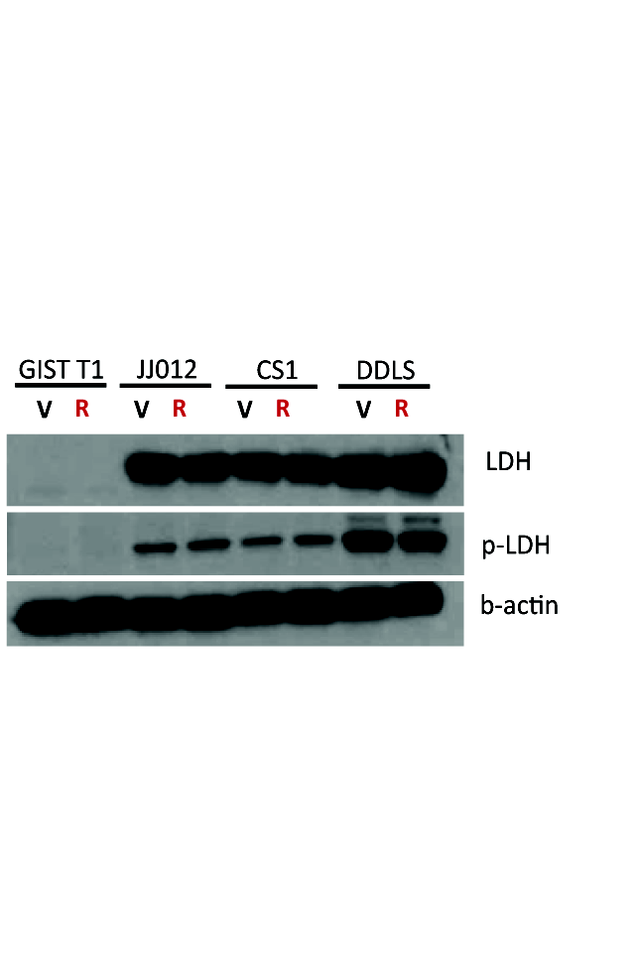

**Figure S2.** Protein expression level detected with Western blot. Lactate Dehydrogenase (LDH), phosphorylated-LDH (p-LDH) and beta actin as a loading control.

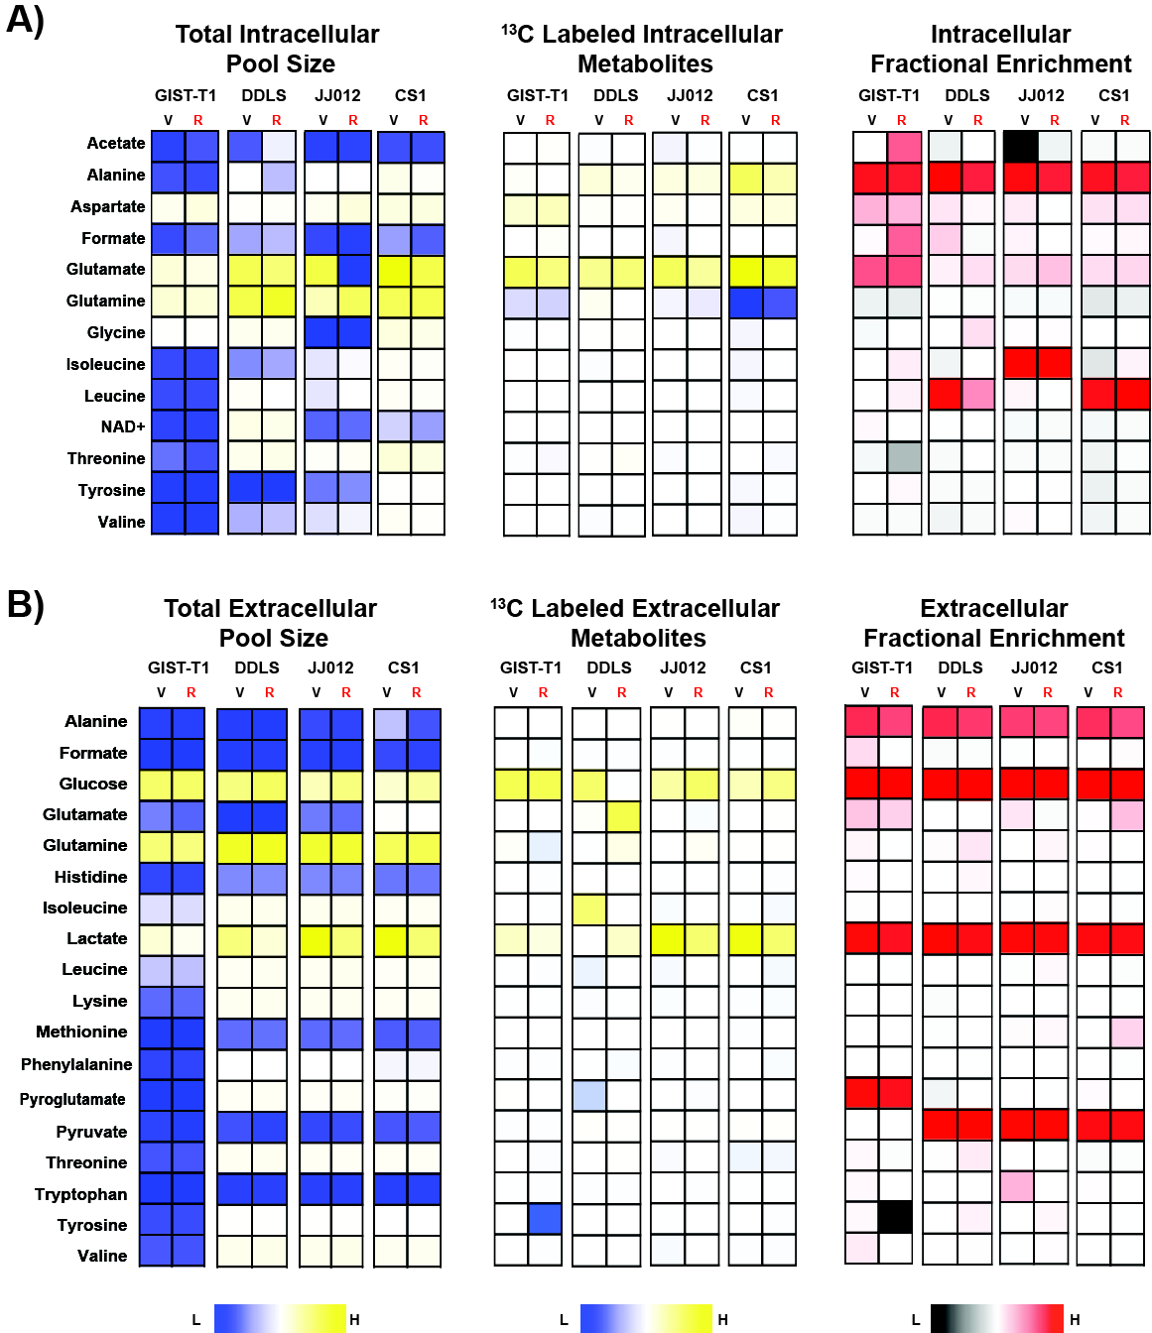

**Figure S3. A)** Metabolic profile of total and labeled intracellular **B)** and extracellular pool size of vehicle vs. rapamycin treated GIST-T1, DDLS, JJ012 and CS1. Last column on both panels shows the fractional enrichment of each metabolite analyzed.

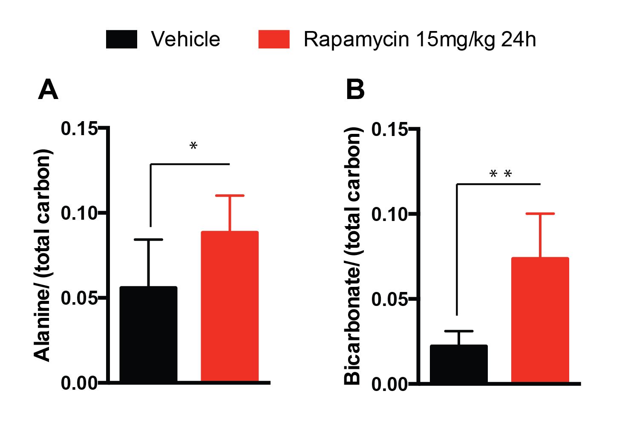

**Figure S4.** Bar plots represent the ratio of **A)** HP alanine/(HP total carbon) and **B)** HP bicarbonate/(HP total carbon) in CS1 tumor treated for 24 hours with 6% DMSO (black) and 15mg/kg of rapamycin (red). Results are expressed as mean ± SD. p-values < 0.05 (*) and p-values < 0.01 (**) were considered significantly different from control.

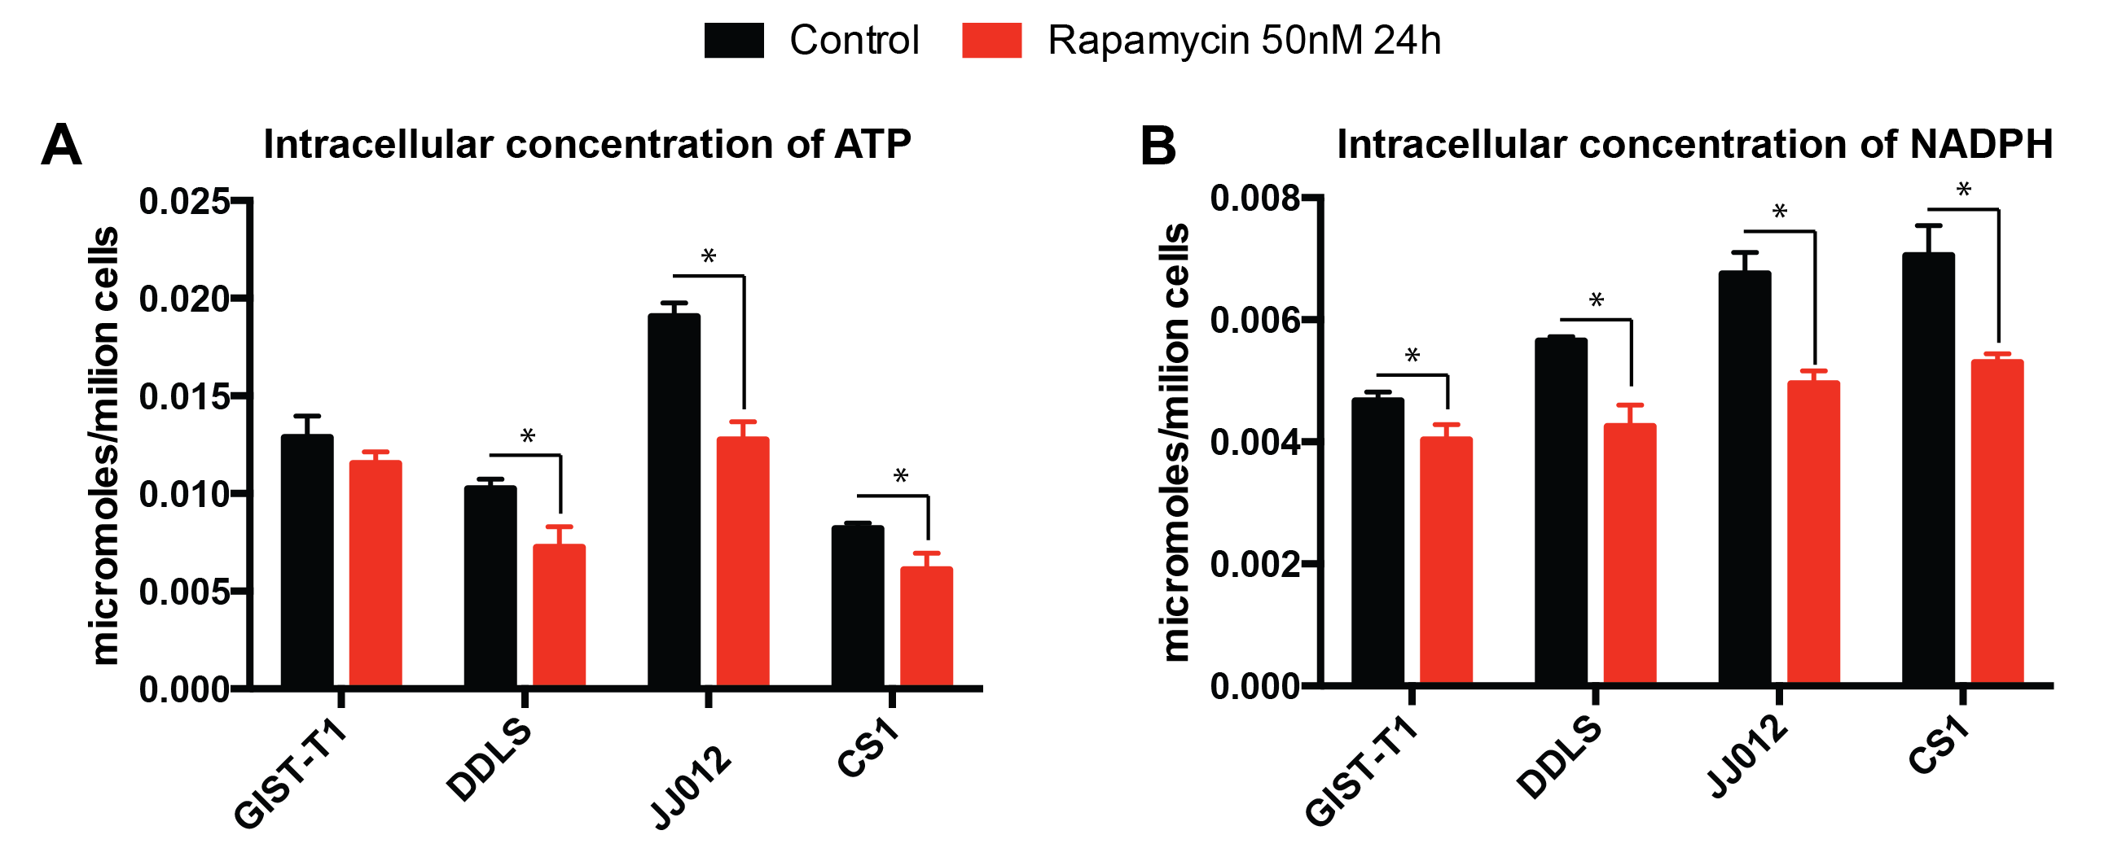

**Figure S5. A)** Intracellular concentration of ATP and **B)** NADPH of DMSO control (black) vs. rapamycin (red) treated GIST-T1, DDLS, JJ012 and CS1. Results are expressed as mean ± SD. p-values < 0.05 were considered significantly different from control (*).