Supplementary Figure S5
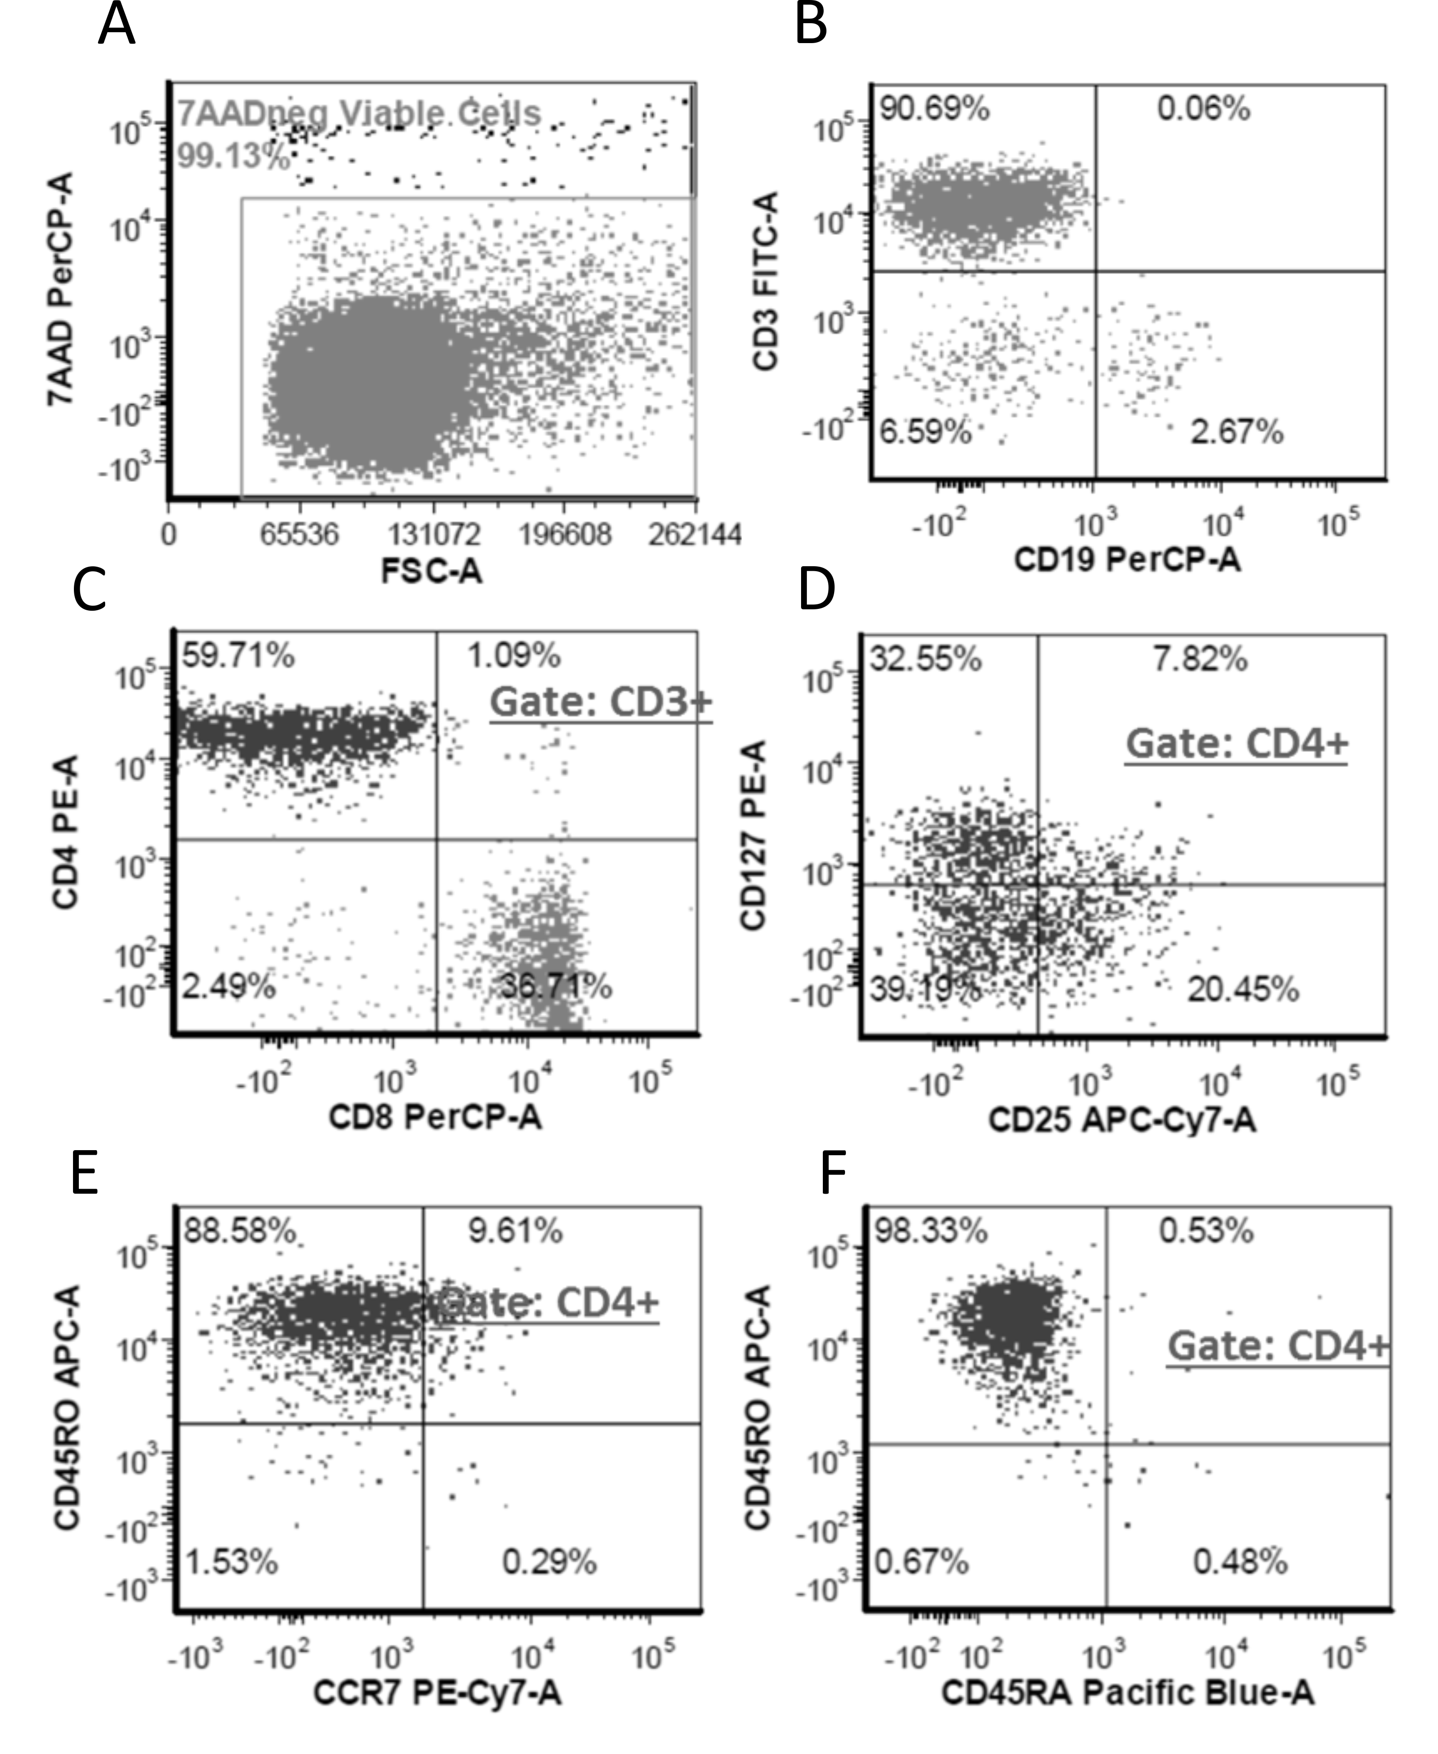
Viability and phenotyping of freshly isolated TILs isolated from a HNC patient (A) Viability for TILs was measured by flow cytometry using the nuclear dye 7-AAD for a representative case. 7-AAD fluorescence was plotted as a function of forward scatter (FSC-A). Rectangle gates were drawn to identify the 7-AAD⁺ (non-viable/dead) and 7-AAD⁻ (live) cell populations and the numbers above the gates are the percentages of 7-AAD⁻ cell populations. (B) Representative scatter plots for measuring CD3 expression as a function of CD19 expression in TILs. The fluorescence intensity of FITC (CD3) and PerCP (CD19) was detected in each cell. Quadrant gates were drawn based on unstained and single stained controls and the numbers in each quadrant correspond to the percentage of cells. (C) Representative scatter plots for measuring CD4 expression as a function of CD8 expression in CD3⁺ TILs. The fluorescence intensity of PE (CD4) and PerCP (CD8) was detected in each cell. Quadrant gates were drawn based on unstained and single stained controls and the numbers in each quadrant correspond to the percentage of cells. (D) Representative scatter plots for measuring T_{reg} frequency in TILs. CD127 was measured as a function of CD25 expression in CD3⁺CD4⁺TILs. The fluorescence intensity of PE (CD127) and APC-Cy7 (CD25) was detected in each cell. Quadrant gates were drawn based on unstained and single stained controls and the numbers in each quadrant correspond to the percentage of cells. T_{reg} cells were defined as CD4⁺, CD25⁺ and CD127⁻cells. (E) Representative scatter plots for measuring T_{EM} incidence in TILs. CD45RO expression was measured as a function of CCR7 expression in CD3⁺CD4⁺TILs. The fluorescence intensity of APC (CD45RO) and PE-Cy7 (CCR7) was detected in each cell. Quadrant gates were drawn based on unstained and single stained controls and the numbers in each quadrant correspond to the percentage of cells. T_{EM} cells were defined as CD4⁺CD45RO⁺CCR7⁻CD45RA⁻ cells (F) Representative scatter plots for measuring CD45RO expression as a function of CD45RA expression in CD3⁺CD4⁺TILs. The fluorescence intensity of APC (CD45RO) and Pacific blue (CD45RA) was detected in each cell. Quadrant gates were drawn based on unstained and single stained controls and the numbers in each quadrant correspond to the percentage of cells. Shown here is a representative experiment from a single HNC patient. Similar experiments were performed on freshly isolated TILs from 3 HNC patients.

