Supplementary Figure S4
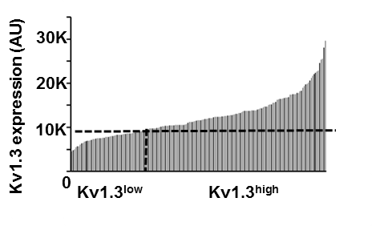

Quantitation of Kv1.3 protein expression in CD8⁺ TIL. Kv1.3 protein expression in 128 CD8⁺ cells in a representative HNC patient was quantitated by image analysis of confocal microscopy images acquired after immunofluorescence staining as described in Materials and Methods. Bars represent mean fluorescence intensity of Kv1.3 protein in an individual CD8⁺ cell. The dotted line drawn from the ordinate represents the median Kv1.3 fluorescence, which was used to define the Kv1.3^{high} and Kv1.3^{low} CD8⁺ cell populations on the individual cells represented on the X axis as described in Materials and Methods. (128 cells from 10 fields from a single HNC patient)

