Supplementary Figure S2
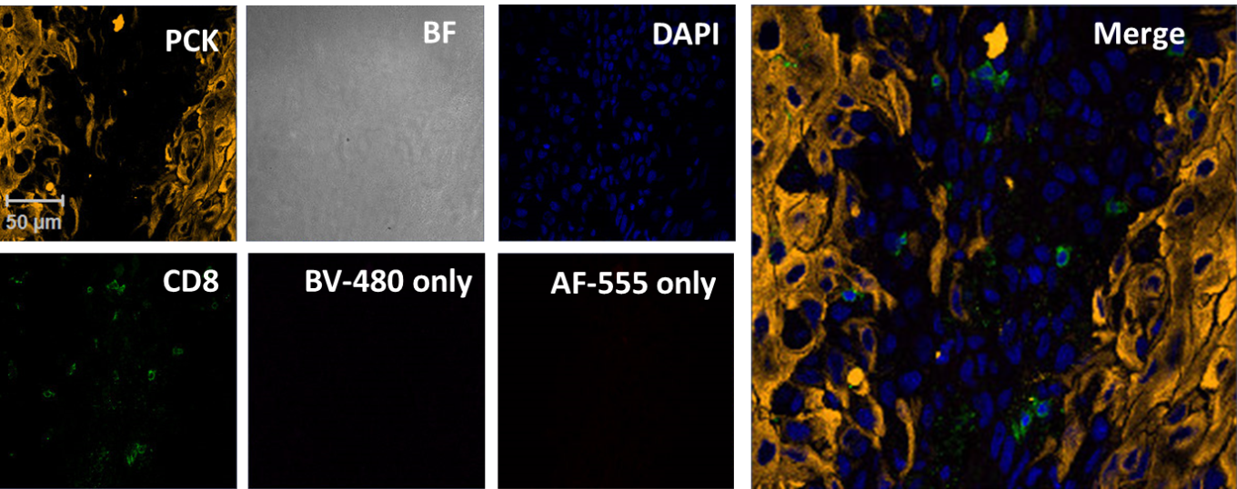

Assessment of background staining for non-conjugated antibodies. Frozen sections from HNC patients were stained overnight with only secondary antibodies that were used for for the guinea pig and rabbit primary antibodies used in the immunofluorescence experiments. Sections were fixed, blocked and stained overnight with Alexa Fluor 555-anti guinea pig and Brilliant Violet 480 anti-Rabbit secondary antibodies only without adding the respective primary antibodies. The slides were then stained with the following conjugated antibodies: Alexa-488 anti-human pan cytokeratin (PCK, yellow pseudocolor) and Alexa Fluor 647 anti-human CD8 (green). Nuclei were stained with DAPI (blue) and images were acquired by confocal microscopy at 40X magnification as described in Materials and Methods. Shown here is a confocal image from a representative field from a single HNC patient.

