Supplementary Figure S1
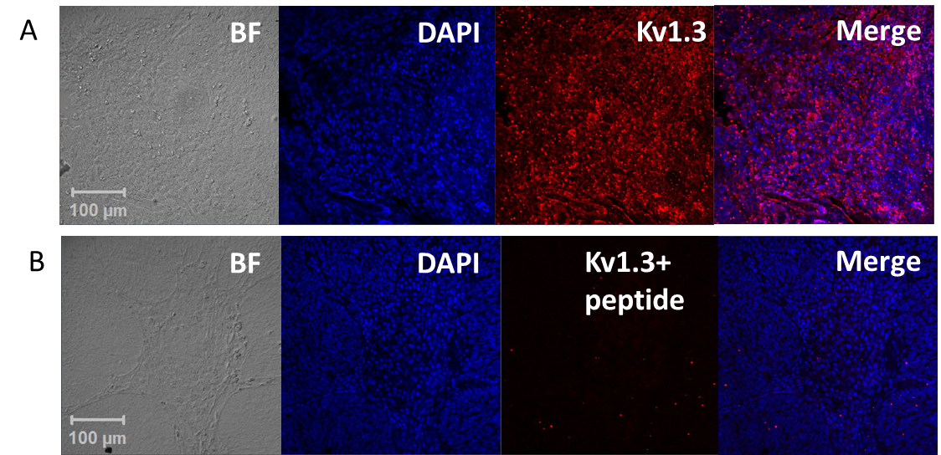

Specificity of Kv1.3 antibodies. Slides prepared from 5 μm FFPE sections from a healthy human tonsil were fixed and deparaffinized according to standard immunohistochemistry protocols. Heat mediated antigen retrieval was performed in a vegetable steamer by boiling the slides for 20 min in sodium citrate buffer (10 mM sodium citrate, 0.05% tween-20, pH6.0). The slides were blocked at room temperature with PBS + 10% FBS. One of the slides (Representative image in A) was incubated with the polyclonal guineapig anti-human Kv1.3 antibody (Alomone labs, Israel, 0.8 mg/ml stock) at 1:50 fold dilution. The antibody was preadsorbed for the other slide (Representative image in B) by incubating the antibody with 3X amount of the specific Kv1.3 peptide that was used to generate the guineapig antibody (Alomone labs) for one hour on a shaker at room temperature (we added 4.8 μg peptide to 1.6 μg antibody). Both slides were washed and incubated with Alexa 555- anti gp secondary antibody (red pseudocolor in the images). Slides were washed and nuclei were stained with 1 μg/ml DAPI (blue pseudocolor in the images). Slides were visualized at 20X with Zeiss LSM 710 confocal microscope and images were acquired with the Zen software as described in Materials and Methods. Shown here are representative confocal images at 20X magnification of slides treated with (A) Kv1.3 antibody only and (B) Kv1.3 antibody preadsorbed with peptide.

