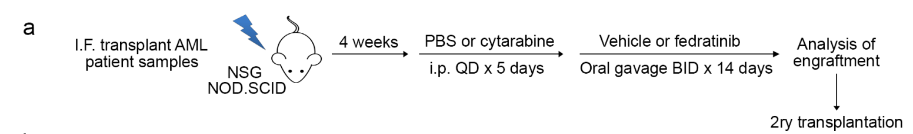
C
A
B
Compared to FED alone
***P < 0.001
**P < 0.01
*P < 0.05
***
***
***
***
*
**
**
***
*
Supplemental Figure 1. Pretreatment with cytarabine potentiates the effects of FED in AML xenografts. (A) Schematic illustrating the experimental protocol for combination drug testing. (B) Summary of human CD45+CD33+ AML engraftment in the injected femur and non-injected bones of engrafted mice treated with vehicle, cytarabine (Ara-C) alone, FED alone, or Ara-C+FED. Each symbol represents one mouse (C) Summary of human CD45+CD33+ AML engraftment in the bone marrow of mice serially transplanted with cells from vehicle- or FED-treated primary mice. Data from injected femur and non-injected bones were combined for the analysis. For (B,C) bars indicate mean values. *, P < 0.05; **, P < 0.01; ***, P < 0.001.

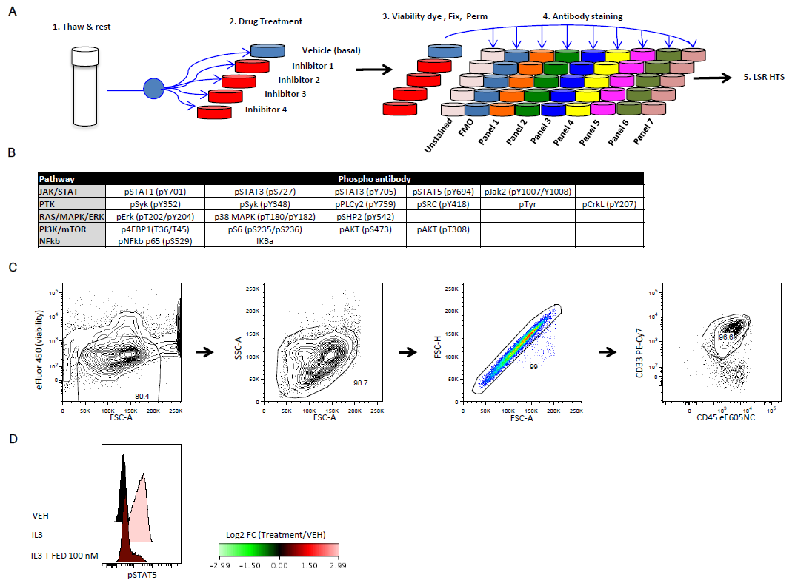
Supplemental Figure 2. PF cytometry analysis of AML samples. (A) Schematic of PF cytometry analysis work flow. Viably frozen AML samples were thawed and subjected to the PF cytometry work flow as shown. Normalized basal expression levels were calculated by subtracting the MFI of the FMO control (without phospho-antibodies) from the MFI of the phospho-antibody-stained sample. The Log₂ FC ratio was calculated as the Log₂ of the ratio of (MFI of drug-treated sample)/(MFI of vehicle-treated sample). (B) Summary table of all phospho-antibodies and surface markers used in PF analysis. (C) Pre-gating scheme used for PF analysis of AML samples. Samples were gated on viable cells (viability dye-negative cells vs forward scatter area, FSC-A). Debris and doublets or aggregates were excluded based on FSC-A vs side scatter area (SSC-A) and FSC-height (H) vs FSC-A respectively. AML blasts were gated based on CD45dim expression in combination with CD33 expression, FSC and SSC. There was significant inter-sample variability in these parameters, therefore the blast gating strategy was optimized for each sample. Non-blast normal hematopoietic cells were excluded based on high CD45 expression. In the vast majority of samples, the proportion of CD45hi cells with FSC and SSC characteristics similar to those of normal peripheral blood mononuclear cells was <10%. We used the gating strategy that best excluded the CD45hi cells for each sample. (D) Histogram showing pSTAT5 levels in OCI-AML5 cells pre-treated or not with FED 100 nM for 1 h and stimulated with IL-3 (20 ng/mL) for 3 minutes. MFI, mean fluorescence intensity; FMO, fluorescence minus one; FC, fold change.

Supplemental Figure 3. Immunophenotypic and phosphoprotein signaling heterogeneity of AML patient samples. (A, B) Immunophenotypic profiles of X-R (A) and X-NR (B) patient samples, showing inter-patient heterogeneity. (C) Correlation between normalized basal and post-FED changes in pSTAT5 levels. (D) Representative PF analysis of AML samples treated with FED in vitro. Shaded contour plots show CD34 vs pSTAT5 profiles of two X-R PF responders and 2 X-NR PF non-responders after in vitro treatment with vehicle (DMSO), or FED (100 nM) for 1 hour prior to antibody staining. (E) Table showing sensitivity and specificity of pSTAT5 PF biomarker for predicting in vivo response to FED treatment in xenograft assays for the initial patient cohort.

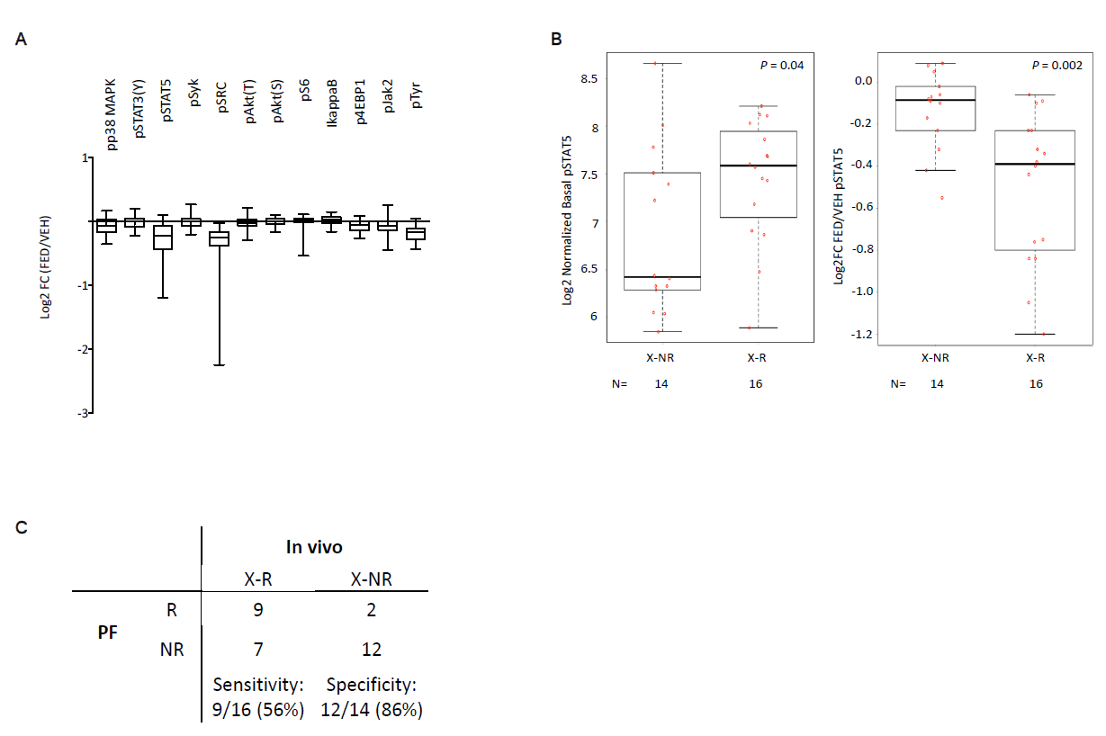

Supplemental Figure 4. PF analysis of validation cohort samples. (A) Box and whisker plots of Log₂ FC ratios (calculated as described for Supplemental Figure 2) showing the impact of FED treatment on phosphoprotein levels in AML samples from the validation cohort. Cells were treated with vehicle (DMSO) or FED (100 nM) for 1 hour prior to antibody staining. Horizontal lines in boxes indicate medians, boxes span interquartile range and whiskers extend to the minimum and maximum values. (B) Basal and post-FED treatment changes in pSTAT5 levels in patient samples classified as non-responders (X-NR) or responders (X-R) in xenograft assays. (C) Table showing sensitivity and specificity of pSTAT5 PF biomarker for predicting in vivo response to FED treatment in xenograft assays. FC, fold change.

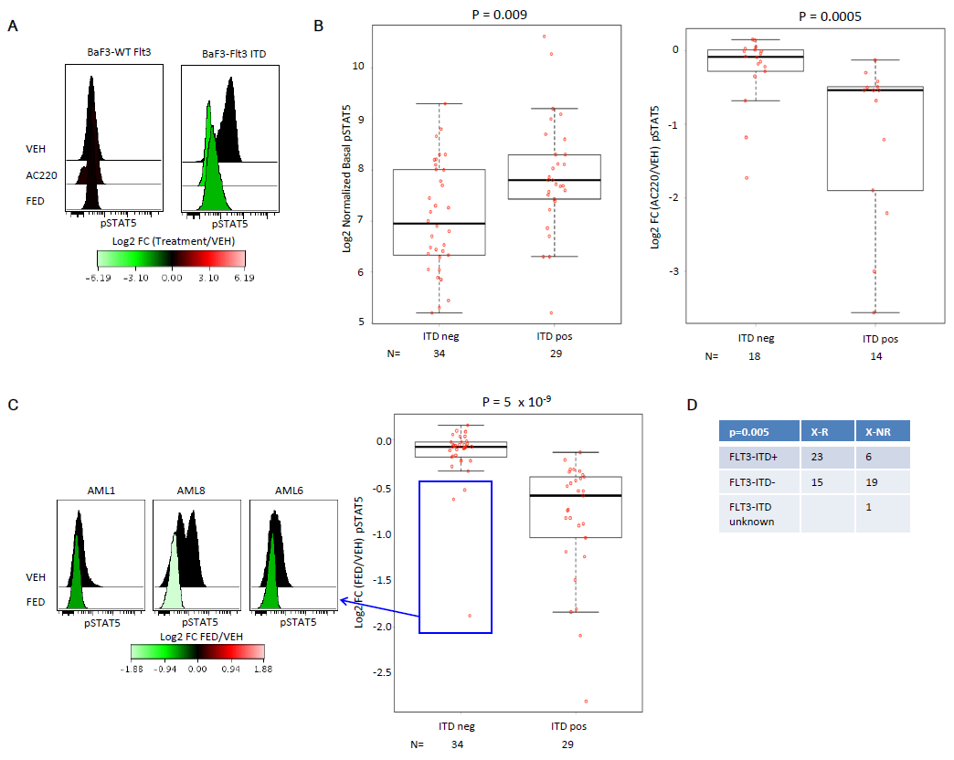
Supplemental Figure 5. Effects of FED treatment on FLT3 activity. (A) Histograms showing pSTAT5 levels in Ba/F3 cells expressing wild-type (WT) Flt3 or Flt3-ITD following treatment with AC220 (5 nM) or FED (100 nM) for 1 h, compared to vehicle (VEH) control. (B,C) Box and whisker plots showing pSTAT5 levels in patient samples without (ITD neg) or with (ITD pos) FLT3-ITD (initial and validation cohorts combined), under basal conditions and after in vitro AC220 (B) or FED (C) treatment (Mann-Whitney U test). Normalized basal MFIs and Log₂ FC ratios were calculated as described for Supplemental Figure 2. Cells were treated with vehicle (DMSO), FED (100 nM) or AC220 (5 nM) for 1 h prior to antibody staining. Horizontal lines in boxes indicate medians, boxes span interquartile range and whiskers extend to the minimum and maximum values. The histograms in (C) show post-FED treatment levels of pSTAT5 in 3 FLT3-ITD– patient samples. (D) Summary table showing correlation between in vivo response in xenograft assays and presence or absence of FLT3-ITD in combined initial and validation cohorts (Fisher’s exact test).
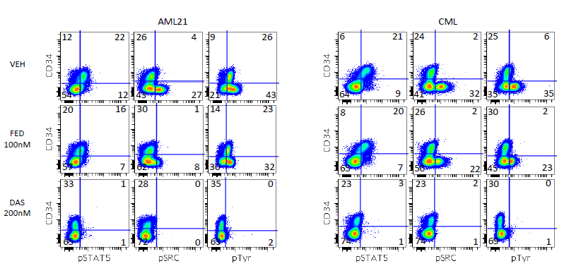

Supplemental Figure 6. Effects of FED and DAS treatment on pSTAT5, pSRC and pTyr in BCR-ABL1+ AML samples. Shaded contour plots showing CD34 vs. pSTAT5, pSRC or pTyr expression profiles of sample AML21 and a representative chronic phase CML patient sample following in vitro treatment with vehicle (DMSO), FED (100 nM) or DAS (200nM) for 1 hour prior to antibody staining.

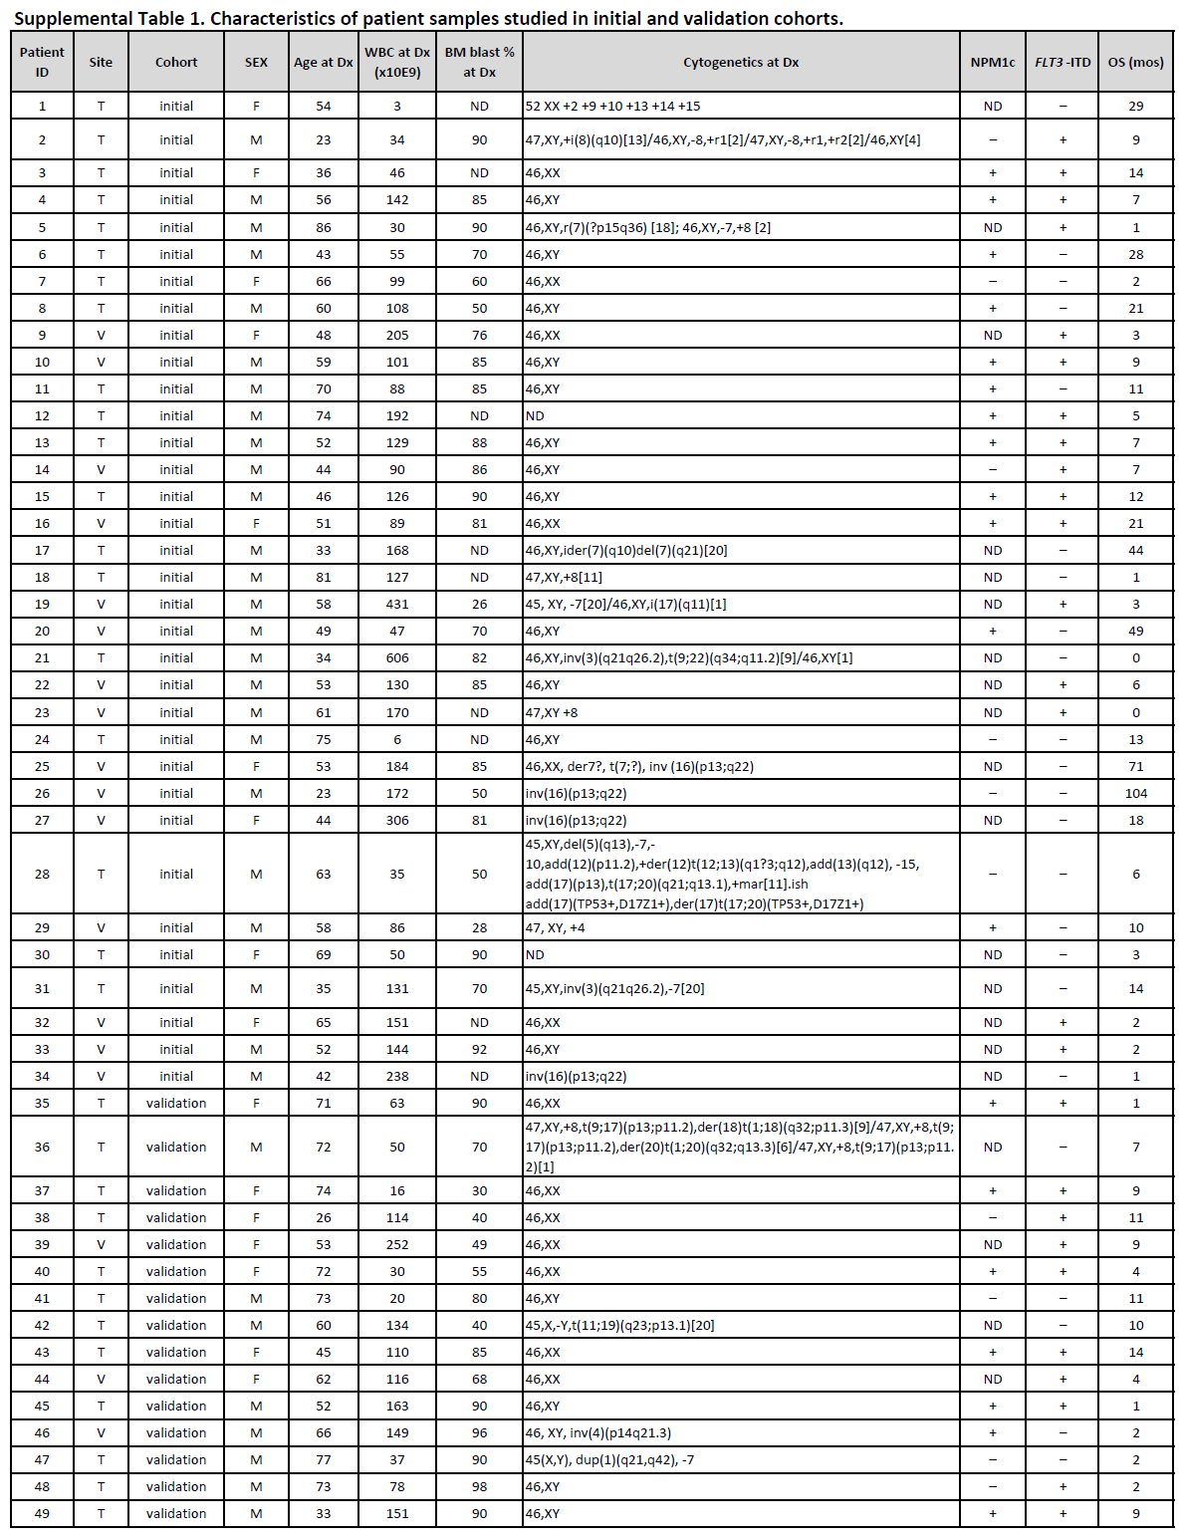
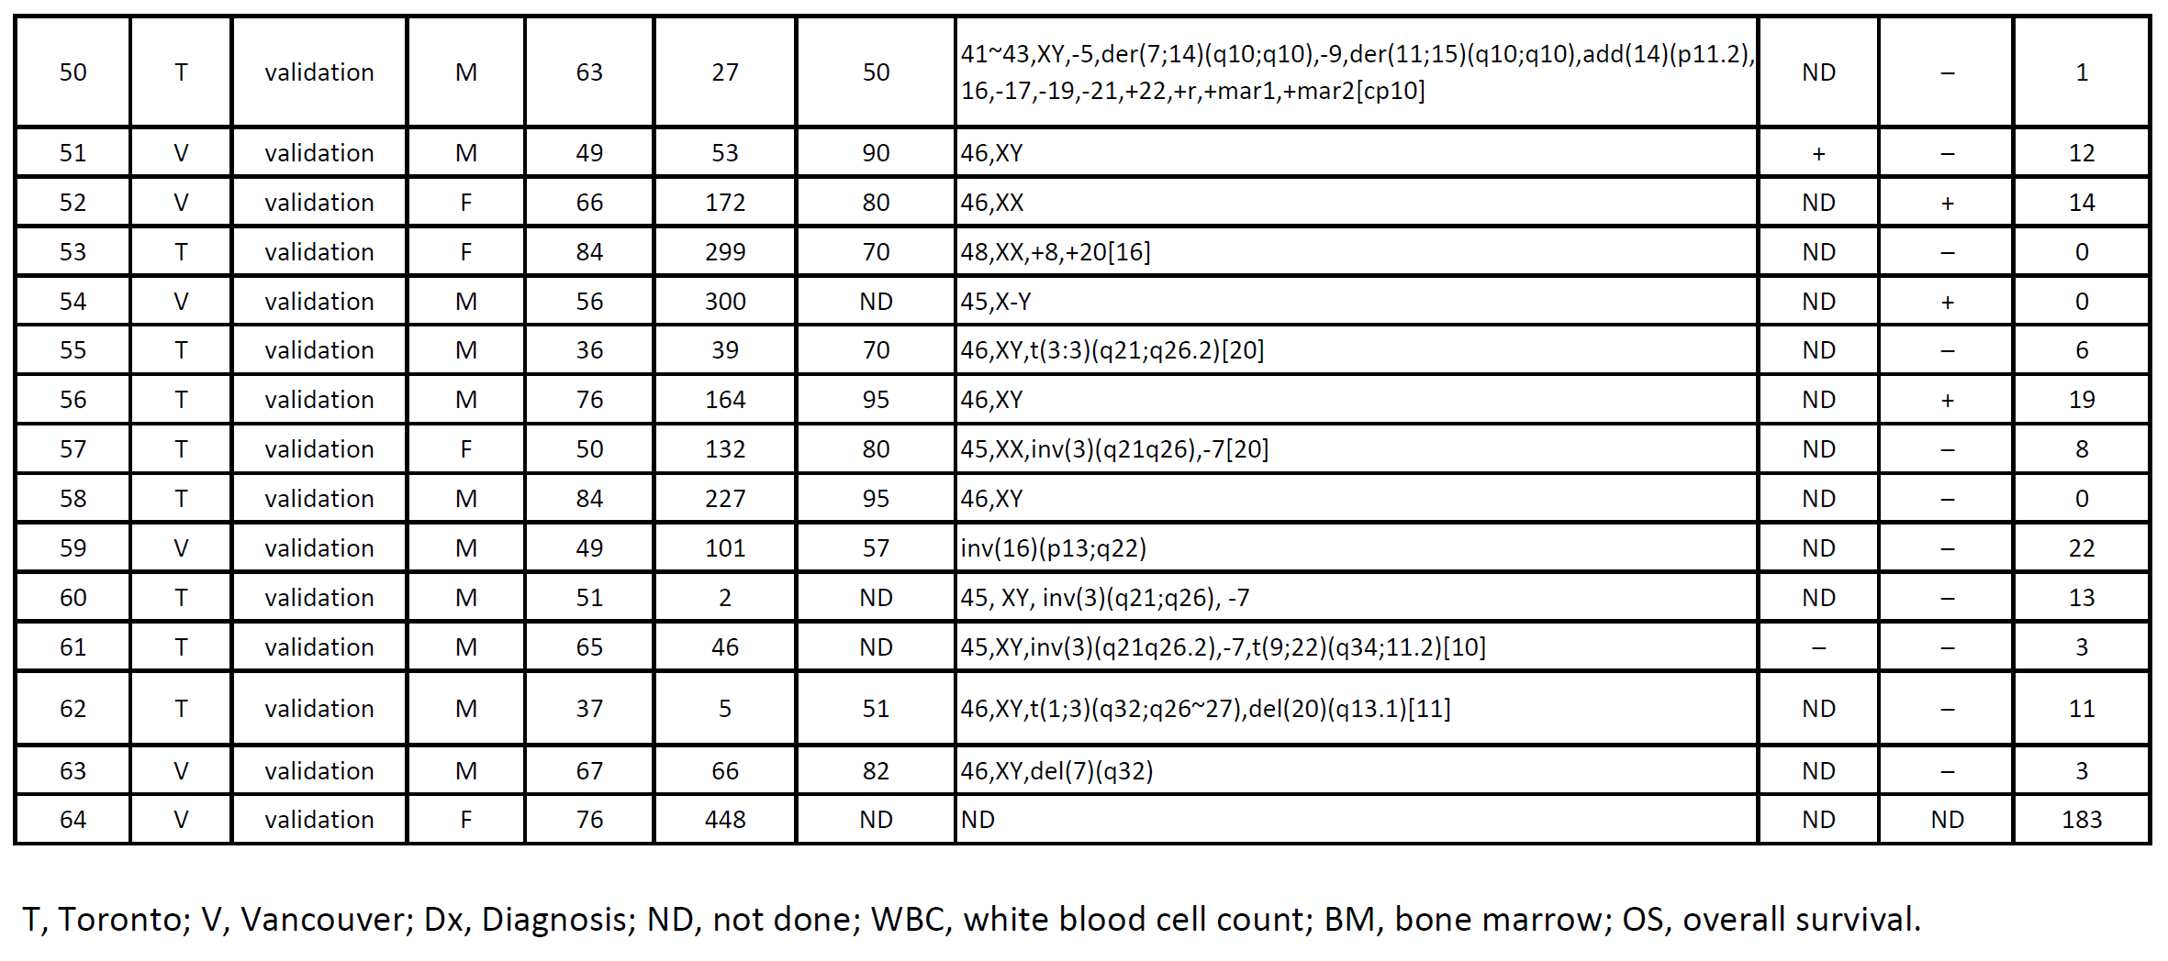

Supplemental Methods
Xenotransplantation assay
The following human-specific antibodies were used to evaluate the level of human leukemic engraftment in xenotransplanted mice: (T) anti-CD45-APC, anti-CD3-FITC, anti-CD19-PE, anti-CD34-APC-Cy7, anti-CD38-PE-Cy7, anti-CD15-V450 (all BD); anti-CD14-Texas Red and anti-CD33-PE-Cy5 (both Beckman Coulter); (V) anti-CD45-FITC (clone 2D1) and anti-CD33-PE (clone P67.6), (both from StemCell Technologies), and anti-CD13-PE and anti-CD3-APC (both from BD).

Phosphoflow cytometric analysis
AML patient samples tested in vivo were subjected to PF analysis following short-term drug treatment in vitro. Viably frozen samples were thawed and serum starved for 1 h at 37°C in serum and phenol red-free RPMI 1640 media supplemented with 25 mM Hepes (pH 7.2), 1 mM sodium pyruvate, 2 mM L-glutamine, and 0.1 mM non-essential amino acids. Cells were then treated with DMSO (vehicle), FED (100 nM), AC220 (5 nM, Selleck Chemicals), RUX (300nM, Selleck Chemicals) or DAS (100-200nM, Toronto Research Chemicals) for another hour. During the last 30 min of inhibitor treatment, cells were incubated with Fixable Blue reagent (1:1000, Invitrogen) or Fixable eFluor450 (1:2000, eBioscience) following manufacturer’s instructions for dead cell discrimination. Cells were then fixed by adding BD Biosciences Cytofix buffer at 1:1 (v/v) for 10 minutes at 37°C, washed with staining buffer (PBS with 1% (w/v) bovine serum albumin), and then permeabilized by adding BD Biosciences Perm III buffer to cells while vortexing at 10⁷ cells/ml and incubated on ice for 30 m. After washing with staining buffer, phospho-marker and extracellular staining was carried out at 22°C for 30 m at 10⁷ cells/ml with previously optimized concentrations of the following antibodies: phospho-Erk (pT202/pY204) [clone 20A], phospho-STAT3 (pS727) [clone 49/p-Stat3], phospho-Syk (pY352) [clone 17A/P-ZAP70], phospho-PLCγ2 (pY759) [K86-689.37], IkBa [clone L35A5], phospho-STAT3 (pY705) [clone 4/P-STAT3], phospho-Syk (pY348) [clone I120-722], phospho-SHP2 (pY542) [clone L99-921], phospho-AKT (pT308) [clone J1-223.371], phospho-AKT (pS473) [clone M89-61], phospho-NFκB p65 (pS529) [clone K10-895.12.50], phospho-p38 MAPK (pT180/pY182) [clone 36/p38)], phospho- STAT5 (pY694) [clone 47], phospho-SRC (pY418) [clone K98-37], phospho-STAT1 (pY701) [clone 4a], phospho-4EBP1 (pT36/pT45) [clone M31-16], phospho-S6 (pS235/pS236) [N7-548], phospho-CrkL (pY207)[clone K30-391.50.80], CD123 [clone 9F5], CD33 [clone P67.6], CD38 [clone HB7], CD34 [clone 8G12] (all BD Biosciences, San Jose CA); phospho-Tyr [clone P-Tyr-100], IkBa [clone L35A5], phospho-Jak2 (pY1007/Y1008) [clone C80C3] (all Cell Signaling Technology, Danvers MA); CD45 [clone 2D1] (eBioscience, San Diego CA). Data was acquired on a BD LSRFortessa (approximately 30,000 live cells were collected) and analyzed using FlowJo and Cytobank software (http://cytobank.org/).¹⁴ Normalized basal median fluorescence intensity (MFI) was calculated by subtracting the MFI of the phospho-antibody stained sample minus the MFI of the Fluorescence minus one (FMO) control (stained with surface markers but without phospho-antibodies). The Log₂ fold change (FC) ratio was calculated as the Log₂ of the ratio of (MFI of drug-treated sample)/(MFI of vehicle-treated sample).

