**Supplementary Figures**

**Figure Legends**

**Figure S1.** The distribution of unfolding (ΔΔ*Gfold*) and binding (ΔΔ*Gbind*) free energy changes for Single, Recurrent and Random class mutations for all states in CBL activation cycle.Positive and negative values for ΔΔ*Gfold* or ΔΔ*Gbind* correspond to destabilizing and stabilizing effects. Insets show enlarged distribution tails of probability density functions. The distributions are smoothed by the Gaussian kernel density estimation.

**Figure S2.** The distribution of local RMSD (Å) of mutant structures for Single, Recurrent and Random class mutations for CBL-E2-S and pCBL-E2-S states.RMSD was calculated over the mutated sites and those residues within 4Å from mutated sites. The distributions are smoothed by the Gaussian kernel density estimation.

**Figure S3.** Mean values and standard errors of local RMSD (Å) of mutant structures for different classes of mutations for CBL-E2-S and pCBL-E2-S states, respectively.

**Figure S4.** The number of “Single” and “Recurrent” mutations located on CBL-E2 interface, non-interface and interior regions in inactive CBL-E2-S and active pCBL-E2-S structures. “Interior” is a part of the non-interface region. “Interface” is defined as: ΔrASA > 0; “Non-Interface”: ΔrASA = 0; Interior: ΔrASA = 0 & rASAc < 25%. ΔrASA = rASAm – rASAc. Here rASAm is the relative solvent accessibility (ASA) (the ratio between ASA of a residue in protein and in water) in monomer and rASAc is the relative ASA in a complex (1).

**Figure S5**. Structures of wild type (green) and K382E mutant (tan) for nCBL (A), CBL-S (B), CBL-E2-S (C) and pCBL-E2-S (D) states.

**Figure S6**. EGFR ubiquitination by Cbl mutants that retain wild-type activity in A549 (A) and Hela cells (C). A549 cells were transfected with plasmids encoding wild-type or mutant Cbl proteins along with the EGFR and hemagglutinin (HA)-epitope tagged ubiquitin. HeLa cells were transfected with plasmids encoding wild-type or mutant Cbl proteins along with hemagglutinin (HA)-epitope tagged ubiquitin. The vector control and wild-type, CBL transfectant cells were incubated with or without EGF and EGFR was immunoprecipitated (IP EGFR) from each lysate. Ubiquitination of the EGFR was measured by blotting the immunoprecipitated EGFR for HA. EGFR levels in the immunoprecipitate were determined in parallel blots. The bottom two panels show Cbl protein expression and HSC70 for loading in the cell lysates. The MW in kDa is shown to the left of the blots. Quantification of the blots for A549 (B) and Hela (D) were performed by densitometry as described in Figure 3. The mean value +/- SD for three experiments for each Cbl protein is shown for A549 in B. The densitometry data for HeLa cells shows the mean value +/- SD of two experiments in D.

**Figure S1.**

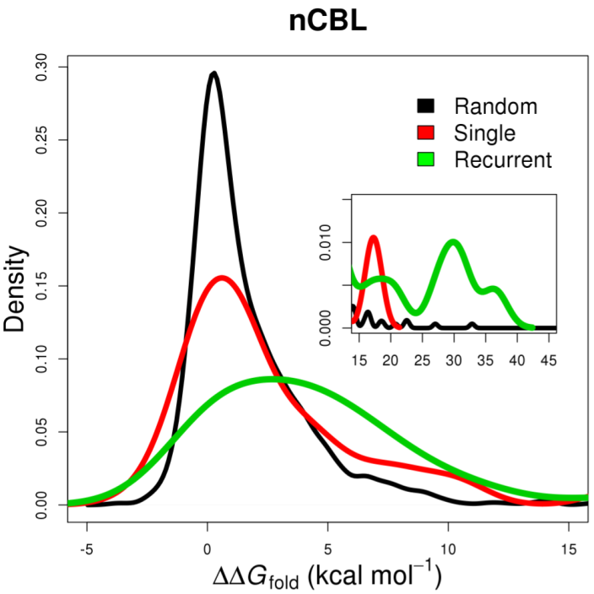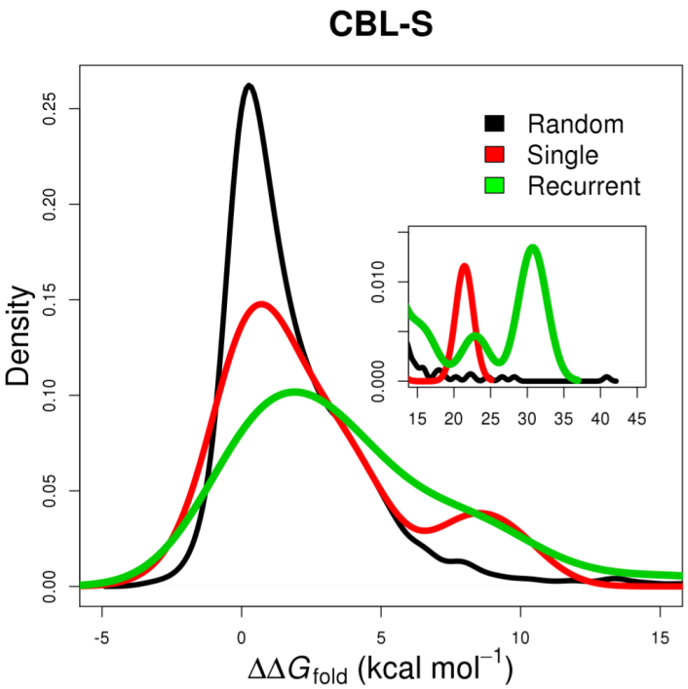

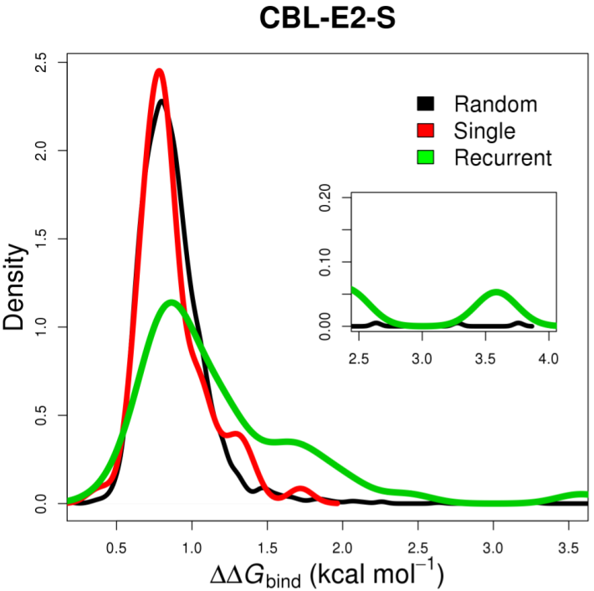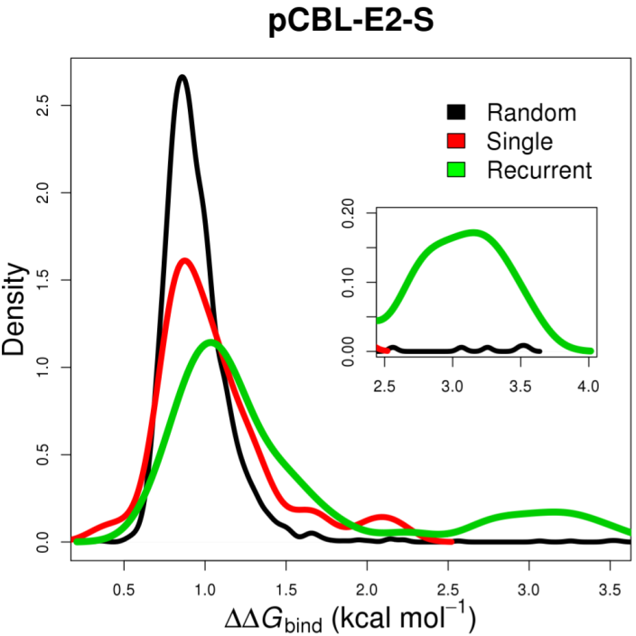

**Figure S2.**

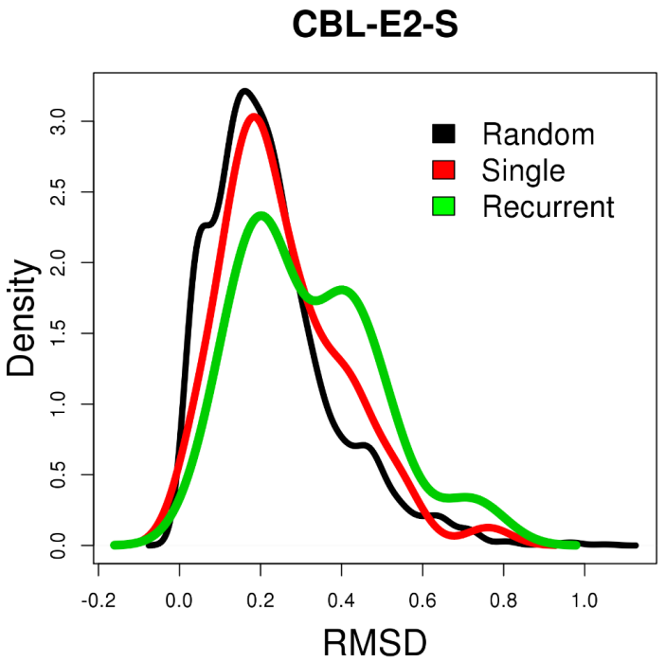 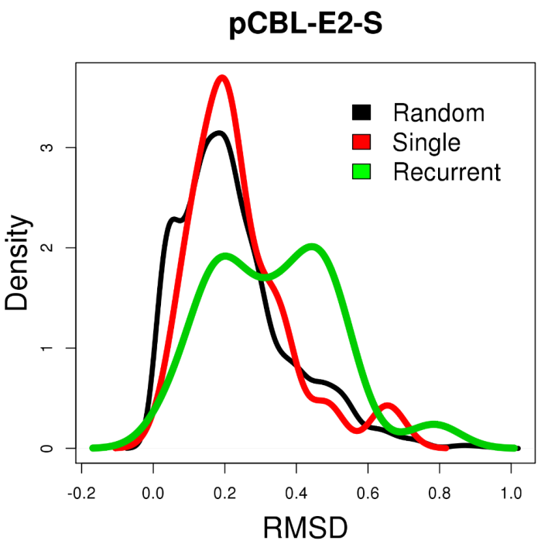

**Figure S3.**

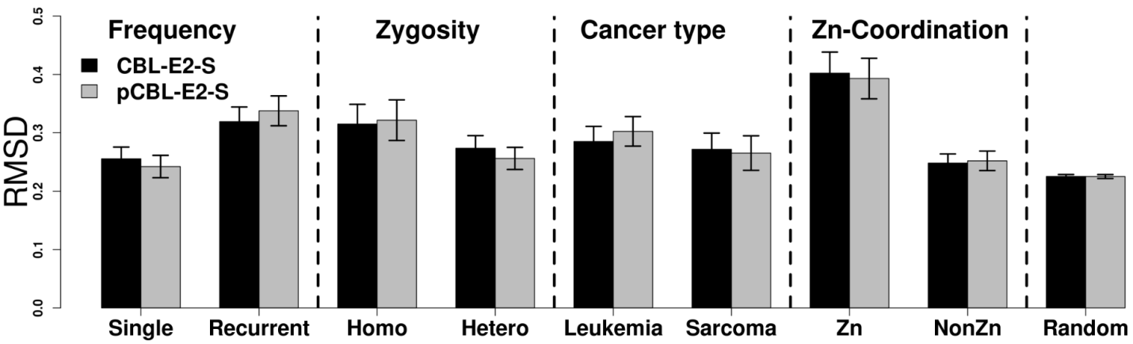

**Figure S4.**

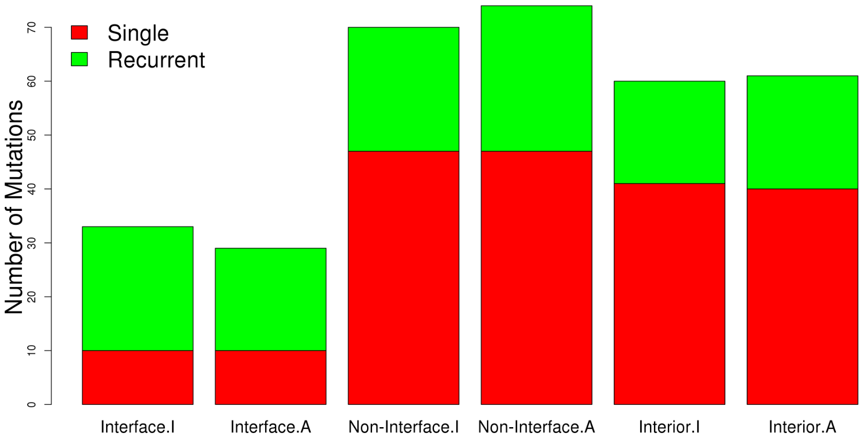

CBL-E2-S pCBL-E2-S

**Interface**

CBL-E2-S pCBL-E2-S

**Non-Interface**

CBL-E2-S pCBL-E2-S

**Interior**

Interior

**Figure S5.**

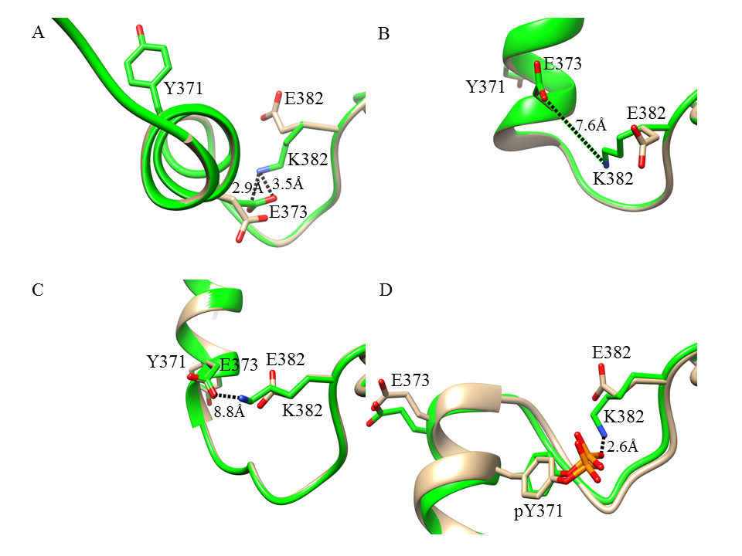

**Figure S6**.



**References**

1. Levy ED. A Simple Definition of Structural Regions in Proteins and Its Use in Analyzing Interface Evolution. Journal of molecular biology. 2010;403:660-70.