Supplementary data for:

**Pharmacological inhibition of centrosome clustering by slingshot-mediated cofilin activation and actin cortex destabilization**

Gleb Konotop, Elena Bausch, Tomoaki Nagai, Andrey Turchinovich, Natalia Becker, Axel Benner, Michael Boutros, Kensaku Mizuno,Alwin Krämer and Marc Steffen Raab

**Supplementary data includes:**

Extended experimental procedures

Supplementary Fig. S1. Effect of CP-673451 and Crenolanib on centrosome amplification in U2OS cells.

Supplementary Fig. S2. Crenolanib prolongs of mitotic duration.

Supplementary Fig. S3. CP-673451 activates cofilin in a dose-dependent manner in a variety of cancer cell lines.

Supplementary Fig. S4. Inhibition of cofilin phosphorylation by LIMKi3 and Damnacanthal.

Supplementary Fig. S5. Immunoblot analysis showing transient overexpression of different cofilin constructs and representative images of transfection efficiencies in U2OS-EGFP-PLK4 cells.

Supplementary Fig. S6. Validation of SSH knock-down by real-time PCR.

Supplementary Fig. S7. Effect of CP-673451 on SSH1 phosphatase activity.

Supplementary Fig. S8. Immunoblot analysis of different cell lines showing that CP-673451 increases Akt and MEK1/2 phosphorylation under normal cultivation conditions.

Supplementary Table S2. Average percentages of multipolar telophases in various cell lines after 24 hours of exposure to CP-673451 or crenolanib.

Supplementary Table S1 (description). Screen results.

Supplementary Movie S1-S3 (description). Mitosis in HeLa cells treated with DMSO, 1 µM or 2µM CP-673451.

**Extended experimental procedures**

**Cell lines (used for supplementary data)**

U2OS (wt), HeLa, SCC-114, HEK293T and H2B-mCherry-α-tubulin-EGFP-HeLa cell lines were cultivated in DMEM+GlutaMAX™. LOVO and 3Flag-STIL-HCT116 cells were cultivated in RPMI and McCoy’s media, respectively. MFC10A cells were grown in DMEM/F-12, with 5% horse serum (Life Technologies), 20 ng/ml hEGF (Invitrogen), 0.5 µl/ml hydrocortisone, 100 ng/ml cholera toxin and 10 µg/ml bovine insulin (Sigma-Aldrich). BJ fibroblasts were grown in MEM containing 1% sodium pyruvate and 1% non-essential amino acids (Life Technologies). All unmodified cancer cell lines were obtained from ATCC, validated by Multiplex human Cell Authentication (MCA) and tested for mycoplasma contamination. All media (Life Technologies) were supplemented with 10% FCS (Biochrom) unless otherwise indicated. Cell lines were maintained at 37°C and 5% CO2.

**Small-molecule screening assay and statistical analysis**

Kinase inhibitor (273 molecules) and FDA-approved (843 molecules) libraries were ordered from Selleckchem. EGFP-PLK4-U2OS cells were split into two populations: one was treated with 2 µg/ml tetracycline for induction of PLK4 expression, and the other with vehicle only (H2O). After induction (48 hours), both populations were replated on white bottom 384-well plates (Perklin Elmer), using a MultidropTM Combi Reagent Dispenser (Thermo). After another 24 hours of rest in fresh medium, libraries were added equally to both cell populations. After 5 days of incubation with the drugs, relative cell viabilities were determined using CellTiter-Glo® Luminescent Cell Viability Assay (Promega). Library dilution and pipetting was performed on a Biomek® FX (Beckman&Coulter). Plate incubation and readout was done on a Freedom EVO® robotic platform (Tecan) equipped with a LIA-Arm, 2 plate hotels (Liconic), a MultidropTM combi reagent dispencer (Thermo), a micro-plate washer (Biotek) and an Infinite F500 plate reader (Tecan). Induced and non-induced cells were screened in separate plates, in 4 replicates and with at least 60 DMSO-treated wells for each cell population and plate. Preparation steps for statistical analysis (reading, configuration, annotation and normalization) were performed separately for each plate layout according to the method described in Boutros et al. (56). “Percent of control” was employed for data normalizations, using DMSO-treated cells as reference. For compound-wise comparison between induced and non-induced groups linear regression models were applied. The empirical Bayes method (57) was used to moderate the standard errors of the estimated parameters. To account for multiple testing, p values were adjusted by the Benjamini-Hochberg procedure to control the false discovery rate (FDR) at level 0.05. The centrosome clustering inhibition (CCI) index is a relative value that reflects how a compound affects the viability of U2OS-EGFP-PLK4 cells with normal centrosome content (uninduced) in comparison to their isogenic counterparts with amplified centrosomes (induced). During normalization, the raw viability value *x* of each compound-read in each cell population is corrected to the median value of each population’s respective viability in the presence of DMSO, which acts as a negative control. The normalized viability value for each replicate is given as *xnorm*, where

.

The *CCI* *index* is calculated for each compound as a difference between the averages of *xnorm* of uninduced and induced cells:

,

(i.e. normalized viability reduction of induced versus non-induced cells by 10, 20, 30 and 50% corresponds to CCI indices of 0.15, 0.32, 0.51, 1, respectively). All statistical analyses were performed within the statistical software environment R (v3.1.2), using the R/Bioconductor packages cellHTS2 (v2_2.24.1) and limma (v3.16.8).

**Dose-response curves**

Dose-response curves were obtained as described (small-molecule screen) in 96-well format. Relative cell viabilities were determined with CellTiter-Glo® Luminescent Cell Viability Assay (Promega), by measuring luminescence with an Infinite200 plate reader (Tecan). Each measurement was performed in triplicate.

**Plasmid generation and siRNA**

ToPuro vector was produced by substituting the zeozine resistance of pCDNA™4/TO (Life Technologies) for the puromycin resistance cassette, using *Stu*I and *Sap*I. To generate ToPuro-EGFP-PLK4, amplified PLK4 cDNA (primers: GGACTCGAGAAATGGCGACC-TGCATCGG; GGACTCGAGTCAATGAAAATTAGGAGTCGG) was introduced into the *Xho*I site of pEGFP-C1 (Clontech). Subsequently, the EGFP-Plk4 sequence was cut out with *Nhe*I and *Sma*I, blunted and cloned into the *Eco*RV site of ToPuro. GFP-cofilin was generated by cloning cofilin cDNA (primers: GGAACTCGAGGGATGGCCTCCGGTGTG-GCTGTC; GCAAGGGATCCTCACAAAGGCTTGCCCTCCAGG) into pEGFP-C1, using the *Xho*I and *Bam*HI. GFP-SSH1 was generated by cloning SSH1L cDNA (primers: GGA-ACTCGAGGGATGGCCCTGGTGACCCTGCAGCG; GCAAGGTCGACTCAGCTTTTG-CTCATCCACGAAGGG) into the *Xho*I and *Sal*I sites of pEGFP-C1. All Plasmid DNA transfections were performed with TurboFECT (Life Technologies). Gene silencing of PDGFR-β, SSH1, SSH2 and SSH3 were performed with siGENOME Human SMARTpools M-003163-03-0005, M-008083-00-0005, M-008084-01-0005 and M-008937-00-0005, respectively. SiGenome Non-targeting siRNA Pool #1 was used as negative control (Dharmacon). Gene silencing experiments were carried out with Lipofectamine2000 (Thermo Fisher), at a final siRNA concentration of 50 nM for 72 hours unless otherwise indicated. For silencing experiments using induced EGFP-PLK4-U2OS cells, tetracycline was added 6 hours post transfection and removed after 48 hours, followed by 24 a hours resting period.

**Measurement of gene transcript levels**

Transcript levels of SSH1, SSH2 and SSH3 were analyzed by real-time PCR using the following TaqMan® Gene Expression Assays (Applied Biosystems): Hs00368014m1 (SSH1), Hs00810681 (SSH2), Hs00215309m1 (SSH3). Relative transcript levels were normalized to GAPDH (Hs99999905m1). RNA was extracted using the miRNeasy mini kit (Quiagen). RT reaction was made with TaqMan® RT Reagents (Applied Biosystems).

**Immunoblotting**

Samples were lysed in 100-300 µl of Laemmli loading buffer (250 mM Tris–HCl pH 6.4; 2%SDS; 100 nM β-MeEtOH) and proteins were separated by 10% or 15% SDS-PAGE and transferred to nitrocellulose membranes (Amersham). Membranes were blocked with 5% non-fat milk powder (Biorad) in 1xTBS containing 0.1% Tween-20. Membranes were incubated overnight at 4°C with primary (1:1000 in blocking solution) and for 1 hour at RT with secondary antibodies (1:5000 in blocking solution). After incubation, membranes were washed with 1xTBS/Tween (3 x 5 minutes) and developed with Pierce ECL Western Blotting Substrate (Thermo Scientific). Horseradish peroxidase (HRP) conjugated goat-anti mouse or goat-anti rabbit (Santa Cruz) antibodies were used as secondary antibodies.

**Image acquisition**

Time-lapse microscopy was performed at a Zeiss Cell Observer.Z1 equipped with a 10x Plan-Neofluar and an AxioCam CCD (Zeiss). During imaging cells were kept in 8 well µ-Slides (Ibidi GmbH) under controlled environmental conditions. Fluorescence microscopy was performed on a Zeiss Axiovert 200M equipped with a 40x Plan-Neofluar, 63x Plan-Apochromat and an AxioCam Mrm (Zeiss). Cells grown on coverslips were washed with 1xPBS and fixed in 4% PFA (15 minutes) or ice-cold methanol (7 minutes). Following PFA fixation, coverslips were permeabilized in 0.5% Triton X-100/PBS. Samples were blocked in 1x PBS containing 10% goat serum (Life Technologies) for 30 minutes, and incubated with primary antibodies for 1 hour. After 3 washes with 1x PBS samples were incubated with species-specific AlexaFluor® 488 or 568-conjugated antibodies for 30 minutes (1:1000; Molecular probes). After three more PBS washes, coverslips were mounted in DAPI-containing embedding medium (Vector laboratories). Primary antibodies included: Eg5 (clone 20, 1:500, BD), CP-110 (1:100, Acris), γ-tubulin (Tu-30, 1:1000, Exbio), pericentrin (1:1000, Abcam). Phalloidin-FITC (1:1000, Sigma-Aldrich) was used to stain F-actin. For telophase count cells were stained against Eg5.

**In vitro kinase assay**

293T cells were transfected with Myc-hLIMK1 (WT) or (DA, D460A (kinase-dead mutant)) using FuGene HD (Promega). After 48 hours, cells were washed with PBS and lysed with lysis buffer (50 mM Tris-HCl (pH 7.5), 150 mM NaCl, 1% NP-40, 10% glycerol, 1 mM DTT, 50 mM NaF, 1 mM Na3VO4, 50 mM EGTA, 1 mM PMSF, 10 mg/ml leupeptin, and 3 mg/ml pepstatin). After centrifugation to remove debris, Myc-hLIMK1 was immunoprecipitated with anti-Myc antibody and protein A-sepharose for 4 hours at 4ºC. The precipitates were washed with lysis buffer three times and with kinase buffer (20 mM Tris-HCl (pH 7.5), 10 mM MgCl2 and 1 mM DTT), and then incubated in kinase buffer containing 50 µM ATP, 185 kBq of [g-32P]ATP and His6-cofilin in the presence or absence of CP-673451 or 5 µM damnacanthal for 1 hour at 30ºC. The reaction mixtures were boiled in SDS sample buffer, and then analyzed by autoradiography and immunoblotting with anti-cofilin and anti-myc antibodies.

**In vitro phosphatase assay**

293T cells were transfected with the plasmid for SSH1-(Myc+His) (WT or CS), using Fugene HD (Roche). After 2 days, cells were lysed with lysis buffer (150 mM NaCl, 50 mM Tris-HCl pH 7.5, 1% NP-40, 10% glycerol, 1 mM dithiothreitol, 1 mM PMSF, 10 μg/ml leupeptin, 10 μM E-64 and 3 μg/ml pepstatin ). After centrifugation to remove debris, supernatants were incubated with anti-Myc antibody and protein A-Sepharose (GE Healthcare) for 4 h at 4ºC. The immunoprecipitates were washed with lysis buffer three times and then with reaction buffer (20 mM Tris-HCl pH 7.5, 10 mM MgCl2 and 1 mM dithiothreitol). The precipitants were incubated with 152 ng of purified cofilin-(His)6 and 4 μM of F-actin at 30°C for 1 hr in 35 μl of F-buffer (20mM Tris-HCl, pH 7.5, 100 mM NaCl, 2 mM MgCl2, and 0.1 mM dithiothreitol ). Reaction mixtures were separated by SDS-PAGE and analyzed by immunoblotting with anti-Myc, anti-cofilin and anti-P-cofilin antibodies. F-actin was stained with Amidoblack.

**Supplementary references:**

56. Boutros M, Brás LP, Huber W. Analysis of cell-based RNAi screens. Genome Biol 2006;7:R66.

57. Smyth GK. Linear models and empirical bayes methods for assessing differential expression in microarray experiments. Stat Appl Genet Mol Biol 2004;3:Article3.

**Supplementary figure S1**

C:\Users\konotop\Desktop\Picture2.tif

**Supplementary figure S1.** **Effect of CP-673451 and Crenolanib on centrosome amplification in U2OS cells.** Plot indicates the mean percentages ± SD of interphase cells with more than 2 centrosome signals after 24, 48 and 72 hours of drug exposure (counts/sample = 400, averaged from 2 independent experiments).

**Supplementary** D:\Dropbox\Manuscript CP Cre\Figures\Extended Figures\Fig S1.tif**figure S2**

**Supplementary figure S2. Crenolanib prolongs mitotic duration.** Mitotic durations in HeLa-H2B-mCherry-α-tubulin-EGFP exposed to the indicated concentrations of CP-673451 or crenolanib were quantified by time-lapse microscopy. To increase mitotic events, cells were synchronized in G1/S-phase with a single 2 mM thymidine treatment (18 hours). Compounds were added 3 hours after release. Imaging started 6 hours after release for a total of 16 hours. Values indicate the time from nuclear envelope breakdown until the onset of anaphase. Bars indicate averages.

**Supplementary figure S3**

**D:\Dropbox\Manuscript CP Cre\Figures\Extended Figures\Fig S2.tif**

**Supplementary figure S3. CP-673451 activates cofilin in a dose-dependent manner in a variety of cancer cell lines.** Exponentially growing cell lines were maintained under normal cultivation conditions and treated with the indicated concentrations of CP-673451 for a period of 3 hours. Cofilin activation was detected using a phospho-Ser3-cofilin antibody. Total cofilin indicates equal loading.

**Supplementary figure S4**

**D:\Dropbox\Manuscript CP Cre\Figures\Extended Figures\Fig S3.1.tifD:\Dropbox\Manuscript CP Cre\Figures\Extended Figures\Fig S3.2.tif**

**Supplementary figure S4. Inhibition of cofilin phosphorylation by LIMKi3 and damnacanthal.** Non-induced EGFP-PLK4-U2OS cells were exposed to increasing concentrations of LIMKi3 (left panel) or damnacanthal (right panel) for a period of 6 hours. Cofilin activation was analyzed by immunoblotting with anti phospho-Ser3-cofilin antibodies. α-Tubulin and NO66 antibodies were used as loading control.

**Supplementary figure S5**

**A**

**D:\Dropbox\Manuscript CP Cre\Figures\Extended Figures\Fig S4A.tif**

**B**

**D:\Dropbox\Manuscript CP Cre\Figures\Extended Figures\Fig S4B.tif**

**Supplementary figure S5. Immunoblot analysis showing transient overexpression of different cofilin constructs and representative images of transfection efficiencies in EGFP-PLK4-U2OS cells.** (**A**) Immunoblot shows the levels of endogenous cofilin (P-Cofilin and Cofilin) and exogenous cofilin (P-GFP-Cofilin and GFP-Cofilin). Non-induced cells were transiently transfected with the indicated constructs (24 hours). Lysates were analyzed via immunoblot with antibodies against total cofilin (both lower panels) or phospho-Ser3-cofilin (both upper panels). Note that the antibody that specifically detects phospho-Ser3 residue of cofilin reacted with the phospho-mimicking S3E residue. (**B**) Fluorescence and the corresponding transmitted light images of induced cells, transiently transfected with the indicated constructs, at the end of a time-lapse experiment (approx. 14 hours post transfection). Scale bars, 100 µm.

**Supplementary figure S6**

**D:\Dropbox\Manuscript CP Cre\Figures\Extended Figures\Fig S5.tif**

**Supplementary figure S6. Validation of SSH knock-down by real-time PCR.** U2OS cells were transfected with RNAi pools against SSH1 (siSSH1), SSH2 (siSSH2), SSH3 (siSSH3) or control, at a final concentration of 50 nM, for a period of 72 hours. After normalization to GAPDH transcript levels (housekeeping), relative SSH transcript amounts of all samples were compared to the SSH transcript levels of cells transfected with non-targeting control siRNA (100%). Bars indicate average values ± SD of 2 independent experiments. PCR reactions were performed in duplicate.

**Supplementary figure S7**

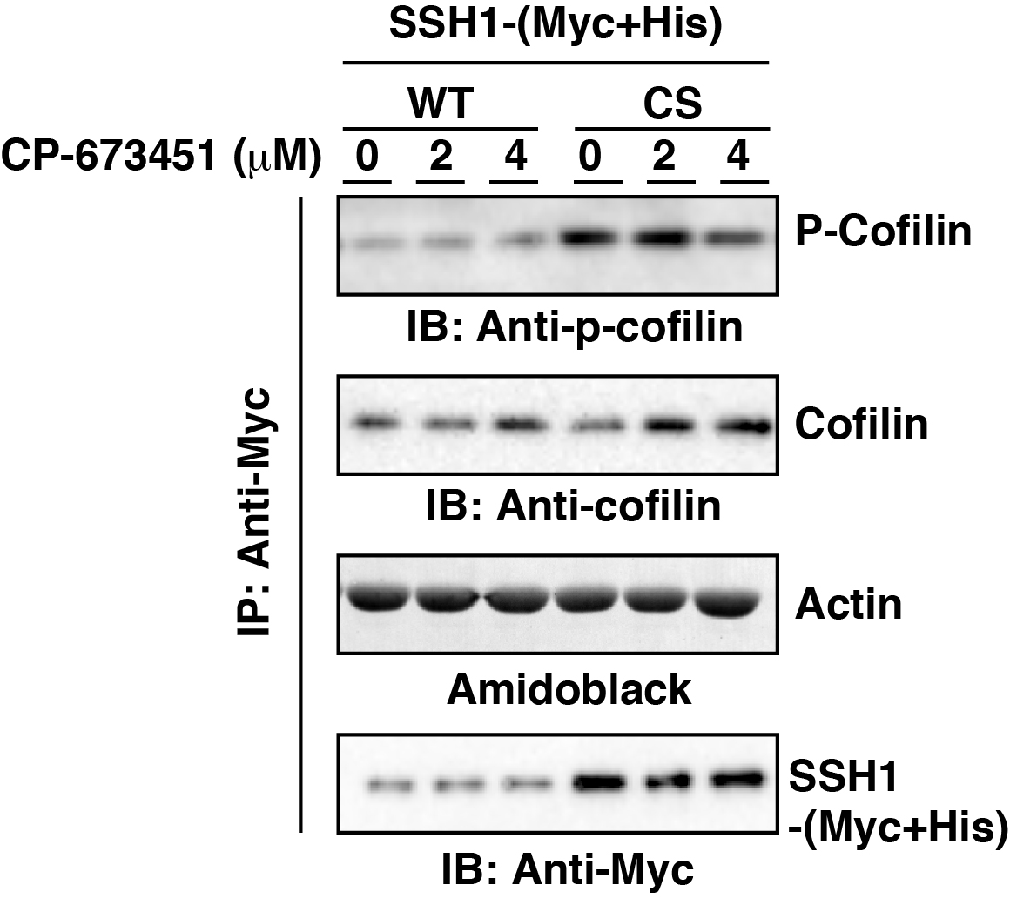

**Supplementary figure S7. Effect of CP-673451 on SSH1 activity.** (Myc+His)-tagged wild-type (WT) SSH1 or its inactive CS mutant was expressed in 293T cells and immunoprecipitated with an anti-Myc antibody. The precipitates were subjected to in vitro phosphatase assay in the presence or absence of CP-673451, using purified cofilin-(His)6 as a substrate. The phosphatase activity was measured by immunoblotting with an anti-P-cofilin antibody.

**Supplementary figure S8**

**D:\Dropbox\Manuscript CP Cre\Figures\Extended Figures\Fig S6A.tif**

**A**

**D:\Dropbox\Manuscript CP Cre\Figures\Extended Figures\Fig S6B.tifD:\Dropbox\Manuscript CP Cre\Figures\Extended Figures\Fig S6C.tif**

**C**

**B**

**Supplementary figure S8. Immunoblot analysis of different cell lines showing that CP-673451 increases MEK1/2 and Akt phosphorylation under normal growth conditions.** (**A**) Indicated cell lines, maintained under normal culture conditions (in the presence of serum) were treated with the indicated concentrations of CP-673451 for 3 hours. Levels of phosphorylated Ser217/221-MEK1/2 and Ser473-Akt were detected with the respective phospho-specific antibodies. Total cofilin levels indicate equal loading. (**B**) Immunoblot analysis of phospho-Ser473-Akt in U2OS after 24 hours exposure to the indicated concentrations (µM) of CP-673451. Total cofilin was used as loading control. (**C**) Immunoblot comparing phospho-Ser217/221-MEK and phospho-Ser473-Akt between U2OS cells transfected with siRNA pool targeting PDGFR-β (siPD-β) or non-targeting control pool (siCtrl). After a 72 hours knock-down cells were treated with 2 µM CP-673451 (CP), crenolanib (Cre) or DMSO (D) for 3 hours. Equal loading is shown by total cofilin levels.

**Supplementary table S2. Average percentages of multipolar telophases in various cell lines after 24 hours of exposure to CP-673451 or crenolanib.** Centrosome amplification indicates the percentage of cells containing more than 2 γ-tubulin signals (cell counted n = 400/cell line). For telophase quantification, cells were immunostained against Eg5. At least 300 telophases from 2 independent experiments were counted for each sample. EGFP-PLK4-U2OS and 3Flag-STIL-HCT116 cells were induced for 48 hours and rested in fresh media for another 24 hours before compound treatment. Telophases could not be quantified in some samples due to very low amounts of mitotic events or aberrant mitotic morphology (n/a).

D:\Dropbox\Manuscript CP Cre\Figures\Table 1.tif

**Supplementary table S1. Screen results.** For each library and concentration, compounds are divided into two groups, according to readout significance (black, P < 0.05; grey P > 0.05) and sorted from highest to lowest CCI index. Compounds highlighted in bold representa CCI index higher than 0.3, indicating that viability of cells with CA was significantly affected in comparison to cells with normal centrosome content (by approx. 20%). Relative overall viability of each drug-treated cell population in comparison to the corresponding DMSO-treated population (maximum viability = 1) is indicated by rel.Control or rel.Tet. Compounds that eradicated both cell populations, giving a false positive result are highlighted in red (i.e. Crizotinib).

**Supplementary Movies.** Representative fluorescence time-lapse microscopy comparing mitotic events of H2B-mCherry-α-tubulin-EGFP- HeLa cells treated with DMSO (movie 1), 1 µM CP-673451 (movie 2) and 2 µM CP-673451 (Movie 3). To increase mitotic events, cells were synchronized in S-phase with a single 2 mM thymidine treatment for 18 hours. Compounds were added at the indicated concentrations 3 hours after release and imaging started 6 hours after release. Images were made in 5 minute intervals. Total mitosis duration: movie 1 and 3 – 2 hours; movie 2 – 3 hours. Scale bars, 10 µm.