**Supplemental Data**

**Supplemental Figure S1.** IL-6 and IL-6 receptor regulate proliferation of cancer lines. A, Effect of IL-6 and IL-6R siRNA knockdown on cell growth and signaling. DU145 cells were transfected with siRNA against IL-6 or IL-6R. The levels of IL-6, sIL-6R, and pSTAT3 were measured in cell supernatant or cell lysates. Cell proliferation was measured using the CellTiter Glo® assay. B, Over-expression of IL-6 stimulated MCF-7 tumor growth. The same number of MCF-7 or MCF-7/IL-6 cells were plated. Triplicate wells were read after 7 days, and relative luminescence units corresponding to cell growth are shown. Two million MCF-7 or MCF-7/IL-6 cells mixed with 50% Matrigel were injected into the mammary fat pads of athymic nude mice with or without estrogen pellets.

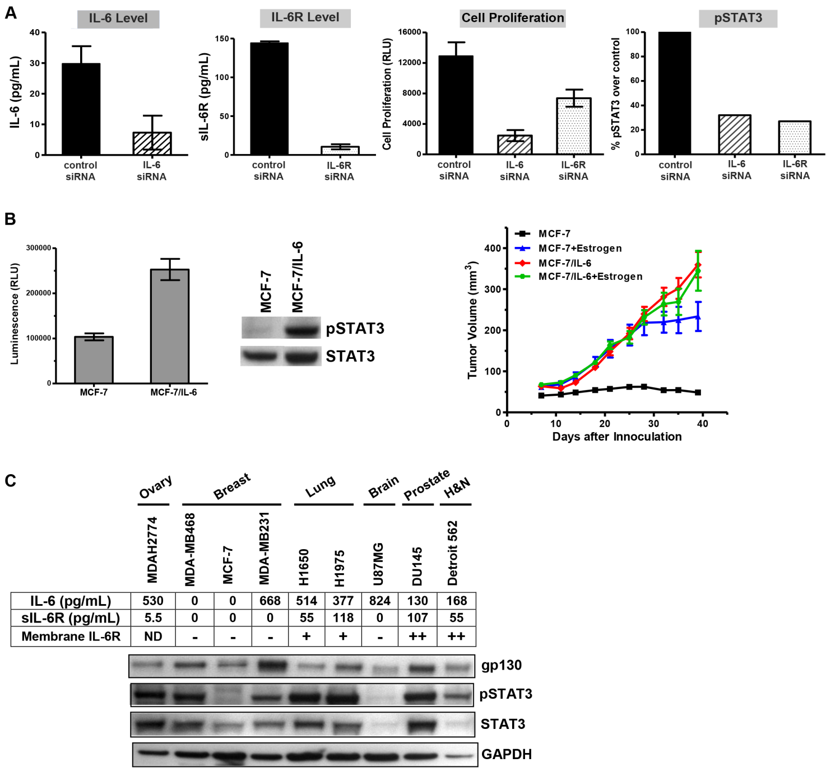

**Supplemental Figure S2.** Representative FACS plots of membrane IL-6R in MDA-MB-468 (negative), DU145 & Detroit 562 (positive), and U266 (positive control) lines.

MDA-MB468

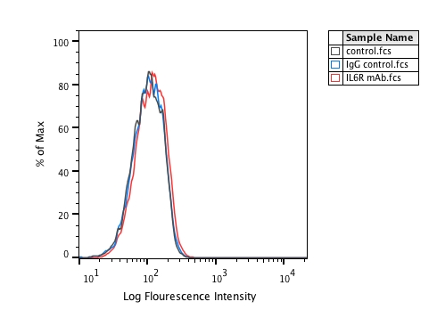

DU145

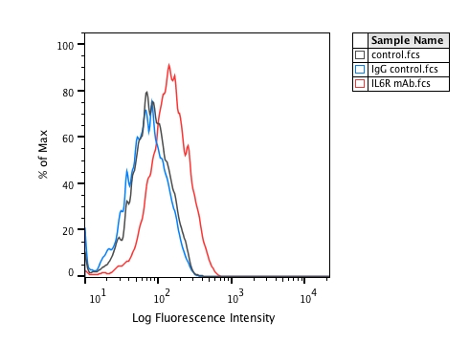

Detroit 562

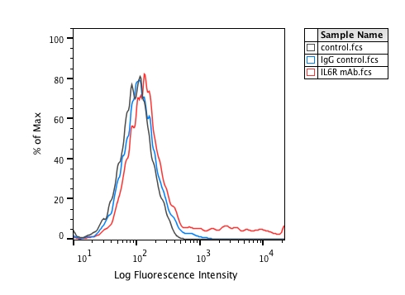

U266

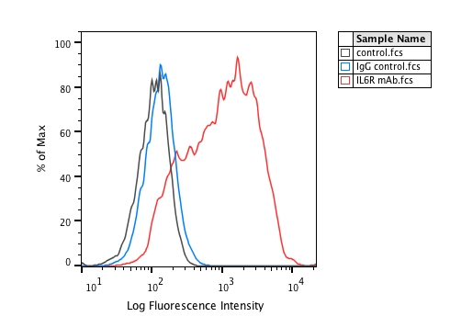

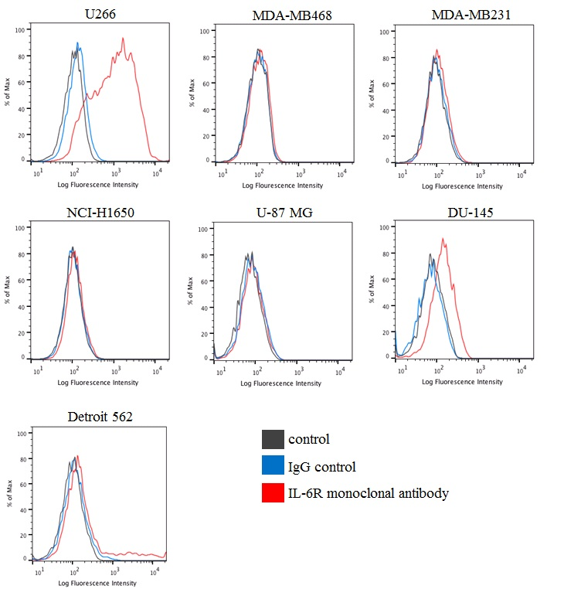

**Supplemental Figure S3.** Comparison of *in vivo* anti-tumor activities of MEDI5117 and siltuximab (CNTO328) in DU145 and MDAH-2774 tumor xenograft models.

DU145 or MDAH-2774 cells were implanted into the right flank of female athymic mice. Mice were randomized into treatment groups when the subcutaneous (SC) tumors reached approximately 150 to 200 mm3 in volume. MEDI5117 or CNTO328 was administered to the tumor-bearing mice via IP injection at a dose of 30 mg/kg, twice per week, n = 10 animals/group.

Untreated

Isotype control

MEDI5117

CNTO328

**5**

**10**

**15**

**20**

**25**

**30**

**35**

**40**

**45**

**100**

**200**

**300**

**400**

**500**

**600**

**700**

**800**

**900**

**Days Post Implantation**

**T**

**u**

**m**

**o**

**r**

**V**

**o**

**l**

**u**

**m**

**e**

**(**

**m**

**m**

**3**

**)**

**DU145**



**Supplemental Figure S4.** MEDI5117 inhibits human IL-6 in a dose-dependent manner *in vivo*. An *in vivo* model was generated where human IL-6 was administered by intraperitoneal injection into male C57/B/6/J mice and concentrations of the acute phase protein haptoglobulin was measured.

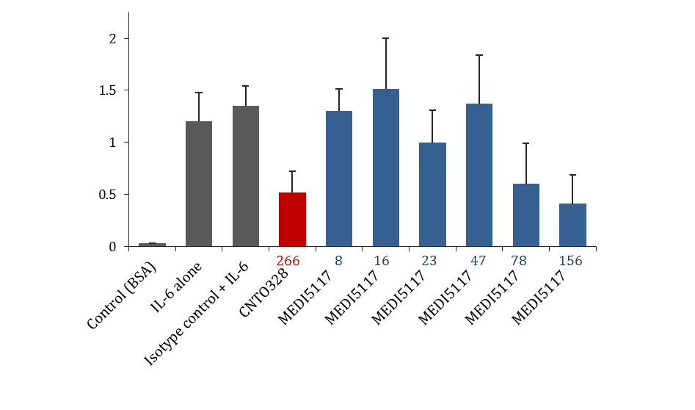

mAb (g/kg) + IL-6 (12 g/kg)

Plasma haptoglobin (mg/mL)

*

*

*

p<0.05 vs isotype control + IL-6

*

**Supplemental Figure S5.** *In vivo* efficacy of MEDI5117 in combination with various chemotherapeutics in different tumor xenograft models.

A. *In vivo* efficacy study in DU145 xenograft model testing MEDI5117 in combination with taxotere. MEDI5117 was dosed at 30 mg/kg IP twice per week for 4 weeks. Doxorubicin was dosed at 6 mg/kg I.V. every 4 days for 3 doses.

B. *In vivo* efficacy study in NCI-H1650 xenograft model testing MEDI5117 in combination with gemcitabine and cisplatin. Groups of animals were either untreated or treated with vehicle or with MEDI5117 alone (30 mg/kg dosed IP twice per week for 3 weeks), or gemcitabine (120 mg/kg IP) with cisplatin (4 mg/kg IP) dosed every 4 days for 2 doses, or the combination of MEDI5117 with gemcitabine-cisplatin. Tumors were collected for human IL-6 and pSTAT3 assays.

C. *In vivo* efficacy study in NCI-H1650 xenograft model testing MEDI5117 in combination with alimta (Pemetrexed) and carboplatin. MEDI5117 was dosed at 30 mg/kg IP twice per week for 5 weeks. Alimta was dosed at 100 mg/kg IP daily for 5 days. Carboplatin was dosed at 70 mg/kg IP every 4 days for 3 doses.

D. *In vivo* efficacy study in MDAH2774 xenograft model testing MEDI5117 in combination with doxorubicin. MEDI5117 was dosed at 30 mg/kg IP twice per week for 4 weeks. Doxorubicin was dosed at 6 mg/kg I.V. every 4 days for 3 doses. Tumors were collected for human IL-6 and pSTAT3 assays.

E. *In vivo* efficacy study in MDAH2774 xenograft model testing MEDI5117 in combination with topotecan. MEDI5117 was dosed at 30 mg/kg IP twice per week for 4 weeks. Topotecan was dosed at 1 mg/kg I.V. daily for 5 days, stopped for 2 days, then repeated with one more cycle.

**A.**



**Treatment**

**Regrowth**

**60 %\***

**ΔTGI**

**Overall**

**Response**

**0 %**

**0 %**

**46 %**

**85 %**

**114 %**

**\* 30% PR, 30% CR**

**B.**

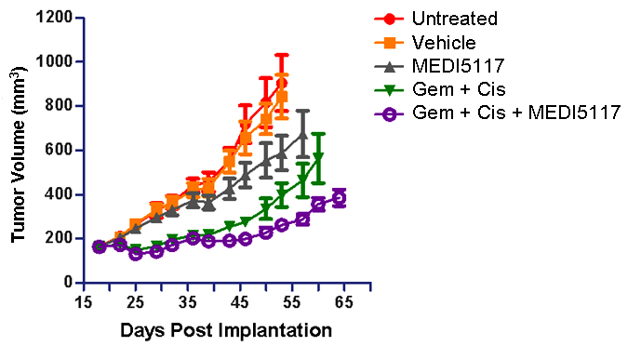



**C.**



**D.**





**E.**



**Supplemental Figure S6**. Expression of cytokines in BT474 and BT474-PTEN-LTT cells. A. Expressions of cytokiees IL-6, IL-8, TGF-b and sIL-6R as assessed by ELISA showing that these cytokines are significantly higher in BT474-PTEN-LTT cells compared to the BT474. B. Surface IL-6R expression was analyzed by Flow cytometry and showing an enhanced expression of this protein in BT474-PTEN-LTT cells.



