Supplementary
Materials & Methods

Primary human cancer cells. The single cell-derived (SCD) tumor was generated by injecting a single autofluorescent positive CSC isolated from PDAC-185 (1). For in vitro studies, PDX tumors were minced, enzymatically digested with collagenase (Stem Cell Technologies, Vancouver, BC) for 60 min at 37°C and after centrifugation for 5 min at 1,200 rpm the pellets were resuspended and cultured in RPMI medium (Roswell Park Memorial Institute) supplemented with 10% fetal bovine serum (FBS) and 50units/mL penicillin/streptomycin.
Illumina methylation array. Total DNA was isolated using standard phenol-chloroform extraction. Bisulfite converted DNA was isothermally amplified at 37°C (20-24h). The amplified DNA product was fragmented by an endpoint enzymatic process. Fragmented DNA was precipitated, resuspended, and applied to an Infinium Human Methylation450K BeadChip (this array allows for the comparison of the DNA methylation status of 485,578 CpG loci across samples, covering all RefSeq genes at single-nucleotide resolution, microRNAs and differently methylated regions) and hybridized at 48°C (16-24h). During hybridization, the amplified and fragmented DNA samples anneal to specific oligomers covalently linked to the different bead types. The bead chips were then subjected to a single-base extension reaction. This reaction incorporates labeled nucleotides into the extended primers hybridized to DNA on the BeadChip. For methylation analysis, IDAT files were loaded into the R environment using the Bioconductor minfi package 3. The arrays were then background and control normalized using the minfi package. Technical differences between Infinium I and Infinium II probes were removed using Subset-quintile Within-Array Normalization, developed by Maksimovic et al. and available in the minfi package (2). The methylation status for each probe was recorded as a β-value.
Genomic region analysis. A probe was marked to be in a ‘‘promoter’’ region if it was located in the first exon, the 5' UTR, or a region up to 2 kbp upstream of the transcription start site (TSS) of any given transcript. Similarly, an ‘‘intragenic’’ probe was labeled if it was inside any intron or any exon other than the first. Intergenic probes were determined as those not falling into either of the two previous categories. A contingency table was built for each subset of probes and genomic regions, with one variable indicating whether a given probe belonged or not to the subset, and the other indicating whether a given probe was labeled with the selected region. Significance of the association was determined by a Pearson’s Chi-squared test with Yates’ continuity correction. A significance level of 0.05 was used to determine whether a subset was dependent with respect to a given genomic region and an odds ratio was used as a measure of effect size.
CGI status analysis. The CGI locations used in the analyses were obtained from the R/Bioconductor package FDb.InfiniumMethylation.hg19 (R package version 1.0.1). The definition of CGI was done as described previously (3). Specifically, ‘‘CpG shores’’ were defined as the 2-kbp regions flanking a CGI. ‘‘CpG shelves’’ were defined as the 2-kbp regions either upstream of or downstream from each CpG shore. Probes not belonging to any of the regions previously mentioned were assigned to the category ‘‘non-CGI.’’ Each probe was assigned to only one of the categories. In order to study the association between the given subset and the different CGI categories a 4-3-2 contingency table was constructed for every subset of probes. Firstly, a Chi-squared test was used to determine if any of the categories had a significant association with the given subset. Additionally, a 2-3-2 contingency table was defined and another Chi-squared test was used to independently evaluate the association of the given subset with each status level, a significance level of 0.05 being employed for all tests. Effect size was reported as the odds ratio for each of the individual tests.
AntagomiRs. The miR-17-92 cluster was knocked down using a mix of hsa-miR-17, 18a, 19a, 19b, and 20a antagomiRs (1.2μM each) or scrambled control. All antagomiRs were chemically synthesized as 2-O-methyl-oligoribonucleotide phosphorothioates containing cholesterol as modification of the 3’ end to facilitate cellular uptake (BioSpring, Frankfurt, Germany).
Cell viability assay. Cells were seeded in 96-well plates (Nalgen Nunc International, Penfield, NY) at a concentration of 10⁴ cells per well in 100µL of complete medium, allowed to attach for 24h and then treated with Zebularine or Decitabine for an additional 24h. Cytotoxicity was assessed using a bioluminescence-based Toxilight BioAssay assay following the manufacturer’s recommendations (Lonza, Basel, Switzerland). All the experiments were done in triplicates.
Apoptosis assay. Cancer cells and CSCs were plated at 3x10⁵ cells/well in 6-well multi-well plates and cultured in the presence of Zebularine (75μM) for the indicated days. Attached and floating cells were collected, resuspended and stained for the CSC surface marker CD133 prior to staining with AnnexinV (550474) in AnnexinV binding buffer (556454; both from BD Pharmingen, San Jose, CA). Cells were then stained with DAPI and analyzed by flow cytometry.
Cell cycle analysis. Cells were trypsinized, washed in PBS, centrifuged, and pellets were fixed in 200µl of 70% ethanol and stored at -20°C until use. Cells were centrifuged and pellets resuspended in 200µl of PBS containing 10µg/mL of RNAse A and incubated for 1h at 37°C. Cells were then stained with DAPI and analyzed by flow cytometry. For the identification of G0 quiescent population, cells were fixed in 70% ethanol at -20°C overnight, washed with PBS twice and stained with Ki67 (BD) for 30min at room temperature, followed by an additional wash with PBS. Cells were stained with DAPI to perform cell cycle analyses using a FACS CANTO II (BD) instrument.
Protein extraction and Western blotting. Cells were harvested in RIPA buffer (Sigma-Aldrich, St. Louis, MI) supplemented with a protease inhibitor cocktail (Roche Applied Science, Indianapolis, IN). The cell lysate was centrifuged at 14,000 rpm and the supernatant was collected. Protein lysates were quantified using a BCA Protein Assay Reagent kit (Pierce, Thermo Scientific, Waltham, MA). 50µg of protein was resolved by SDS-PAGE and transferred to nitrocellulose membranes (Amersham, Piscataway, NJ). Membranes were sequentially blocked with 1X TBS containing 5% BSA (w/v), or 5% (w/v) milk and 0.1% Tween20 (v/v), incubated with a 1:1,000 dilution of antibodies against NANOG (D73G4; Cell signaling); α-TUBULIN (#2144; Cell Signaling Tech, Danver, MA), β-ACTIN (Sigma-Aldrich), DNMT1 (D63A6; Cell signaling), and P21 (12D2; Cell Signaling) overnight at 4ºC, washed three times with 1X PBS containing 0.1% Tween20 (v/v), incubated with horseradish peroxidase-conjugated goat anti-rabbit or goat anti-mouse antibody (Sigma-Aldrich), and washed again to remove unbound antibody. Bound antibody complexes were detected with SuperSignal chemiluminescent substrate (GE Healthcare, Little Chalfont, UK).
RNA extraction and RT-qPCR. Total RNA was isolated by the guanidine thiocyanate method using standard protocols (4). One µg of purified RNA was used for cDNA synthesis using the QuantiTect Reverse Transcription Kit (Qiagen), followed by SYBR green RTqPCR using an Applied Biosystems 7500 real-time thermocycler (Applied Biosystems. Waltham, MA). Thermal cycling consisted of an initial 10min denaturation step at 95°C followed by 40 cycles of denaturation (15sec at 95°C) and annealing/extension (1min at 60°C). For miR analysis, 1µg of total RNA was reverse-transcribed using the NCode VILO miR cDNA synthesis kit according to the manufacturer's recommendations (Invitrogen, Waltham, MA). This step adds a polyadenylate tail to the miR population within the total RNA samples. The resulting cDNA was subjected to real-time PCR using SYBR Green ER qPCR Mix (Invitrogen). The Universal qPCR Primer was provided in the VILO kit and the forward primer for miR-17, 18a, 19a, 19b, 20a, 92a, 203, 205 Snord95 and Snord44 were purchased from Qiagen or Exiqon (Vedaek, Denmark).
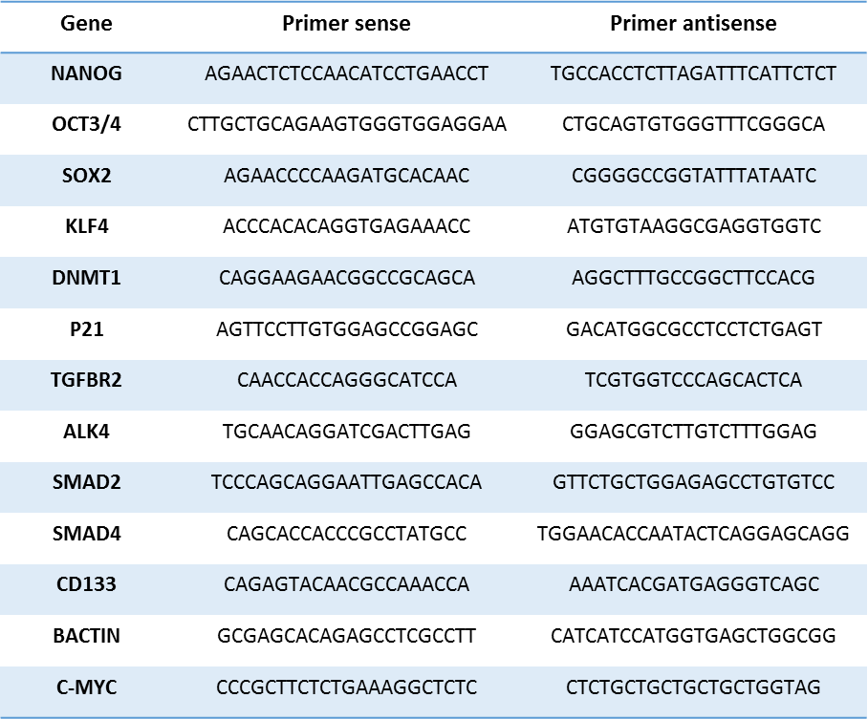
List of primers used for RT-qPCR
5mC quantification. Standard protocol was followed for the manual dot blot analysis. Briefly, DNA samples were diluted with TE buffer, denatured by heating to 99°C for 5min, chilled rapidly on ice and then loaded on a Hybond N+ nylon membrane (GE Health, Piscataway, NJ, USA). DNA was cross-linked using a Hoefer™ UVC 500 Ultraviolet Crosslinker (70,000 micro-joules/cm2). After crosslinking, membranes were blocked with 5% fetal bovine serum (BSA) for 1 h at room temperature, and then incubated with a polyclonal anti-5mC antibody (Active Motif, Carlsbad, CA, USA; #39649, 1:250) at 4°C overnight. 5mC was visualized by chemiluminescence. For quantification of 5mC we used the MethylFlashTM Methylated DNA Quantification Kit (Epigenetek; P-1034-96). In brief, 200 ng of DNA was added to the wells and subsequent quantification of 5mC was performed following the manufacturer’s instructions.
CRISPR/Cas9-mediated knockout of DNMT1. In order to disrupt DNMT1, two sgRNAs targeting the CDS were designed according to http://crispr.mit.edu. Specific guide RNAs were synthesized as complimentary oligos, phosphorylated with T4 polynucleotide kinase (New England Biolabs), annealed, and cloned into the BbsI (New England Biolabs) site of pKLV-U6gRNA/BbsI-PKG-puro2A-BFP. The ligation mixture was transformed into OneShot chemically competent DH5alpha cells (Invitrogen). After plasmid DNA extraction (Qiagen), the sequence of the construct was verified by automated DNA sequence analysis. Replication-incompetent lentiviral particles, contacting two different sgRNAs were produced in HEK293T following PEI-based transfection of cells with the packaging plasmids pCDNA3.1-VSV-G and pPAX2, as well as either one of the sgRNA plasmids. Forty-eight hours post transfection the medium was collected, cleared by low-speed centrifugation, filtered through 0.45µm pore-size PVDF filters, and stored in aliquots at -80ºC. The viruses were subsequently titered by flow cytometry analysis of BFP expression in 293T cells infected with increasing dilutions of virus. 185 PDAC cells stably expressing Cas9 were infected with viruses containing both DNMT1 sgRNAs at MOI=5 and selected with puromycin (1.5µg/ml) for 2 weeks. Loss of DNMT1 expression was confirmed by western blot analysis.
Sequences of CRISPR sgRNA used in this study:

NAME | sgRNA sequence (5′–3′)
DNMT1 gRNA#1 (forward) | CACCGCGCTGCCCGACGATGTCCGC
DNMT1 gRNA#1 (reverse) | TAAAACGCGGACATCGTCGGGCAGCGC
DNMT1 gRNA#2 (forward) | CACCGTGCCCGACGATGTCCGCAGG
DNMT1 gRNA#2 (reverse) | TAAAACCCTGCGGACATCGTCGGGCAC

Immunofluorescence. Primary pancreatic cancer cells were seeded on cover slips in 6-well culture dishes (Corning, One Riverfront Plaza, NY) and treated with Zebularine. Following 7 days of treatment, cells were washed twice with 1X PBS, fixed with 4% formaldehyde for 10 min and blocked for 5 min with 10% heat inactivated normal donkey serum. After blocking, cells were permeabilized with 0.2% Triton X-100 for 10 min and incubated with the following antibodies: anti-Cytokeratin (CK3-6H5)-FITC (1:10, # 130-080-101 Miltenyi Biotec) and anti-E-Cadherin (1:50;
# 610182 BD Biosciences). For E-Cadherin staining, cells were washed two times with 1X PBS and stained with Alexa-Fluor555-conjugated secondary antibody (1:500; # 558617 BD Biosciences). The nuclei of cells were stained with DAPI (5μg/ml; Sigma, St. Louis, MO) and cover slips were analyzed using an LSM-710 confocal microscope (Leica, Heidelberg, Germany).
Immunohistochemistry. For histopathological analysis, FFPE blocks were serially sectioned (3µm thick) and stained with hematoxylin and eosin (H&E).

Supplementary references
1. Miranda-Lorenzo I, Dorado J, Lonardo E, Alcala S, Serrano AG, Clausell-Tormos J, et al. Intracellular autofluorescence: a biomarker for epithelial cancer stem cells. Nat Methods 2014;11(11):1161-9.
2. Maksimovic J, Gordon L, Oshlack A. SWAN: Subset-quantile within array normalization for illumina infinium HumanMethylation450 BeadChips. Genome Biol 2012;13(6):R44.
3. Wu H, Caffo B, Jaffee HA, Irizarry RA, Feinberg AP. Redefining CpG islands using hidden Markov models. Biostatistics 2010;11(3):499-514.
4. Chomczynski P, Sacchi N. Single-step method of RNA isolation by acid guanidinium thiocyanate-phenol-chloroform extraction. Anal Biochem 1987;162(1):156-9.

