Supplementary Information

Controlling extracellular matrix assembly by modulators of collagen fibril alignment attenuates invasive tumor cell behavior
Moran Grossman, Nir Ben-Chetrit, Alina Zhuravlev, Ran Afik, Elad Bassat, Inna Solomonov, Yosef Yarden and Irit Sagi.

This file contains:
Fig S1-S10
Table S1-S2
Supplementary materials and methods

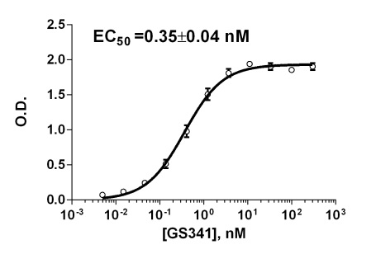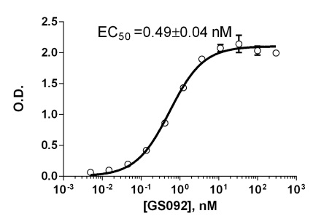
Fig. S1. Comparison of binding affinities of representative anti-LOXL2 clones (GS341 and GS092) to the catalytic domain of LOXL2 determined by ELISA.
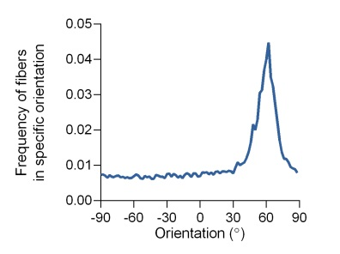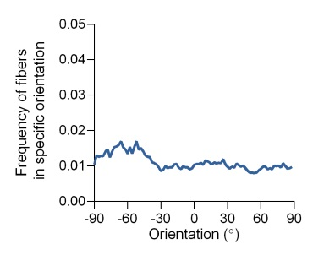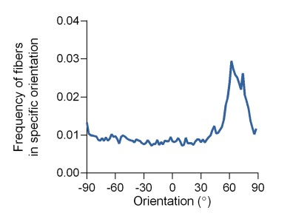
IgG GS341 GS092
Fig. S2. Representative directionality analysis of the SHG images displayed in Fig. 1e obtained by Fourier component analysis in Fiji using the ‘directionality’ plugin created by Jean-Yves Tinevez (http://pacific.mpi-cbg.de/wiki/index.php/Directionality).
A GS341 B GS092 C GS341
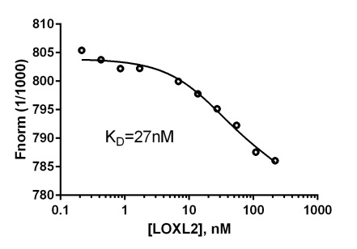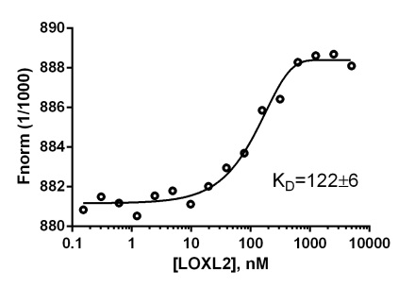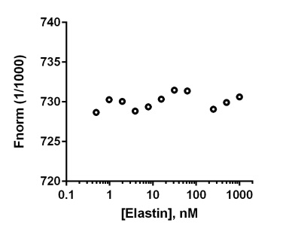
Fig. S3. Determination of the binding dissociation constants of GS341 and GS092 to LOXL2 using MST. A,B) Binding of LOXL2 to fluorescently labeled GS341. LOXL2 is titrated against fluorescently labeled GS341 or GS092. The antibody’s thermophoresis behavior changed upon binding of the protein to the antibody, and the affinity was calculated to be 27nM and 122nM, respectively. C) Competitive MST. 20nM of LOXL2 and 20nM of labeled GS341 were pre-incubated in room temperature. Aliquots of this mixture were mixed with increasing amounts of elastin followed by thermophoresis measurements. No significant change is observed in thermophoresis.
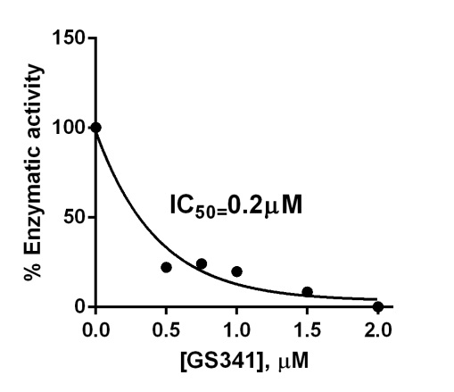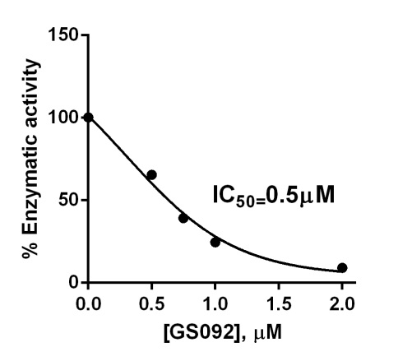
Fig. S4. The enzymatic activity of LOXL2 was measured by coupling horse radish peroxidase activity to LOXL2 and using the conversion of Amplex Red to resofurin as a readout, using λ_{ex}=540 nm and λ_{em}=590 nm.
Fig. S5. Western blotting of lysates and supernatants of the fibroblast cells exposed to the GS341 antibody did not identify any cross-reactivity of the antibody with other family members. In addition, western blotting of commercial human and mouse LOXL2 using GS341 as the primary antibody revealed cross-reactivity of the GS341 antibody with both human and mouse LOXL2.

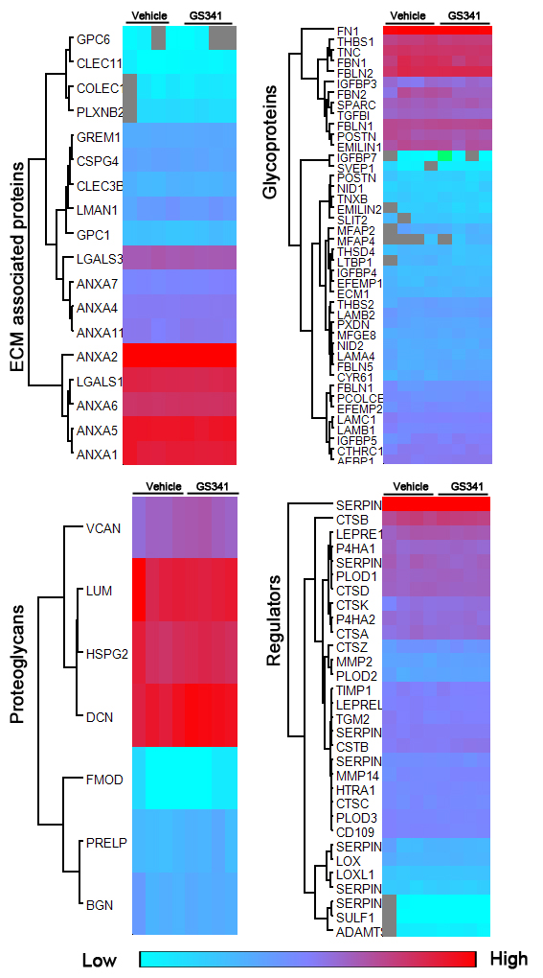
Fig. S6. Global proteomic mass spectrometry analyses of ECM proteins from HDF cells. Results were obtained in quadruplets. Presented are four replicates for each treatment.

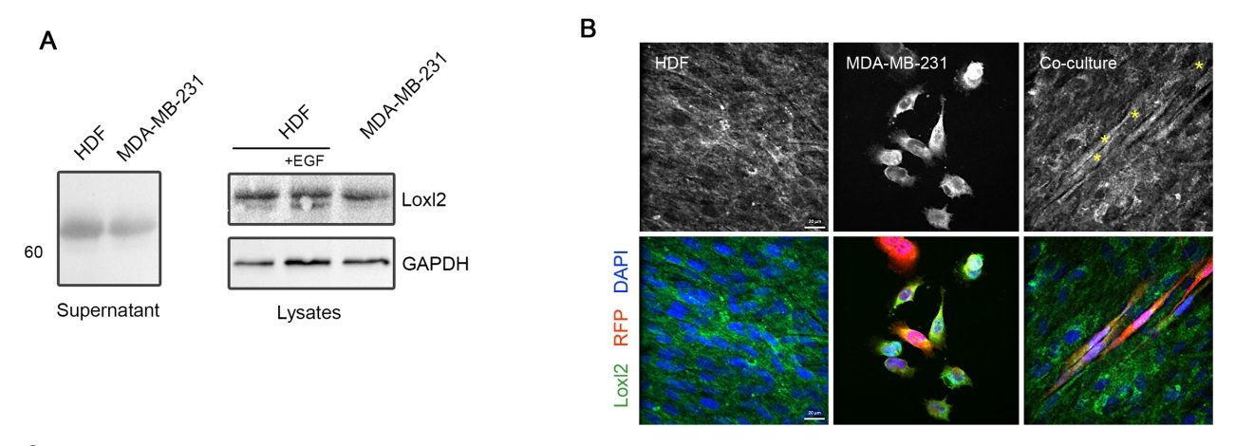
Fig. S7. LOXL2 is expressed by both the HDF cells and the cancer MDA-MB-231 cells. (A) Western blot analyses of cell supernatants and lysates of both HDF and MDA-MB-231 cells indicate expression of LOXL2 by both the stroma and the tumor. (B) The presence of LOXL2 in both HDF and MDA-MB-231 cells was confirmed by immunofluorescence staining for LOXL2 (Alexa fluor; green) (cancer cells are also fluorescently labeled by RFP; red).
A B
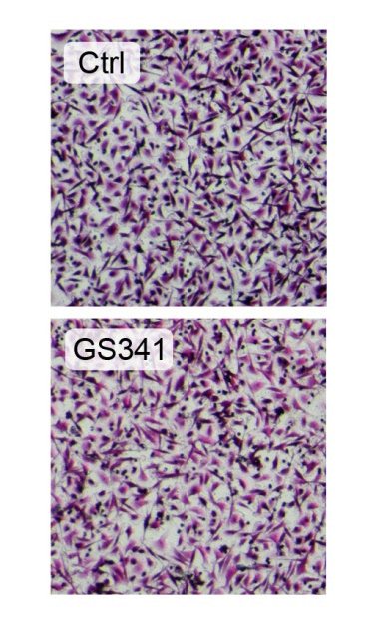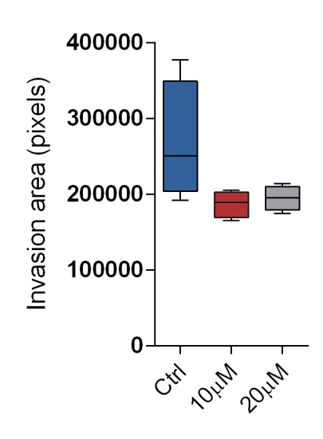
Fig. S8. The effect of anti-LOXL3 antibodies on invasion. A) 2D Matrigel invasion assay. Cells were plated in an invasion chamber in the presence of control or 10µM GS341 in the medium and incubated for 24 hours. The invaded cells were stained with crystal violet and counted. B) Evaluation of the effect of GS092 on 3D spheroid invasion did not identify statistically significant inhibition of invasion of MDA-MB-231 cells, in contrast to GS341.
 | 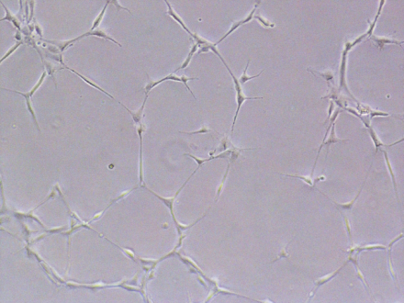
Vehicle | GS341
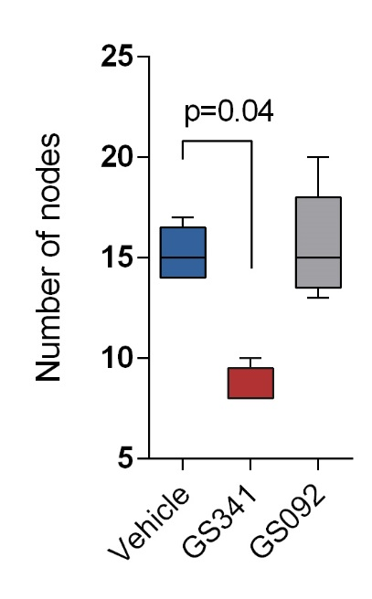
Fig. S9. The effect of GS341 and GS092 on tube formation. HUVEC were seeded in Matrigel-coated 48-well tissue culture plates in the presence of 1µM G341 or GS092 and incubated in growth medium supplemented with bFGF (50 ng/ml) for 24 h. The average number of tubes was derived from five microscopic fields.
Fig. S10. Quantification of lung metastases after injection of MDA-MB-231 cells into the mammary fat pad of SCID mice following treatment with GS341.

Supplementary materials and methods.

Enzyme inhibition assay
The enzymatic activity of LOXL2 was measured by coupling horse-radish peroxidase (HRP) activity to LOXL2 and using the conversion of Amplex Red (Invitrogen) to resofurin as our readout, as described previously, except that here we used collagen type I as a substrate (24). Collagen type I from rat tail (AdvanceBioMatrix) was naturalized by adding PBS and NaOH according to the manufacture’s procedure. Prior to the enzymatic assay, 25nM LOXL2 (R&D) was incubated with an increasing concentration of antibodies for 1 hour in room temperature. The enzymatic reaction was induced by adding a substrate mixture (50mM sodium borate pH 8, 100µM Amplex Red reagent, 0.25 mg/ml collagen) to the enzyme mixture (50mM sodium borate pH 8, 2 U/mL HRP, and LOXL2:Ab mixtures) and fluorescence was measured using a SynergyHT plate reader in kinetics mode with 540 nm excitation wavelength and 590 nm emission wavelength. To account for the background noise, we conducted measurements of the solution mixture without LOXL2 and the signal obtained was subtracted from kinetic measurements. The initial reaction rates at different antibody concentrations were determined from the slope of linear fits to the initial increase in fluorescence, and the inhibition constants (IC₅₀) were evaluated by fitting the data to the equation: v_{i}/v₀ = 1 / (1+[I]/IC₅₀) x 100, where v_{i} is initial velocity in the presence of the inhibitor, v₀ is the initial velocity in the absence of inhibitor, and I is the inhibitor concentration.

MST
GS341 or GS092 (20µM) were labeled with 100nM Alexa647 and incubated for 15 minutes with increasing concentrations of LOXL2, in a binding buffer containing 50mM Tris pH 8, 150mM NaCl, 10mM MgCl₂, 1% BSA and 0.05% Tween. Samples were measured using a Monolith NT.115 (Nanotemper, Germany) with 50% Laser-power, laser on time of 35 seconds and 40% LED-power. Attempts to measure the thermophoresis of labeled LOXL2 with increasing concentration of antibodies failed, probably due to distortion of binding site upon labeling of LOXL2.
MST competition assay
20nM of labeled GS341and 20nM of LOXL2 were pre-incubated in room temperature. The LOXL2: GS341 samples were incubated for 15 minutes with increasing concentrations of elastin (sigma), in binding buffer and measured as described above.
Immunoblotting analysis
Cells were washed briefly with ice-cold saline and scraped in a buffered detergent solution [25mM Hepes pH 7.5, 150mM NaCl, 0.5% Nadeoxycholate, 1% NP-40, 0.1% SDS, 1mM EDTA, 1mM EGTA, 0.2mM Na3VO4 and a protease inhibitor cocktail diluted at 1:1000]. For equal gel loading, a bicinchoninic acid (Pierce) reagent was used to determine protein concentrations. After gel electrophoresis, proteins were transferred to a nitrocellulose membrane. The membrane was blocked in a PBST buffer [PBS and 0.05% Tween 20] containing 10% low-fat milk, blotted with a primary antibody for 60 minutes, washed with PBST and incubated for 1 hour with a secondary antibody conjugated to horseradish peroxidase.
Tube formation assay
HUVECs were grown in DMEM medium containing 10% FCS and antibiotics in a humidified incubator at 5% CO2 supplemented with bFGF for 48 hours and harvested at 80% confluency. HUVECs were seeded at a concentration of 1.6x10⁴ cells/well on 48-well plate coated with 150 µL Matrigel (BD bioscience). After 24 hours, the cells were photographed and the number of tubular nodes in five microscopic fields of view was counted.
Table S1. List of buffers used for purification of the catalytic domain of LOXL2.
Buffer A | 25% sucrose, 50mM Tris-HCl pH 8, 0.1M NaCl, 0.2mM EDTA, 1mM DTT, ~10mg lysozyme
Buffer B | 2M urea, 2% Triton, 50mM Tris-HCl pH 8, 0.1M NaCl, 0.2mM EDTA, 1mM DTT
Buffer C | 8M urea, 50mM MOPS pH 7.5
Buffer D | 6M Urea, 25mM MOPS pH 7.5
Buffer E | 6M urea, 25mM MOPS pH 7.5 and 150mM BME
Buffer F | 0.4M arginine, 25mM MOPS pH 7.5, 200mM NaCl, 40uM CuCl₂, 1mM glutathion reduced, 0.1mM glutathion oxidized
Buffer G | 50mM MOPS pH 7.5 and 150mM NaCl

Table S2. Primers used for real-time PCR.
LOX forward | 5'-TTCCAGTACGGTCTCCCAGA-3'
LOX reverse | 5'-TGGCCAGACAGTTTTCCTCC-3'
LOXL1 forward | 5'-GAGGCCACCGACTACGATGT-3'
LOXL1 reverse | 5'-CTGTGGTAATGCTGGTGGCAG-3'
LOXL2 forward | 5'-GTACAAGCCAGAGCAACCCC-3'
LOXL2 reverse | 5'-CCTGTGCACTGGATCTCGTT-3'
LOXL3 forward | 5'-AAGCAACAACAGTCGAAGCC-3'
LOXL3 reverse | 5'-TCCAGAGCAGCGAACTTCAC-3'
LOXL4 forward | 5'-TTCACCCACTACGACCTCCTCA-3'
LOXL4 reverse | 5'-CAGCAGCCTACAGTCACTCCCT-3'

