Figure S1
A
CCF642
IUPAC: (5Z)-3-(4-methoxyphenyl)-5-[(5-nitrothiophen-2-yl)methylidene]-2-sulfanylidene-1,3-thiazolidine-4-one
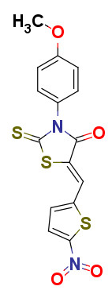

B

HRMS

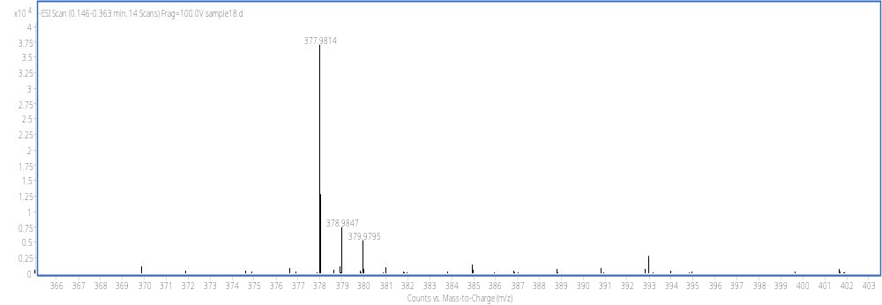

HRMS: m/z calcd for M⁺: 377.9808 ; found: 377.9814

C

H-NMR

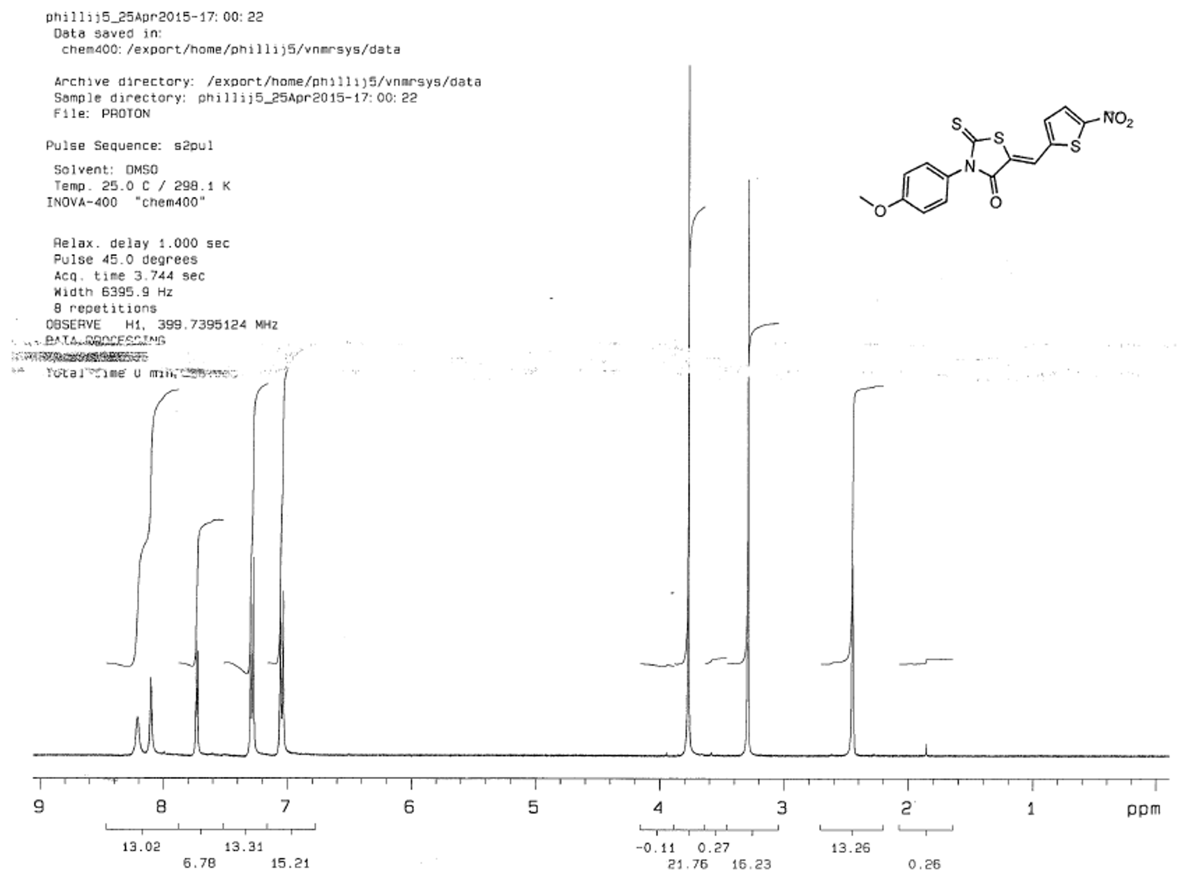

D

B-CCF642
IUPAC: N-(2-{4-[(5Z)-5-[(5-nitrothiophen-2-yl)methylidene]-4-oxo-2-sulfanylidene-1,3-thiazolidin-3-yl]phenoxy}ethyl)-5-{2-oxo-hexahydrordo-1H-thieno[3,4-d]imidazolidine-4-yl}pentanamide
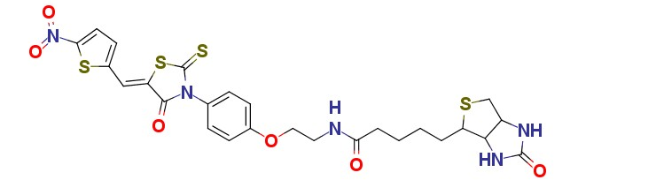

E

HRMS

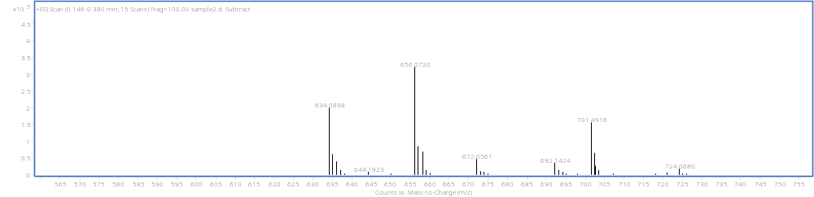

HRMS: m/z calcd for (M+H)⁺: 634.08; found: 634.089

F

H-NMR
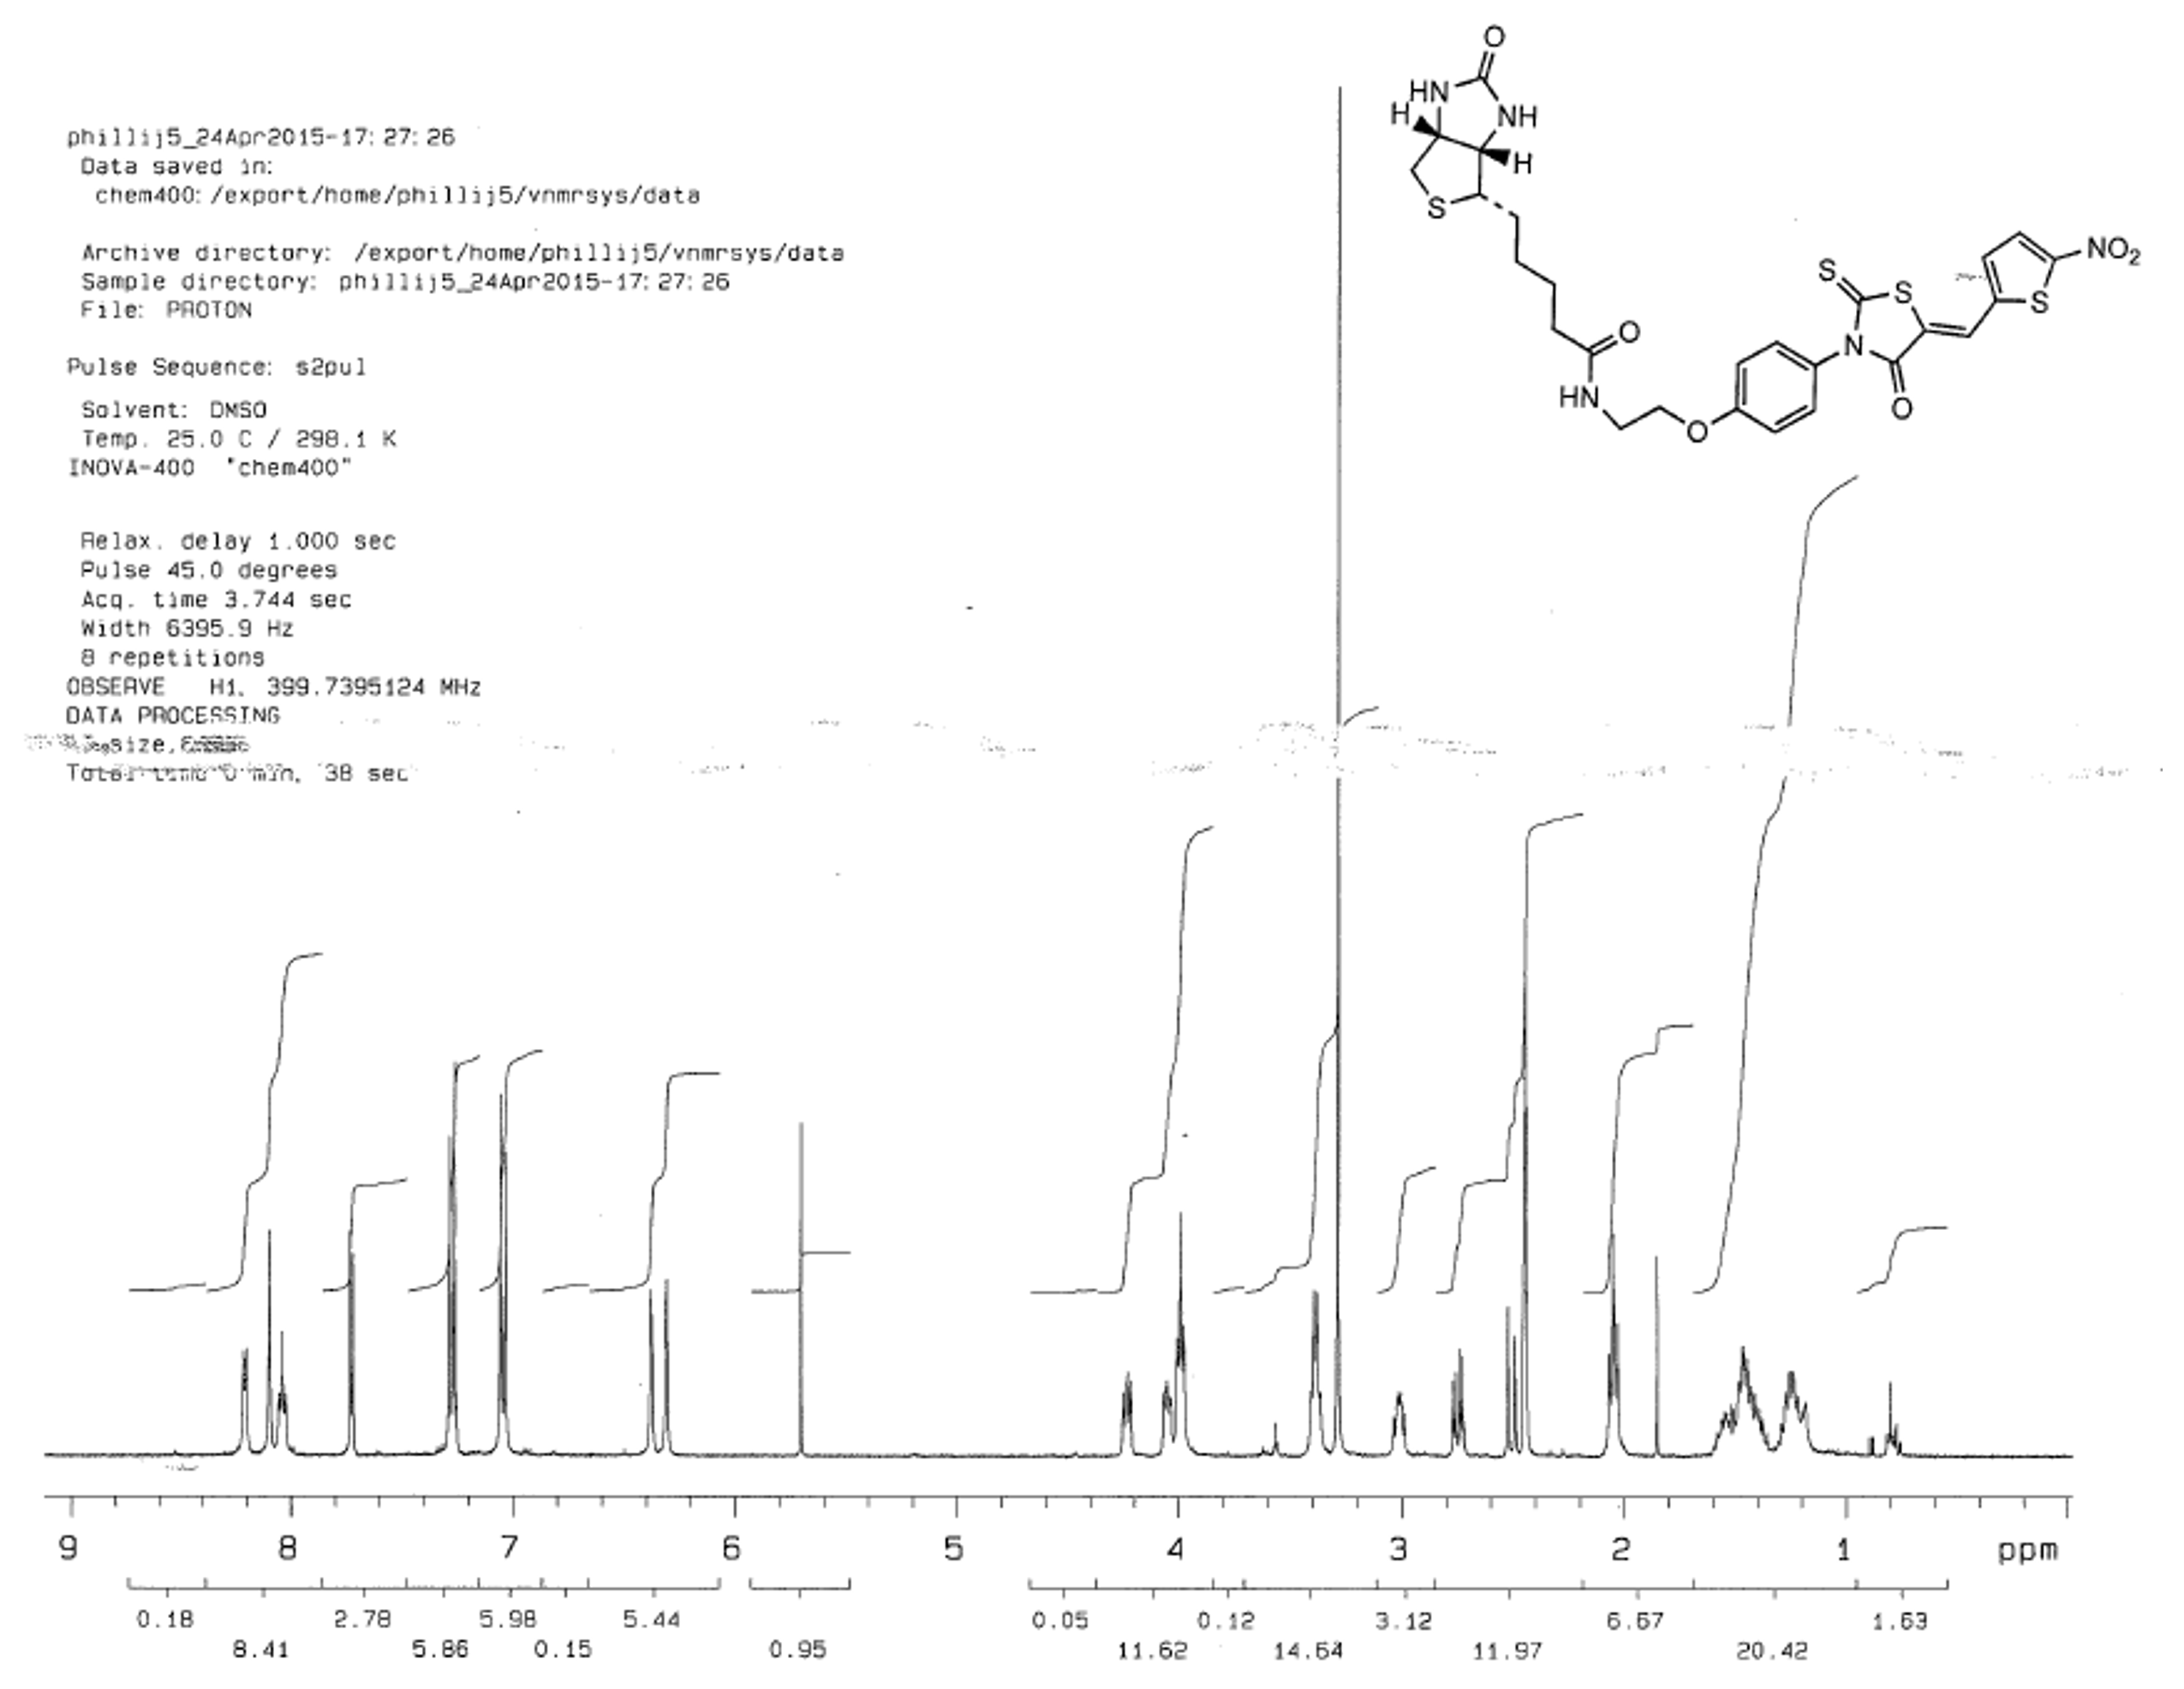
G
CCF642-COOH
IUPAC: 5-{[(5Z)-3-(4-methoxyphenyl)-4-oxo-2-sulfanylidene-1,3thiazolidine-5-ylidene]methyl}thiphene-2-carboxylic acid
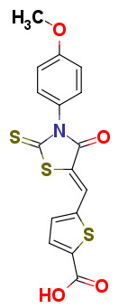

H

HRMS

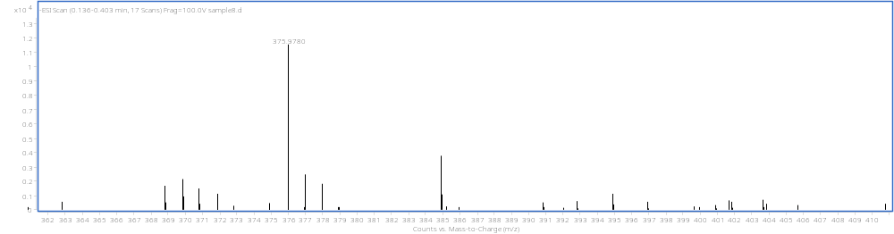

HRMS: m/z calcd for (M-H)⁺: 375.9777; found: 375.9780

I

H-NMR


