Supplementary Data
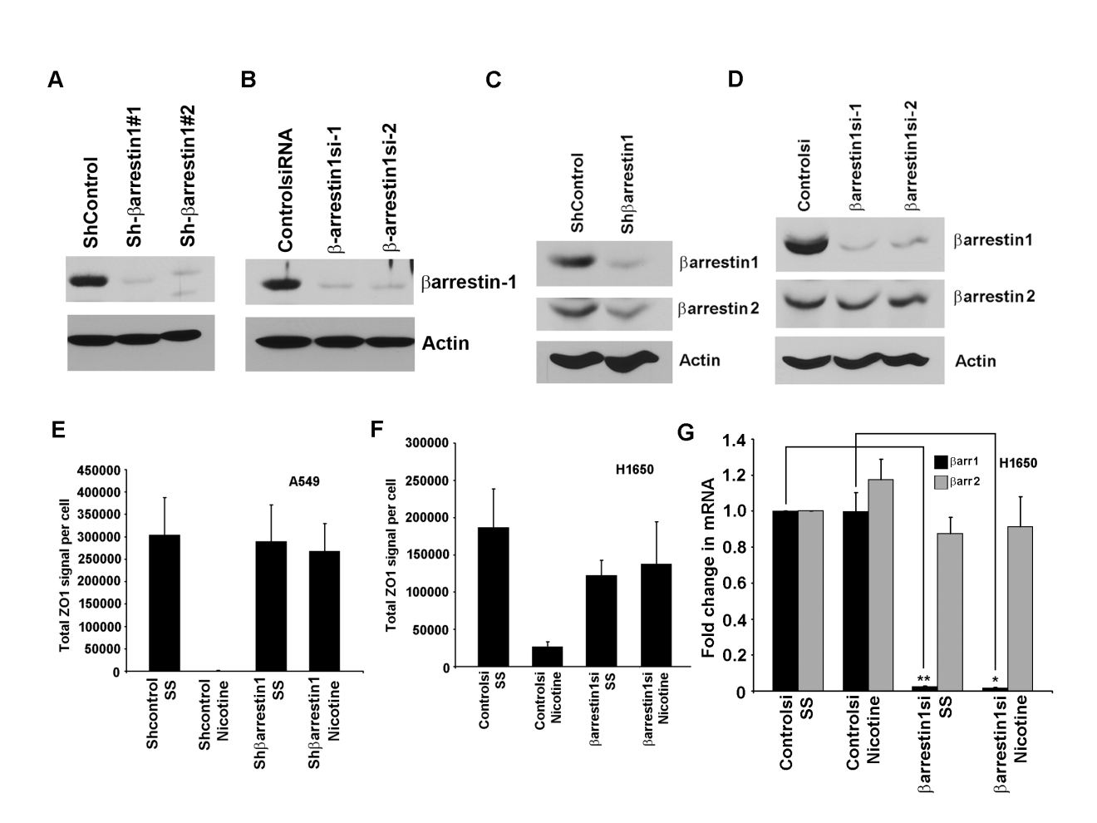Supplementary Figure S1. β-arrestin-1 depletion by siRNAs and shRNAs
(A) Levels of β-arrestin-1 as seen by western blots from shcontrol cells and stable shβ-arrestin-1 clones. Shβ-arrestin-1#1 and 1#2 are two shRNA expressing clones with significant depletion of β-arrestin-1.
(B) Western blots showing levels of β-arrestin-1 after transfection using two different siRNA species specific to β-arrestin-1.
(C) Western blotting for β-arrestin-2 from shcontrol cells and shβ-arrestin-1 clones.
(D) Western blots showing levels of β-arrestin-2 after transfection using two different siRNA species specific to β-arrestin-1 showing the specificity of β-arrestin-1 siRNA.
(E) Quantification of ZO1 signal from A549 and (F) H1650 cells. Representative Immunofluorescence images are shown in Figure1A.
(G) Levels of β-arrestin-1 and β-arrestin-2 mRNA after siRNA transfection in H1650 cells as seen by qRT-PCR. (**=p<0.005, *=p<0.05).
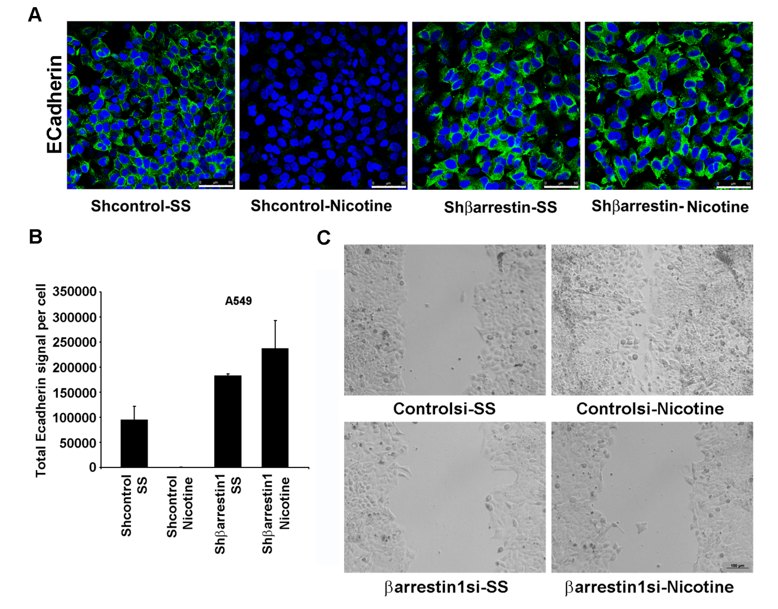
Supplementary Figure S2. β-arrestin-1 is necessary for nicotine induced downregulation of E-cadherin and migration
(A) Immunofluorescence assay showing E Cadherin (green) staining from Shcontrol and Shβarrestin cells after nicotine stimulation. Nicotine downregulated E-cadherin levels in shcontrol cells while shβ-arrestin1 cells did not show any reduction in E-cadherin. Nuclei were counterstained with DAPI (blue). Scale bar: 50µm. (B) quantification of E-cadherin signal from the immunofluorescence images. (C) Nicotine induced migration of cells is affected by depletion of β-arrestin-1 as seen by wound healing assay. Scale bar: 100µm.
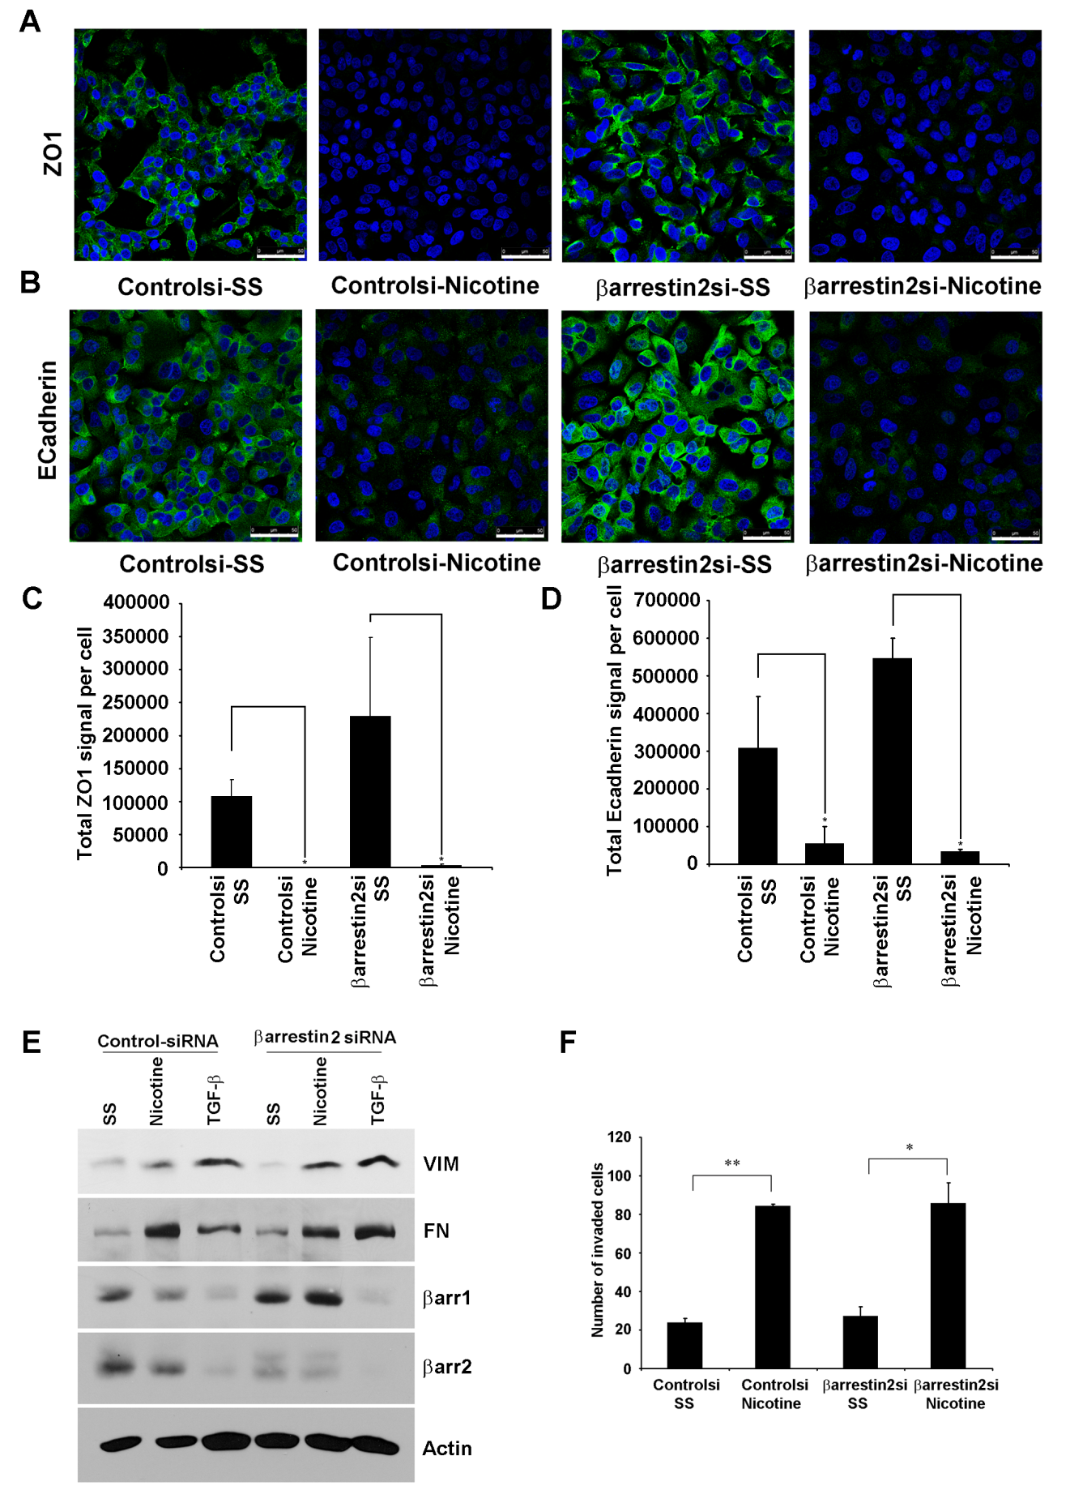

Supplementary Figure S3. β-arrestin-2 is not required for nicotine induced invasion and expression of mesenchymal markers
To investigate whether β-arrestin-2 modulates EMT related gene expression pattern in response to nicotine stimulation, A549 cells were transfected with β-arrestin-2 siRNA or a non-targeting control siRNA, subsequently serum starved and stimulated with nicotine. The levels of the tight junction protein ZO1 and E-Cadherin were assessed by immunofluorescence. As shown in Figure 3 A-D, the intensity of staining for ZO1 and E-Cadherin from nicotine treated cells were significantly lower, irrespective of the presence of β-arrestin-2. This suggests that β-arrestin-2 might not have a major role in nicotine induced suppression of epithelial genes. In addition, we assessed the levels of mesenchymal genes vimentin and fibronectin in response to nicotine after specific depletion of β-arrestin-2 using siRNAs. Nicotine could induce vimentin and fibronectin even in β-arrestin-2 depleted A549 cells as seen by western blots (Figure 3E), suggesting that β-arrestin-2 plays only a marginal role in nicotine-induced EMT. Absence of β-arrestin-2 did not affect the expression of these genes in response to TGF-β either, further demonstrating a reduced role for β-arrestin-2 in the regulation of these genes. Confirming these findings, Boyden Chamber assays showed that β-arrestin-2 depleted cells could invade as efficiently as control cells in response to nicotine stimulation (Figure 3F). This is in striking contrast to the results obtained when β-arrestin-1 was depleted from these cells (Figure 1 C and D).

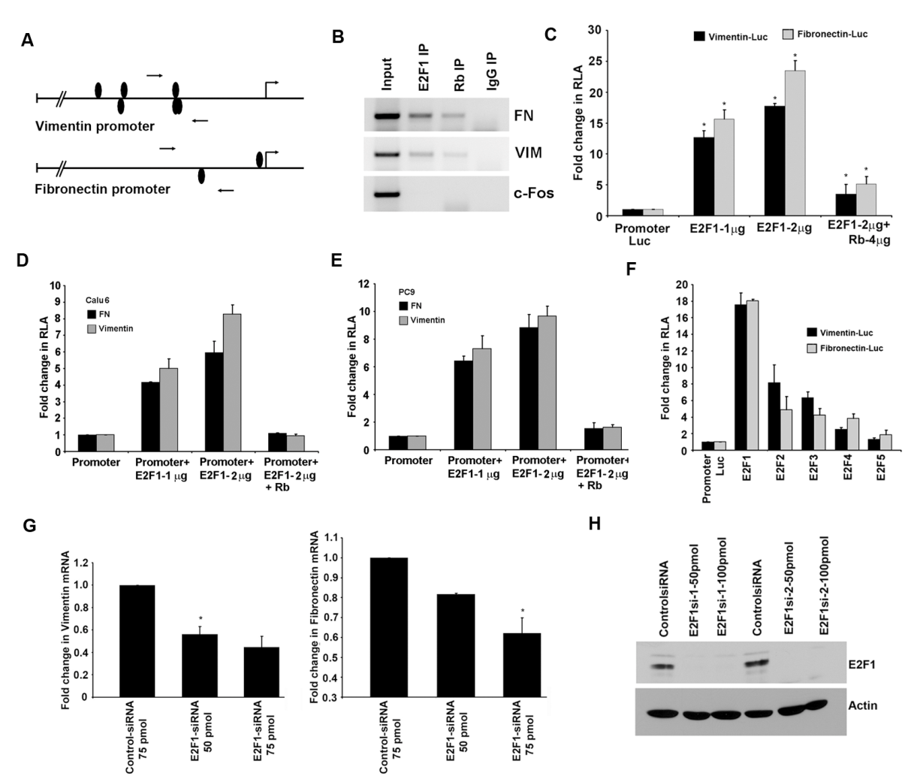
Supplementary Figure S4. Fibronectin and vimentin promoters are E2F1 and Rb responsive.
(A) A schematic of fibronectin and vimentin promoters showing potential E2F binding sites. Position of primers used for ChIP assay spanning the putative E2F binding sites are indicated by arrows. (B) ChIP assays conducted on asynchronously growing A549 cells demonstrating the association of E2F1 and Rb on vimentin and fibronectin promoters. (C) Transient transfection experiments showed that E2F1 could induce fibronectin and vimentin promoters and Rb could inhibit E2F1 mediated transcription from these promoters.
(D&E) Regulation of vimentin and fibronectin promoter induction by E2F1 and Rb in NSCLC cell lines Calu6 (D) and PC9 (E). Cotransfection with E2F1 induces these promoters in both PC9 and Calu6 and E2F1 mediated transcriptional induction could be repressed by cotransfection with Rb. (F) Transient transfection assays performed in A549 cells showing the transcriptional induction of fibronectin and vimentin promoters by E2F family members (E2F1-E2F5). (G) Depletion of E2F1 by transiently transfecting E2F1 siRNA reduced the expression of vimentin and fibronectin in A549 cells in a dose dependent manner as seen by RT-PCR.
(H) Western blots showing levels of E2F-1 after transfection using two different siRNA species specific to E2F-1.

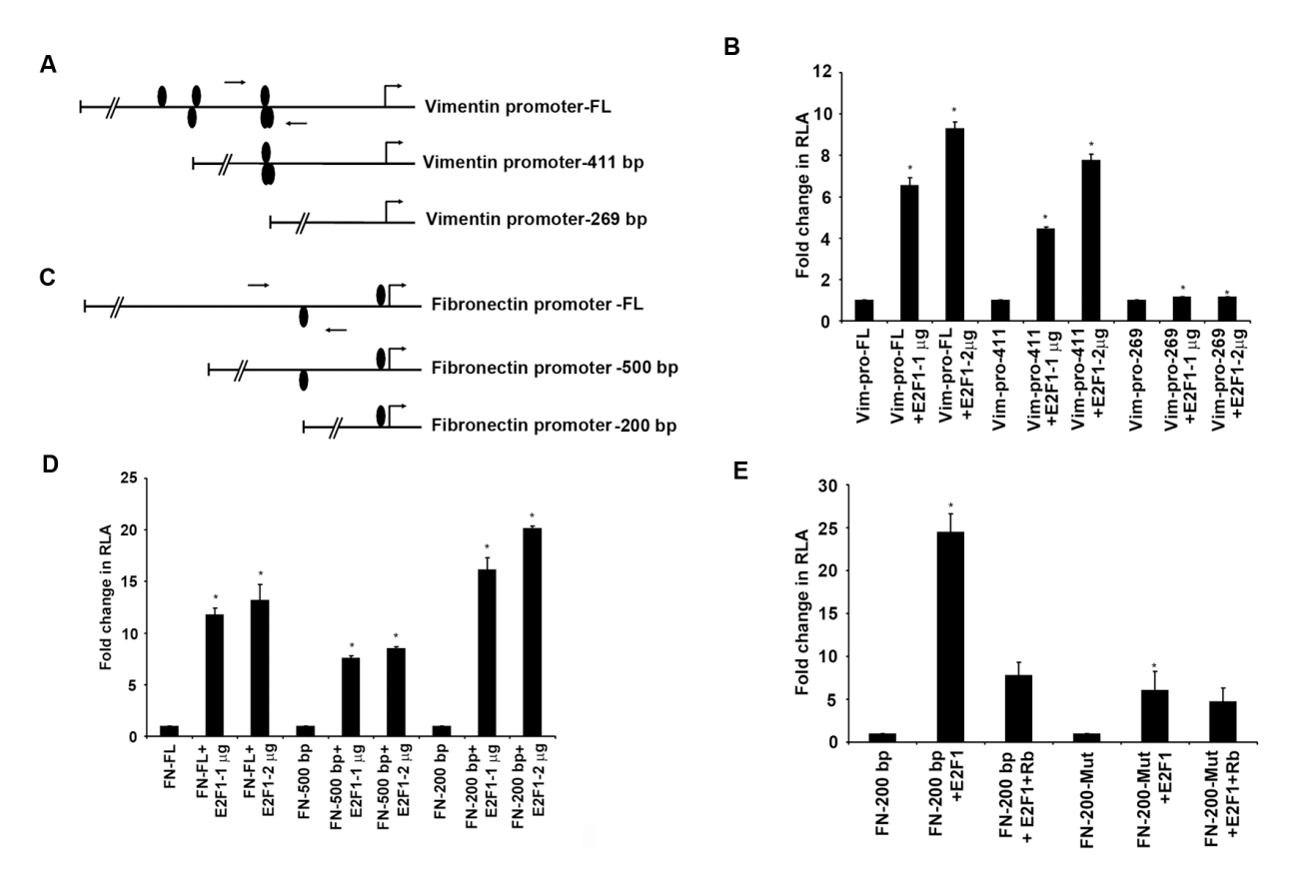

Supplementary Figure S5. Fine mapping of E2F1 responsive region in vimentin and fibronectin promoters
(A) Schematic of deletion mutants of vimentin promoter showing the position of E2F binding sites. (B) Transient transfection assays using these mutants revealed that the shortest fragment (269bp) that did not have E2F binding site was not E2F1 responsive. (C) Schematic of deletion mutants of fibronectin promoter showing the position of E2F binding sites (D) All the three promoter constructs had putative E2F binding sites and were responsive to E2F1 in transient transfections. (E) An E2F site mutant of the shortest promoter fragment (FN-200-Mut) showed significantly lower response to E2F in co-transfection assays. (*=p<0.05)
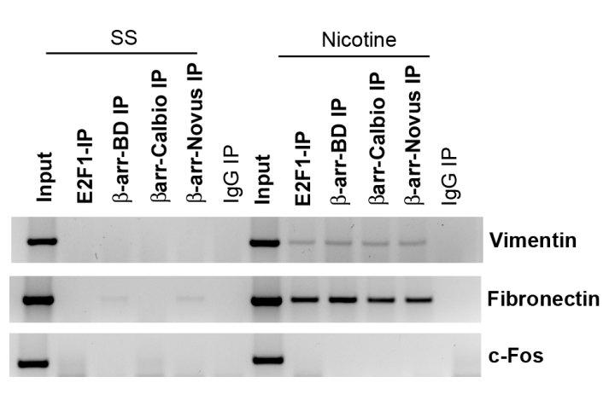

Supplementary Figure S6. β-arrestin-1 is recruited on vimentin and fibronectin promoters in response to nicotine stimulation

ChIP assays conducted on quiescent and nicotine treated A549 cells using different commercial sources of β-arrestin-1 antibodies. ChIP assay showing the presence of E2F1 and β-arrestin-1 on c-fos, fibronectin and vimentin promoters. Quiescent A549 cells were induced with nicotine for 24 hours and ChIP assay was performed with the indicated antibodies. There was increased association of E2F1 and β-arrestin-1 on fibronectin and vimentin promoters in response to nicotine.

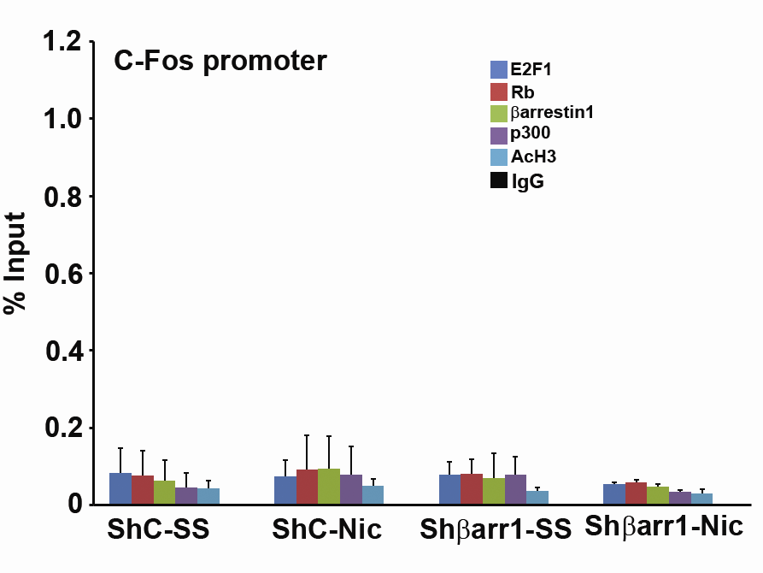

Supplementary Figure S7. E2F1, Rb, β-arrestin-1, p300, and Ac-H3 are not recruited on c-Fos promoter
ChIP assays followed by real time PCR did not show significant association of E2F1, Rb, β-arrestin-1, p300, and Ac-H3 with the unrelated c-Fos promoter in serum starved or nicotine treated shcontrol cells and shβ-arrestin1 cells.
Supplementary Figure S8. Levels of β-arrestin-1 after transfecting cells with β-arrestin-1 expression constructs
(A) β-arrestin-1 levels after transfecting the indicated β-arrestin-1 expression constructs as seen by RT-PCR. (B) β-arrestin-1 levels after transfecting increasing amounts of β-arrestin-1-RFP expression construct (2 and 4µg) as seen by western blots. (Note: All the lanes were run on the same gel, but were noncontiguous). (C) Levels of β-arrestin-1-Q394L protein after transient transfection of 2µg and 4µg of the expression vector in shβ-arrestin-1 cells, as seen by western blotting.
Supplementary Figure S9. β-arrestin-1 mediates the induction of EMT promoting transcription factors ZEB1 and ZEB2
(A-D) Depletion of β-arrestin-1 results in ablation of nicotine induced expression of ZEB1 and ZEB2, as seen by RT-PCR. Panels A & B show levels of ZEB1 and ZEB2 in A549 cell after depleting β-arrestin-1 using two different siRNAs. Panels C & D show levels of ZEB1 and ZEB2 in H1650 after depleting β-arrestin-1 using two different siRNAs. (E & F) Levels of β-arrestin-1 after siRNA-mediated depletion in A549 and H1650 cells, as seen by RT-PCR.

Supplementary Figure S10. Nicotine induces β-arrestin-1 recruitment to ZEB1 and ZEB2 promoters
(A) Schematic showing putative E2F binding sites on ZEB1 and ZEB2 promoters. (B) ChIP assays showing nicotine induced recruitment of β-arrestin-1 to ZEB1 and ZEB2 promoters. (C) ZEB1 and ZEB2 promoters are induced by E2F1 in transient transfection experiments.

Position of putative E2F binding sites in fibronectin, vimentin, ZEB1 and ZEB2 promoters

Promoter | # Of E2F Binding Sites | E2F Binding Sites | Nucleotide Sequence | Matrix Sim.
Fibronectin | 2 | -35 to -51  -220 to -236 | gaggGGCGggaggggac  tgatgGCCCgccaggac | 0.825  0.850
Vimentin | 6 | -330 to -346  -331 to -347  -333 to -349  -604 to -620  -607 to -623  -645 to -661 | tattgccgcCAAAgatt  atctttGGCGgcaatag  ctttgGCGGcaatagat  ccttGGCGggtaagtac  cttacCCGCcaagggag  aaatcacgaGAAGactg | 0.897  0.844  0.888  0.813  0.759  0.760
ZEB1 | 6 | -128 to -144  -131 to -147  -170 to -186  -216 to -232  -833 to -849  -840 to -856 | ggttgCCGCaaaccgcc  ggtttGCGGcaaccgtg  ggggcgaggGAAAagtt  ggatGCCGggaaaccgt  ggggaGCGCggaccggg  agagGGCGgggagcgcg | 0.779  0.779  0.759  0.846  0.860  0.791
ZEB2 | 2 | -141 to -157  -185 to -201 | acagggcggAAAAcggt  ccaaggggcGAAAgtta | 0.885  0.849

Supplementary Table 1: Position of putative E2F binding sites in fibronectin, vimentin, ZEB1 and ZEB2 promoters (1Kb upstream of transcription start site) as revealed by promoter analysis using Genomatix MatInspector program.

Supplementary Table 2: Partial list of promoter regions where β-arrestin-1 is recruited upon nicotine stimulation as revealed by ChIP-sequencing

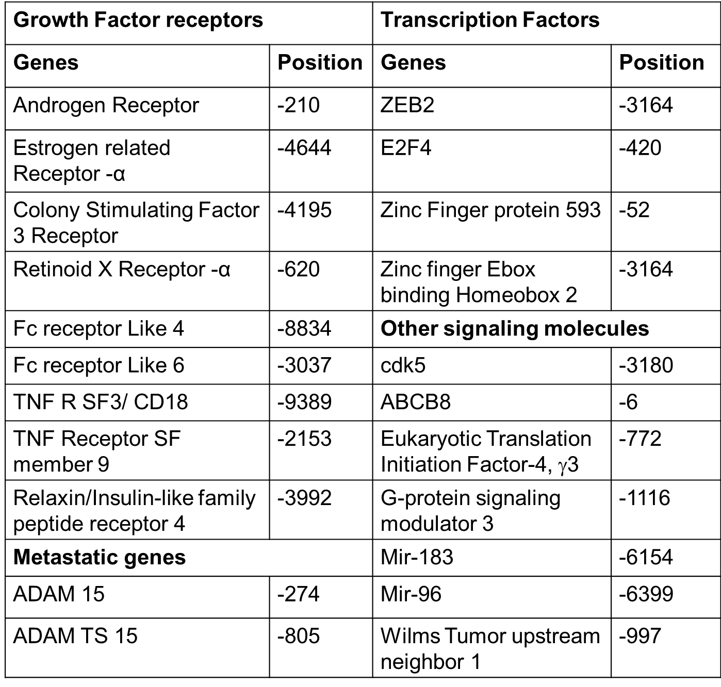

ChIP-sequencing was carried out to identify β-arrestin-1 associated regions in the genome upon nicotine stimulation. A549 cells were serum starved and subsequently stimulated with nicotine; ChIP assays were performed from serum starved as well as nicotine treated cells and the immunoprecipitated DNA was sequenced. The data were analyzed to identify the genomic regions/promoter regions were β-arrestin-1was recruited upon nicotine treatment.

Correlation among measures of vimentin, fibronectin and β-arrestin-1

 | Log (VIM_18s) | Log (FN1_18s) | LG (ARRB1_18s)
Log (VIM_18s) | r = 1  n = 117 | r = 0.70  p-value <.0001  n = 117 | r = 0.59  p-value <.0001  n = 116
Log (FN1_18s) | - | r = 1  n = 117 | r = 0.52  p-value <.0001  n = 116
LG (ARRB1_18s) | - | - | r = 1  n = 116
r= Pearson correlation coefficient, n= number of observation used.

Supplementary Table 3: Pearson’s correlation coefficient (r) showing correlation of vimentin, fibronectin and β-arrestin-1 expression from 116 NSCLC samples. β-arrestin-1 expression showed a very strong positive correlation with vimentin (r=0.59, p<0.0001) and fibronectin (r=0.52; p<0.0001).

