Supplemental Data for

Oncogenic G protein GNAQ induces uveal melanoma and intravasation in mice

Jenny Li-Ying Huang, Oscar Urtatiz, and Catherine D. Van Raamsdonk

AFFILIATION:
Department of Medical Genetics
University of British Columbia
2350 Health Sciences Mall
Vancouver, British Columbia, V6T 1Z3
Canada

CONTACT INFORMATION:
Catherine D. Van Raamsdonk
cvr@mail.ubc.ca
Table of Contents

Figure S1. Body weight of 3 month old mice.
Figure S2. Melanocytic proliferation in the skin of Rosa26-fs-GNAQ^{Q209L}/+; Mitf-cre/+ animals.
Figure S3. Loss of hair pigmentation in 5 month-old Rosa26-fs-GNAQ^{Q209L}/+; Mitf-cre/+ mice.
Figure S4. Gross eye phenotypes in study mice.
Figure S5. RNA expression from the Rosa26 promoter compared to the Gnaq promoter in mouse melanocytes.
Figure S6. Additional controls for Rosa26-fs-GNAQ^{Q209L}/+; Tyr-creER/+ experiments.
Figure S7. Hyper-pigmentation of meninges in trunk.

Table S1. Efficiency of Mitf-cre at P40.

Table S2. Individual results of auditory brainstem response (ABR) testing.
Table S3. Efficiency of Tyrosinase-creER using a 5 day tamoxifen treatment in adult mice.

Supplemental Materials and Methods.
GNAQ/Gnaq Pyrosequencing primers.

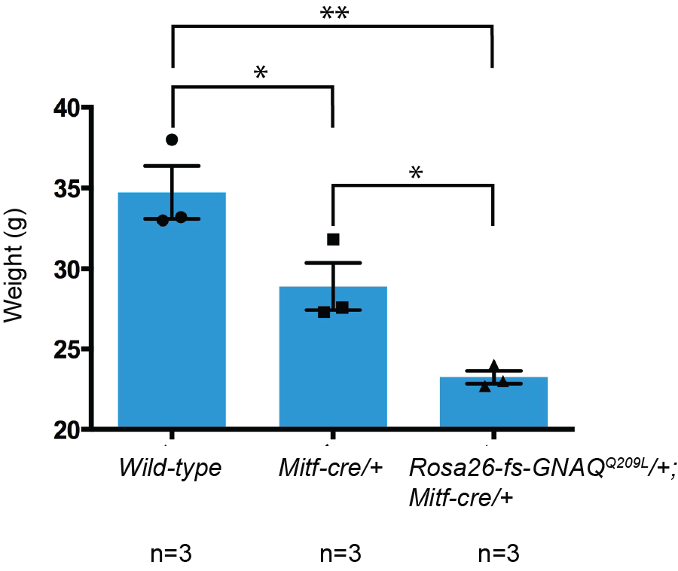

Figure S1. Body weight of 3 month old mice.

Male littermates were weighed at 3 months of age. Mitf-cre/+ mice weighed less than their wild-type (+/+) littermates. Rosa26-fs-GNAQ^{Q209L}/+; Mitf-cre/+ mice weighed less than Mitf-cre/+ mice, indicating an overall impact on health by oncogenic GNAQ. The p-values (ANOVA) indicated by the asterisks is the graph are:
Wild-type versus Mitf-cre/+, p=0.0468.
Mitf-cre/+ versus Rosa26-fs-GNAQ^{Q209L}/+; Mitf-cre/+, p=0.0423.
Wild-type versus Rosa26-fs-GNAQ^{Q209L}/+; Mitf-cre/+, p=0.0018.
Graph displays mean ± standard error of the mean (SEM). n = number of mice weighed.

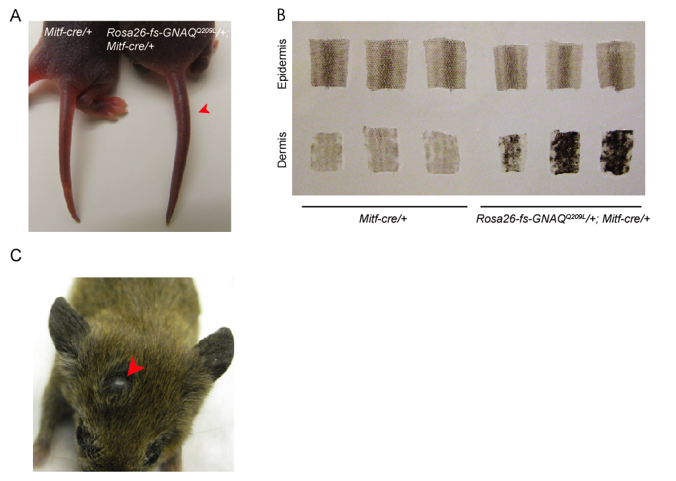

Figure S2. Melanocytic proliferation in the skin of Rosa26-fs-GNAQ^{Q209L}/+; Mitf-cre/+ animals.

A. Rosa26-fs-GNAQ^{Q209L}/+; Mitf-cre/+ exhibit tail darkening (red arrowhead) starting 5 days after birth. B. The tail dermis of 3 week-old Rosa26-fs-GNAQ^{Q209L}/+; Mitf-cre/+ animals exhibit non-uniform hyper-pigmentation, while the epidermis appears to be pigmented normally. C. A pigmented lesion (red arrowhead) was found on the head of a 5 month-old Rosa26-fs-GNAQ^{Q209L}/+; Mitf-cre/+ mouse.

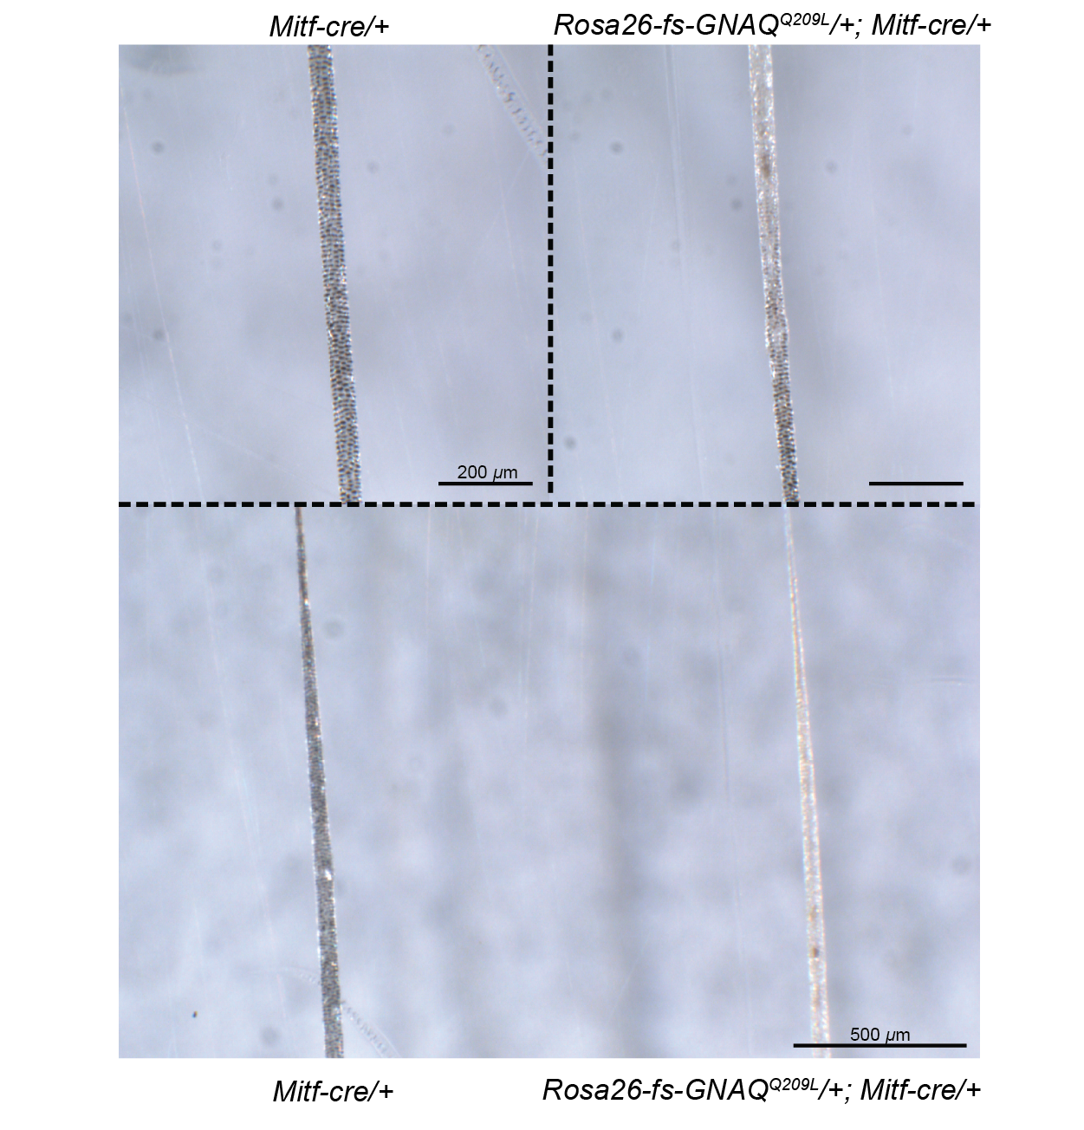

Figure S3. Loss of hair pigmentation in 5 month-old Rosa26-fs-GNAQ^{Q209L}/+; Mitf-cre/+ mice.

Irregularly deposited and reduced pigmentation in two representative hairs (right) plucked from 5 month-old Rosa26-fs-GNAQ^{Q209L}/+; Mitf-cre/+ animals. Pigmented septules are visible in the control Mitf-cre/+ hairs (left).

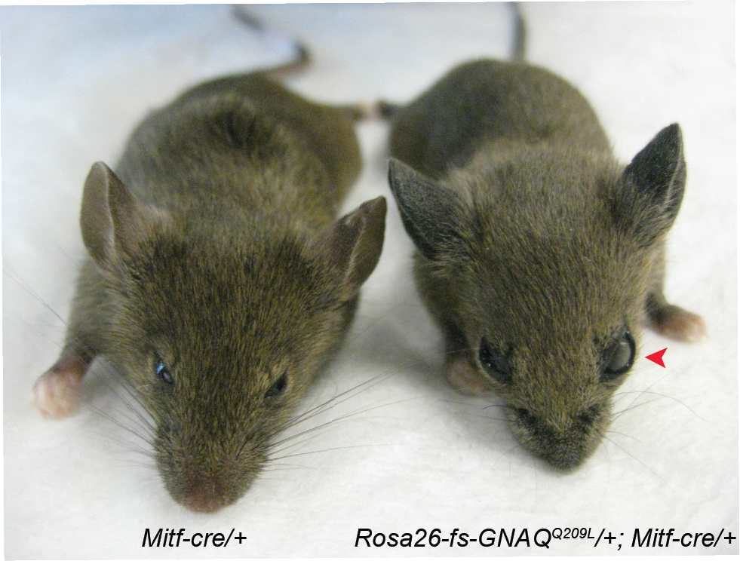

Figure S4. Gross eye phenotypes in study mice.

Eye bulging (red arrowhead) in a 3 month-old Rosa26-fs-GNAQ^{Q209L}/+; Mitf-cre/+ animal and mild microphthalmia in its Mitf-cre/+ littermate.

Wild-type Gnaq allele Rosa26-GNAQ^{Q209L} transgenic allele

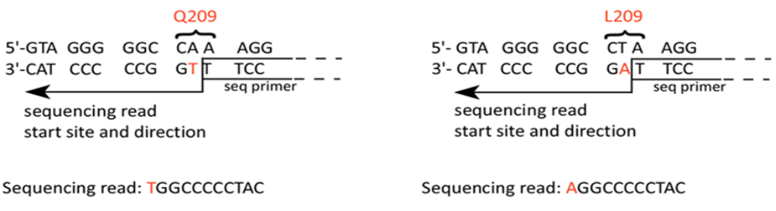

A B
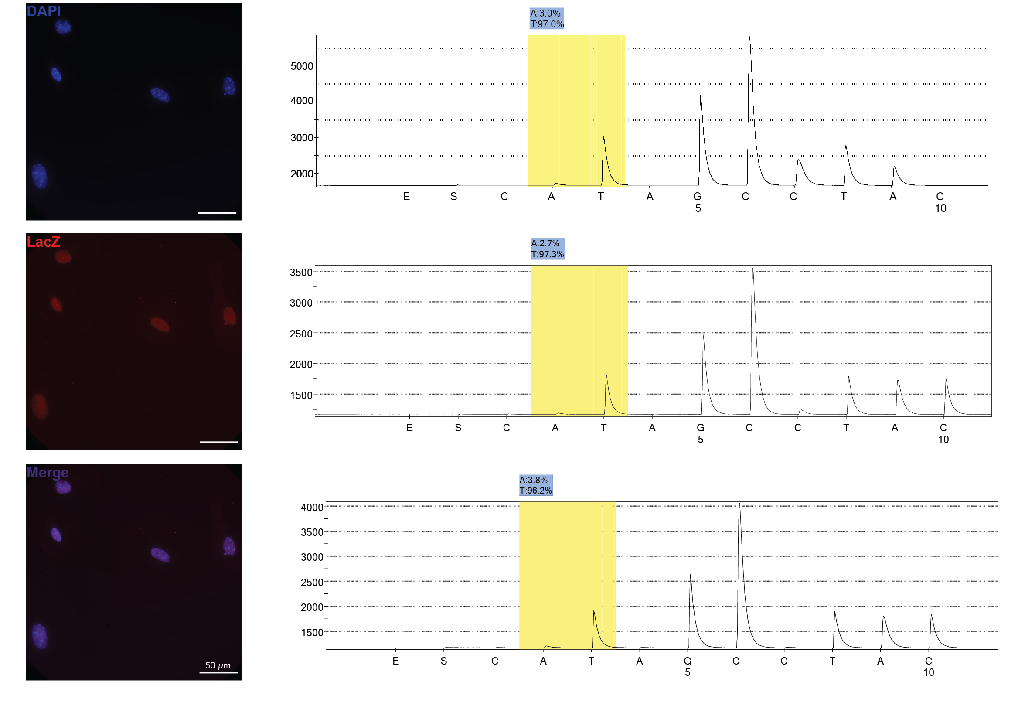
Figure S5. RNA expression from the Rosa26 promoter compared to the Gnaq promoter in mouse melanocytes. A. Primary melanocyte cell cultures from Rosa26-fs-LacZ/Rosa26-fs-GNAQ^{Q209L}; Mitf-cre/+ mice were successfully obtained, as indicated by staining positive for beta-galactosidase. B. Pyrosequencing traces of 3 independent melanocyte cultures. On average, the T peak produced by the two wild-type Gnaq mouse alleles is 30-fold greater than the A peak produced by the GNAQ^{Q209L} allele expressed from the Rosa26 promoter (96.8% versus 3.2%).
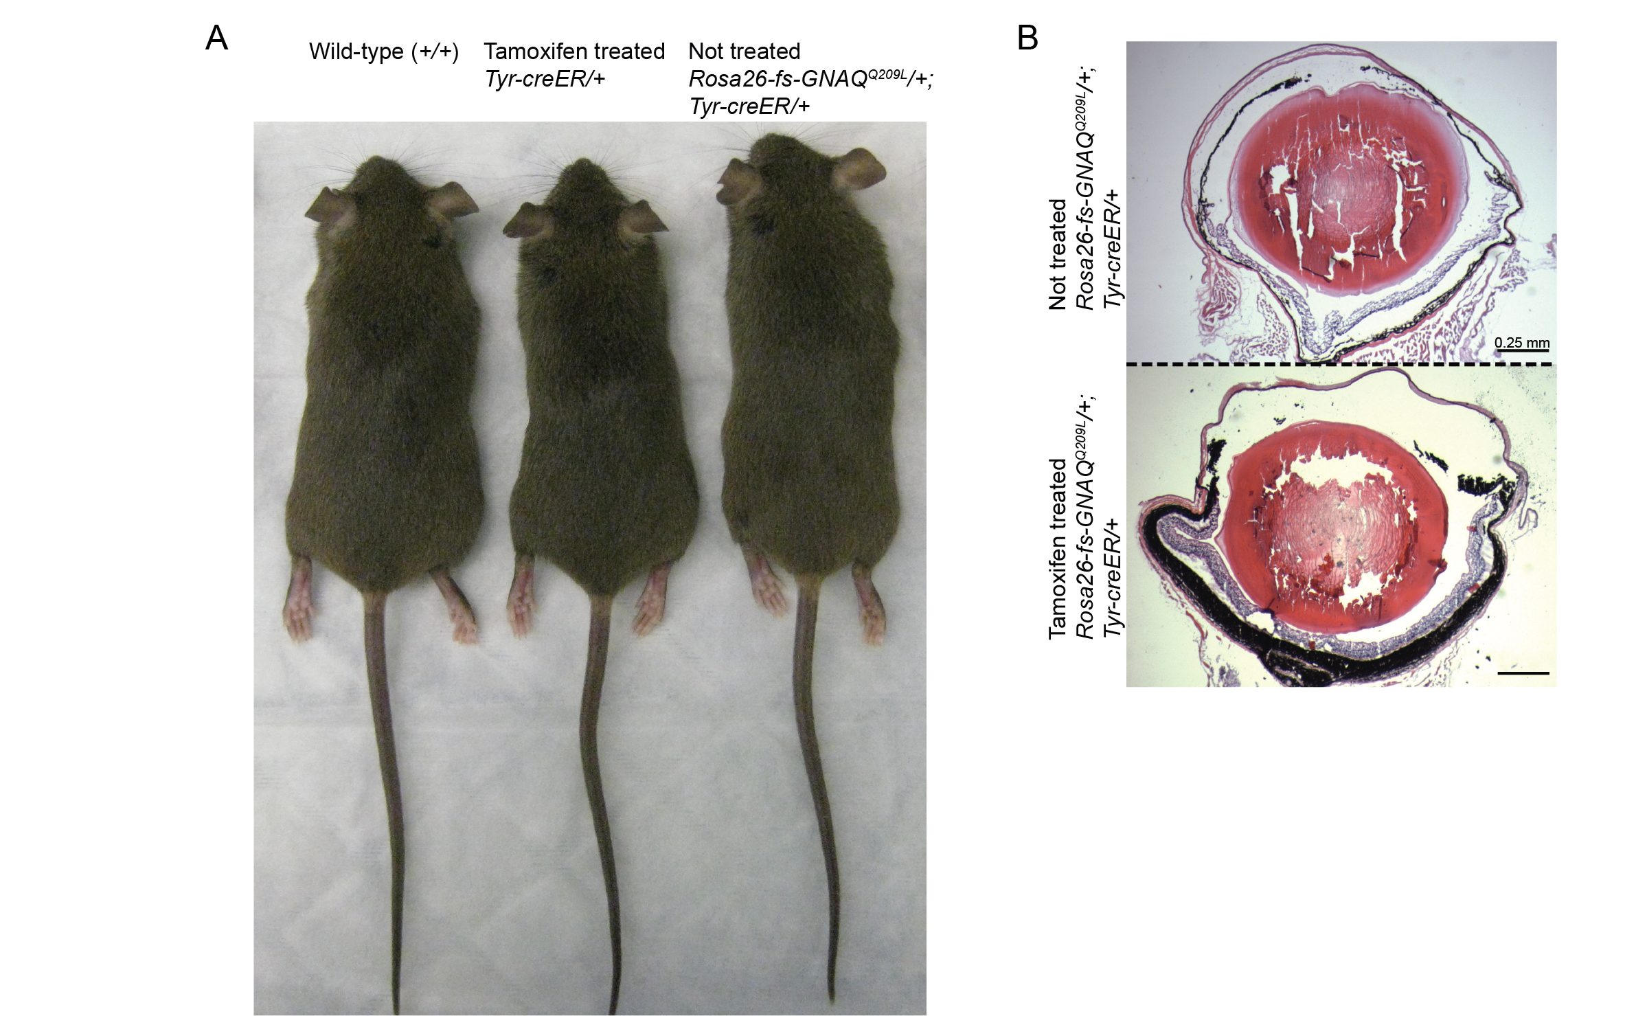

Figure S6. Additional controls for Rosa26-fs-GNAQ^{Q209L}/+; Tyr-creER/+ experiments.

A. Untreated wild-type (+/+), tamoxifen treated Tyr-creER/+, and untreated Rosa26-fs-GNAQ^{Q209L}/+; Tyr-creER/+ control mice exhibit normal skin pigmentation two months following the last treatment. B. (Top) A Rosa26-fs-GNAQ^{Q209L}/+; Tyr-creER/+ mouse not treated with tamoxifen exhibits normal eye morphology. (Bottom) A Rosa26-fs-GNAQ^{Q209L}/+; Tyr-creER/+ tamoxifen treated mouse aged to 8.5 months exhibits the same eye phenotype as those aged to 4 months, indicating that the melanocytic hyperplasia is stable (compare to Figure 5E).
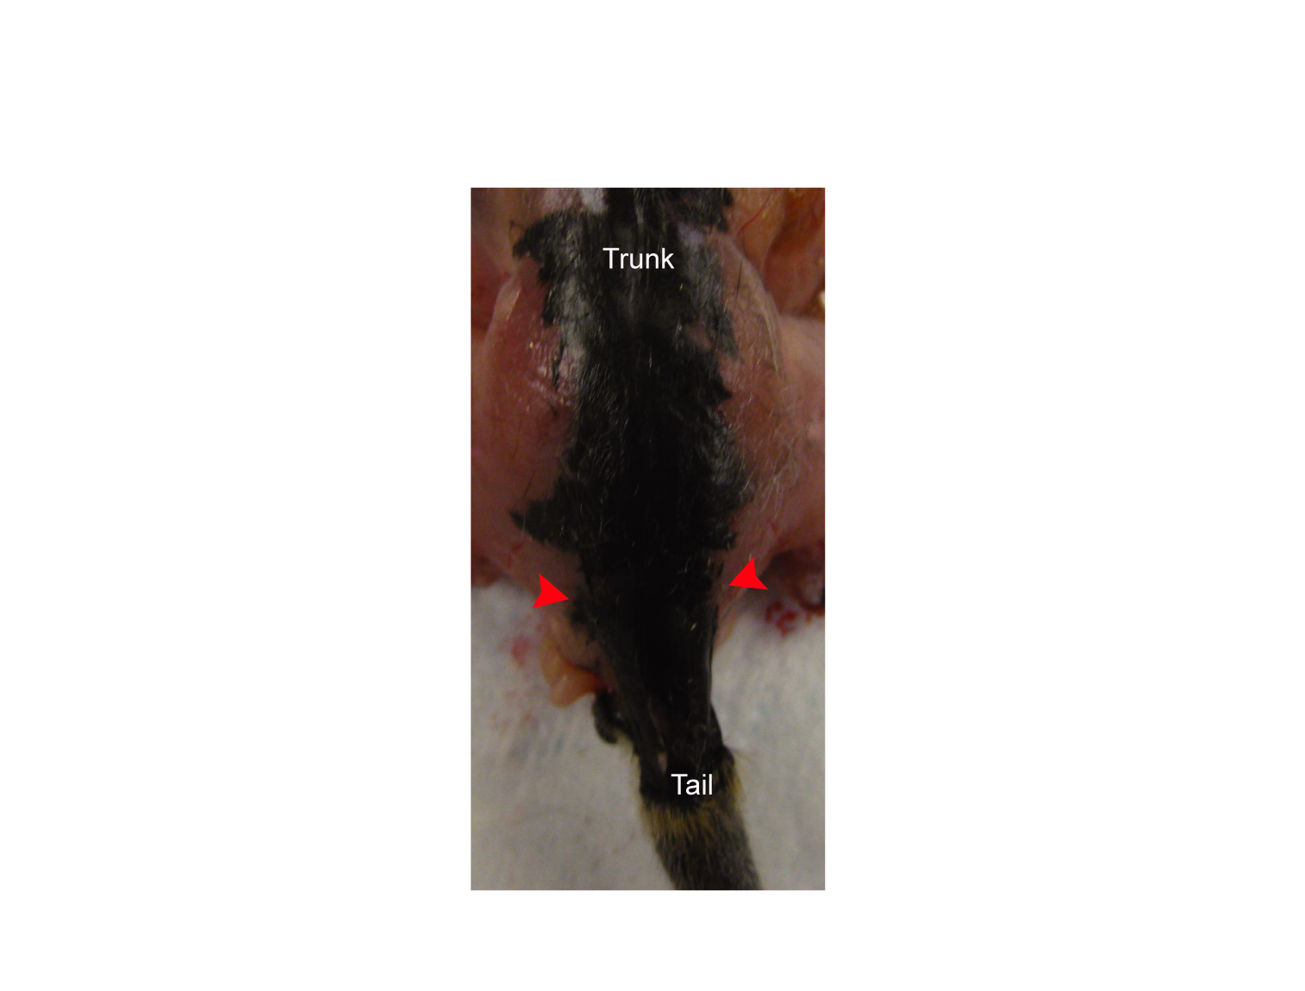
Figure S7. Hyper-pigmentation of meninges in trunk.

The trunk skin was removed to assess pigmentation of the meninges overlying the spinal cord. Heavy pigmentation was observed in every Rosa26-fs-GNAQ^{Q209L}/+; Mitf-cre/+ animal. Red arrowheads indicate width of hyper-pigmentation at 3 months of age.
Table S1 Efficiency of Mitf-cre at P40.
Genotype | Average number of LacZ⁺ cells per scale
Dct-LacZ/+
Animal 1 | 94.15 ± 5.81
Animal 2 | 94.50 ± 6.70
Animal 3 | 120.62 ± 6.17
Average | 103.09 ± 10.73
Rosa26-fs-LacZ/+; Mitf-cre/+
Animal 1 | 81.36 ± 5.00
Animal 2 | 73.85 ± 7.67
Animal 3 | 50.75 ± 7.26
Animal 4 | 73.00 ± 7.81
Average | 69.74 ± 7.62
Percentage of efficiency | 67.65%
ª P40 Dct-LacZ/+ (n=3) and Rosa26-fs-LacZ/+; Mitf-cre/+ (n=4) tail skins were stained with X-gal and the epidermis was split from the dermis. The number of LacZ-positive cells was counted in one row of epidermal scales per sample (± SEM).

Table S2 Individual results of auditory brainstem response (ABR) testing.
Mitf-cre/+ animals at P34 | 6kHz | 12kHz | 18kHz | 24kHz | 30kHz
Animal 1 | 35 dB | 10 dB | 20 dB | 25 dB | 35 dB
Animal 2 | 35 dB | 15 dB | 15 dB | 20 dB | 30 dB
Animal 3 | 35 dB | 15 dB | 25 dB | 25 dB | 45 dB
Animal 4 | 35 dB | 25 dB | 20 dB | 30 dB | 45 dB
Animal 5 | 65 dB | 25 dB | 20 dB | 35 dB | 55 dB
Rosa26-fs-GNAQ^{Q209L}/+; Mitf-cre/+ animals at P34 | 6kHz | 12kHz | 18kHz | 24kHz | 30kHz
Animal 6 | 35 dB | 10 dB | 10 dB | 25 dB | 35 dB
Animal 7 | 45 dB | 15 dB | 15 dB | 25 dB | 45 dB
Animal 8 | 65 dB | 25 dB | 20 dB | 35 dB | 55 dB
Animal 9 | 75 dB | 20 dB | 25 dB | 30 dB | 45 dB
Animal 10 | NR | 65 dB | 75 dB | 85 dB | NR
ª ABR-testing was performed on the same animals in each cohort twice, once at P34 and then again at P76, at various frequencies (6 kHz, 12 kHz, 18 kHz, 24 kHz, and 30 kHz.) The decibel (dB) of sound pressure required to obtain a brainstem response for each frequency is shown in the table. The maximal dB tested was 90. NR indicates that the brainstem did not respond during the test. The hearing of individual Rosa26-fs-GNAQ^{Q209L}/+; Mitf-cre/+ mice worsened between P34 and P76.
Mitf-cre/+ animals at P76 | 6kHz | 12kHz | 18kHz | 24kHz | 30kHz
Animal 1 | 30 dB | 15 dB | 15 dB | 25 dB | 40 dB
Animal 2 | 30 dB | 15 dB | 20 dB | 25 dB | 40 dB
Animal 3 | 30 dB | 20 dB | 20 dB | 35 dB | 40 dB
Animal 4 | 35 dB | 15 dB | 20 dB | 20 dB | 40 dB
Animal 5 | 75 dB | 40 dB | 30 dB | 50 dB | 55 dB
Rosa26-fs-GNAQ^{Q209L}/+; Mitf-cre/+ animals at P76 | 6kHz | 12kHz | 18kHz | 24kHz | 30kHz
Animal 6 | 45 dB | 15 dB | 20 dB | 25 dB | 35 dB
Animal 7 | 75 dB | 30 dB | 40 dB | 60 dB | 85 dB
Animal 8 | 75 dB | 40 dB | 35 dB | 40 dB | 55 dB
Animal 9 | NR | 80 dB | 85 dB | 90 dB | NR
Animal 10 | NR | 80 dB | 80 dB | NR | NR

Table S3 Efficiency of Tyrosinase-creER using a 5 day tamoxifen treatment in adult mice.
Genotype | Average number of LacZ⁺ cells per scale
Dct-LacZ/+
Animal 1 | 121.25 ± 6.30
Animal 2 | 117.21 ± 6.34
Animal 3 | 105.04 ± 4.79
Average | 114.50 ± 5.96
Rosa26-fs-LacZ/+; Tyr-creER/+
Animal 1 | 50.36 ± 4.42
Animal 2 | 43.27 ± 4.61
Animal 3 | 40.88 ± 3.74
Average | 44.84 ± 3.49
Percentage of efficiency | 39.20%
ª Dct-LacZ/+ (n=3) and tamoxifen treated Rosa26-fs-LacZ/+;Tyr-creER/+ (n=3) tail skins were stained with X-gal and the epidermis was split from the dermis. The number of LacZ-positive cells was counted in two rows of epidermal scales per sample (± SEM). Efficiency was calculated 7 days following the last tamoxifen treatment.
Supplemental Materials and Methods

GNAQ/Gnaq Pyrosequencing primers

First round primers for human or mouse cDNA (spanning an intron to prevent genomic DNA amplification):

Forward cDNA primer (M13 adaptor sequence is italicized)
5'-CGCCAGGGTTTTCCCAGTCACGACTCATTTTCAGAATGGTCGATGTA-3’

Reverse cDNA primer
5’-AGCAGTGTATCCATTTTCTTCTCT-3’

Second round primers for human or mouse cDNA:

Forward biotinylated M13 primer
5'-Biotin-CGCCAGGGTTTTCCCAGTCACGAC-3'

Reverse cDNA primer
5’-AGCAGTGTATCCATTTTCTTCTCT-3’

--------------------------------------------------------------------------------------------------------------------------------
First round primers for human genomic DNA:

Forward gDNA primer (M13 adaptor sequence is italicized)
5'-CGCCAGGGTTTTCCCAGTCACGACCCTTGCAGAATGGTCGATGTA-3'

Reverse gDNA primer
5'-TCCCCACACCCTACTTTCTATC-3'

Second round primers for human genomic DNA:

Forward biotinylated M13 primer
5'-Biotin-CGCCAGGGTTTTCCCAGTCACGAC-3'

Reverse gDNA primer
5'-TCCCCACACCCTACTTTCTATC-3'

------------------------------------------------------------------------------------------------------------------------------------

Sequencing primer used for all pyrosequencing runs:

5’-TTTTCTTCTCTCTGACCTT-3’

