Supplemental Material.
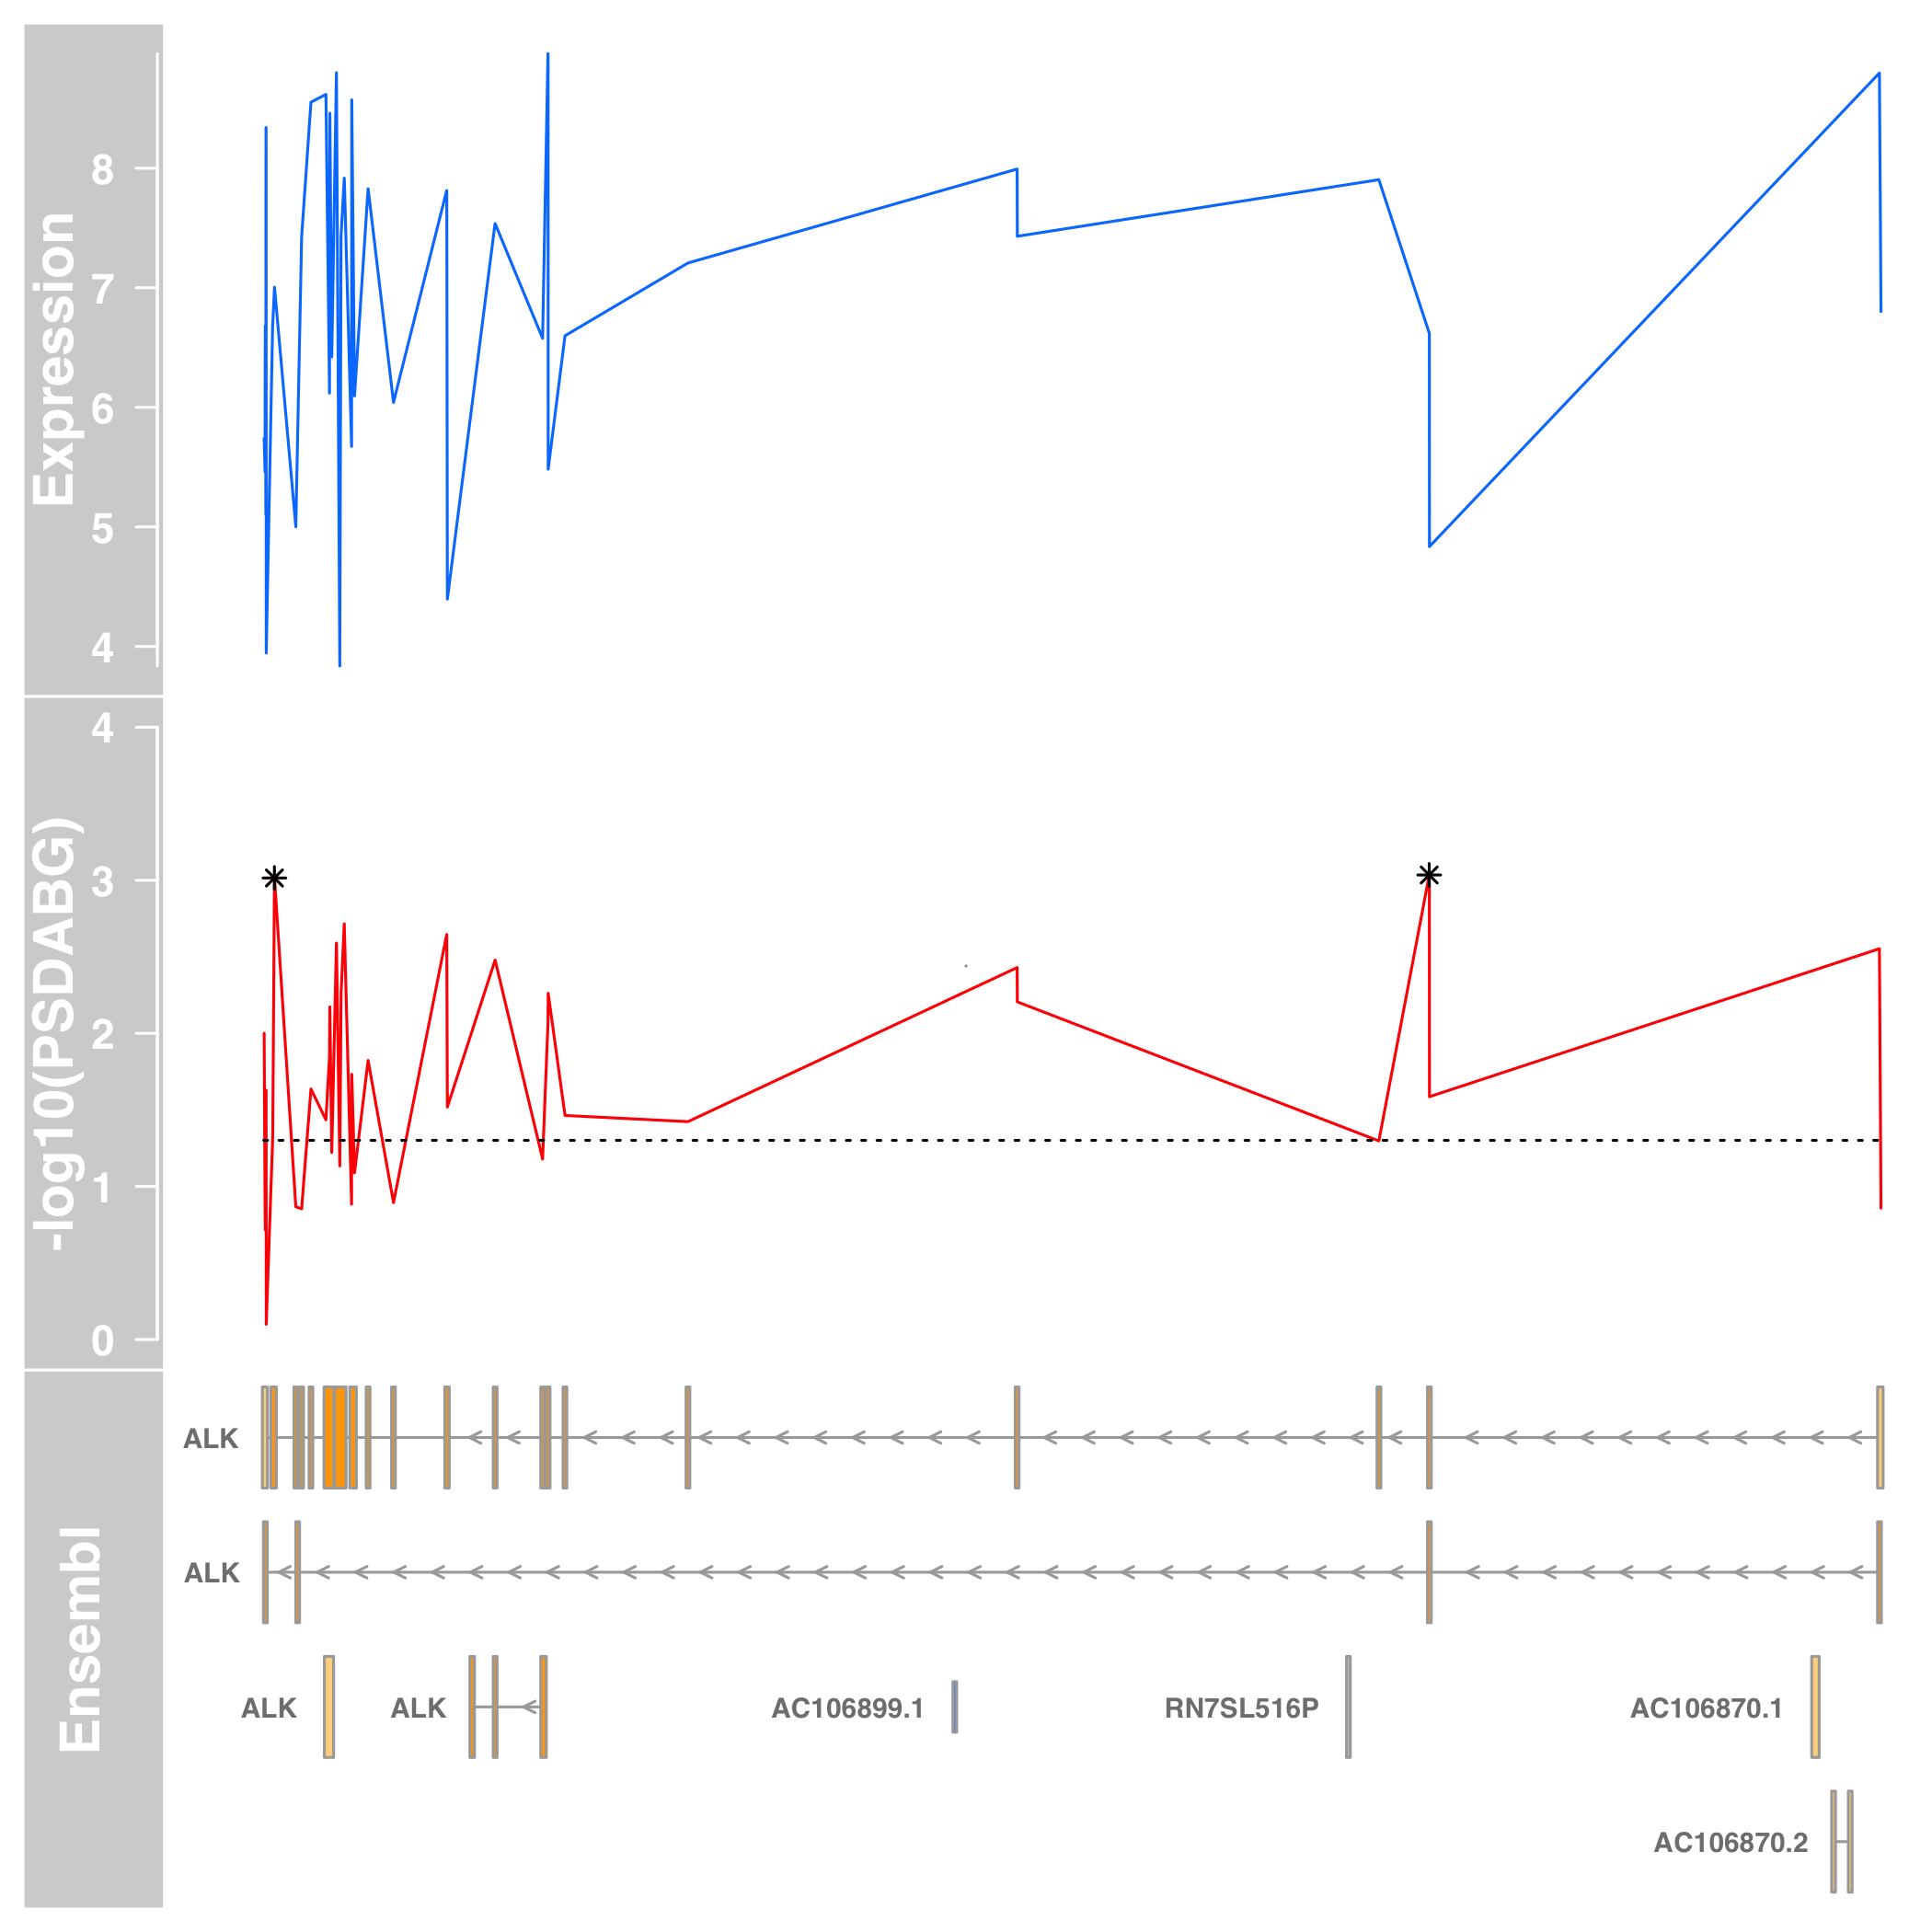
Supplemental Figure 1. ALK is expressed in the B-ALL sample with the ALK A348D mutation. Expression levels and PSDABG values from Affymetrix exon arrays. (Top) The blue line indicates the normalized expression values for sample 09206 for the gene region encompassing ALK. (middle) The red line indicates the -log10 (PSDABG) values for the same region with the black dotted line indicating .05 significance and the asterisks representing significance after Bonferroni correction for the 40 tests. (bottom) Ensembl 77 (GRCh37 freeze) gene models for the region of chromosome 2 encompassing ALK.

