**Supplemental Figures**

**Table S1. Differential equations for plasma PK and tumor deposition models**

|  |  |
| --- | --- |
| Plasma PK Model | |
| nal-IRI |  |
| CPT-11 |  |
| SN-38 |  |
|  |  |
| Tumor Deposition Model | |
| nal-IRI |  |
| CPT-11 |  |
| SN-38 |  |
|  |  |

**Figure S1.** Pharmacokinetic profile of nal-IRI across various tissues.NOD SCID mice bearing HT-29 tumors were treated with single intravenous dose of nal-IRI (20 mg/kg). Tumors and other tissues were collected at various intervals and the SN-38 were measured by HPLC analysis (n=4 animals / time point).



**Figure S2.** Precision of parameter estimates. Log-likelihood profiling was implemented as described by Raue et al (19). The changes in -2 log-likelihood function from the optimum, *(-2LL)* were computed for a given parameter value. When *(-2LL)* becomes 3.87, the confidence intervals (95%, p=0.05) for each parameter estimate were calculated as indicated by the intersection of black dashed line and blue solid line. (A) PSnal-IRI=[6.5e-5, 9.2e-5] and (B) Vmax,CES,t=[0.019, 0.0245].

**A**

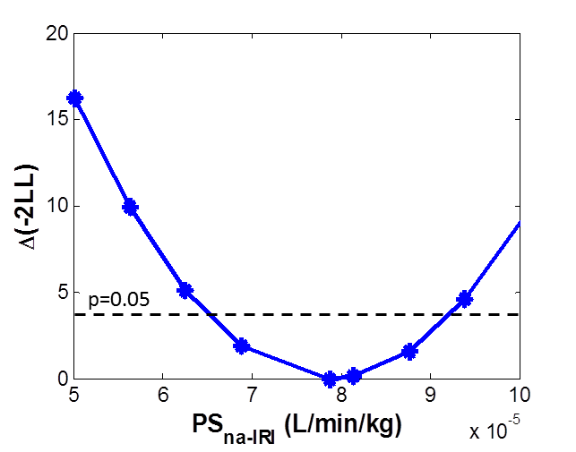

**B**

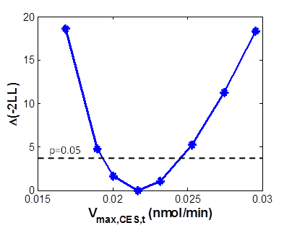**Figure S3.** Comparing the concentrations of free CPT-11 and total CPT-11 in plasma and tumors. The mechanistic tumor PK model was used to simulate the levels of total and free CPT-11 following the administration of 20 mg/kg nal-IRI. The free CPT-11 concentrations in plasma (A) were less than ~10% of total CPT-11 at 24 hours following nal-IRI administration. (B) In the tumors, the free CPT-11 concentrations was less than 10% of the total CPT-11 at 24 hours.

**A B**



**Figure S4.** Surrogates for tumor depostion and local activation of nal-IRI. (A) The levels of CPT-11 in tumor were simulated by changing nal-IRI permeability, PSnal-IRI. The linear relationship between CPT-11 levels in tumor at 72 hr after nal-IRI administration and nal-IRI permeability confirms the validity of using CPT-11 levels at 72 hr as a surrogate measure for nal-IRI permeability. (B) The SN-38 duration above 120 nM was computed from the simulated SN-38 profiles after nal-IRI administration and plotted against SN-38 levels in tumor at 72 hr. The positive relationship supports the use of SN-38 concentration at 72 hr as a surrogate for SN-38 duration.   
**A**



**B**



**Table S2.** Concentrations of CPT-11, SN-38 and CES activity in the panel of xenograft models.

|  |  |  |  |  |  |  |
| --- | --- | --- | --- | --- | --- | --- |
| Tumor model | CPT-11 (ng/g) | | SN-38 (ng/g) | | CES activity (ng/ml) | |
| Median | %CV | Median | %CV | Median | %CV |
| HT-29 | 2763.0 | 87.7 | 108.8 | 80.6 | 4.6 | 14.0 |
| SK-ES-1 | 5495.8 | 69.9 | 127.1 | 56.0 | 3.6 | 9.0 |
| A549 | 843.9 | 54.9 | 7.8 | 82.3 | 4.2 | 19.1 |
| MDA-MB-231 | 2108.0 | 52.2 | 43.2 | 62.4 | 4.4 | 24.4 |
| LoVo | 1633.5 | 58.7 | 11.0 | 59.9 | 3.2 | 18.7 |
| AsPC-1 | 1341.3 | 51.5 | 24.9 | 12.1 | 5.8 | 11.2 |
| A2780 | 4783.0 | 65.1 | 97.1 | 103.4 | 4.1 | 13.9 |
| CTG-0062 | 184.5 | 124.1 | 69.95 | 13.3 | 8.6 | 1.6 |
| CTG-0079 | 99.8 | 67.5 | 10.6 | 33.9 | 1.3 | 65.3 |
| CTG-0158 | 36.7 | 131.2 | 5.15 | 174.0 | 4.0 | 21.2 |
| CTG-0252 | 267.9 | 69.2 | 10.05 | 45.2 | 1.4 | 15.7 |
| CTG-0283 | 140.0 | 42.6 | 11.1 | 110.2 | 4.1 | 29.7 |
| CTG-0288 | 171.9 | 63.4 | 8.1 | -† | 2.6 | 38.1 |

†Only one sample was above the detection limit.

**Figure S5.** *In vitro* activation of nal-IRI in U937 cell lines. Human histiocytic lymphoma cell lines (U937) was differentiated to macrophages following 24 hours exposure to 16.2 nM phorbol 12-myristate 13-acetate. nal-IRI (5 µM) was incubated at 37OC with (white bars) or without (black bars) the activated macrophages. The amount of SN-38 released in the media was measured at 24 hours and 48 hours following incubation using HPLC analysis (n=2-3).

