**SA-4-1BBL and MPL combination as an adjuvant system shows robust therapeutic efficacy by increasing intratumoral CD8+ T effector/CD4+Foxp3+ T regulatory cell ratio**

Abhishek K. Srivastava *et al*.

Supplementary Materials

Including: Supplementary Figures and Tables, and Material and Methods,



**Figure S1.** Kinetics ofTumor growth of individual mice subjected to various treatments. **(**A), Data from Fig. 1A and (B), data from Fig. 1B are presented for individual animals in each group. Data are pooled from two independent experiments.



**Figure S2.** Vaccination with the SA-4-1BBL/MPL induces strong polyfunctional CD8+ T cell effector responses. Absolute number (from Fig. 2 A-C) of E749-57 peptide-specific CD8+ T cells per million of total dLN cells expressing intracellular IFN-γ mono, IFN-γTNF-α double, and IFN-γTNF-αIL-2 triple cytokines. Data shown are the mean + SEM of 3-4 mice per group. * P< 0.05, *** P< 0.001, ns> 0.05.



**Figure S3.** Vaccination with the SA-4-1BBL/MPL adjuvant system induces strong memory responses that correlate with vaccine efficacy. Splenocytes from the groups described in Fig. 2 were phenotyped to test the percentage of effector memory CD44hiCD62LlowCD8+ T cells. Data shown are the mean + SEM of 3-4 mice per group and representative of two independent experiments. * P< 0.05, ns> 0.05.



**Figure S4.** Two vaccinations with the SA-4-1BBL/MPL further improve the therapeutic response than one vaccination in the 3LL lung metastasis model.Mice (*n* = 4-5/group) were challenged with 2x105 live 3LL cells by i.v. tail injection and vaccinated (s.c.) twice on days 6 and 13 post-tumor challenge with SVN (50 µg) alone or with SA-4-1BBL (25 µg), MPL (25 µg), or SA-4-1BBL/MPL combination (25 µg/agent). Lungs were harvested 27 days post tumor challenge and assessed for tumor growth as described in Fig. 5A. Data are representative of two independent experiments * P< 0.05, *** P< 0.001, ns> 0.05.

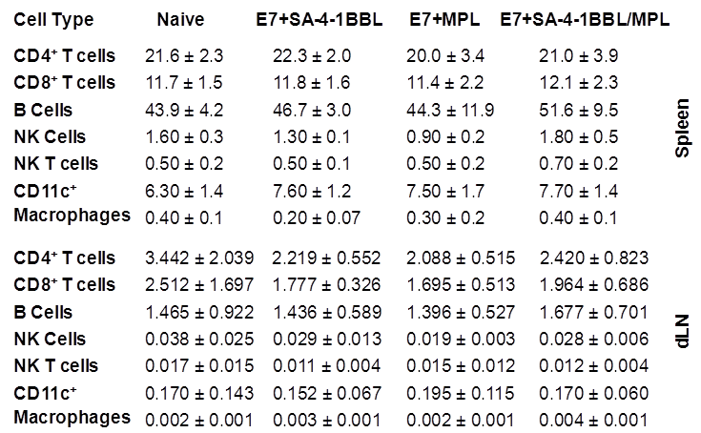

**Table S1.** Therapeutic efficacy ofSA-4-1BBL/MPL lacks vaccine associated toxicity. Naïve C57BL/6 mice were vaccinated with single and combination vaccines. Mice were euthanized after 18 hrs and assessed for total number of CD8+, CD4+ T cells, B cells, NK cells, NK T cells, DCs and macrophages in draining LN (dLNs) and spleen. Data shown are the mean + SEM of 3-4 mice per group

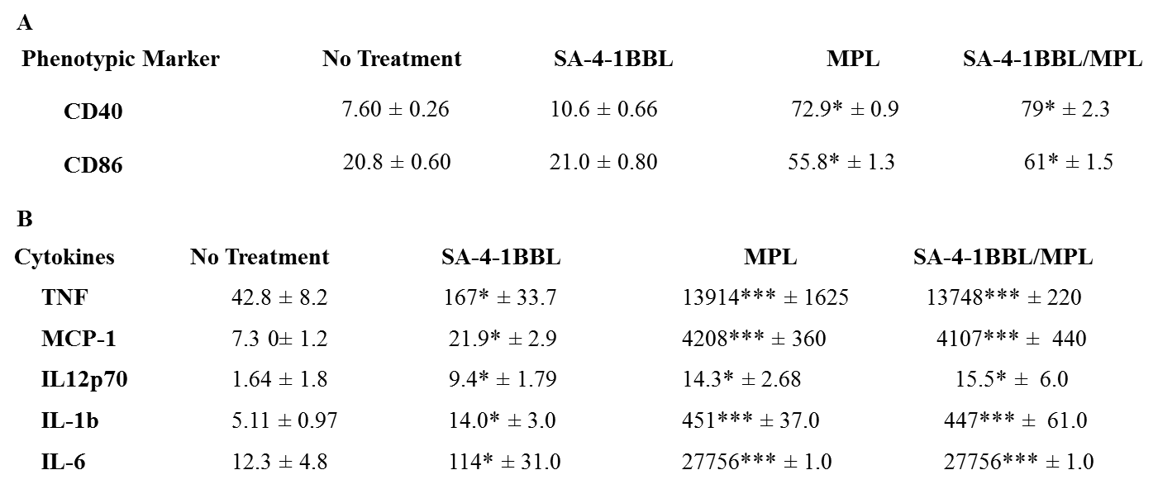

**Table S2**. Effect of SA-4-1BBL/MPL on DCs. DCs were harvested on day 6 of culture and incubated for 48 hrs with MPL or SA-4-1BBL (25µg each), or SA-4-1BBL/MPL (25µg/agent) or medium (no treatment). (A), Expression of the maturation markers CD40 and CD86 was assessed by flow cytometry and represented in (%). Data shown are the mean + SEM of triplicate culture assayed and representative of three independent experiments. (B), Cytokine secretion was measured in supernatant and represented in pg/ml. Data shown are the mean + SEM of triplicate culture assayed. The statistical significance is shown as compared to no treatment. * P< 0.05, *** P< 0.001.

**Material and Methods:**

**Memory phenotyping**

For memory T cell typing, spleens were processed as described previously (13) and lymphocytes were stained with anti-CD8-APC-Cy7, anti-CD62L-FITC, and anti-CD44-APC Abs followed by analysis on flowcytometry.

**Analysis of autoantibody to ssDNA**

A ssDNA ELISA was performed to assess the presence of auto-Abs in treated mice as described (21). Briefly, ninety six titer plates coated with 1 µg/well of heat-denatured calf thymus DNA (ssDNA, Sigma) were blocked with PBS containing 5% BSA + 0.5% Tween 20 + 0.1% naïve C57BL/6 serum. Serum dilutions were added to wells and incubated at 4oC overnight. Wells were washed 3 times, incubated with anti-mouse IgG-HRP, and absorbance was measured at 450 nm.

**DC activation and cytokine bead array analyses**

For DC generation, bone marrow cells from C57BL/6 were cultured at a density of 2 × 105 cells/mL in Petri dishes in complete RPMI-1640 medium (Gibco, NY, USA) with 20ng/mL recombinant mouse granulocyte-macrophage colony-stimulating factor (GM-CSF; Peprotech Inc., New Jersey, USA).  Media was changed on day 3 and cells were collected on day 6 from each dish, washed, and counted.

For DC activation, DCs were incubated for 48 hrs with MPL or SA-4-1BBL alone (25ug each), or SA-4-1BBL/MPL combination or medium (no treatment). Expression of the maturation markers CD40 and CD86 was assessed by flow cytometric analysis. Supernatants were also tested for TNF, IL-1β, IL-6, IL-12p70 and MCP-1 cytokine secretion using bead array analysis according to the manufacturer’s instructions (BeadlyteTM mouse multi-cytokine flex kit; Upstate, Lake Placid, NY).