Supplemental Data

Molecular homology and difference between spontaneous canine mammary cancers and human breast cancers

Deli Liu, Huan Xiong, Angela E Ellis, Nicole C Northrup, Carlos O. Rodriguez Jr, Ruth M. O'Regan, Stephen Dalton, Shaying Zhao

Description of Supplemental Data.

Seven Supplementary Tables Provided as Separate Excel files.
Table S1. Canine MC case information, including histopathological description, ER status, genomic-wide studies, notable genomic changes, age, breed and sex. This table provides supplementary data for Figure 1.

Table S2. Supplementary data for CNA discovery in canine MCs by aCGH and WGS analyses, including CNA result summary, amplified/deleted gene list and chimeric sequence reads related to the superamplicon. These data support Figure 2.

Table S3. Supplementary data for mutation discovery in canine MCs by WES and RNA-seq analyses, including read mapping information, mutated gene listed, base substitution type, etc. The data support Figure 3.

Table S4. Supplementary data for differentially expressed genes among canine complex carcinomas, simple carcinomas and normal tissues, including the gene list and enriched functions among the genes. The data support Figure 3.

Table S5. Supplementary data for Figure 5, indicating no differences in histone modification intensity between luminal epithelial cells and myoepithelial cells in complex carcinomas.

Table S6. Supplementary data for differentially expressed genes between canine ER+ and ER- carcinomas, including the gene list and enriched functions among the genes. The data support Figure 6.

Table S7. Supplementary data for Figure 7, providing altered genes and their function information.

One Document File Containing Six Supplementary Figures and Supplementary Methods.
Fig. S1. Supplementary data for large scale genomic aberrations illustrated in Figure 2, including: A) the distribution of mapped read density of WGS; B) PCR confirmation of translocation and fusion junctions of a superamplicon; and C) PCR and RT-PCR amplification of MGAM, ZFAND3, and the ZFAND3-MGAM fusion gene.

Fig. S2. The distribution of mapped read density of WES, supplementary data for Figure 3.

Fig. S3. Differentially expressed genes and functions among complex, simple carcinomas and normal mammary glands, supplementary data for Figure 3.

Fig. S4. IHC images of histone modifications in canine normal mammary glands at 400X magnification, supplementary data for Figure 4.

Fig. S5. IHC images of histone modifications in simple carcinomas, complex carcinomas and normal mammary glands at 200X magnification, supplementary data for Figure 5.

Fig. S6. Supplementary data for homology between canine MCs and human breast cancers described in Figure 6. These include differentially expressed genes between ER+ and ER- carcinomas at FDR ≤ 0.1 and an example of PAM50 clustering indicating canine and human tumor IDs.

Supplemental Methods.
- The detailed data analyses of WGS, WES and RNA-seq.
- The PCR primer information.

Fig. S1 (related to Figure 2).
Large scale genomic aberrations were found in simple carcinomas.
(A) The distribution of mapped read density of WGS for three carcinomas and their matching normal samples, used for CNA and translocation discovery.
(B) PCR confirmation of translocation and fusion junctions of a composite superamplicon discovered in a simple carcinoma (ID 76). The primers highlighted in yellow are used in RT-PCR analysis with cDNA. gDNA: genomic DNA. Only the intended junctions were amplified.
(C) PCR and RT-PCR amplification of MGAM, ZFAND3, and the ZFAND3-MGAM fusion gene in four simple carcinoma cases (purple) and three complex carcinoma cases (black). For case 76, both gDNA and cDNA are examined. For the remaining cases, only cDNA samples were examined. While the fusion gene was detected only in tumor 76, MGAM, an intestinal gene, is prominently expressed in 3 out of 7 tumors examined (76T, 40241T and 397889T) but none of the matching normal samples (N). ZFAND3 is expressed in every tumor and normal sample examined.
The primers used in the study are provided in Supplemental Experimental Procedures.

Fig. S2 (related to Figure 3).
WES analysis revealed frequent somatic sequence mutations in canine simple carcinomas.
The distribution of mapped read density of WES for the tumor and matching normal samples of five simple carcinomas cases, used for somatic sequence mutation finding. See also Table S3.

Fig. S3 (related to Figure 3).
Chromatin modification genes are significantly downregulated in complex carcinomas, compared to simple carcinomas and normal mammary gland tissues.
Left panel shows the heatmap of a subset of differentially expressed genes between complex and simple carcinomas at FDR ≤ 0.2 (Figure 3D) that also significantly (p ≤ 0.05) differ from normal mammary glands in their expression level. The genes are listed in Table S4H. Right panel illustrates the significantly enriched functions of each gene cluster indicated (see also Tables S4I-S4K).

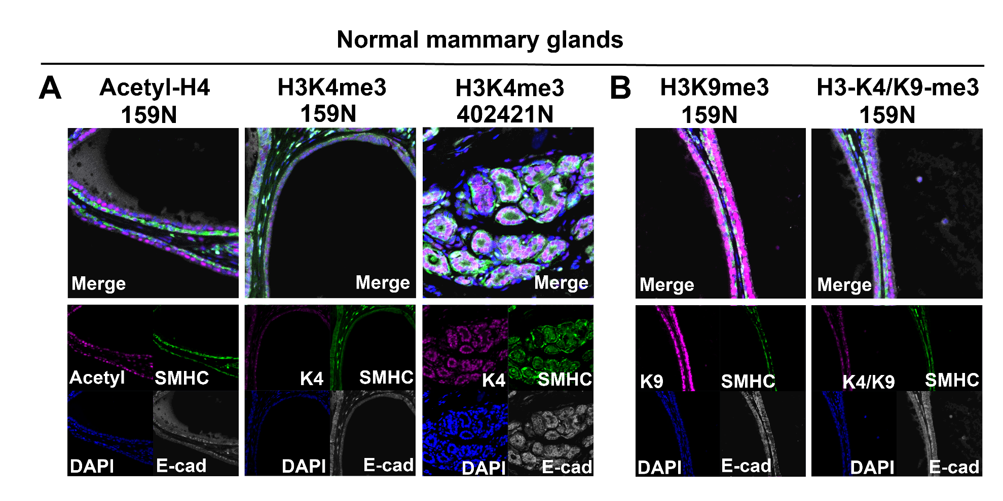
Fig. S4 (related to Figure 4).
Active and repressive histone modifications are both depleted in myoepithelial cells, when compared to luminal cells, in normal mammary glands.
(A) Representative IHC images of active modifications acetyl-H4 (Acetyl) and H3K4me3 (K4).
(B) Representative IHC images of repressive modification H3K9me3 (K9), and of H3-K4/K9-me3 (K4/k9) where the antibody works only when H3K4me3 and H3K9me3 are both present simultaneously.
Images are at 400X magnification.

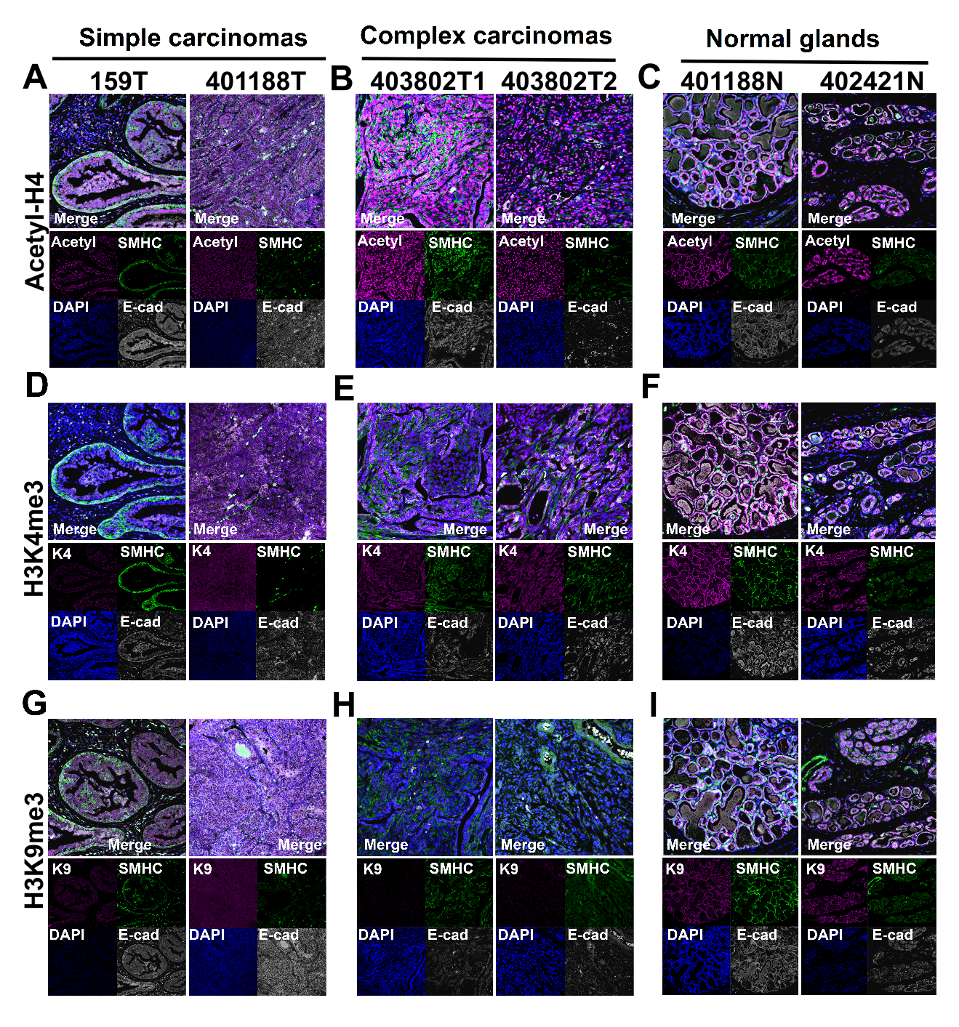
Fig. S5 (related to Figure 5).
Active histone modification H4-acetylation is enriched but repressive modification H3K9me3 is depleted in complex carcinomas.
(A-C) Representative IHC images of acetyl-H4 of simple carcinomas (A), complex carcinomas (B), and normal mammary glands (C).
(D-F) Representative IHC images of H3K4me3 of simple carcinomas (D), complex carcinomas (E), and normal mammary glands (F).
(G-I) Representative IHC images of H3K9me3 of simple carcinomas (G), complex carcinomas (H), and normal mammary glands (I).
Images are at 200X magnification.

Fig. S6 (related to Figure 6).
Subtype analysis reveals homology between canine MCs and human breast cancers.
(A) Differentially expressed genes between ER+ and ER- carcinomas at FDR ≤ 0.1. Left panel is the heatmap of 376 such genes (Table S6G), while right panel illustrates the significantly enriched functions of each gene cluster indicated.
(B) An example of PAM50 clustering of canine carcinomas and human breast carcinomas of five intrinsic subtypes from TCGA RNA-seq studies (1). Canine simple carcinomas and the ER- complex carcinoma 518 cluster with the basal-like subtype of human breast cancer.

Supplemental Methods
The data analysis pipeline was summarized in the diagram blow and described the following sections.

WGS and WES sequence alignment. Paired-end sequence reads of WGS and WES of each sample were aligned to the dog reference genome (canFam2, downloaded from the UCSC genome site) using BWA v0.6.2 (bio-bwa.sourceforge.net). Sorted bam files were generated by SAMtools v0.1.18 (samtools.sourceforge.net), and the duplicated mapped reads marked with Picard v1.60 (picard.sourceforge.net) were excluded. About 90-95% of WGS and 88-92% of WES reads were uniquely mapped to the dog reference genome, which were used for further analysis described below.

Identification of somatic sequence mutations and significantly mutated genes with WES. WES bam files were locally realigned to the dog reference genome using GATK (www.broadinstitute.org/gatk/) to reduce false mutations, and somatic base substitutions and small indels were detected by VarScan 2 (varscan.sourceforge.net/). Then, the results were filtered by removing known dog SNPs (2,544,508 in total) from the Broad Institute at www.broadinstitute.org/mammals/dog/snp2. Finally, the remaining mutations were annotated using ANNOVAR (www.openbioinformatics.org/annovar) with the xenoRefGene with additional improvement. The significantly mutated genes were identified as described (4). Briefly, the probability of a gene having the observed mutations at each of CpG dinucleotide sites and A, C, G, and T mononucleotide sites was calculated via a binomial distribution. Based on these, the mutation probability of each gene was computed and a FDR cutoff of 0.05 was used to select those significantly mutated.

Translocation and chimeric fusion gene identification. Somatic translocations were identified by applying BreakDancer (breakdancer.sourceforge.net) and CREST (5) on WGS data and then by removing germline translocations found in the matching normal samples. Chimeric fusion genes were uncovered by examining genes flanking the translocation breakpoints, in combination with RNA-seq analysis described below.

RNA-seq analysis. RNA-seq read pairs were aligned to the dog reference genome with TopHat v2.0.5 (tophat.cbcb.umd.edu). The uniquely mapped paired (~70-79%) were used to quantify a gene’s expression level by calculating its FPKM (fragments per kilobase of exon per million mapped fragments) value using Cufflinks (cufflinks.cbcb.umd.edu) with the default parameters and the canine xenoRefGene annotation downloaded from the UCSC genome site. Base substitutions in RNA-seq sequences were detected with VarScan 2 for genes with RNA-seq read coverage ranged from 30X to 300X (Table S3I).

Gene expression clustering analysis. Differentially expressed genes between complex and simple carcinomas or ER+ and ER- tumors were identified by performing t-tests with the natural log-transformed FPKM value of each gene and using a FDR cutoff of 0.2 or 0.1. Heatmaps were then generated by clustering the selected genes using their log-transformed FPKM values via hierarchical clustering. Gene functional annotation and enrichment analyses were achieved using the DAVID Functional Annotation tool (david.abcc.ncifcrf.gov) and literature reports. For PAM50 classification analysis, the canine ortholog of each human PAM50 gene was quantified and normalized following the same procedure described for the TCGA RNA-seq study (1). Then, PAM50 clustering with canine and human cancers was conducted as described (6). Human cancers consist of 20 randomly selected tumors for each of the luminal A or B, HER2-enriched and basal-like subtypes, as well as all 7 normal-like tumors in the current TCGA database. This PAM50 clustering analysis was repeated 100 times to ensure that each TCGA human tumor was sampled at least once.

Statistics
Statistic significances between groups were evaluated by conducting Student’s t-tests or Wilcoxon tests, and p-values ≤ 0.05 or 0.01 were considered significant. False discovery rate (FDR) control by the Benjamini and Hochberg step-up method (7) was used to correct for multiple testing. FDR ≤ 0.2, 0.1, or 0.05 were considered significant. Error bars in the figures represent SD.

Expression Primers used in qRT-PCR Analysis:

CTNNB1:
Forward, 5’-AGATGAAGGCATGCAGATCC-3’
Reverse, 5’-GCCAAACGCTGGACATTAGT-3’

BRAF:
Forward, 5’- TATCACGGAGCAATCCCAAG-3’
Reverse, 5’- CCTCTGTTTATTGGGCAGGA-3’

GAPDH:
Forward, 5’- TGTCCCCACCCCCAATGTATC-3’
Reverse, 5’- CTCCGATGCCTGCTTCACTACCTT-3’

MYC:
Forward, 5’- GACAAGAGGCGAACACACAA-3’
Reverse, 5’- CAAAGAAGCTCCGTTTCAGC-3’

PTEN:
Forward, 5’- GGTCTGCCAGCTAAAGGTGA-3’
Reverse, 5’- AACTTGTCTTCCCGTCGTGT-3’

ESR1:
Forward, 5’- TGGCCAGTACCAGTGACAAA-3’
Reverse, 5’- TGCACAGTAGCGAGTCTCCTT-3’

ERBB2:
Forward, 5’- CCCTCTCCAGCGGTACAGT-3’
Reverse, 5’- CGACGTAGCCATCAGTCTCA-3’

PGR:
Forward, 5’- CAGGTGTACCAGCCGTACCT-3’
Reverse, 5’- GAAGCTGTACTGTGGGCTCTG-3’

SOX2:
Forward, 5’- TGCAGTACAACTCCATGACCA-3’
Reverse, 5’- CTGCGAGTAGGACATGCTGTAG-3’

Primers for PCR Confirmation of Translocation and Fusion Junctions of Figs. S1B and S1C
Primer | Sequence | Chr | Strand | Start | End
1 | TTTGTCACTGCGCTGTCTG | 12 | + | 9097883 | 9097901 | gDNA
2 | TTGGTGTGGTCTATGTGTCCTC | 12 | - | 9098681 | 9098702 | gDNA
3 | AGGTGAGTACGAGTCAGCAATG | 12 | - | 9098796 | 9098817 | gDNA
4 | ATAACCACGCCAACTCTTAGTCC | 12 | + | 10059418 | 10059440 | cDNA
5 | CTGTAATCAGTCAGCCAGTCC | 12 | + | 10090709 | 10090729 | gDNA
6 | TGCTCATAAACTCCTGGATCA | 12 | - | 10091513 | 10091533 | gDNA
7 | CCCATGTGGTCAAACGTACA | 12 | - | 10138004 | 10138023 | cDNA
8 | TCCTTGGAGCGAGGTCTCT | 16 | + | 9683483 | 9683501 | gDNA
9 | GGACTTCAGGTCAACACAGGTC | 16 | - | 9683948 | 9683969 | gDNA
10 | TCGGAGGTGAAGTCCTATCTTATC | 16 | + | 10055566 | 10055589 | cDNA
11 | CGGAGGTGAAGTCCTATCTTATC | 16 | + | 10055567 | 10055589 | gDNA
12 | AACCTGGGTACTGTGAAGCTC | 16 | - | 10056293 | 10056313 | gDNA
13 | TGCCAACATCTGCGGTTATA | 16 | - | 10061573 | 10061592 | cDNA

Supplemental References
1. Cancer Genome Atlas N. Comprehensive molecular portraits of human breast tumours. Nature. 2012;490:61-70.
2. Tang J, Le S, Sun L, Yan X, Zhang M, Macleod J, et al. Copy number abnormalities in sporadic canine colorectal cancers. Genome research. 2010;20:341-50.
3. Youmans L, Taylor C, Shin E, Harrell A, Ellis AE, Seguin B, et al. Frequent Alteration of the Tumor Suppressor Gene APC in Sporadic Canine Colorectal Tumors. PloS one. 2012;7:e50813.
4. Sjoblom T, Jones S, Wood LD, Parsons DW, Lin J, Barber TD, et al. The consensus coding sequences of human breast and colorectal cancers. Science. 2006;314:268-74.
5. Wang J, Mullighan CG, Easton J, Roberts S, Heatley SL, Ma J, et al. CREST maps somatic structural variation in cancer genomes with base-pair resolution. Nature methods. 2011;8:652-4.
6. Parker JS, Mullins M, Cheang MC, Leung S, Voduc D, Vickery T, et al. Supervised risk predictor of breast cancer based on intrinsic subtypes. Journal of clinical oncology : official journal of the American Society of Clinical Oncology. 2009;27:1160-7.
7. Benjamini Y, Hochberg Y. Controlling the False Discovery Rate - a Practical and Powerful Approach to Multiple Testing. J Roy Stat Soc B Met. 1995;57:289-300.

