Supplementary Data

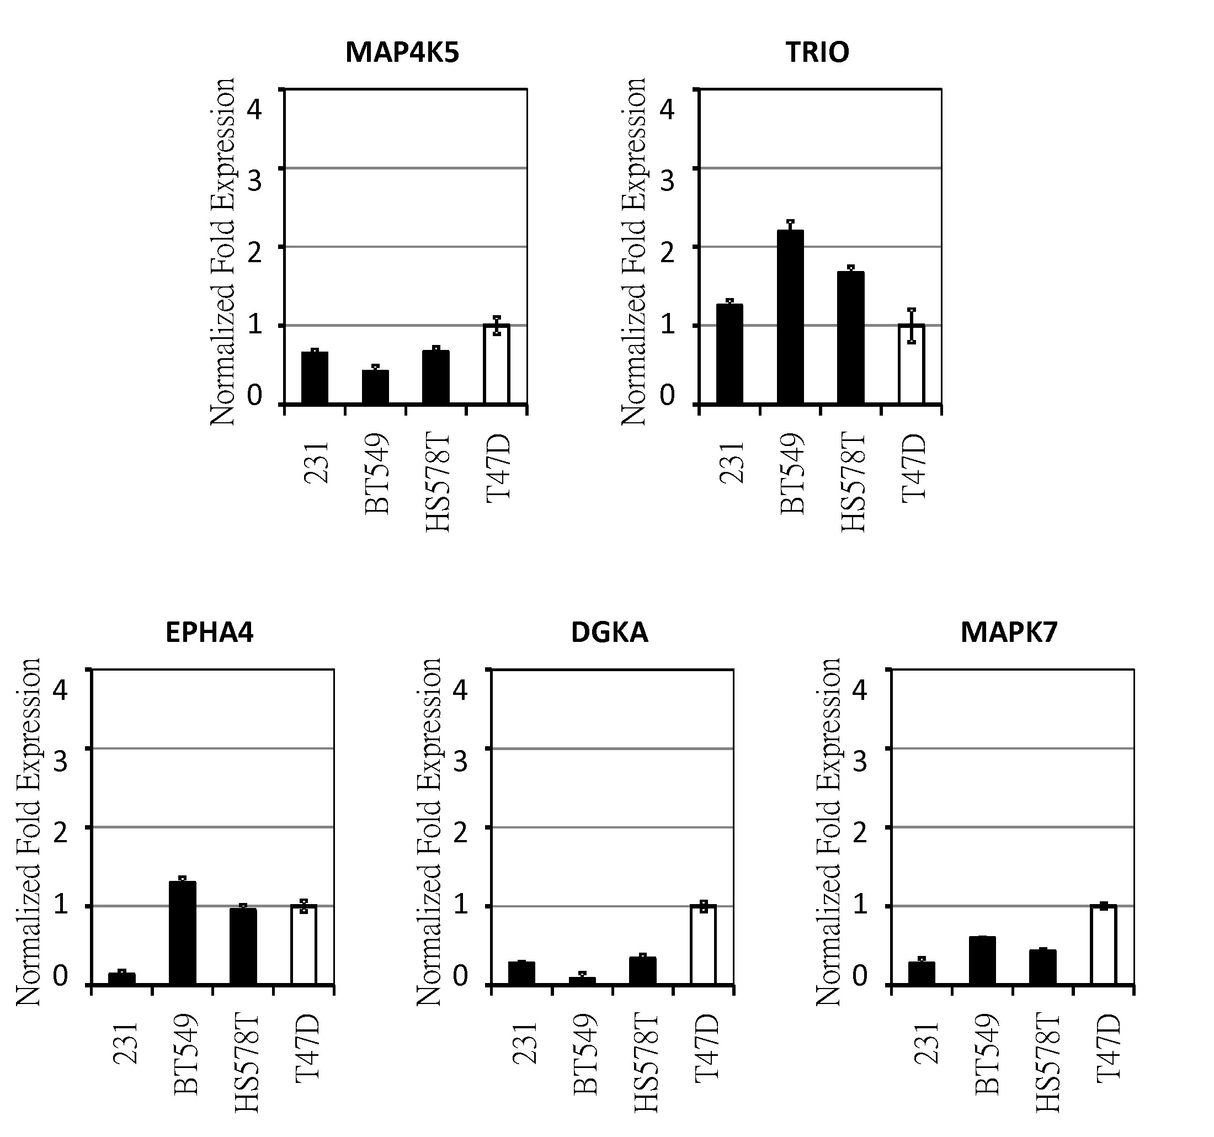
Supplementary Figure S1. The mRNA expression of MAP4K5, TRIO, EPHA4, DGKA and MAPK7 in TNBC cells (black bars) compared with expression in non-TNBC cells (white bar, T47D). RNA levels were quantitated and normalized to GAPDH by subtracting the cycling threshold for the control from the cycling threshold for the target. Primers were as follows:
MAP4K5: 5’-CCAACTGCTGAAAGACTTCTGAC-3’ and
5’-CTGCTTCAGTGTAATGTGCGTGG-3’
TRIO: 5’-GAAGGAGCCCATTCACATCCCT-3’ and
5’-GGCGATGGAAATCGTATCAGGC -3’
EPHA4: 5’-ACCAAGCAGTGCGAGAGTTTGC-3’ and
5’-CTCTCTTGCCAGGCACTTTGAG-3’
DGKA: 5’-CCTCCTAAAGGATGGTCCTGAG-3’ and
5’-AGAATCCAGCCTACTGTGCCGT-3’
MAPK7: 5’-GTCTTCCATGTCAGAGTCACCTG-3’ and
5’-CCAGGTCAAAGCCAACACCGTA-3’

Supplementary Figure S2. Inhibition of PKC-α, MET, and CDK6 reduced stem cell-like population. (A) Flow cytometric analysis of the CD24^{-/low} CD44⁺ population in MDA-MB-231cells. Cells were treated with safingol─Crizotinib (Sa+Cr; 3 μM+3 μM), safingol─PD0332991 (Sa+PD; 3 μM+7 μM), or Crizotinib─PD0332991 (3 μM+7 μM) separately or in combination, for 2 days. Error bars denote ±SD (n = 3, ** P < 0.01) (B) Representative images showing mammosphere formation of drug-treated MDA-MB-231 cells described in (A). The number of spheres formed is shown in each image (lower left).

