**SUPPPLEMENTARY DATA**

**Cancer Prevention with Resistant Starch in Lynch syndrome patients in the CAPP2 Randomised Placebo Controlled Trial:**

**planned 10-year follow-up**

John C Mathers, Faye Elliott, Finlay Macrae, Jukka-Pekka Mecklin, Gabriela Möslein, Fiona E. McRonald, Lucio Bertario, D. Gareth Evans, Anne-Marie Gerdes, Judy W.C. Ho, Annika Lindblom, Patrick J. Morrison, Jem Rashbass, Raj S. Ramesar, Toni Seppälä, Huw J. W. Thomas, Harsh J. Sheth, Kirsi Pylvänäinen, Lynn Reed, Gillian M. Borthwick, D Timothy Bishop, John Burn; on behalf of the CAPP2 Investigators

**Supplementary Table S1:** Characteristics of all CAPP2 Study participants at 10 years follow-up

|  |  |  |  |
| --- | --- | --- | --- |
|  | **Resistant Starch**  **(n=463)** | **Placebo**  **(n=455)** | **All participants**  **(n=918)** |
| **Time in CAPP2 intervention study (months)\*** | 24.6  (13.8, 0.8-74.4) | 25.3  (13.2, 1.1-60.6) | 25.0  (13.5, 0.8-74.4) |
| **Months between study entry and last known follow-up date \*** | 94.7  (37.9, 1.6-120) | 91.8  (38.9, 1.1-120) | 93.2  (38.4, 1.1-120) |
| **Years between study entry and last known follow-up date (categorised)(n)** |  | | |
| ≤2 | 41 | 45 | 86 |
| >2 and ≤4 | 34 | 31 | 65 |
| >4 and ≤6 | 49 | 59 | 108 |
| >6 and ≤8 | 27 | 34 | 61 |
| >8 and ≤10 | 312 | 286 | 598 |
| **Participants with first colorectal cancer (n)** |  | | |
| Since randomisation | 44 | 36 | 80 |
| Within 2 years of randomisation | 10 | 10 | 20 |
| More than 2 years from randomisation | 34 | 26 | 60 |
| **Participants with extra-colonic LS cancer (n)** |  | | |
| Since randomisation | 22 | 42 | 64 |
| Within 2 years of randomisation | 7 | 11 | 18 |
| More than 2 years from randomisation | 15 | 31 | 46 |
| **Participants with one or more LS cancer (including colorectal) (n)** |  | | |
| Since randomisation | 65 | 74 | 139 |
| Within 2 years of randomisation | 17 | 21 | 38 |
| More than 2 years from randomisation | 48 | 53 | 101 |
| **Participants with non-LS cancers (n)** |  |  |  |
| Since randomisation | 37 | 34 | 71 |
| Within 2 years of randomisation | 3 | 6 | 9 |
| More than 2 years from randomisation | 34 | 28 | 62 |
| **Types of extra-colonic LS cancers** (n)** |  |  |  |
| Brain | 1 | 3 | 4 |
| Upper GI |  |  |  |
| Stomach | 1 | 3 | 4 |
| Duodenum | 0 | 6 | 6 |
| Bile duct | 0 | 2 | 2 |
| Pancreas | 2 | 7 | 9 |
| Urinary+ | 4 | 7 | 11 |
| Ovarian | 2 | 5 | 7 |
| Endometrium | 14 | 15 | 29 |

* Data are mean (SD; range)

**2 participants in resistant starch and 4 participants in placebo had more than one extra-colonic LS cancer

+ Urinary cancers include ureter and kidney cancer

**Supplementary Table S2:** Cox proportional and negative binomial regression analysis (adjusted for age and gender) for colorectal cancer, non-colorectal cancer LS cancers, all LS cancers and non-LS cancers in participants randomly assigned to Resistant Starch (RS) or placebo at 10 years follow-up

|  |  |  |  |  |
| --- | --- | --- | --- | --- |
|  | **Hazard ratio \***  **(95% CI)** | **p value** | **Incidence rate ratio † (95% CI)** | **p value** |
| **Colorectal Cancer** | | | | |
| Intention-to-treat analysis (N=918, 80 events) |  | | | |
| Resistant Starch versus placebo | 1.16 (0.75-1.80) | 0.51 | 1.11 (0.70-1.74) | 0.66 |
| Per-Protocol Analysis‡ (N=521, 52 events) |  | | | |
| ≥2 years' placebo | 1.0 | - | 1.0 | - |
| ≥2 years' Resistant Starch | 1.35 (0.78-2.35) | 0.28 Ω | 1.29 (0.73-2.28) | 0.39 |
| Cumulative RS dose§ (N=918, 80 events) |  | | | |
| Units of 100 Resistant Starch | 1.01 (0.99-1.03) | 0.28 Ω | 1.01 (0.99-1.03) | 0.40 |
| **Non-colorectal LS cancers** | | | | |
| Intention-to-treat analysis (N=918, 64 events) |  | | | |
| Resistant Starch versus placebo | 0.51 (0.30-0.85) | 0.011 | 0.50 (0.30-0.84) | 0.0088 |
| Per-Protocol Analysis‡ (N=521, 39 events) |  | | | |
| ≥2 years' placebo | 1.0 | - | 1.0 | - |
| ≥2 years' Resistant Starch | 0.35 (0.17-0.72) | 0.0044 | 0.32 (0.15-0.66) | 0.0022 |
| Cumulative RS dose§ (N=918, 64 events) |  | | | |
| Units of 100 Resistant Starch | 0.95 (0.92-0.98) | 0.0037 | 0.94 (0.92-0.98) | 0.0028 |
| **All LS cancers** | | | | |
| Intention-to-treat analysis (N=918, 139 events) |  | | | |
| Resistant Starch versus placebo | 0.84 (0.60-1.17) | 0.30 | 0.78 (0.56-1.09) | 0.15 |
| Per-Protocol Analysis‡ (N=521, 87 events) |  | | | |
| ≥2 years' placebo | 1.0 | - | 1.0 | - |
| ≥2 years' Resistant Starch | 0.81 (0.53-1.23) | 0.32 Ω | 0.74 (0.49-1.14) | 0.18 |
| Cumulative RS dose§ (N=918, 139 events) |  | | | |
| Units of 100 Resistant Starch | 0.99 (0.97-1.01) | 0.23 Ω | 0.99 (0.97-1.01) | 0.18 |
| **All non-LS cancers** | | | | |
| Intention-to-treat analysis (N=918, 71 events) |  | | | |
| Resistant Starch versus placebo | 1.04 (0.66-1.67) | 0.85 | 0.92 (0.55-1.53) | 0.75 |
| Per-Protocol Analysis‡ (N=521, 42 events) |  | | | |
| ≥2 years' placebo | 1.0 | - | 1.0 | - |
| ≥2 years' Resistant Starch | 1.27 (0.69-2.33) | 0.45 | 1.19 (0.61-2.30) | 0.61 |
| Cumulative RS dose§ (N=918, 71 events) |  | | | |
| Units of 100 Resistant Starch | 1.00 (0.98-1.03) | 0.86 | 1.00 (0.97-1.03) | 0.86 |

* adjusted for gender and age at consent

† Incidence rate ratio from negative binomial regression.

‡ The threshold for 2 years’ intervention was consumption of more than 1400 starch sachets; rounded from a 2-year total of 1461 to allow for early scheduling of the exit colonoscopy or occasional missed dosage.

§ Units of 100 starch= total number of starch sachets taken divided by 100. Ω Violation of proportional hazards assumption.

**Supplementary Table S3:** Hazard ratios and 95% Confidence Intervals for cancer in those randomised to resistant starch *v.* placebo in the English, Welsh and Finnish participants at 20 years follow-up combined with the other centres at 10 years follow-up, firstly unadjusted and then adjusted for aspirin treatment stratified by gender and age at consent (grouped into tertiles)

|  |  |  |  |  |  |  |  |  |  |
| --- | --- | --- | --- | --- | --- | --- | --- | --- | --- |
|  |  | **Unadjusted** | | | | **Adjusted for aspirin randomisation arm** | | | |
| **Intention-to-treat Resistant Starch (RS) versus placebo** | **Subgroup** | **N(events)** | **Hazard ratio†**  **(95% CI)** | **p-value** | **P-value for interaction between gender and starch** | **N(events)** | **Hazard ratio†**  **(95% CI)** | **p-value** | **P-value for interaction between gender and starch** |
| **Colorectal Cancer** | Overall | 918(105) | 0.92 (0.63-1.35) | 0.66 |  | 842(96) | 1.00 (0.67-1.50) | 0.98 |  |
|  | Females | 517(49) | 1.43 (0.81-2.53) | 0.22 | 0.03 | 468(45) | 1.35 (0.75-2.44) | 0.32 | 0.18 |
|  | Males | 401(56) | 0.61 (0.36-1.04) | 0.07 | 374(51) | 0.75 (0.43-1.31) | 0.32 |
| **Non-colorectal LS cancers** | Overall | 918(75) | 0.52 (0.32-0.83) | 0.006 |  | 842(70) | 0.54 (0.33-0.88) | 0.013 |  |
|  | Females | 517(61) | 0.53 (0.31-0.89) | 0.02 | 0.96 | 468(57) | 0.55 (0.32-0.94) | 0.030 | 0.96 |
|  | Males | 401(14) | 0.50 (0.17-1.49) | 0.21 | 374(13) | 0.58 (0.19-1.78) | 0.34 |
| **All LS cancers** | Overall | 918(174) | 0.74 (0.55-0.99) | 0.05 |  | 842(160) | 0.80 (0.58-1.09) | 0.15 |  |
|  | Females | 517(106) | 0.87 (0.60-1.28) | 0.49 | 0.19 | 468(98) | 0.87 (0.59-1.30) | 0.51 | 0.52 |
|  | Males | 401(68) | 0.57 (0.35-0.93) | 0.02 | 374(62) | 0.69 (0.42-1.15) | 0.15 |
| **All non-LS cancers** | Overall | 918(89) | 0.95 (0.62-1.43) | 0.80 |  | 842(74) | 0.88 (0.56-1.39) | 0.59 |  |
|  | Females | 517(50) | 0.97 (0.56-1.69) | 0.92 | 0.94 | 468(39) | 0.83 (0.44-1.55) | 0.55 | 0.74 |
|  | Males | 401(39) | 0.92 (0.49-1.72) | 0.79 | 374(35) | 0.94 (0.48-1.84) | 0.86 |
| **Colorectal Cancer** |  |  |  |  |  |  |  |  |  |
|  | Age <39.0 years | 305(29) | 0.98 (0.47-2.03) | 0.95 |  | 298(29) | 1.00 (0.48-2.09) | 0.99 |  |
|  | Age ≥39.0 <50.3 years | 306(40) | 0.85 (0.46-1.59) | 0.62 |  | 291(39) | 0.84 (0.45-1.58) | 0.60 |  |
|  | Age ≥50.3 years | 307(36) | 1.00 (0.52-1.93) | 0.99 |  | 253(28) | 1.28 (0.60-2.73) | 0.53 |  |
| **Non-colorectal LS cancers** |  |  |  |  |  |  |  |  |  |
|  | Age <39.0 years | 305(10) | 0.47 (0.13-1.68) | 0.24 |  | 298(10) | 0.48 (0.13-1.72) | 0.26 |  |
|  | Age ≥39.0 <50.3 years | 306(29) | 0.66 (0.31-1.38) | 0.27 |  | 291(28) | 0.69 (0.32-1.45) | 0.33 |  |
|  | Age ≥50.3 years | 307(36) | 0.47 (0.23-0.95) | 0.04 |  | 253(32) | 0.48 (0.22-1.03) | 0.059 |  |
| **All LS cancers** |  |  |  |  |  |  |  |  |  |
|  | Age <39.0 years | 305(39) | 0.81 (0.43-1.52) | 0.51 |  | 298(39) | 0.83 (0.44-1.56) | 0.56 |  |
|  | Age ≥39.0 <50.3 years | 306(67) | 0.75 (0.46-1.21) | 0.23 |  | 291(65) | 0.75 (0.46-1.23) | 0.26 |  |
|  | Age ≥50.3 years | 307(68) | 0.74 (0.46-1.20) | 0.22 |  | 253(56) | 0.84 (0.49-1.44) | 0.52 |  |
| **All non-LS cancers** |  |  |  |  |  |  |  |  |  |
|  | Age <39.0 years | 305(9) | 1.46 (0.36-5.87) | 0.60 |  | 298(8) | 1.25 (0.30-5.27) | 0.76 |  |
|  | Age ≥39.0 <50.3 years | 306(34) | 0.93 (0.48-1.83) | 0.84 |  | 291(31) | 0.86 (0.42-1.73) | 0.67 |  |
|  | Age ≥50.3 years | 307(46) | 1.03 (0.58-1.85) | 0.91 |  | 253 (35) | 1.04 (0.52-2.04) | 0.92 |  |

†Hazard ratio for Intention-to-treat Resistant Starch (RS) versus placebo

**Supplementary Table S4**: Characteristics of the English, Welsh and Finnish participants in the CAPP2 Study with up to 20 years follow-up

|  |  |  |  |
| --- | --- | --- | --- |
|  | **Resistant Starch**  **(n=190)** | **Placebo**  **(n=179)** | **All participants**  **(n=369)** |
| **Time in CAPP2 intervention study (months)\*** | 25.5 (14.0, 0.8-74.4) | 27.2 (13.8, 1.8-58.9) | 26.3 (13.9, 0.8-74.4) |
| **Months between study entry and last known follow-up date\*** | 178.3 (35.9, 24.1-238.7) | 174.8 (38.4, 33.4-238.9) | 176.6 (37.1, 24.1-238.9) |
| **Years between study entry and last known follow-up date (categorised)(n)** |  | | |
| ≤2 | 0 | 0 | 0 |
| >2 and ≤6 | 5 | 5 | 10 |
| >6 and ≤10 | 3 | 9 | 12 |
| >10 and ≤14 | 48 | 54 | 102 |
| >14 and ≤18 | 115 | 92 | 207 |
| >18 and ≤20 | 19 | 19 | 38 |
| **Participants with first colorectal cancer (n)** |  | | |
| Since randomisation | 32 | 38 | 70 |
| Within 2 years of randomisation | 4 | 5 | 9 |
| More than 2 years from randomisation | 28 | 33 | 61 |
| **Participants with extra-colonic LS cancer (n)** |  | | |
| Since randomisation | 12 | 28 | 40 |
| Within 2 years of randomisation | 1 | 5 | 6 |
| More than 2 years from randomisation | 11 | 23 | 34 |
| **Participants with one or more LS cancer (including colorectal) (n)** |  | | |
| Since randomisation | 44 | 62 | 106 |
| Within 2 years of randomisation | 5 | 10 | 15 |
| More than 2 years from randomisation | 39 | 52 | 91 |
| **Participants with non-LS cancers (n)** |  |  |  |
| Since randomisation | 22 | 26 | 48 |
| Within 2 years of randomisation | 0 | 1 | 1 |
| More than 2 years from randomisation | 22 | 25 | 47 |
| **Types of extra-colonic LS cancers (n)** |  |  |  |
| Brain | 1 | 0 | 1 |
| Upper GI |  |  |  |
| Stomach | 0 | 3 | 3 |
| Duodenum | 1 | 4 | 5 |
| Bile duct | 0 | 2 | 2 |
| Pancreas | 3 | 4 | 7 |
| Urinary+ | 1 | 7 | 8 |
| Ovarian | 2 | 2 | 4 |
| Endometrium | 5 | 7 | 12 |

*Data are mean (SD; range). **1 participant in resistant starch and 1 participant in placebo had more than one extra-colonic LS

+ Urinary cancers include ureter and kidney cancers

**Supplementary Table S5:** Baseline characteristics of CAPP2 Study participants

|  |  |  |  |  |
| --- | --- | --- | --- | --- |
| **Variable** | **All participants (N=918)** | **Intervention phase only (n=134)** | **Followed from start of intervention to 10th anniversary (n=415)** | **Followed from start of intervention to 20th anniversary (n=369)** |
| **Age at study entry – years** |  |  |  |  |
| Mean (s.d.) | 45.0 (10.9) | 44.3 (11.3) | 45.1 (10.9) | 45.2 (10.8) |
| Range | 21.5-78.8 | 21.5-77.9 | 24.7-78.8 | 24.6-75.5 |
| **Sex no. (%)** |  |  |  |  |
| Female | 517 (56.3) | 76 (56.7) | 236 (56.9) | 205 (55.6) |
| Male | 401 (43.7) | 58 (43.3) | 179 (43.1) | 164 (44.4) |
| **Geographic region no. (%)** |  |  |  |  |
| England/Wales | 227 (24.7) | 1 (0.8) | 0 (0) | 226 (61.3) |
| Finland | 143 (15.6) | 0 (0) | 0 (0) | 143 (38.7) |
| Other Northern Europe | 267 (29.1) | 70 (52.2) | 197 (47.5) | 0 (0) |
| Scotland/Ireland | 45 (4.9) | 13 (9.7) | 32 (7.7) | 0 (0) |
| Australia and Hong Kong | 132 (14.4) | 23 (17.2) | 109 (26.3) | 0 (0) |
| Southern Europe | 56 (6.1) | 24 (17.9) | 32 (7.7) | 0 (0) |
| South Africa | 44 (4.8) | 2 (1.5) | 42 (10.1) | 0 (0) |
| Americas | 4 (0.4) | 1 (0.8) | 3 (0.7) | 0 (0) |
| **Eligibility status at recruitment no. (%)** |  |  |  |  |
| Clinical diagnosis | 160 (17.4) | 25 (18.7) | 73 (17.6) | 62 (16.8) |
| Genetic diagnosis | 758 (82.6) | 109 (81.3) | 342 (82.4) | 307 (83.2) |
| **Mutation no./total no. (%)** |  |  |  |  |
| MLH1 | 453/758 (59.8) | 64/109 (58.7) | 181/342 (52.9) | 208/307 (67.8) |
| MSH2 | 280/758 (36.9) | 42/109 (38.5) | 144/342 (42.1) | 94/307 (30.6) |
| MSH6 | 25/758 (3.3) | 3/109 (2.8) | 17/342 (5.0) | 5/307 (1.6) |

**Supplementary Table S6:** Cox proportional and negative binomial regression analysis (adjusted for age and gender) for colorectal cancer, non-colorectal LS cancers, all LS cancers and non-LS cancers in English, Welsh and Finnish population with up to 20 years follow-up randomly assigned to Resistant Starch (RS) or placebo.

|  |  |  |  |  |
| --- | --- | --- | --- | --- |
|  | **Hazard ratio * (95% CI)** | **p value** | **Incidence rate ratio†**  **(95% CI)** | **p value** |
| **Colorectal Cancer** | | | | |
| Intention-to-treat analysis (N=369, 70 events) |  | | | |
| Resistant Starch versus placebo | 0.76 (0.48-1.22) | 0.26 | 0.70 (0.45-1.10) | 0.12 |
| Per-Protocol Analysis‡ (N=233, 48 events) |  | | | |
| ≥2 years' placebo | 1.0 | - | 1.0 | - |
| ≥2 years' Resistant Starch | 1.15 (0.65-2.02) | 0.64 | 0.92 (0.54-1.58) | 0.76 |
| Cumulative RS dose§ (N=369, 70 events) |  | | | |
| Units of 100 Resistant Starch | 1.00 (0.98-1.02) | 0.93 | 0.99 (0.97-1.02) | 0.50 |
| **Non-colorectal LS cancers** | | | | |
| Intention-to-treat analysis (N=369, 40 events) |  | | | |
| Resistant Starch versus placebo | 0.40 (0.20-0.78) | 0.0077 | 0.45 (0.23-0.86) | 0.016 |
| Per-Protocol Analysis‡ (N=233, 25 events) |  | | | |
| ≥2 years' placebo | 1.0 | - | 1.0 | - |
| ≥2 years' Resistant Starch | 0.31 (0.12-0.77) | 0.012 Ω | 0.33 (0.13-0.83) | 0.019 |
| Cumulative RS dose§ (N=369, 40 events) |  | | | |
| Units of 100 Resistant Starch | 0.94 (0.89-0.98) | 0.0040 | 0.94 (0.90-0.98) | 0.0070 |
| **All LS cancers** | | | | |
| Intention-to-treat analysis (N=369, 106 events) |  | | | |
| Resistant Starch versus placebo | 0.63 (0.43-0.92) | 0.018 | 0.60 (0.42-0..87) | 0.0060 |
| Per-Protocol Analysis‡ (N=233, 70 events) |  | | | |
| ≥2 years' placebo | 1.0 | - | 1.0 | - |
| ≥2 years' Resistant Starch | 0.79 (0.50-1.27) | 0.34 | 0.69 (0.44-1.08) | 0.10 |
| Cumulative RS dose§ (N=369, 106 events) |  | | | |
| Units of 100 Resistant Starch | 0.98 (0.96-1.00) | 0.074 | 0.98 (0.96-1.00) | 0.025 |
| **All non-LS cancers** | | | | |
| Intention to treat analysis (N=369, 48 events) |  | | | |
| Resistant Starch versus placebo | 0.76 (0.43-1.35) | 0.35 | 0.73 (0.41-1.28) | 0.27 |
| Per-Protocol Analysis‡ (N=233, 30 events) |  | | | |
| ≥2 years' placebo | 1.0 | - | 1.0 | - |
| ≥2 years' Resistant Starch | 0.71 (0.34-1.47) | 0.35 | 0.70 (0.33-1.49) | 0.35 |
| Cumulative RS dose§ (N=369, 48 events) |  | | | |
| Units of 100 Resistant Starch | 0.98 (0.95-1.01) | 0.25 | 0.98 (0.95-1.01) | 0.29 |

*adjusted for age at consent and gender. † Incidence rate ratio from negative binomial regression.

‡ The threshold for 2 years’ intervention was consumption of more than 1400 starch sachets; rounded from a 2-year total of 1461 to allow for early scheduling of the exit colonoscopy or occasional missed dosage.

§ Units of 100 starch= total number of starch taken divided by 100.

Ω Violation of proportional hazards assumption

**Supplementary Table S7:** Dukes stage of first colorectal cancer post study entry by randomisation group. Data were available on 67 colorectal tumours at 10 years with no evidence of any difference between the two treatment groups (p = 0.68 Fisher exact after combining C and D into a single stage).

|  |  |  |  |
| --- | --- | --- | --- |
| **Dukes Stage** | **Placebo** | **Resistant Starch** | **Total** |
| **A** | 15 (45.5%) | 17 (50.0%) | 32 |
| **B** | 14 (42.4%) | 11 (32.4%) | 25 |
| **C** | 4 (12.1%) | 5 (14.7%) | 9 |
| **D** | 0 (0%) | 1 (2.9%) | 1 |
| **TOTAL** | 33 (100%) | 34 (100%) | 67 |

**Supplementary Table S8:** Summary of first LS cancer type post study entry by years since randomisation in participants randomly assigned to Resistant Starch or placebo, in English, Welsh and Finnish participants at 20 years follow-up combined with the other centres at 10 years follow-up

|  |  |  |  |  |  |  |  |  |  |  |  |  |  |  |  |  |
| --- | --- | --- | --- | --- | --- | --- | --- | --- | --- | --- | --- | --- | --- | --- | --- | --- |
| **Years since randomisation** | **CRC** | | **Brain** | | **Stomach/duodenum** | | **Bile duct/pancreas** | | **Urinary** | | **Ovarian** | | **Endometrium/uterine** | | **Multiple sites\*** | |
| **Resistant Starch** | **Placebo** | **Resistant Starch** | **Placebo** | **Resistant Starch** | **Placebo** | **Resistant Starch** | **Placebo** | **Resistant Starch** | **Placebo** | **Resistant Starch** | **Placebo** | **Resistant Starch** | **Placebo** | **Resistant Starch** | **Placebo** |
| **0-2** | 7 | 3 | 0 | 0 | 1 | 2 | 0 | 1 | 2 | 0 | 0 | 2 | 3 | 6 | 1 | 0 |
| **2-4** | 5 | 14 | 1 | 0 | 0 | 1 | 1 | 2 | 0 | 0 | 1 | 1 | 1 | 3 | 0 | 1 |
| **4-6** | 11 | 10 | 0 | 0 | 0 | 2 | 0 | 3 | 0 | 1 | 0 | 0 | 5 | 3 | 1 | 1 |
| **6-8** | 13 | 5 | 0 | 1 | 0 | 3 | 1 | 0 | 1 | 1 | 0 | 0 | 1 | 0 | 0 | 2 |
| **8-10** | 8 | 4 | 0 | 0 | 0 | 0 | 0 | 1 | 1 | 3 | 0 | 0 | 1 | 1 | 0 | 1 |
| **10-12** | 3 | 6 | 0 | 0 | 0 | 1 | 0 | 1 | 0 | 2 | 0 | 0 | 0 | 0 | 0 | 0 |
| **12-14** | 3 | 2 | 0 | 0 | 1 | 0 | 0 | 0 | 0 | 1 | 0 | 0 | 0 | 0 | 0 | 0 |
| **14-16** | 2 | 4 | 1 | 0 | 0 | 0 | 1 | 0 | 0 | 0 | 0 | 0 | 0 | 0 | 0 | 0 |
| **16-18** | 0 | 5 | 0 | 0 | 0 | 0 | 0 | 0 | 1 | 0 | 0 | 0 | 1 | 1 | 0 | 0 |
| **18-20** | 0 | 0 | 0 | 0 | 0 | 0 | 0 | 0 | 0 | 0 | 0 | 0 | 0 | 0 | 0 | 0 |
| **Total** | 52 | 53 | 2 | 1 | 2 | 9 | 3 | 8 | 5 | 8 | 1 | 3 | 12 | 14 | 2 | 5 |

*First cancer in participants diagnosed with multiple extra-colonic LS cancers

**Supplementary Table S9:** Summary of non-LS cancers occurring in CAPP2 10 year follow-up within England, Finland and Wales in the first decade since randomisation and also the second decade as well as all other Centres in the first decade. Data obtained from CAPP2 Database as well as PHE for England and Wales and Finnish clinical records.

|  |  |  |  |  |  |  |  |  |  |
| --- | --- | --- | --- | --- | --- | --- | --- | --- | --- |
| **Type of non-LS cancer1** | **England, Finland and Wales 1-10 years** | | **Other Centres2 1-10 years** | | **Total - All Centres 1-10 years** | |  | **England, Finland and Wales 10-20 years** | |
| **Resistant Starch** | **Placebo** | **Resistant Starch** | **Placebo** | **Resistant Starch** | **Placebo** |  | **Resistant Starch** | **Placebo** |
| **Bladder** | 4 | 0 | 0 | 3 | 4 | 3 |  | 0 | 1 |
| **Bone** | 0 | 0 | 1 | 0 | 1 | 0 |  | 0 | 0 |
| **Breast** | 3 | 2 | 4 | 3 | 7 | 5 |  | 0 | 2 |
| **Cervix** | 0 | 1 | 0 | 0 | 0 | 1 |  | 0 | 0 |
| **Chondrosarcoma** | 0 | 0 | 1 | 0 | 1 | 0 |  | 0 | 0 |
| **Connective tissue** | 0 | 0 | 1 | 0 | 1 | 0 |  | 0 | 0 |
| **Leukemia** | 0 | 0 | 0 | 1 | 0 | 1 |  | 0 | 0 |
| **Lung** | 1 | 1 | 0 | 1 | 1 | 2 |  | 1 | 2 |
| **Lymphoma** | 0 | 0 | 1 | 1 | 1 | 1 |  | 0 | 0 |
| **Meningioma** | 0 | 0 | 1 | 0 | 1 | 0 |  | 0 | 0 |
| **Neurofibrosarcoma** | 0 | 0 | 1 | 0 | 1 | 0 |  | 0 | 0 |
| **Oesophagus** | 0 | 1 | 0 | 1 | 0 | 2 |  | 1 | 0 |
| **Prostate** | 2 | 2 | 6 | 1 | 8 | 3 |  | 1 | 2 |
| **Skin** | 4 | 8 | 5 | 7 | 9 | 15 |  | 5 | 3 |
| **Thyroid** | 0 | 1 | 0 | 0 | 0 | 1 |  | 0 | 0 |
| **Tongue** | 0 | 0 | 1 | 0 | 1 | 0 |  | 0 | 0 |
| **Urethra** | 0 | 0 | 1 | 0 | 1 | 0 |  | 0 | 0 |
| **Total** | **14** | **16** | **23** | **18** | **37** | **34** |  | **8** | **10** |

1Type of first non-LS cancer post study entry. 2 Centres excluding England, Finland and Wales

**Supplementary Figure S1:** Time to first colorectal cancer and time to any LS cancer in CAPP2 study participants from England, Finland and Wales with up to 20 years follow-up and from the remaining centres with up to 10 years follow-upanalysed using Cox proportional hazards (HR and 95% confidence intervals) comparing those on Resistant Starch versus those on placebo and depicted by Cumulative incidence curves. The figures also show the number of participants at risk by time on study as well as 95% confidence intervals for the cumulative incidence of cancer. Figure 1A shows the intention to treat analysis (n=463 Resistant Starch, 455 placebo) by randomisation group. Figure 1B shows the per protocol analysis of all those achieving 2 years Resistant Starch or placebo (n=255 Resistant Starch; n=266 placebo). Figure 1C shows the intention to treat analysis for LS cancer other than CRC and Figure 1D shows the per protocol analysis for this same comparison. Figures 1E and 1F show the results for ITT and per protocol analysis of all LS cancers combined. Finally, Figures 1G and 1H show the results for all non-LS cancers.

266 260 235 192 170 98 94 74 47 15 0

255 251 232 204 188 106 103 86 53 13 0

**Number at risk**

**Placebo** 455 402 366 298 264 151 136 98 60 17 0

**Resistant** 463 416 381 327 298 176 164 129 75 18 0

**Starch**

266 264 234 195 170 100 96 74 42 14 0

255 252 233 197 175 91 86 69 39 9 0

**Number at risk**

**Placebo** 455 406 364 299 262 148 132 94 54 16 0

**Resistant** 463 416 378 319 283 158 145 111 60 14 0

**Starch**



**Supplementary Figure S2:** Time to first colorectal cancer and time to any LS cancer in CAPP2 Study participants (n=918) for the first ten years after randomisation analysed using Cox proportional hazards (HR and 95% confidence intervals) comparing those on Resistant Starch versus those on placebo and depicted by Cumulative incidence curves. The figures also show the number of participants at risk by time on study as well as 95% confidence intervals for the cumulative incidence of cancer. Figure 2A shows the intention to treat analysis (n=463 Resistant Starch, 455 placebo) by randomisation group. Figure 2B shows the per protocol analysis of all those achieving 2 years Resistant Starch or placebo (n=255 Resistant Starch; n=266 placebo). Figure 2C shows the intention to treat analysis for LS cancer other than CRC and Figure 2D shows the per protocol analysis for this same comparison. Figures 2E and 2F show the results for ITT and per protocol analysis of all LS cancers combined. Finally, Figures 2G and 2H show the results for all non-LS cancers.

**Number at risk**

**Placebo** 455 399 352 279 242 135 117 82 47 14 0

**Resistant** 463 411 371 307 270 152 140 106 58 13 0

**Starch**

266 259 226 182 157 90 84 64 36 12 0

255 250 230 192 168 88 83 66 38 8 0

266 264 239 196 174 102 98 75 49 15 0

255 252 228 202 181 102 99 82 50 13 0

**Number at risk**

**Placebo** 455 406 368 300 263 152 138 97 61 17 0

**Resistant**  463 420 375 326 290 172 158 124 69 18 0

**Starch**



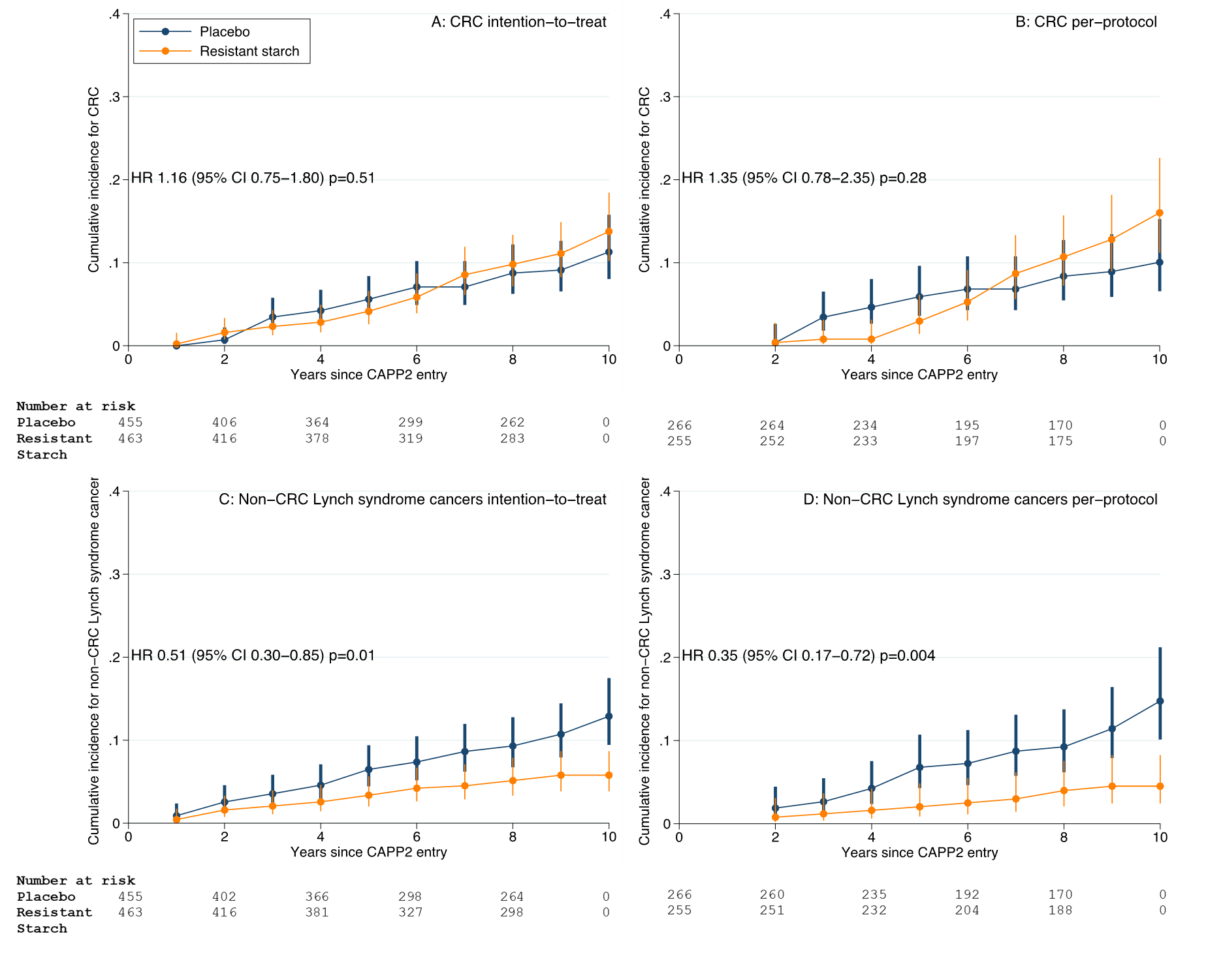

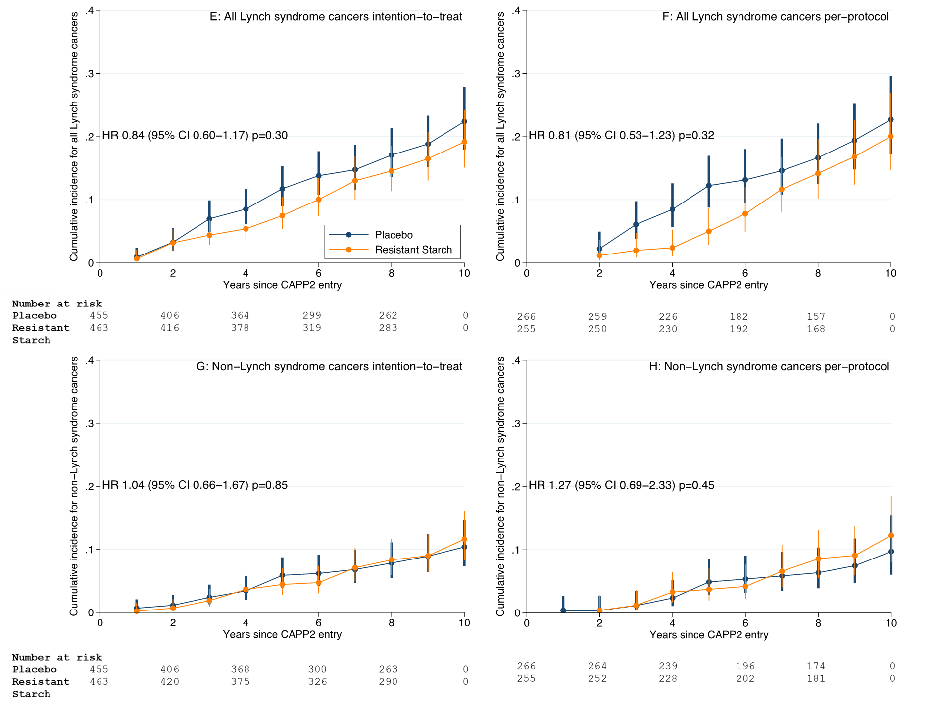

**Supplementary Figure S3:** Time to first colorectal cancer and time to any LS cancer in CAPP2 Study participants from England, Wales and Finland (n=369; 226 England and Wales, 143 Finland) for the first twenty years after randomisation analysed using Cox proportional hazards (HR and 95% confidence intervals) comparing those on Resistant Starch versus those on placebo and depicted by Cumulative incidence curves. The lifetables show the number of persons at risk by time and study and 95% confidence intervals for cumulative incidence. Figure 3A shows the intention to treat analysis (n=190 Resistant Starch; n=179 placebo) by randomisation group. Figure 3B shows the per protocol analysis of all those achieving 2 years Resistant Starch or placebo (n=113 Resistant Starch; n=120 placebo). Figure 3C shows the intention to treat analysis for LS cancer other than CRC and Figure 3D shows the per protocol analysis for this same comparison. Figures 3E and 3F show the results for ITT and per protocol analysis of all LS cancers combined. Finally, Figures 3G and 3H show the results for all non-LS cancers.

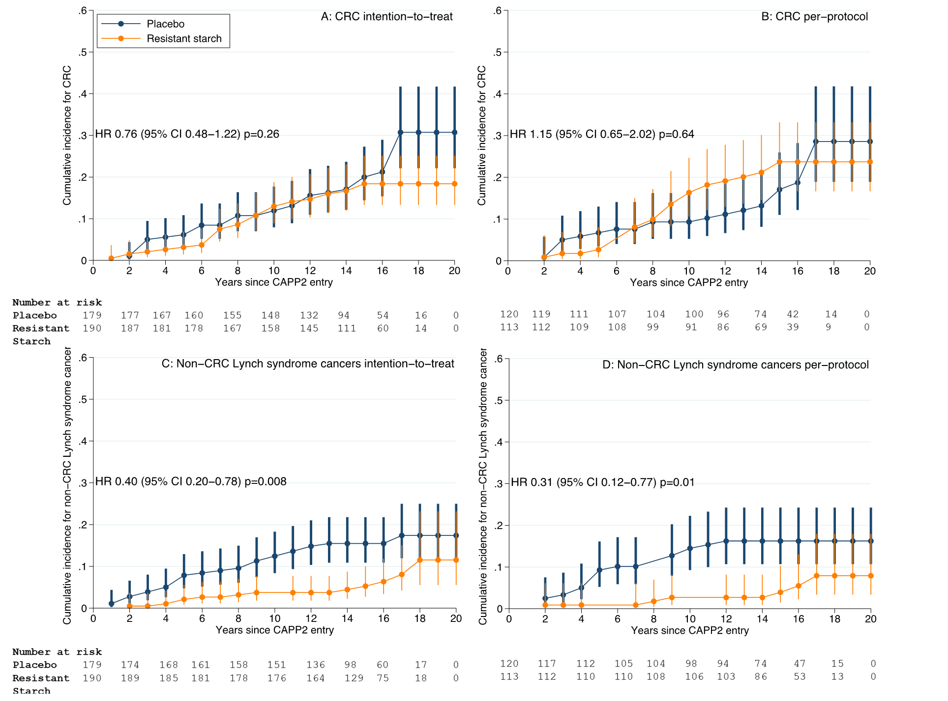

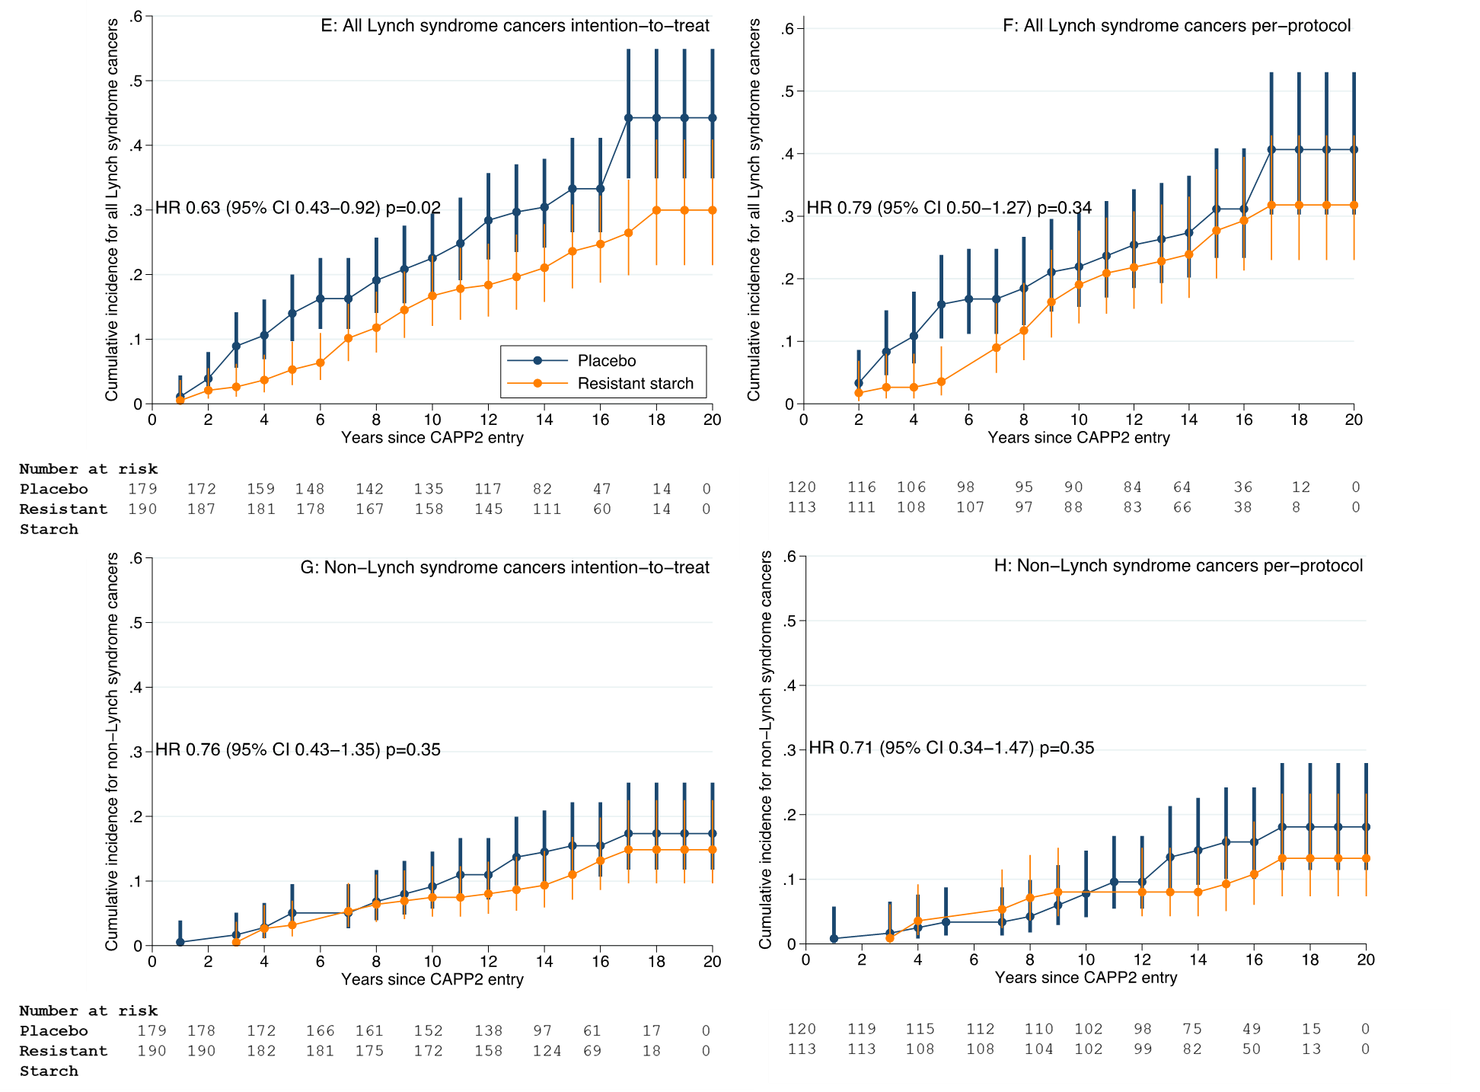

**Supplementary Figure S4**: Time to first extra-colonic LS cancer for individual sites [A, brain; B, stomach/duodenum; C, bile duct/pancreas; D, urinary tract including ureter and kidney; E, ovary; F, endometrium/uterus] in CAPP2 Study participants from England, Wales and Finland (n=369; 226 England and Wales, 143 Finland) for the first twenty years after randomisation and from the remaining centres with up to 10 years follow-up analysed using Cox proportional hazards (p-value shown) comparing those on Resistant Starch versus those on placebo and depicted by Cumulative incidence curves.Total number of cancers in each intervention group also shown.

