Supplementary Figure S1. Association of NSAID pills taken per month with risk of breast cancer among BBD patients.
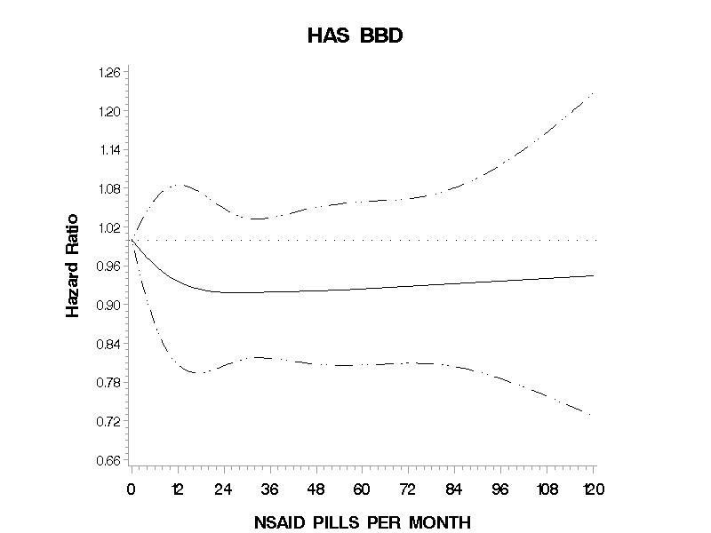
Pills per month modeled using a restricted cubic spline in Cox proportional hazards regression analysis accounting for age as a stratification variable and adjusting for history of benign breast disease, race, weight gain as an adult, highest educational level achieved, oral contraceptive use, smoking status, age at menarche, age at menopause, use of hormone replacements, family history of breast cancer, parity, age at first birth, history of undergoing mammograms, history of hypertension, history of diabetes, history of cardiovascular disease, daily caloric intake and alcohol consumption.

