**Supplementary Tables**

**Supplementary Table 2.** Identified metabolites for the four study foods organized into the chemical classes for control (no navy bean powder) and navy bean (17.5g/serving navy bean powder).

*Indicates tentative metabolite identification and no purified chemical standard.

**Supplementary Table 3**. Plasma metabolites classified into metabolic pathways for all participants.

*Indicates tentative metabolite identification and no purified chemical standard.

**Supplementary Table 4**. Urine metabolites classified into metabolic pathways for all participants.

*Indicates tentative metabolite identification and no purified chemical standard.

**Supplementary Figures**

**Supplementary Figure 1.**

CONSORT FLOW DIAGRAM: Study design for plasma and urine metabolome analysis in 20 colorectal cancer survivors (CRC) randomized to either control or navy bean intervention. The plasma and urine metabolomes were analyzed for statistical comparisons to the respective baseline at both 2 and 4 weeks post intervention, and for comparisons between the navy bean and control groups at 4 weeks post intervention.

**Supplementary Figure 2.**

Meals and snack metabolome for placebo-control and navy bean intervention. **A.** Meals and snacks metabolome for placebo-control and navy bean intervention, each bar represents total number of identified metabolites in chemical class, the shaded portion is the number of metabolites potentially derived from navy beans. Normalized intensities are shown for baked pasta, blackberry cobbler, caraway crackers and strawberry smoothie in **B**. pipecolate, **C**. S-methylcysteine, and **D**. N-delta-acetylornithine, the black bars represent placebo-control and the grey bars represent navy bean intervention meals and snacks.

**Supplementary Figure 3.**

Navy bean consumption significantly increased the median scaled relative abundance (MSRA) of amino acid metabolism in plasma at 2 and 4 weeks.

* significant compared to their baseline (*p* <0.05)

**Supplementary Figure 4.**

Navy bean consumption significantly increased the median scaled relative abundance (MSRA) of phytosterols and phytochemicals in urine after 2 and 4 weeks. * significant compared to their baseline *(p* <0.05)

**Figure S1.**

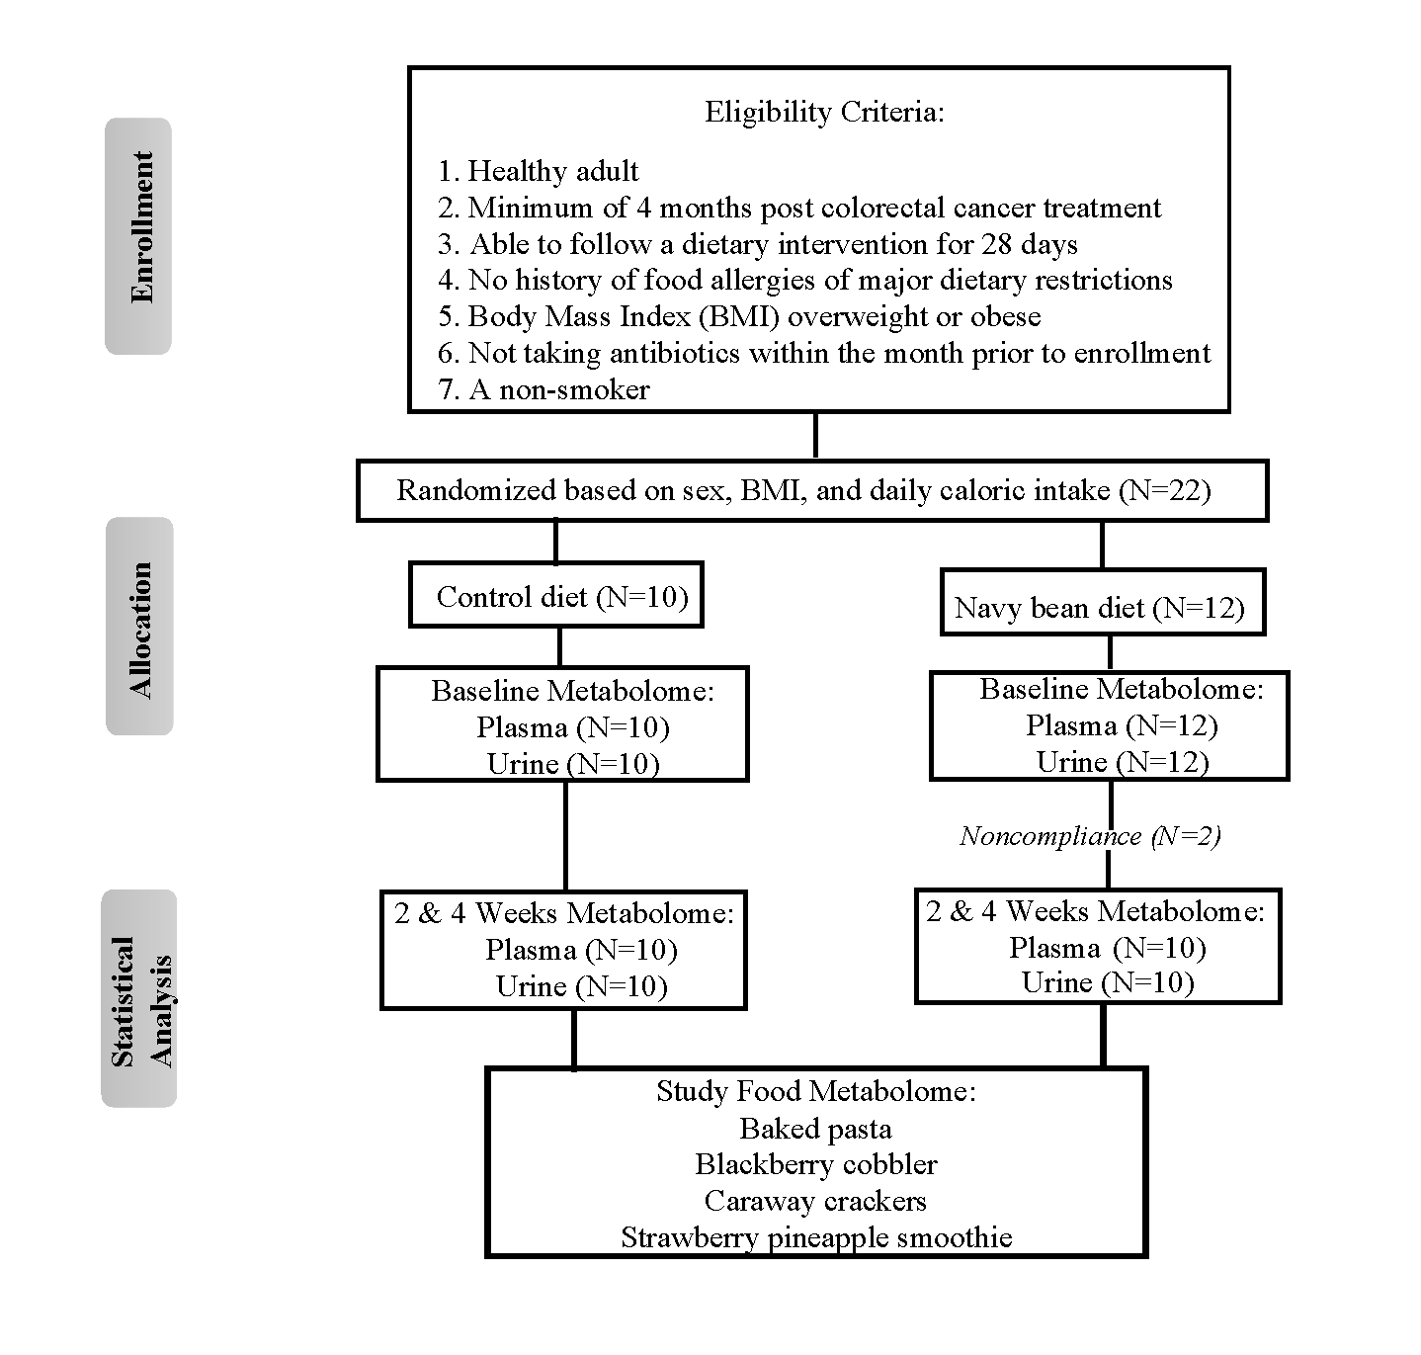

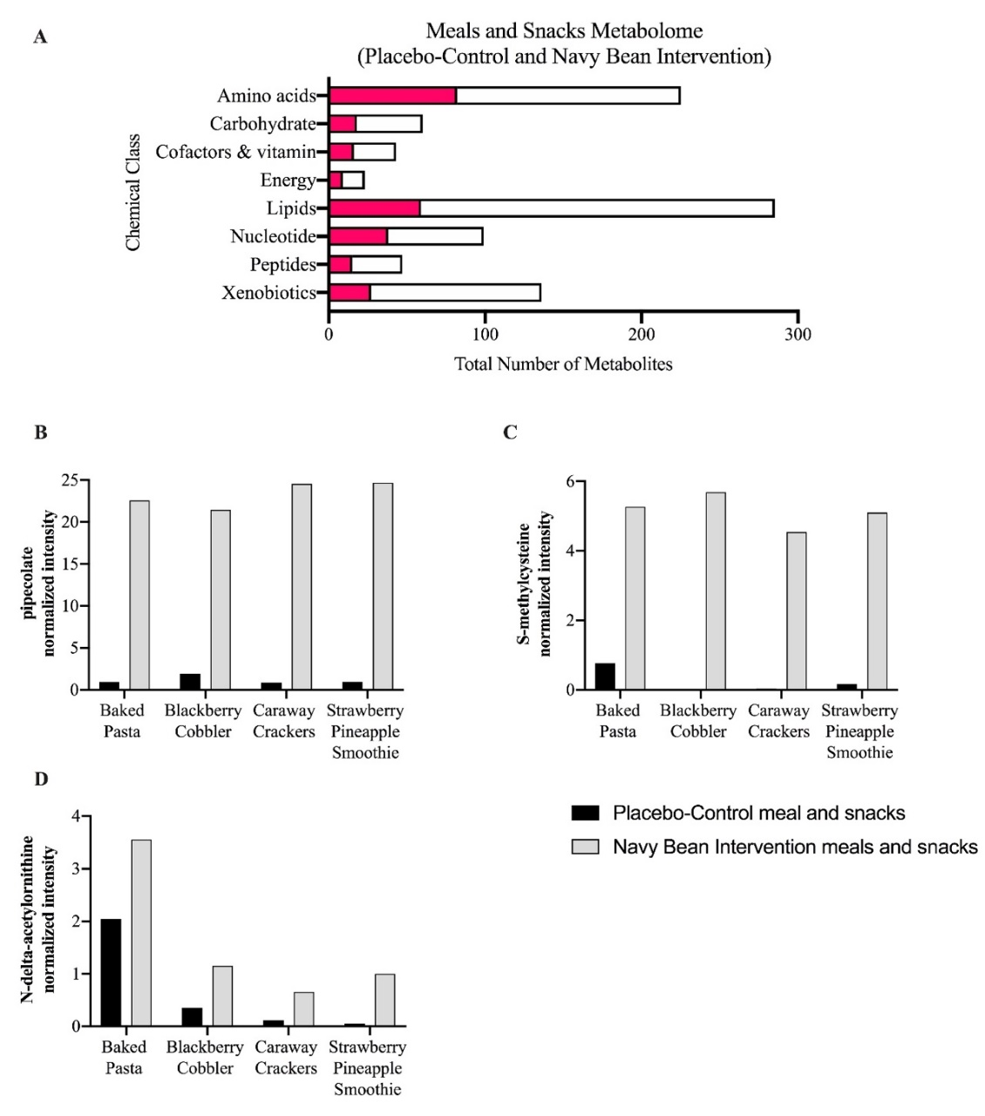**Figure S2.**

**Figure S3.**



**Figure S4.**

