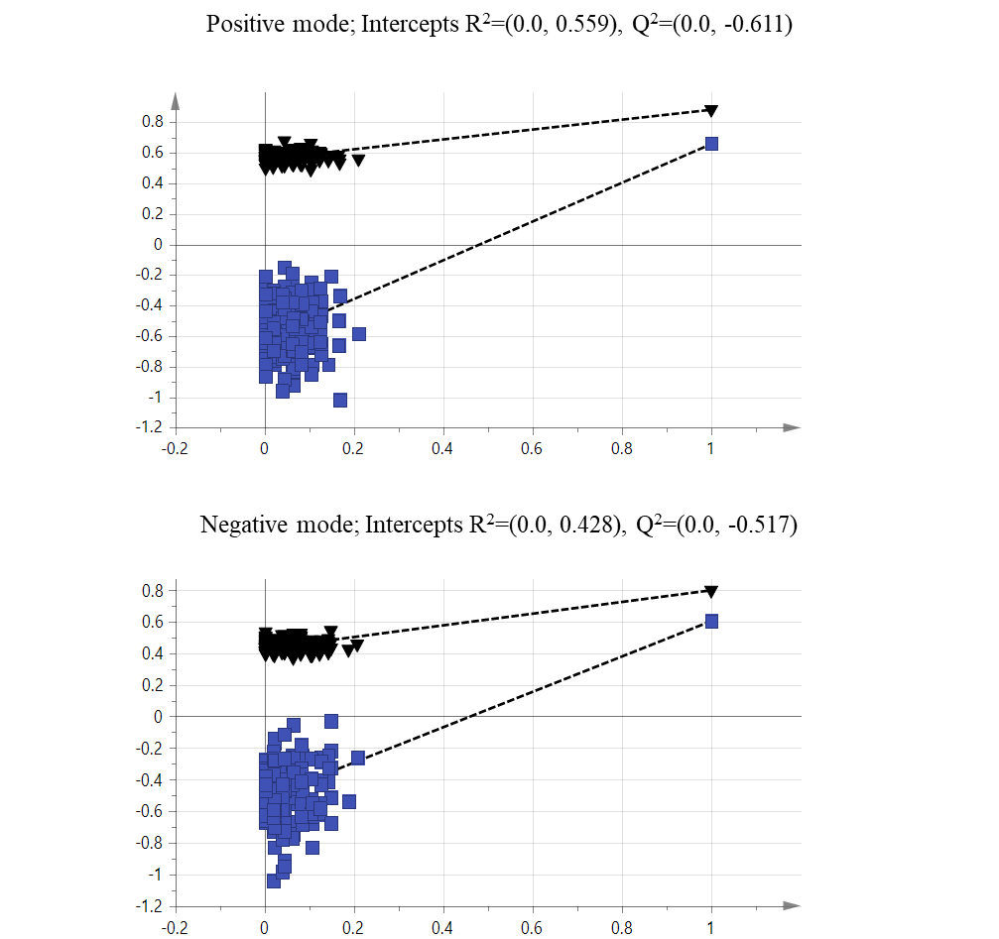

Supplementary Figure S1: Permutation plots for the OPLS-DA model showing R² (black triangle) and Q² (blue square) values.

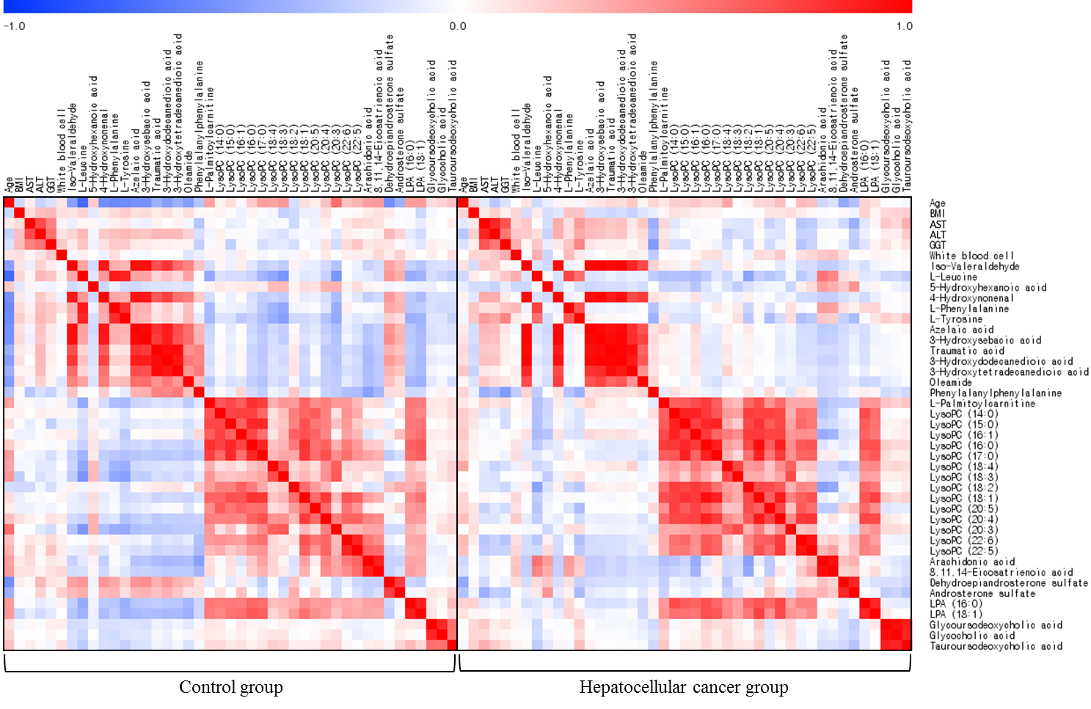

Supplementary Figure S2. Correlation matrix among the clinical parameters and major metabolites in the control and HCC groups.
Correlations were obtained using Pearson’s correlation coefficient. Red indicates a positive correlation, and blue indicates a negative correlation.
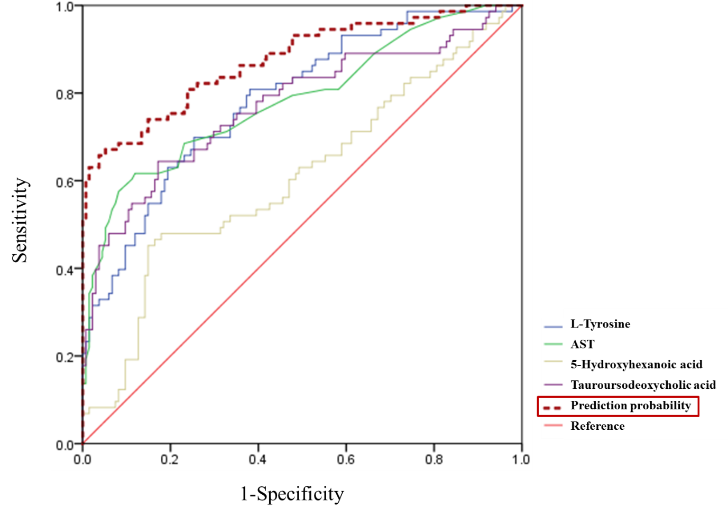

Supplementary Figure S3. ROC curves for L-tyrosine, AST, 5-hydroxyhexanoic acid, and tauroursodeoxycholic acid for the incidence of hepatocellular cancer.
AST was tested by logarithmic transformation.
Supplementary Table S1. Detailed method for pathway analysis.
Pathway analysis
To identify the most relevant pathways associated with the selected metabolites, a metabolic pathway analysis was performed using MetaboAnalyst 3.0, a web-based analysis module (http://metaboanalyst.ca) based on the Kyoto Encyclopedia of Genes and Genomes (KEGG) database. Through pathway analysis, we mapped 11 correlated metabolic pathways with the identified 55 metabolites. Enrichment analysis was conducted for the 55 metabolites (VIP >1.5) and eleven pathways all had low q-values (false discovery rate [FDR] <0.05). These pathways also had high pathway impacts (over 0) obtained from topology analysis (Supplementary Table S5).
We performed two different types of pathway analyses: enrichment and topology analyses. The enrichment analysis was conducted using a hypergeometric test that compares the numbers of significant metabolites within a specific pathway with the expected value. In addition to considering the over-representation of significant metabolites in the examined pathways, another important feature of pathway analysis is the structure. The topology analysis considers the position of significant metabolites in metabolic pathways that are annotated by KEGG. Pathway impact was estimated in the topology analysis. The pathway impact is the cumulative value of the significant metabolites and this value is normalized by summing the importance of each metabolite in a particular pathway.

Supplementary Table S2. Levels of liver enzymes according to the mean diagnostic time after inclusion.
 | Mean diagnostic time after inclusion, y
 | <2 | 2 to 4.4 | 4.5 to 5.4 | ≥5.5 | P for trend
Cases (n) | 14 | 27 | 16 | 18
 | Mean (SD)
AST (IU/L) | 40.5 (15.0) | 41.9 (20.6) | 30.7 (12.1) | 56.4 (62.6) | 0.282
ALT (IU/L) | 40.0 (21.0) | 44.6 (25.5) | 38.0 (22.2) | 77.8 (147.4) | 0.169
γ-GTP (U/L) | 86.6 (80.5) | 109.6 (184.9) | 50.3 (33.2) | 91.8 (113.7) | 0.723

Supplementary Table S3. CV-ANOVA assessing the reliability of the generated models.
Positive ion mode | SS | DF | MS | F | P-value | SD
Total correlation | 208 | 208 | 1 |  |  | 1
Regression | 136.907 | 18 | 7.60596 | 20.3275 | 4.46E-35 | 2.75789
Residual | 71.0926 | 190 | 0.374172 |  |  | 0.611696
Negative ion mode | SS | DF | MS | F | P-value | SD
Total correlation | 208 | 208 | 1 |  |  | 1
Regression | 125.531 | 16 | 7.84572 | 18.2661 | 1.63E-30 | 2.80102
Residual | 82.4685 | 192 | 0.429523 |  |  | 0.65538
SS: sum of squares, DF: number of degrees of freedom, MS: mean squares, F: F-statistic, SD: standard deviation.

Supplementary Table S4. Peak intensities of the seven major metabolites according to the mean diagnostic time after inclusion.
 | Mean diagnostic time after inclusion, y
 | <2 | 2 to 4.4 | 4.5 to 5.4 | ≥5.5 | P for trend
Cases (n) | 14 | 27 | 16 | 18
 | Peak intensities
5-Hydroxyhexanoic acid | 7919178 | 2292689 | 6656661 | 1695598 | 0.053
L-Tyrosine | 31457689 | 33660203 | 31624526 | 32004296 | 0.884
Tauroursodeoxycholic acid | 3095822 | 8464559 | 1193367 | 3687906 | 0.401
Oleamide | 1027701 | 1955029 | 1028931 | 6593994 | 0.009
Androsterone sulfate | 10982045 | 11137551 | 19149379 | 8219642 | 0.919
LysoPC (16:1) | 32688629 | 34039566 | 24389358 | 44300927 | 0.192
LysoPC (20:3) | 21682918 | 34039566 | 20303728 | 30908438 | 0.290

Supplementary Table S5. Metabolic pathway analysis of all subjects.
Metabolic pathway | Hit(s) | P | FDR | Impact
Tyrosine metabolism | L-Tyrosine | 2.64E-19 | 1.85E-18 | 0.04724
Phenylalanine metabolism | L-Tyrosine | 7.92E-19 | 4.16E-18 | 0.11906
 | L-Phenylalanine
Phenylalanine, tyrosine and tryptophan biosynthesis | L-Tyrosine | 1.83E-16 | 6.39E-16 | 0.008
 | L-Phenylalanine
 | L-Tryptophan
Valine, leucine and isoleucine degradation | L-Leucine | 7.29E-12 | 1.70E-11 | 0.02232
Valine, leucine and isoleucine biosynthesis | L-Leucine | 7.29E-12 | 1.70E-11 | 0.01325
Tryptophan metabolism | L-Tryptophan | 1.44E-08 | 2.76E-08 | 0.10853
Glycerophospholipid metabolism | LysoPC (18:1) | 3.11E-06 | 5.45E-06 | 0.10429
Linoleic acid metabolism | Linoleic acid | 2.57E-05 | 4.15E-05 | 0.65625
 | Gamma-linoleic acid
Arachidonic acid metabolism | Arachidonic acid | 6.30E-05 | 9.45E-05 | 0.2255
 | 15(S)-HETE
Primary bile acid biosynthesis | Glycocholic acid | 0.001403 | 0.001841 | 0.00846
Fatty acid metabolism | Palmitic acid | 0.002902 | 0.003585 | 0.02959
 | L-Palmitoylcarnitine
Hit, the matched metabolites uploaded in MetaboAnalyst. FDR, the P-value adjusted using the false discovery rate. Impact, the pathway impact value calculated from pathway topology analysis.

Supplementary Table S6. Area under the ROC curve (AUC) for the risk factors of HCC incidence.
 | AUC±SE | P-value | Cut-off value | Sensitivity | Specificity
L-Tyrosine | 0.785±0.033 | <0.001 | 26356320.19 | 0.699 | 0.701
AST | 0.784±0.035 | <0.001 | 26.50 | 0.685 | 0.769
5-Hydroxyhexanoic acid | 0.608±0.042 | 0.010 | 996837.90 | 0.548 | 0.552
Tauroursodeoxycholic acid | 0.773±0.037 | <0.001 | 314191.00 | 0.699 | 0.701
Prediction probability | 0.875±0.027 | <0.001
AST was tested by logarithmic transformation.
Supplementary Table S7. List of unidentified peaks with VIP values >1.5.
List of unidentified peaks |  | Observed mass (M+H) |  | Normalized peak intensities |  |  |  |  | VIP
 |  |  |  | Control |  | HCC
1 |  | 100.0754† |  | 17,203,479 | ±568,850 | 11,775,370 | ±660,630 |  | 9.4773
2 |  | 100.0754† |  | 53,749,033 | ±1,546,057 | 34,191,407 | ±2,211,825 |  | 6.7567
3 |  | 100.0755† |  | 374,859,942 | ±7,204,392 | 311,099,966 | ±10,985,945 |  | 3.4623
4 |  | 100.0756† |  | 63,491 | ±7,778 | 983,916 | ±228,620 |  | 4.2576
5 |  | 100.0756† |  | 3,788,471 | ±194,191 | 3,852,503 | ±310,395 |  | 2.7944
6 |  | 100.0756† |  | 4,040,208 | ±131,314 | 2,756,594 | ±156,160 |  | 1.7093
7 |  | 100.0760† |  | 30,783,899 | ±1,198,836 | 21,249,064 | ±1,169,993 |  | 7.2749
8 |  | 101.0788† |  | 34,281 | ±5,960 | 707,279 | ±224,883 |  | 2.2422
9 |  | 105.0909† |  | 6,858,542 | ±387,869 | 3,552,791 | ±368,485 |  | 1.8699
10 |  | 122.0573† |  | 34,071,292 | ±1,165,417 | 21,977,310 | ±1,348,694 |  | 1.9119
11 |  | 145.1220† |  | 133,297,241 | ±2,410,890 | 98,990,432 | ±4,565,633 |  | 2.8711
12 |  | 149.0118† |  | 136,198,345 | ±2,290,225 | 112,824,177 | ±4,351,170 |  | 3.1896
13 |  | 149.0119† |  | 56,946,168 | ±1,626,400 | 36,111,046 | ±2,116,962 |  | 3.6394
14 |  | 149.0119† |  | 79,703,111 | ±1,390,478 | 63,175,379 | ±2,229,433 |  | 2.6943
15 |  | 149.0119† |  | 44,525,529 | ±2,339,038 | 25,877,605 | ±1,796,047 |  | 3.5097
16 |  | 149.0120† |  | 5,176,223 | ±163,739 | 4,479,058 | ±247,891 |  | 2.7288
17 |  | 149.0120† |  | 41,629,281 | ±1,082,018 | 29,892,302 | ±1,732,810 |  | 2.7373
18 |  | 159.1376† |  | 13,915,225 | ±578,491 | 10,684,993 | ±721,312 |  | 3.3309
19 |  | 163.9760† |  | 4,271,841 | ±252,204 | 4,038,232 | ±310,408 |  | 2.0456
20 |  | 163.9764† |  | 12,998,144 | ±214,949 | 13,649,003 | ±526,232 |  | 3.0559
21 |  | 163.9764† |  | 60,456,619 | ±11,716,153 | 107,824,040 | ±17,421,549 |  | 2.5710
22 |  | 164.9842† |  | 33,236,168 | ±6,721,510 | 53,836,205 | ±9,476,952 |  | 1.6443
23 |  | 168.5829† |  | 9,972,534 | ±1,857,600 | 15,642,016 | ±2,669,653 |  | 1.5851
24 |  | 184.0729† |  | 16,497,467 | ±3,294,312 | 22,026,259 | ±3,751,353 |  | 4.3022
25 |  | 187.0963† |  | 6,365,553 | ±1,155,608 | 10,599,632 | ±1,896,849 |  | 1.8709
26 |  | 188.0702† |  | 2,057,759 | ±365,164 | 4,106,384 | ±803,255 |  | 1.5936
27 |  | 188.0703† |  | 52,458,566 | ±10,300,553 | 69,481,113 | ±10,413,058 |  | 3.2712
28 |  | 189.0429† |  | 3,338,387 | ±692,026 | 5,842,669 | ±1,026,503 |  | 2.7148
29 |  | 201.1118† |  | 3,247,924 | ±438,778 | 917,265 | ±332,762 |  | 2.5130
30 |  | 211.0937† |  | 37,541,010 | ±358,613 | 39,039,244 | ±255,621 |  | 1.7119
31 |  | 215.1275† |  | 40,345,828 | ±664,511 | 40,346,712 | ±996,759 |  | 2.6623
32 |  | 217.1433† |  | 1,497,213 | ±133,520 | 349,588 | ±53,967 |  | 1.7595
33 |  | 231.1230‡ |  | 21,364,998 | ±983,789 | 12,117,416 | ±1,465,854 |  | 1.5248
34 |  | 233.1381† |  | 1,776,337 | ±334,656 | 4,128,601 | ±632,202 |  | 2.9400
35 |  | 241.1042† |  | 1,097,374 | ±129,418 | 414,472 | ±102,186 |  | 2.5303
36 |  | 245.1385‡ |  | 1,872,943 | ±690,592 | 1,317,903 | ±693,309 |  | 1.7457
37 |  | 255.1201† |  | 3,629,031 | ±104,099 | 4,427,303 | ±179,418 |  | 2.9059
38 |  | 256.2354‡ |  | 83,415,450 | ±1,519,941 | 68,432,925 | ±2,325,892 |  | 2.1448
39 |  | 257.1742† |  | 7,029,196 | ±132,260 | 8,448,979 | ±328,302 |  | 1.7735
40 |  | 257.1745† |  | 280,740 | ±60,862 | 847,751 | ±306,856 |  | 2.9426
41 |  | 262.0857† |  | 1,470,337 | ±159,901 | 631,588 | ±122,467 |  | 1.5336
42 |  | 269.1356† |  | 8,015,637 | ±670,236 | 2,392,490 | ±444,135 |  | 3.4624
43 |  | 273.1700‡ |  | 27,058,510 | ±602,753 | 21,736,109 | ±902,854 |  | 1.7599
44 |  | 280.2353‡ |  | 3,746,321 | ±281,165 | 2,942,424 | ±259,793 |  | 1.9657
45 |  | 282.2515‡ |  | 4,157,394 | ±471,261 | 24,345,518 | ±5,798,547 |  | 2.6199
46 |  | 297.1670† |  | 6,166,486 | ±190,835 | 4,598,178 | ±195,626 |  | 3.1856
47 |  | 304.2355‡ |  | 427,693 | ±66,317 | 5,333,525 | ±1,929,371 |  | 1.9856
48 |  | 304.2606† |  | 38,671,311 | ±758,897 | 45,781,998 | ±530,815 |  | 1.5919
49 |  | 312.3619† |  | 74,264,728 | ±836,604 | 82,972,517 | ±567,544 |  | 2.2269
50 |  | 314.1575† |  | 67,157,445 | ±1,156,921 | 73,223,785 | ±780,392 |  | 1.5367
51 |  | 317.2083† |  | 80,891,564 | ±1,029,837 | 89,589,376 | ±663,323 |  | 2.0012
52 |  | 319.2238† |  | 60,840,461 | ±604,189 | 66,124,333 | ±296,307 |  | 2.2332
53 |  | 325.1978† |  | 79,316,307 | ±1,196,267 | 85,412,864 | ±564,563 |  | 1.5001
54 |  | 327.2314† |  | 2,540,670 | ±266,534 | 1,234,723 | ±183,641 |  | 3.0162
55 |  | 328.2353‡ |  | 86,599 | ±16,969 | 1,467,996 | ±562,118 |  | 2.0370
56 |  | 339.2323‡ |  | 417,805 | ±65,851 | 4,764,811 | ±1,088,275 |  | 3.7453
57 |  | 340.2355‡ |  | 82,775 | ±21,529 | 1,661,412 | ±495,514 |  | 1.8606
58 |  | 341.2079† |  | 1,262,213 | ±143,545 | 618,307 | ±105,304 |  | 1.9090
59 |  | 342.3360† |  | 2,357,745 | ±79,511 | 1,691,435 | ±82,772 |  | 2.0913
60 |  | 343.2237† |  | 10,916,881 | ±919,960 | 3,303,821 | ±612,463 |  | 2.6543
61 |  | 343.2255† |  | 52,651,423 | ±788,743 | 56,104,239 | ±718,584 |  | 2.1502
62 |  | 345.2817‡ |  | 4,297,426 | ±170,101 | 2,725,905 | ±228,840 |  | 2.2046
63 |  | 359.2186† |  | 53,929,166 | ±845,792 | 61,102,380 | ±764,335 |  | 1.5778
64 |  | 359.2216‡ |  | 9,121,573 | ±263,900 | 7,371,656 | ±295,973 |  | 1.5022
65 |  | 367.2238† |  | 60,252,248 | ±820,788 | 65,803,649 | ±696,648 |  | 3.0821
66 |  | 383.2188† |  | 39,308,451 | ±456,175 | 41,499,485 | ±418,761 |  | 2.0768
67 |  | 410.2381‡ |  | 3,330,518 | ±292,848 | 1,714,208 | ±210,259 |  | 1.9220
68 |  | 414.2995† |  | 6,101,987 | ±132,652 | 7,041,210 | ±181,860 |  | 3.1627
69 |  | 415.3028† |  | 1,837,004 | ±404,881 | 2,870,440 | ±553,680 |  | 1.6065
70 |  | 427.2683† |  | 1,599,937 | ±160,869 | 823,223 | ±110,457 |  | 1.5620
71 |  | 432.3099† |  | 2,262,625 | ±248,007 | 1,077,948 | ±149,934 |  | 3.9561
72 |  | 433.2352‡ |  | 40,571 | ±28,558 | 3,883,435 | ±3,787,212 |  | 1.5160
73 |  | 433.3133† |  | 2,187,427 | ±236,994 | 890,879 | ±179,055 |  | 2.0458
74 |  | 437.0533‡ |  | 11,298,688 | ±982,762 | 8,373,687 | ±821,276 |  | 1.5695
75 |  | 443.2635‡ |  | 6,289,367 | ±336,637 | 7,887,979 | ±1,010,196 |  | 2.0281
76 |  | 445.2788† |  | 554,243 | ±54,127 | 1,309,497 | ±382,071 |  | 2.9129
77 |  | 446.2823† |  | 35,033,681 | ±1,161,279 | 23,595,696 | ±995,188 |  | 1.7736
78 |  | 448.3048† |  | 1,239,575 | ±155,340 | 438,670 | ±78,275 |  | 1.6103
79 |  | 449.3085‡ |  | 54,478 | ±54,076 | 7,655,778 | ±7,652,060 |  | 2.3304
80 |  | 451.3241† |  | 1,231,453 | ±154,733 | 437,412 | ±79,677 |  | 1.9437
81 |  | 464.2819† |  | 3,377,533 | ±450,042 | 1,051,928 | ±286,397 |  | 1.9459
82 |  | 467.2605† |  | 1,762,035 | ±136,915 | 1,091,082 | ±90,721 |  | 2.8030
83 |  | 467.3185† |  | 52,164,542 | ±772,593 | 49,910,925 | ±1,250,202 |  | 1.6427
84 |  | 469.3112† |  | 39,023,817 | ±1,053,679 | 30,265,433 | ±1,347,970 |  | 2.1745
85 |  | 472.3022† |  | 7,382,112 | ±748,169 | 2,412,247 | ±655,622 |  | 3.0433
86 |  | 473.3056† |  | 4,536,642 | ±124,798 | 3,492,685 | ±158,756 |  | 1.5358
87 |  | 482.2924† |  | 10,690,197 | ±1,009,001 | 14,627,035 | ±2,236,760 |  | 1.5084
88 |  | 482.3589† |  | 2,523,113 | ±254,605 | 1,232,389 | ±183,629 |  | 2.2880
89 |  | 488.2968† |  | 8,621,148 | ±314,785 | 10,462,976 | ±288,423 |  | 1.7196
90 |  | 490.2897† |  | 866,307 | ±100,114 | 2,160,132 | ±697,150 |  | 2.2164
91 |  | 495.3265† |  | 5,807,033 | ±761,707 | 1,655,870 | ±538,400 |  | 2.8403
92 |  | 497.3420† |  | 7,354,310 | ±173,230 | 7,978,144 | ±213,216 |  | 5.1341
93 |  | 498.3443† |  | 3,558,151 | ±407,078 | 1,351,443 | ±325,984 |  | 1.7976
94 |  | 511.3581† |  | 6,170,205 | ±806,500 | 1,581,190 | ±601,182 |  | 1.8999
95 |  | 516.3049† |  | 3,022,973 | ±422,825 | 923,573 | ±239,138 |  | 2.7721
96 |  | 518.3204† |  | 1,973,807 | ±233,277 | 561,038 | ±140,273 |  | 1.8197
97 |  | 519.3264† |  | 656,364 | ±125,928 | 1,882,444 | ±626,272 |  | 2.1346
98 |  | 521.3419† |  | 510,138 | ±102,857 | 1,046,317 | ±280,605 |  | 3.9686
99 |  | 522.2849† |  | 1,207,937 | ±137,469 | 371,464 | ±89,123 |  | 1.6470
100 |  | 523.3575† |  | 1,412,439 | ±185,750 | 427,337 | ±140,873 |  | 3.2514
101 |  | 531.3520† |  | 1,037,517 | ±168,732 | 211,933 | ±85,276 |  | 1.5945
102 |  | 532.3360† |  | 7,594,126 | ±1,024,939 | 1,901,580 | ±700,771 |  | 2.0721
103 |  | 542.3198† |  | 27,155,222 | ±553,812 | 29,621,993 | ±758,759 |  | 2.2428
104 |  | 543.3260† |  | 5,835,262 | ±736,477 | 1,654,259 | ±594,476 |  | 3.1196
105 |  | 544.3354† |  | 1,268,056 | ±197,855 | 282,363 | ±117,127 |  | 2.4752
106 |  | 545.3418† |  | 1,053,272 | ±163,477 | 208,397 | ±78,496 |  | 2.7729
107 |  | 547.3580† |  | 7,448,073 | ±909,366 | 1,960,273 | ±682,742 |  | 2.5223
108 |  | 553.3336† |  | 258,131 | ±44,233 | 843,100 | ±323,740 |  | 1.9657
109 |  | 556.3233‡ |  | 2,360,034 | ±300,871 | 618,887 | ±230,060 |  | 1.8792
110 |  | 564.3042† |  | 3,021,544 | ±384,858 | 911,077 | ±329,027 |  | 2.3664
111 |  | 569.3415† |  | 7,383,765 | ±1,172,396 | 1,491,070 | ±629,629 |  | 2.3398
112 |  | 570.3394‡ |  | 2,961,368 | ±376,350 | 775,624 | ±285,772 |  | 3.3541
113 |  | 571.3425‡ |  | 2,400,076 | ±164,909 | 1,276,798 | ±104,624 |  | 1.7970
114 |  | 594.3400‡ |  | 3,876,468 | ±587,726 | 857,140 | ±343,815 |  | 1.8992
115 |  | 596.3549‡ |  | 9,879,787 | ±543,267 | 11,007,832 | ±916,373 |  | 1.7969
116 |  | 724.5433† |  | 987,728 | ±162,108 | 185,925 | ±84,500 |  | 1.6904
117 |  | 899.6337† |  | 1,034,299 | ±189,784 | 141,928 | ±67,097 |  | 2.0515
118 |  | 991.6690† |  | 2,257,960 | ±256,653 | 684,583 | ±213,049 |  | 5.7658
119 |  | 992.6730† |  | 1,684,789 | ±114,164 | 743,418 | ±96,377 |  | 4.0087
120 |  | 993.6772† |  | 1,105,026 | ±188,175 | 215,187 | ±84,872 |  | 1.9486
Mean±SE. † Metabolites obtained in ESI-positive ion mode (M/Z [M+H]). ‡Metabolites obtained in ESI-negative ion mode (M/Z [M-H]). VIP: variable importance in the projection.

