Table S1: Demographics and clinical characteristics of patients from whom the parental HBEC cell lines were derived. Cell culture characteristics of parental and derivative HBEC cell lines.
Table S2: List of isogenic immortalized HBEC cell lines with corresponding genetic information and migration rates. All HBEC cell lines over-express TERT and CDK4 for immortalization.
Cell Line Name | Genetic Status | Migration Rate (average cells/field)
H3 | Empty vector | 8µm pore - 516.3 ± 22.08  5µm pore - 227.7 ± 12.57  3µm pore - 15.72 ± 1.009
H3-HM | Empty vector | 8µm pore - 1090 ± 16.17  5µm pore - 921.2 ± 15.96  3µm pore - 285.9 ± 16.73
H3S | Snail over-expression | 8µm pore - 664.9 ± 47.89  5µm pore - 706.5 ± 38.69  3µm pore - 67.92 ± 5.000
H3S-HM | Snail over-expression | 8µm pore - 1821 ± 70.61  5µm pore - 1449 ± 95.66  3µm pore - 194.4 ± 18.22
H3PK | p53-shRNA  KRAS^{V12} over-expression  Empty vector | 8µm pore - 127.7 ± 5.483  5µm pore - 9.776 ± 1.383  3µm pore - 0.0204 ± 0.0204
H3PK-HM | p53-shRNA  KRAS^{V12} over-expression  Empty vector | 8µm pore - 780.3 ± 15.06  5µm pore - 290.7 ± 22.31  3µm pore - 2.531 ± 0.4257
H3PKS | p53-shRNA  KRAS^{V12} over-expression  Snail over-expression | 8µm pore - 142.4 ± 12.38  5µm pore - 27.31 ± 3.395  3µm pore - 0.2449 ± 0.9002
H3PKS-HM | p53-shRNA  KRAS^{V12} over-expression  Snail over-expression | 8µm pore - 811.2 ± 8.514  5µm pore - 572.2 ± 11.90  3µm pore - 14.59 ± 0.9006
H4 | Empty vector | 8µm pore - 938.3 ± 16.04  5µm pore - 114.7 ± 14.74  3µm pore - 13.12 ± 1.174
H4-HM | Empty vector | 8µm pore - 1666 ± 18.21  5µm pore - 497.7 ± 19.81  3µm pore - 98.04 ± 9.335
H4S | Snail over-expression | 8µm pore - 107.6 ± 5.784  5µm pore - 12.36 ± 1.273  3µm pore - 1.800 ± 0.4320
H4S-HM | Snail over-expression | 8µm pore - 476.3 ± 10.15  5µm pore - 361.9 ± 6.460  3µm pore - 52.56 ± 2.629

Table S3: Summary of biophysical properties in highly migratory cell lines displayed as percentage-change over unselected cell lines (delta, ∆). Positive values indicate an increase and negative values a decrease compared to the respective unselected line.
Cell Line | ∆Protrusion Intensity (P²/A) | ∆Deformability (DC) | ∆Diameter (DC)
H3-HM | +3.5% | -10.5% | -10.2%
H3PK-HM | +12.7% | -4.14% | -11.8%
H4-HM | +11.5% | +1.74% | +5.44%

Table S4: Manual quantitation of CD44⁺ H3PKS cells (brown) observed in the lungs of mice in the long-term in vivo assay.
Table S5: Top gene expression changes characterizing the highly migratory phenotype. Snail-dependent and -independent expression changes are highlighted.

Figure S1a: Stitched photomicrographs highlighting the single cell (1 in a field of 10,000) that is phenotypically distinct and highly motile. Repeated observation of these rare cells prompted our selection/enrichment of highly motile epithelial cells using the micropore selection procedure described in the current study.
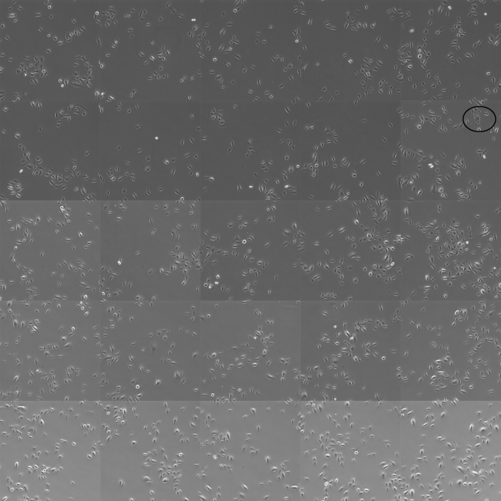
Figure S1b: Photomicrograph of cells before and after selection showing the overlaid outlines produced in ImageJ on top of phase contrast images. Cells without clear borders, undergoing cell division, or that were on edges were excluded from data analysis. 200x total magnification. Scale bars are 50 μm.
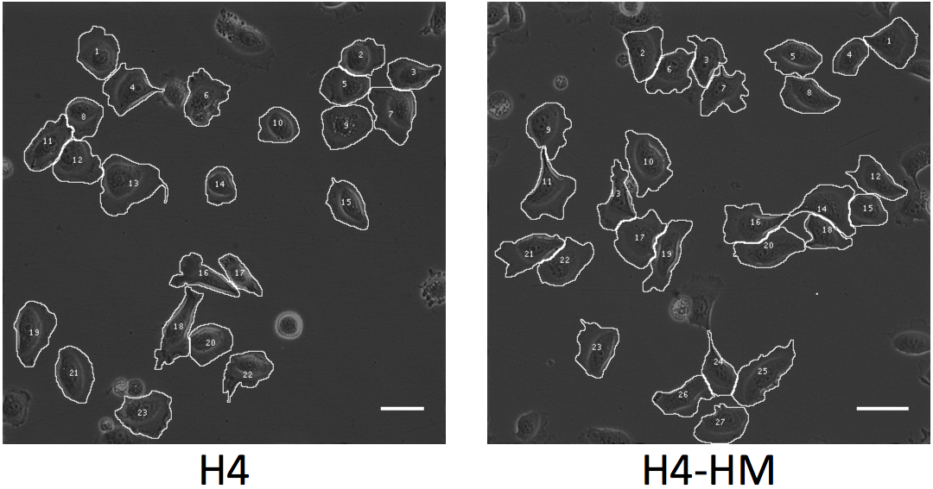
Figure S2a: HBEC-SNAIL selected through increasingly smaller pores have enhanced migratory capacity. Transwell assay was used to determine cell migration, with basal growth medium used in both chambers. Migration quantified by fluorescence microscopy and ImageJ of at least 25 fields; each dot represents the number of cells observed in a single field. Mean ± SEM. ***, P < 0.001.

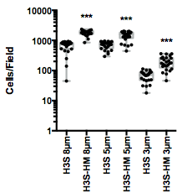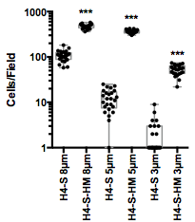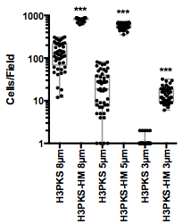
Figure S2b: Dual live/dead cell stain reveals cell viability is compromised soon after migration through 3 μm pores without prior selection. After migration, cells in the bottom chamber were stained with NucRed (all cells) and DAPI (dead cells). Fluorescence imaging took place within 2 hours following staining. This representative image is of H3PK cells. 200x total magnification. Scale bar equals 50 μm.
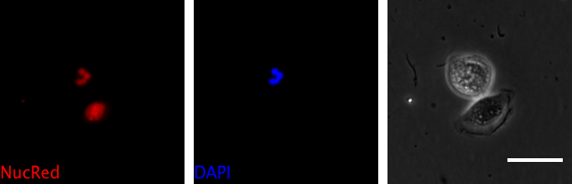

Figure S2c: Without prior selection, less than 50% of cells maintain viability after passing through 3 μm pores. The percentage of live cells in the bottom chamber after a migration assay through 8 or 3μm pores was calculated as the total cells minus the dead cells divided by the total cells. At least 25 different fields were analyzed. Mean ± SEM. *, P < 0.05

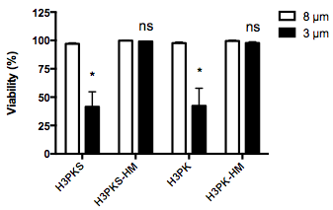

Fig S3: Following tail vein injection, H3PKS-HM cells are capable of movement outside the vasculature (extravasation) and are able to establish growth in the lung parenchyma. Shown is an IHC image of H3PKS-HM cells surrounding a capillary. Section was stained with a human-specific anti-CD44 antibody. This event was not observed in mice injected with unselected cells. Scale bar is 100 µm.

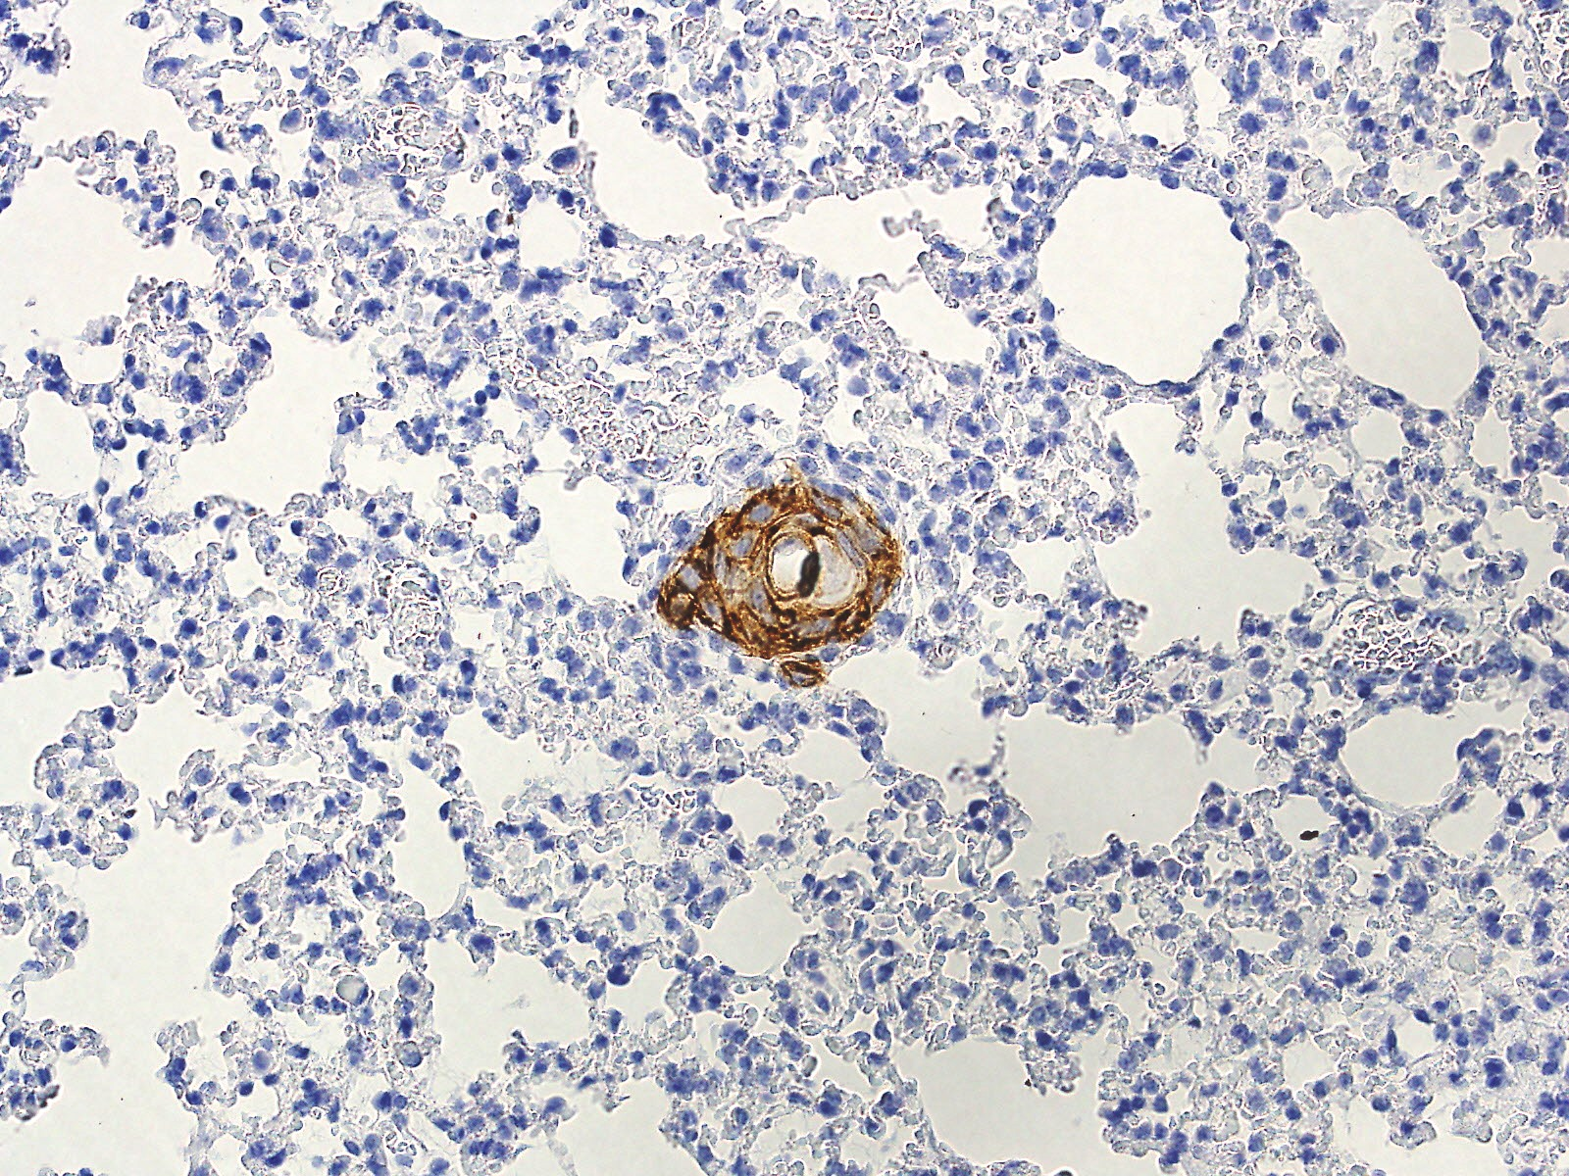

Fig S4: Highly migratory parental cells do not exhibit similar changes to the actin cytoskeleton as seen in HBEC-Snail cells. The F-actin cytoskeleton (green) and nucleus (DAPI, blue) shown for H4/H4-HM and H3PK/H3PK-HM. Scale bar is 50 microns. 200x total magnification.
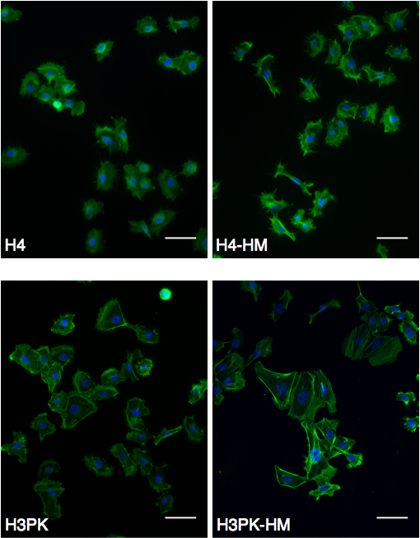
Fig S5: The Rac1 inhibitor NSC-23766 has concentration-dependent effects on H3PK cell proliferation. The effects on cell migration would likely be perturbed if proliferation was altered, and as such the concentration of inhibitor in migration assays (10 micromolar) was selected based on maximum inhibitor concentration with no observable effects on cell growth (up-side-down open triangles).

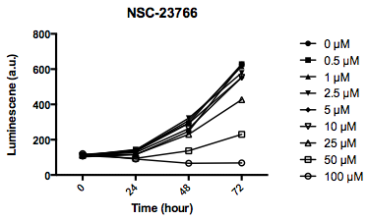

Fig S6: Increased Snail expression is not a consequence of selection through microporous membranes. Western blot for Snail protein shows no significant change in protein expression. Densitometry of blots shown as values between bands.
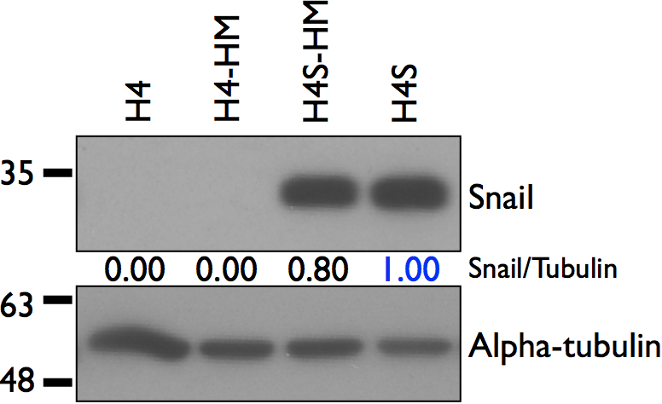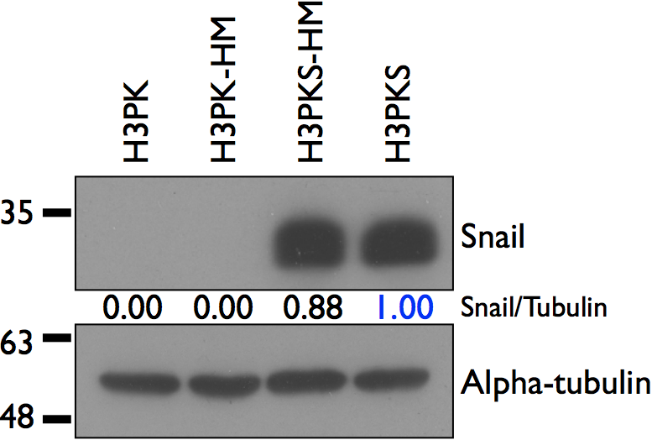

Supplemental Methods

Deformability Cytometry (DC)
Dissociated cell samples were diluted with media to achieve a concentration between 100,000-200,000 cells/mL. The samples were introduced to the DC chip at 800 μL/min using a Harvard Apparatus syringe pump. A Vision Research Phantom v711 high-speed camera recorded videos with the following parameters: 208x32 pixel resolution, 500,000 frames per second sample rate, 290 ns exposure time, and 290 ns EDR. A custom MATLAB script was used for the image analysis of recordings. Metrics extracted from the videos included cell size, maximum aspect ratio (deformability), and time spent in the extensional flow region. At least 1000 cells were analyzed per sample.

Activated GTPase pull down
Cells were plated 10 cm dishes and grown until ~80% confluent and in growth phase. Cell lysates were harvested according to the manufacturer’s protocol and using kit components (Activation Assay Combo Kit Cytoskeleton Inc, Denver, CO). 700 µg of lysate was used for each sample in the pull-down assay (concentration determined by BCA assay). Activated GTPase was eluted from the beads using 15 µL of 2x loading dye and proteins were resolved by SDS-PAGE and transferred to PVDF membranes. Membranes blocked in 0.1% milk and blotted for RhoA or Rac1 using antibodies supplied in the kit (1:500 dilution). Densitometry performed in ImageJ. Values normalized to TUBULIN in “total lysate” fraction.

Proliferation and migration assays using inhibitors
Proliferation assay: 1000 cells were seeded in 4 replicate 96-well plates and incubated overnight. Plates were decanted and various concentrations of NSC-23766 (Cayman Chemical, Ann Arbor, MI) were added. ATPlite assay (PerkinElmer, Waltham, MA) was used to measure ATP levels, which correlates with cell number, at 24 hour intervals. Migration assay: 10,000 cells per well were seeded in 96-well transwells (Corning Inc, Corning, NY). After overnight attachment, media in the top and bottom compartments was decanted and replaced with medium containing inhibitor. After additional 24 hour incubation, the tops of the transwells were swabbed, and cells were fixed, stained and imaged as described earlier. Values were normalized to plating density.

