Supplementary information

Solar-simulated radiation and determination of MED
We employed a 16S-300-003 SolarLight device equipped with a 300-watt xenon lamp, XPS300 power supply, and 0.5 meter liquid light guide with an 8-mm aperture (SolarLight, Glenside, PA) that emits both UVA and UVB, encompassing wavelengths from 290-400nm and weighted to mimic the solar spectrum. Minimal erythemal dose (MED) testing was initiated on the back using a disposable 6-holed adhesive pad (SolarLight), with doses ranging from approximately 20,000-100,000 J/m². Emission was controlled by a shutter switch, and calibrated using a PMA2100 radiometer (SolarLight). The next day (approximately 24 hours later), the MED was determined from the lowest UV dose resulting in erythema that completely filled the 8-mm irradiated site (homogeneous erythema).

RT-PCR reactions
Each cDNA reaction utilized 250 ng RNA and the SuperScript III First-Strand Synthesis Super Mix (ThermoFisher Scientific) and accompanying reagents. Quantitative PCR reactions were each performed in 10 μL using 1 μL cDNA and reagents from a Rotor-gene SYBR Green PCR kit (ThermoFisher Scientific) according to the manufacturer’s instructions. The following primers (4 μM final concentration, Integrated DNA Technologies Inc, Coralville, IA) were used for each respective gene: Gclm, 5’-TGGGCACAGGTAAAACCAA-3’ and 5’-CAGTCAAATCTGGTGGCATC-3’; Gclc, 5’-ATGCCATGGGATTTGGAAT and 5’-AGATATACTGCAGGCTTGGAATG-3’; Slc1A4, 5’-TTTGCGACAGCATTTGCTAC-3’ and 5’-TGTTCTCTTCAATGCACTTCATC-3’; Slc7A11, 5’-CAGAAGCTGCAGTTAGCCAAG-3’ and 5’-ATGAAGTCTCGCGCTCTTGT-3’; RPLP0, 5’-CCTCGTGGAAGTGACATCGT-3’ and 5’-ATCTGCTTGGAGCCCACATT-3’.

Supplementary Table I. Patient characteristics
______________________________________________________________________________
Placebo NAC p-value*
______________________________________________________________________________
Number of subjects 50 50
Males/females (ratio) 33/17 (1.9) 28/22 (1.3) 0.41
Age, median (range) 46 (24-78) 42 (23-68) 0.30
Personal history of melanoma, number (%) 20 (40%) 15 (30%) 0.40
Family history of melanoma, number (%) 17 (34%) 19 (38%) 0.84
MC1R mutation#, number (%) 24 (48%) 26 (52%) 0.84
______________________________________________________________________________
* A t-test was used for age. A Fisher’s exact test was used for all other comparisons.
# High-risk allele.

Supplementary Table II. Open-label post-trial study in 10 patients
_____________________________________________________________________________

Variable Patients* Percent 8-OG (mean, +SD) Univariate analysis
Control UV-irradiated P value#
_____________________________________________________________________________
Treatment
Placebo 49 33.1 +24.2 96.2 +7.5
Drug 10 15.4 +18.4 95.4 +6.0 0.11
_____________________________________________________________________________

Log (x100) TR-1 (mean, +SD) Univariate analysis
Control UV-irradiated Effect ratio┼ (95% CI), P value
_____________________________________________________________________________
Treatment
Placebo 50 1.05 +0.76 1.26 +0.70 1.00
Drug 10 0.76 +0.79 0.93 +0.75 0.89 (0.69 – 1.15), 0.37
_____________________________________________________________________________

Univariate analysis
ΔCT║ Gclm (mean, +SD) Analysis of Covariance
Control UV-irradiated Expression ratio╫ (95% CI), P value
______________________________________________________________________________
Treatment
Placebo 50 9.74 +0.69 9.14 +0.75 1.00
Drug 10 9.35 +1.14 9.49 +1.08 0.69 (0.44 – 1.09), 0.12
______________________________________________________________________________

ΔCT Slc1A4 (mean, +SD)
Control UV-irradiated
______________________________________________________________________________
Treatment
Placebo 50 9.21+0.83 9.40 +1.06 1.00
Drug 10 8.50 +1.07 8.69 +0.67 1.22 (0.81-1.84), 0.34
______________________________________________________________________________

ΔCT Slc7A11 (mean, +SD)
Control UV-irradiated
______________________________________________________________________________
Treatment
Placebo 50 8.97 +1.04 9.03 +0.95 1.00
Drug 10 8.59 +1.99 8.86 +1.67 1.03 (0.65 – 1.64), 0.90
______________________________________________________________________________
* 10 patients received drug 3 h after UV exposure. There were 50 patients in the placebo arm of the randomized trial, but one subject randomized to placebo was excluded from analysis of 8-OG because there was insufficient tissue.
# Wilcoxon test was used to assess significance of differences in the median percent nevus melanocytes with 8-OG expression in the UV-irradiated nevus compared to that in the control (unirradiated) nevus.
┼ The effect ratio is the ratio of log TR-1 expression in nevus melanocytes in the UV-irradiated nevus compared to that in the control (unirradiated) nevus.
║ ΔCT is the difference in CT between the gene of interest and RPLP0.
╫ Analysis of covariance was used to examine the relationship between individual categorical variables and the change in ΔCT, with categorical variable and ΔCT in the un-irradiated nevus as predictors and ΔCT in the irradiated nevus as response. The expression ratio is estimated as 2^{-ΔCT}.

Supplementary Figure S1

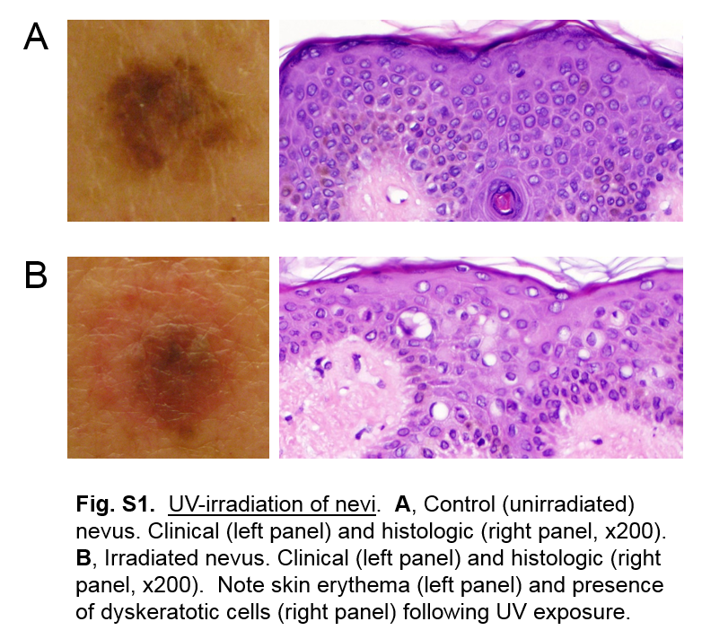

Supplementary Figure S2

