Supplementary Materials
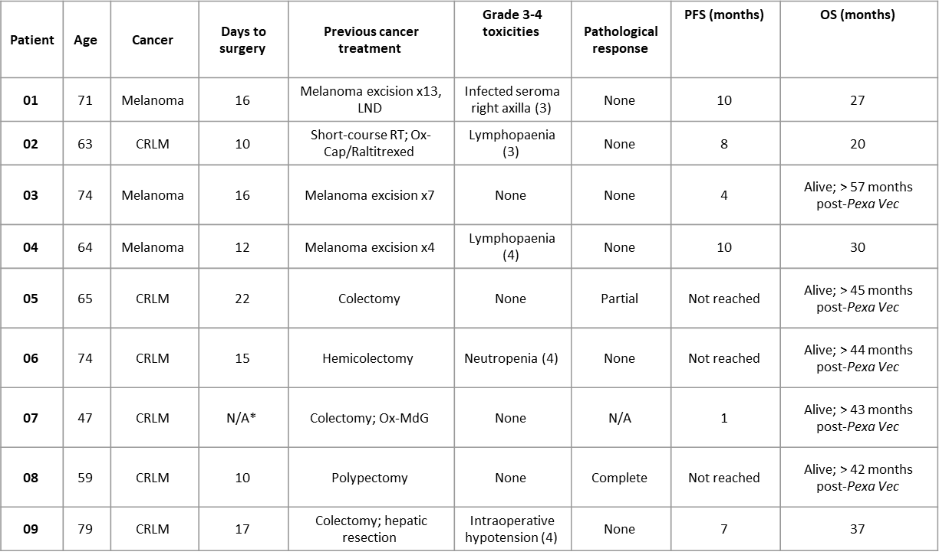
Table S1: Patient demographics
Patient details are listed, including age, time period between Pexa-Vec infusion and surgery, previous treatments, toxicity, survival and pathological tumour response, as determined by the National Health Service pathology diagnostic laboratory at SJUH. *Patient 07 did not have planned surgery due to disease progression. PFS; progression-free survival, OS; overall survival, LND; lymph node dissection, CRLM colorectal cancer liver metastasis, RT; radiotherapy, Ox; Oxaliplatin, Cap; Capecitabine, MdG; modified de Gramont chemotherapy.

Table S2
Multiplex analysis of patient plasma to determine changes in blood concentrations of cytokines and chemokines. Data are shown as mean pg/mL ± sem (n=7-9, dependent on sample availability).

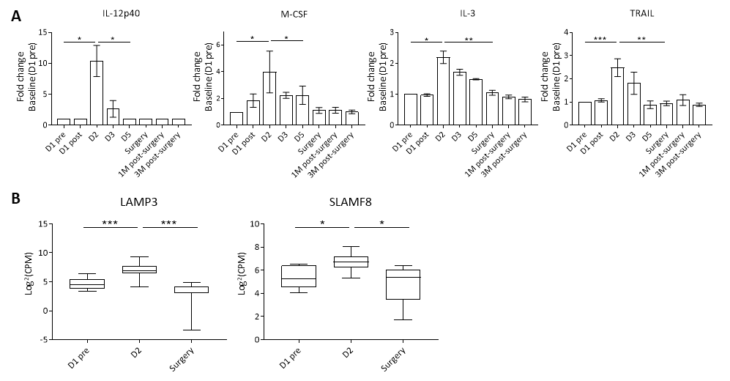
Figure S1: Peripheral blood inflammatory cytokines
A) Multiplex analysis of patient plasma to determine changes in blood concentrations of cytokines and chemokines. Data are shown as fold-change from baseline (D1 pre). *P<0.05, **P<0.01, ***P<0.001 by paired T tests; n=4-9. B) Differential expression analysis of mRNA isolated from CRLM trial patient PBMCs. Data are expressed as log₂(CPM). AdjP value was determined after adjustment using the Benjamini and Hochberg (1995) method for controlling the false discovery rate; *P<0.05, ***P<0.001; n=6.

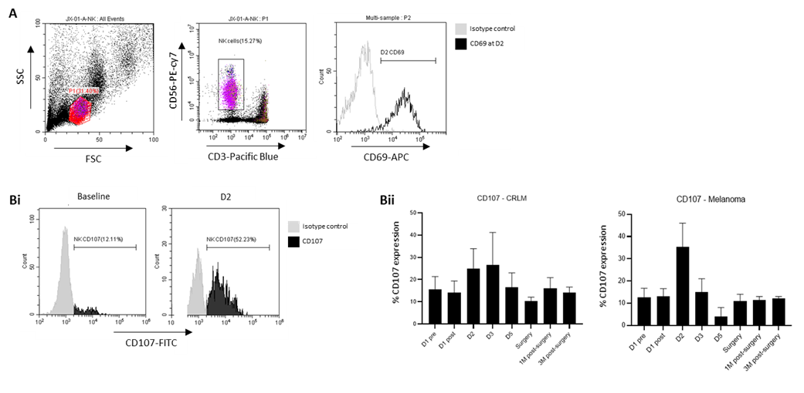
Figure S2
A) Gating strategy used to identify CD3-CD56+ NK cells and representative plot showing cell surface CD69 expression at D2 in Patient 01, with appropriate isotype control. Bi) Representative plots showing CD107 NK degranulation against SW620 tumor-specific targets, at baseline and D2, in patient 02. Bii) CD107 degranulation against tumor-specific targets (SW620 for CRLM patients; Mel888 for melanoma patients) assessed by cell surface CD107 expression, shown as % positive CD107 expression (mean + SEM), n=5-6 for CRLM, n=3 for Melanoma.

 | d1 pre | D2 | Surgery
CXCL10 | 1039 (± 406) | 27970 (± 14575) | 1323 (± 510.9)
Table S3
Differential ISG expression analysis of mRNA isolated from CRLM trial patient PBMCs. CXCL10 data are expressed as mean after normalization ± sem (n=6).

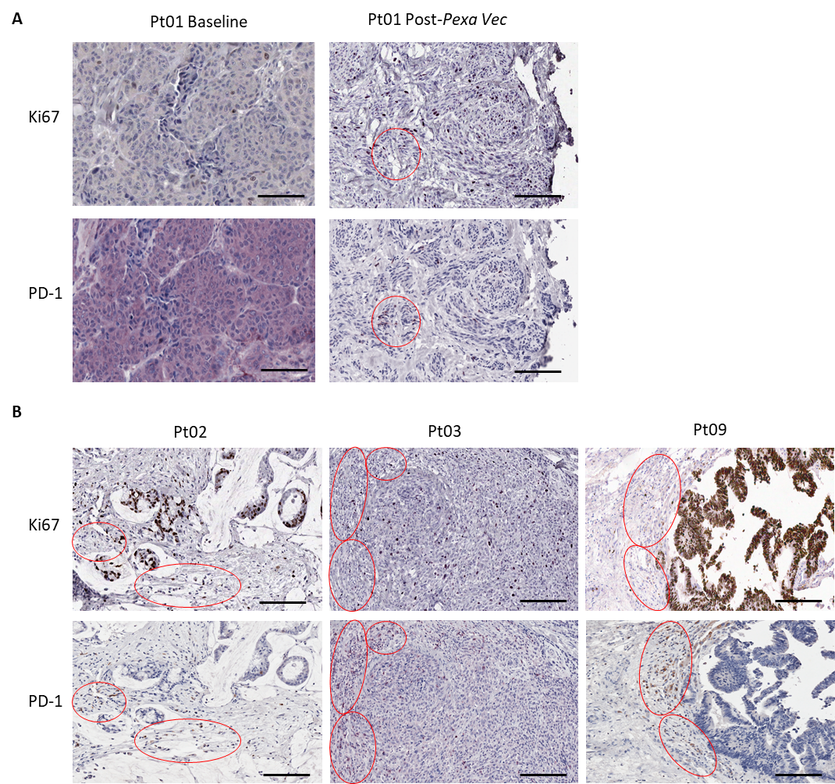
Figure S3: Expression of PD-1 and Ki67 in serial tumor sections
A) IHC showing Ki67and PD-1 expression (purple) within the baseline (pre-treatment) and post-Pexa-Vec tumor specimens from patient 01. B) IHC showing Ki67 and PD-1 expression (patients 02 and 09, brown; patient 03, purple) within the resected tumours from post-Pexa-Vec specimens. Bars represent 200 µm. Clusters of cells positive for PD-1 and their corresponding negative / low Ki67 stains are marked within the red areas.

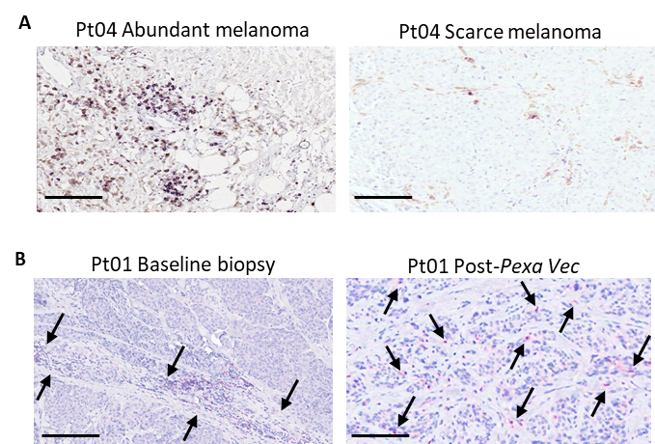
Figure S4: CD8 T-cell tumor localization
A) IHC staining (purple) of CD8-expressing cells within representative sections from patient 04 resected lymph node with abundant (left) or scarce (right) melanin-expressing (brown) malignant melanoma cells. B) IHC staining (red) of CD8-expressing cells within representative sections from patient 01 pre-treatment biopsy (left) and post-Pexa-Vec resection (right). Arrows indicate individual CD8-positive cells or CD8-positive cell clusters. Bars represent 200 µm.

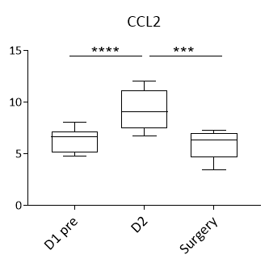
Figure S5: Differential CCL2 expression in response to Pexa-Vec
mRNA isolated from patient PBMCs was assessed for changes in expression of the CCL2 gene. Data are expressed as log₂(CPM). AdjP value was determined after adjustment using the Benjamini and Hochberg (1995) method for controlling the false discovery rate; ***P<0.001, ****P<0.0001; n=6.

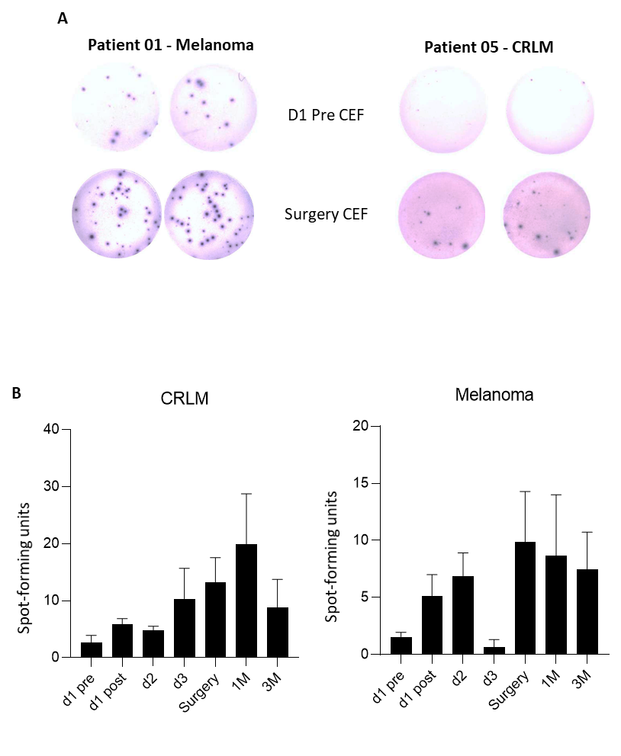
Figure S6: Tumor-targeting T-cell responses following Pexa-Vec therapy
Representative wells (A) of ELISpot analysis from two patients at baseline (pre) and surgery showing IFNγ responses to CEF peptides. B) Plots showing T-cell responses to CEF peptides grouped as patient tumor types. Data is shown as mean sfu + SEM, n=5-6 for CRLM; n=3 for melanoma.

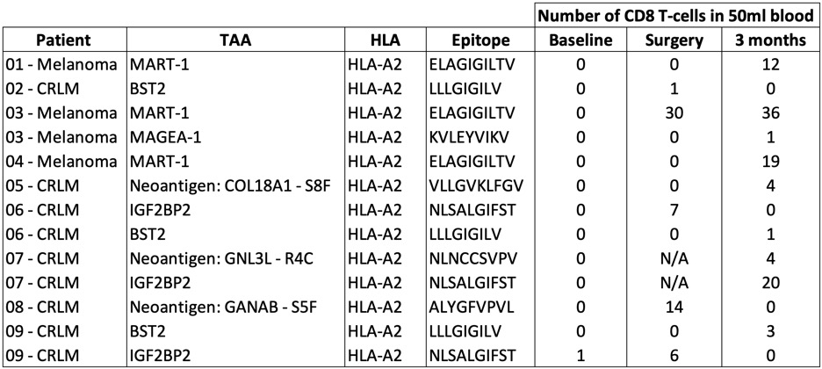
Table S4: T-cell anti-cancer clonal response
Numbers of CD8 T-cells belonging to clones specific for identified TAAs. Receptor sequencing was performed to estimate the number of unique CD8 T-cell clones from PBMCs at the described time points. T-cell clones that are associated with identified TAAs in published databases are shown in the table. BST2; bone marrow stromal cell antigen 2, MART-1, MAGEA-1; melanoma-associated antigen 1, IGF2BP2; insulin-like growth factor 2 mRNA-binding protein 2, HLA; human leucocyte antigen.

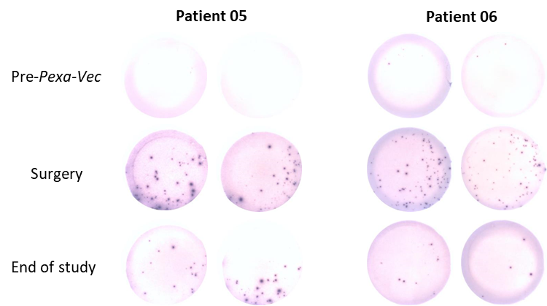
Figure S7: Longitudinal ELISpot analysis of T cells from two patients with or without tumor necrosis.
PMBCs from patient 05 (extensive tumor necrosis) and patient 06 (no tumor necrosis) were analyzed for IFNγ production over the course of Pexa-Vec treatment. Representative duplicate wells are shown.

