Fig S1 – supplementary for Method:
pLL-SLAMF6-V1-3: vs Flag-VAR1
V1-A:
EMBOSS_001 351 CCCATTGACGTCAATGGGAGTTTGTTTTGGCACCAAAATCAACGGGACTT 400

EMBOSS_001 1 -------------------------------------------------- 0

EMBOSS_001 401 TCCAAAATGTCGTAACAACTCCGCCCCATTGACGCAAATGGGCGGTAGGC 450

EMBOSS_001 1 -------------------------------------------------- 0

EMBOSS_001 451 GTGTACGGTGGGAGGTCTATATAAGCAGAGCTGGTTTAGTGAACCGTCAG 500

EMBOSS_001 1 -------------------------------------------------- 0
(NheI/Xb)Kozak start
EMBOSS_001 501 ATCCGCTAGACCATGTTGTGGCTGTTCCAATCGCTCCTGTTTGTCTTCTG 550
||||||||||||||||||||||||||||||||||||||
EMBOSS_001 1 ------------ATGTTGTGGCTGTTCCAATCGCTCCTGTTTGTCTTCTG 38
Flag tag
EMBOSS_001 551 CTTTGGCCCAGGGAATGTAGTTTCAGACTACAAGGACGATGATGACAAGG 600
||||||||||||||||||||||||||||||||||||||||||||||||||
EMBOSS_001 39 CTTTGGCCCAGGGAATGTAGTTTCAGACTACAAGGACGATGATGACAAGG 88

Linker
EMBOSS_001 601 GTTCAGGTCAAAGCAGCTTAACCCCATTGATGGTGAACGGGATTCTGGGG 650
||||||||||||||||||||||||||||||||||||||||||||||||||
EMBOSS_001 89 GTTCAGGTCAAAGCAGCTTAACCCCATTGATGGTGAACGGGATTCTGGGG 138

EMBOSS_001 651 GAGTCAGTAACTCTTCCCCTGGAGTTTCCTGCAGGAGAGAAGGTCAACTT 700
||||||||||||||||||||||||||||||||||||||||||||||||||
EMBOSS_001 139 GAGTCAGTAACTCTTCCCCTGGAGTTTCCTGCAGGAGAGAAGGTCAACTT 188

EMBOSS_001 701 CATCACTTGGCTTTTCAATGAAACATCTCTTGCCTTCATAGTACCCCATG 750
||||||||||||||||||||||||||||||||||||||||||||||||||
EMBOSS_001 189 CATCACTTGGCTTTTCAATGAAACATCTCTTGCCTTCATAGTACCCCATG 238

EMBOSS_001 751 AAACCAAAAGTCCAGAAATCCACGTGACTAATCCGAAACAGGGAAAGCGA 800
||||||||||||||||||||||||||||||||||||||||||||||||||
EMBOSS_001 239 AAACCAAAAGTCCAGAAATCCACGTGACTAATCCGAAACAGGGAAAGCGA 288

EMBOSS_001 801 CTGAACTTCACCCAGTCCTACTCCCTGCAACTCAGCAACCTGAAGATGGA 850
||||||||||||||||||||||||||||||||||||||||||||||||||
EMBOSS_001 289 CTGAACTTCACCCAGTCCTACTCCCTGCAACTCAGCAACCTGAAGATGGA 338

EMBOSS_001 851 AGACACAGGCTCTTACAGAGCCCAGATATCCACAAAGACCTCTGCAAAGC 900
||||||||||||||||||||||||||||||||||||||||||||||||||
EMBOSS_001 339 AGACACAGGCTCTTACAGAGCCCAGATATCCACAAAGACCTCTGCAAAGC 388

EMBOSS_001 901 TGTCCAGTTACACTCTGAGGATATTAAGACAACTGAGGAACATACAAGTT 950
||||||||||||||||||||||||||||||||||||||||||||||||||
EMBOSS_001 389 TGTCCAGTTACACTCTGAGGATATTAAGACAACTGAGGAACATACAAGTT 438

EMBOSS_001 951 ACCAATCACAGTCAGCTATTTCAGAATATGACCTGTGAGCTCCATCTGAC 1000
||||||||||||||||||||||||||||||||||||||||||||||||||
EMBOSS_001 439 ACCAATCACAGTCAGCTATTTCAGAATATGACCTGTGAGCTCCATCTGAC 488

EMBOSS_001 1001 TTGCTCTGTGGAGGATGCAGATGACAATGTCTCA-TCAGAT--GAGTCNT 1047
|||||||||||||||||||||||||||||||||| |||||| |||.| |
EMBOSS_001 489 TTGCTCTGTGGAGGATGCAGATGACAATGTCTCATTCAGATGGGAGGCCT 538

pLL3:

EMBOSS_001 4 TTACAGAGCCCCAGATATCCACAAAGCACATCTGCAAAAGCTGTCCAGTT 53
|||||||| ||||||||||||||||| ||.||||| ||||||||||||||
EMBOSS_001 351 TTACAGAG-CCCAGATATCCACAAAG-ACCTCTGC-AAAGCTGTCCAGTT 397

EMBOSS_001 54 ACA-TCTGAAGGATATTAAGACAACTGAGGAACATACAAAGTTACCAATC 102
||| |||| |||||||||||||||||||||||||||| ||||||||||||
EMBOSS_001 398 ACACTCTG-AGGATATTAAGACAACTGAGGAACATAC-AAGTTACCAATC 445

EMBOSS_001 103 ACAGTCAGCTATTTCAGAATATGACCTGTGAGCTCCATCTGACTTGCTCT 152
||||||||||||||||||||||||||||||||||||||||||||||||||
EMBOSS_001 446 ACAGTCAGCTATTTCAGAATATGACCTGTGAGCTCCATCTGACTTGCTCT 495

EMBOSS_001 153 GTGGAGGATGCAGATGACAATGTCTCATTCAGATGGGAGGCCTTGGGAAA 202
||||||||||||||||||||||||||||||||||||||||||||||||||
EMBOSS_001 496 GTGGAGGATGCAGATGACAATGTCTCATTCAGATGGGAGGCCTTGGGAAA 545

EMBOSS_001 203 CACACTTTCAAGTCAGCCAAACCTCACTGTCTCCTGGGACCCCAGGATTT 252
||||||||||||||||||||||||||||||||||||||||||||||||||
EMBOSS_001 546 CACACTTTCAAGTCAGCCAAACCTCACTGTCTCCTGGGACCCCAGGATTT 595

EMBOSS_001 253 CCAGTGAACAGGACTACACCTGCATAGCAGAGAATGCTGTCAGTAATTTA 302
||||||||||||||||||||||||||||||||||||||||||||||||||
EMBOSS_001 596 CCAGTGAACAGGACTACACCTGCATAGCAGAGAATGCTGTCAGTAATTTA 645

EMBOSS_001 303 TCCTTCTCTGTCTCTGCCCAGAAGCTTTGCGAAGATGTTAAAATTCAATA 352
||||||||||||||||||||||||||||||||||||||||||||||||||
EMBOSS_001 646 TCCTTCTCTGTCTCTGCCCAGAAGCTTTGCGAAGATGTTAAAATTCAATA 695

EMBOSS_001 353 TACAGATACCAAAATGATTCTGTTTATGGTTTCTGGGATATGCATAGTCT 402
||||||||||||||||||||||||||||||||||||||||||||||||||
EMBOSS_001 696 TACAGATACCAAAATGATTCTGTTTATGGTTTCTGGGATATGCATAGTCT 745

EMBOSS_001 403 TCGGTTTCATCATACTGCTGTTACTTGTTTTGAGGAAAAGAAGAGATTCC 452
||||||||||||||||||||||||||||||||||||||||||||||||||
EMBOSS_001 746 TCGGTTTCATCATACTGCTGTTACTTGTTTTGAGGAAAAGAAGAGATTCC 795

EMBOSS_001 453 CTATCTTTGTCTACTCAGCGAACACAGGGCCCCGCAGAGTCCGCAAGGAA 502
||||||||||||||||||||||||||||||||||||||||||||||||||
EMBOSS_001 796 CTATCTTTGTCTACTCAGCGAACACAGGGCCCCGCAGAGTCCGCAAGGAA 845

EMBOSS_001 503 CCTAGAGTATGTTTCAGTGTCTCCAACGAACAACACTGTGTATGCTTCAG 552
||||||||||||||||||||||||||||||||||||||||||||||||||
EMBOSS_001 846 CCTAGAGTATGTTTCAGTGTCTCCAACGAACAACACTGTGTATGCTTCAG 895

EMBOSS_001 553 TCACTCATTCAAACAGGGAAACAGAAATCTGGACACCTAGAGAAAATGAT 602
||||||||||||||||||||||||||||||||||||||||||||||||||
EMBOSS_001 896 TCACTCATTCAAACAGGGAAACAGAAATCTGGACACCTAGAGAAAATGAT 945

EMBOSS_001 603 ACTATCACAATTTACTCCACAATTAATCATTCCAAAGAGAGTAAACCCAC 652
||||||||||||||||||||||||||||||||||||||||||||||||||
EMBOSS_001 946 ACTATCACAATTTACTCCACAATTAATCATTCCAAAGAGAGTAAACCCAC 995

Stop EcoRI
EMBOSS_001 653 TTTTTCCAGGGCAACTGCCCTTGACAATGTCGTGTAAGAATTCGTCGAGG 702
|||||||||||||||||||||||||||||||||||||
EMBOSS_001 996 TTTTTCCAGGGCAACTGCCCTTGACAATGTCGTGTAA------------- 1032

EMBOSS_001 703 GACCTAATAACTTCGTATAGCATACATTATACGAAGTTATACAGTAAGGT 752

pLL-SLAMF6-V3-1: vs Flag-VAR3

VAR3-A:
EMBOSS_001 801 TCAACTCCGCCCCATTGACGCAAATGGGCGGTAGGCGTGTACGGTGGGAG 850

EMBOSS_001 1 -------------------------------------------------- 0

(NheI/Xb)Kozak start
EMBOSS_001 851 GTCTATATAAGCAGAGCTGGTTTAGTGAACCGTCAGATCCGCTAGACCAT 900
||
EMBOSS_001 1 ------------------------------------------------AT 2

EMBOSS_001 901 GTTGTGGCTGTTCCAATCGCTCCTGTTTGTCTTCTGCTTTGGCCCAGTAC 950
||||||||||||||||||||||||||||||||||||||||||||||||||
EMBOSS_001 3 GTTGTGGCTGTTCCAATCGCTCCTGTTTGTCTTCTGCTTTGGCCCAGTAC 52

Flag tag Linker
EMBOSS_001 951 CCCATGAAACCGACTACAAGGACGATGATGACAAGGGTTCAGGTAAAAGT 1000
||||||||||||||||||||||||||||||||||||||||||||||||||
EMBOSS_001 53 CCCATGAAACCGACTACAAGGACGATGATGACAAGGGTTCAGGTAAAAGT 102

EMBOSS_001 1001 CCAGAAATCCACGTGACTAATCCGAAACAGGGAAAGCGACTGAACTTCAC 1050
||||||||||||||||||||||||||||||||||||||||||||||||||
EMBOSS_001 103 CCAGAAATCCACGTGACTAATCCGAAACAGGGAAAGCGACTGAACTTCAC 152

EMBOSS_001 1051 CCAGTCCTACTCCCTGCAACTCAGCAACCTGAAGATGGAAGACACAGGCT 1100
||||||||||||||||||||||||||||||||||||||||||||||||||
EMBOSS_001 153 CCAGTCCTACTCCCTGCAACTCAGCAACCTGAAGATGGAAGACACAGGCT 202

EMBOSS_001 1101 CTTACAGAGCCCAGATATCCACAAAGACCTCTGCAAAGCTGTCCAGTTAC 1150
||||||||||||||||||||||||||||||||||||||||||||||||||
EMBOSS_001 203 CTTACAGAGCCCAGATATCCACAAAGACCTCTGCAAAGCTGTCCAGTTAC 252

EMBOSS_001 1151 ACTCTGAGGATATTAAGACAACTGAGGAACATACAAGTTACCAATCACAG 1200
||||||||||||||||||||||||||||||||||||||||||||||||||
EMBOSS_001 253 ACTCTGAGGATATTAAGACAACTGAGGAACATACAAGTTACCAATCACAG 302

EMBOSS_001 1201 TCAGCTATTTCAGAATATGACCTGTGAGCTCCATCTGACTTGCTCTGTGG 1250
||||||||||||||||||||||||||||||||||||||||||||||||||
EMBOSS_001 303 TCAGCTATTTCAGAATATGACCTGTGAGCTCCATCTGACTTGCTCTGTGG 352

EMBOSS_001 1251 AGGATGCAGATGACAATGTCTCA-TCAGATGAG------TCNGA------ 1287
||||||||||||||||||||||| |||||||.| |. ||
EMBOSS_001 353 AGGATGCAGATGACAATGTCTCATTCAGATGGGAGGCCTTGGGAAACACA 402

pLL3:

EMBOSS_001 301 CAGAGCTGGTTTAGTGAACCGTCAGATCCGCTAGACCATGTTGTGGCTGT 350
|||||||||||||
EMBOSS_001 1 -------------------------------------ATGTTGTGGCTGT 13

EMBOSS_001 351 TCCAATCGCTCCTGTTTGTCTTCTGCTTTGGCCCAGTACCCCATGAAACC 400
||||||||||||||||||||||||||||||||||||||||||||||||||
EMBOSS_001 14 TCCAATCGCTCCTGTTTGTCTTCTGCTTTGGCCCAGTACCCCATGAAACC 63

EMBOSS_001 401 GACTACAAGGACGATGATGACAAGGGTTCAGGTAAAAGTCCAGAAATCCA 450
||||||||||||||||||||||||||||||||||||||||||||||||||
EMBOSS_001 64 GACTACAAGGACGATGATGACAAGGGTTCAGGTAAAAGTCCAGAAATCCA 113

EMBOSS_001 451 CGTGACTAACCCGAAACAGGGAAAGCGACTGAACTTCACCCAGTCCTACT 500
|||||||||.||||||||||||||||||||||||||||||||||||||||
EMBOSS_001 114 CGTGACTAATCCGAAACAGGGAAAGCGACTGAACTTCACCCAGTCCTACT 163

EMBOSS_001 501 CCCTGCAACTCAGCAACCTGAAGATGGAAGACACAGGCTCTTACAGAGCC 550
||||||||||||||||||||||||||||||||||||||||||||||||||
EMBOSS_001 164 CCCTGCAACTCAGCAACCTGAAGATGGAAGACACAGGCTCTTACAGAGCC 213

EMBOSS_001 551 CAGATATCCACAAAGACCTCTGCAAAGCTGTCCAGTTACACTCTGAGGAT 600
||||||||||||||||||||||||||||||||||||||||||||||||||
EMBOSS_001 214 CAGATATCCACAAAGACCTCTGCAAAGCTGTCCAGTTACACTCTGAGGAT 263

EMBOSS_001 601 ATTAAGACAACTGAGGAACATACAAGTTACCAATCACAGTCAGCTATTTC 650
||||||||||||||||||||||||||||||||||||||||||||||||||
EMBOSS_001 264 ATTAAGACAACTGAGGAACATACAAGTTACCAATCACAGTCAGCTATTTC 313

EMBOSS_001 651 AGAATATGACCTGTGAGCTCCATCTGACTTGCTCTGTGGAGGATGCAGAT 700
||||||||||||||||||||||||||||||||||||||||||||||||||
EMBOSS_001 314 AGAATATGACCTGTGAGCTCCATCTGACTTGCTCTGTGGAGGATGCAGAT 363

EMBOSS_001 701 GACAATGTCTCATTCAGATGGGAGGCCTTGGGAAACACACTTTCAAGTCA 750
||||||||||||||||||||||||||||||||||||||||||||||||||
EMBOSS_001 364 GACAATGTCTCATTCAGATGGGAGGCCTTGGGAAACACACTTTCAAGTCA 413

EMBOSS_001 751 GCCAAACCTCACTGTCTCCTGGGACCCCAGGATTTCCAGTGAACAGGACT 800
||||||||||||||||||||||||||||||||||||||||||||||||||
EMBOSS_001 414 GCCAAACCTCACTGTCTCCTGGGACCCCAGGATTTCCAGTGAACAGGACT 463

EMBOSS_001 801 ACACCTGCATAGCAGAGAATGCTGTCAGTAATTTATCCTTCTCTGTCTCT 850
||||||||||||||||||||||||||||||||||||||||||||||||||
EMBOSS_001 464 ACACCTGCATAGCAGAGAATGCTGTCAGTAATTTATCCTTCTCTGTCTCT 513

EMBOSS_001 851 GCCCAGAAGCTTTGCGAAGATGTTAAAATTCAATATACAGATACCAAAAT 900
||||||||||||||||||||||||||||||||||||||||||||||||||
EMBOSS_001 514 GCCCAGAAGCTTTGCGAAGATGTTAAAATTCAATATACAGATACCAAAAT 563

EMBOSS_001 901 GATTCTGTTTATGGTTTCTGGGATATGCATAGTCTTCGGTTTCATCATAC 950
||||||||||||||||||||||||||||||||||||||||||||||||||
EMBOSS_001 564 GATTCTGTTTATGGTTTCTGGGATATGCATAGTCTTCGGTTTCATCATAC 613

EMBOSS_001 951 TGCTGTTACTTGTTTTGAGGAAAAGAAGAGATTCCCTATCTTTGTCTACT 1000
||||||||||||||||||||||||||||||||||||||||||||||||||
EMBOSS_001 614 TGCTGTTACTTGTTTTGAGGAAAAGAAGAGATTCCCTATCTTTGTCTACT 663

EMBOSS_001 1001 CAGCGAACACAGGGCCCCGAGTCCGCAAGGAACCTAGAGTATGTTTCAGT 1050
||||||||||||||||||||||||||||||||||||||||||||||||||
EMBOSS_001 664 CAGCGAACACAGGGCCCCGAGTCCGCAAGGAACCTAGAGTATGTTTCAGT 713

EMBOSS_001 1051 GTCTCCAACGAACAACACTGTGTATGCTTCAGTCACTCATTCAAACAGGG 1100
||||||||||||||||||||||||||||||||||||||||||||||||||
EMBOSS_001 714 GTCTCCAACGAACAACACTGTGTATGCTTCAGTCACTCATTCAAACAGGG 763

EMBOSS_001 1101 AAACAGAAATCTGGACACCTAGAGAAAATGATACTATCACAATTTACTCC 1150
||||||||||||||||||||||||||||||||||||||||||||||||||
EMBOSS_001 764 AAACAGAAATCTGGACACCTAGAGAAAATGATACTATCACAATTTACTCC 813

EMBOSS_001 1151 ACAATTAATCATTCCAAAGAGAGTAAACCCACTTTTTCCAGGGCAACTGC 1200
||||||||||||||||||||||||||||||||||||||||||||||||||
EMBOSS_001 814 ACAATTAATCATTCCAAAGAGAGTAAACCCACTTTTTCCAGGGCAACTGC 863

Stop EcoRI
EMBOSS_001 1201 CCTTGACAATGTCGTGTAAGAATTCGTCGAGGGACCTAATAACTTCGTAT 1250
|||||||||||||||||||
EMBOSS_001 864 CCTTGACAATGTCGTGTAA------------------------------- 882

EMBOSS_001 1251 AGCATACATTATACGAAGTTATACAGTAACGTCCTCCGC 1289

pLL-SLAMF6-V4-4: vs Flag-VAR4

pLL3:

EMBOSS_001 151 ACTCCGCCCCATTGACGCAAATGGGCGGTAGGCGTGTACGGTGGGAGGTC 200

EMBOSS_001 1 -------------------------------------------------- 0
(NheI/Xb)Kozak start
EMBOSS_001 201 TATATAAGCAGAGCTGGTTTAGTGAACCGTCAGATCCGCTAGACCATGTT 250
|||||
EMBOSS_001 1 ---------------------------------------------ATGTT 5

EMBOSS_001 251 GTGGCTGTTCCAATCGCTCCTGTTTGTCTTCTGCTTTGGCCCAGGACAAC 300
||||||||||||||||||||||||||||||||||||||||||||||||||
EMBOSS_001 6 GTGGCTGTTCCAATCGCTCCTGTTTGTCTTCTGCTTTGGCCCAGGACAAC 55

Flag tag Linker
EMBOSS_001 301 TGGACTACAAGGACGATGATGACAAGGGTTCAGGTAGGAACATACAAGTT 350
||||||||||||||||||||||||||||||||||||||||||||||||||
EMBOSS_001 56 TGGACTACAAGGACGATGATGACAAGGGTTCAGGTAGGAACATACAAGTT 105

EMBOSS_001 351 ACCAATCACAGTCAGCTATTTCAGAATATGACCTGTGAGCTCCATCTGAC 400
||||||||||||||||||||||||||||||||||||||||||||||||||
EMBOSS_001 106 ACCAATCACAGTCAGCTATTTCAGAATATGACCTGTGAGCTCCATCTGAC 155

EMBOSS_001 401 TTGCTCTGTGGAGGATGCAGATGACAATGTCTCATTCAGATGGGAGGCCT 450
||||||||||||||||||||||||||||||||||||||||||||||||||
EMBOSS_001 156 TTGCTCTGTGGAGGATGCAGATGACAATGTCTCATTCAGATGGGAGGCCT 205

EMBOSS_001 451 TGGGAAACACACTTTCAAGTCAGCCAAACCTCACTGTCTCCTGGGACCCC 500
||||||||||||||||||||||||||||||||||||||||||||||||||
EMBOSS_001 206 TGGGAAACACACTTTCAAGTCAGCCAAACCTCACTGTCTCCTGGGACCCC 255

EMBOSS_001 501 AGGATTTCCAGTGAACAGGACTACACCTGCATAGCAGAGAATGCTGTCAG 550
||||||||||||||||||||||||||||||||||||||||||||||||||
EMBOSS_001 256 AGGATTTCCAGTGAACAGGACTACACCTGCATAGCAGAGAATGCTGTCAG 305

EMBOSS_001 551 TAATTTATCCTTCTCTGTCTCTGCCCAGAAGCTTTGCGAAGATGTTAAAA 600
||||||||||||||||||||||||||||||||||||||||||||||||||
EMBOSS_001 306 TAATTTATCCTTCTCTGTCTCTGCCCAGAAGCTTTGCGAAGATGTTAAAA 355

EMBOSS_001 601 TTCAATATACAGATACCAAAATGATTCTGTTTATGGTTTCTGGGATATGC 650
||||||||||||||||||||||||||||||||||||||||||||||||||
EMBOSS_001 356 TTCAATATACAGATACCAAAATGATTCTGTTTATGGTTTCTGGGATATGC 405

EMBOSS_001 651 ATAGTCTTCGGTTTCATCATACTGCTGTTACTTGTTTTGAGGAAAAGAAG 700
||||||||||||||||||||||||||||||||||||||||||||||||||
EMBOSS_001 406 ATAGTCTTCGGTTTCATCATACTGCTGTTACTTGTTTTGAGGAAAAGAAG 455

EMBOSS_001 701 AGATTCCCTATCTTTGTCTACTCAGCGAACACAGGGCCCCGCAGAGTCCG 750
||||||||||||||||||||||||||||||||||||||||||||||||||
EMBOSS_001 456 AGATTCCCTATCTTTGTCTACTCAGCGAACACAGGGCCCCGCAGAGTCCG 505

EMBOSS_001 751 CAAGGAACCTAGAGTATGTTTCAGTGTCTCCAACGAACAACACTGTGTAT 800
||||||||||||||||||||||||||||||||||||||||||||||||||
EMBOSS_001 506 CAAGGAACCTAGAGTATGTTTCAGTGTCTCCAACGAACAACACTGTGTAT 555

EMBOSS_001 801 GCTTCAGTCACTCATTCAAACAGGGAAACAGAAATCTGGACACCTAGAGA 850
||||||||||||||||||||||||||||||||||||||||||||||||||
EMBOSS_001 556 GCTTCAGTCACTCATTCAAACAGGGAAACAGAAATCTGGACACCTAGAGA 605

EMBOSS_001 851 AAATGATACTATCACAATTTACTCCACAATTAATCATTCCAAAGAGAGTA 900
||||||||||||||||||||||||||||||||||||||||||||||||||
EMBOSS_001 606 AAATGATACTATCACAATTTACTCCACAATTAATCATTCCAAAGAGAGTA 655

Stop EcoRI
EMBOSS_001 901 AACCCACTTTTTCCAGGGCAACTGCCCTTGACAATGTCGTGTAAGAATTC 950
||||||||||||||||||||||||||||||||||||||||||||
EMBOSS_001 656 AACCCACTTTTTCCAGGGCAACTGCCCTTGACAATGTCGTGTAA------ 699

EMBOSS_001 951 GTCGAGGGACCTAATAACTTCGTATAGCATACATTATACGAAGTATACAG 1000

Fig S1 – supplementary for Method:
Sequencing files of the 3 plasmids used (3 SLAMF6 variants in PLL3.7 plasmid)

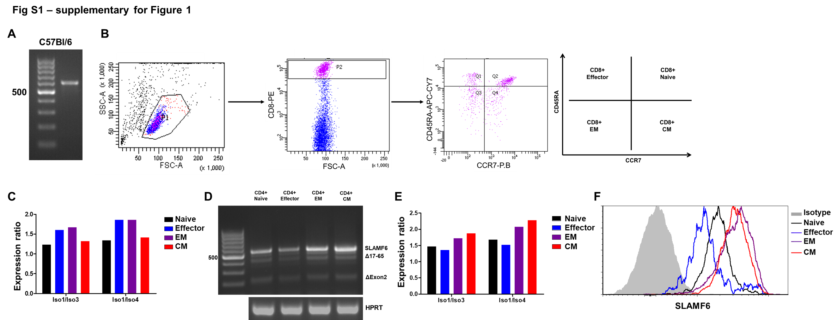
Fig S2 – supplementary for Figure 1:
A, RNA expression of LY108, the murine analog of SLAMF6, in C57Bl/6 splenocytes. B, Gating strategy for cell sorting separating CD8 T cells to subsets according to CD45RA/CCR7 expression. C, Ratio of isoforms as quantitated from Figure 1E. D-F, SLAMF6 isoform in naïve, effector, EM, and CM CD4 T cell subsets. D, RNA expression. E, Ratio of isoforms as quantitated from D. F, Flow cytometry of SLAMF6. EM, effector memory. CM, central memory.

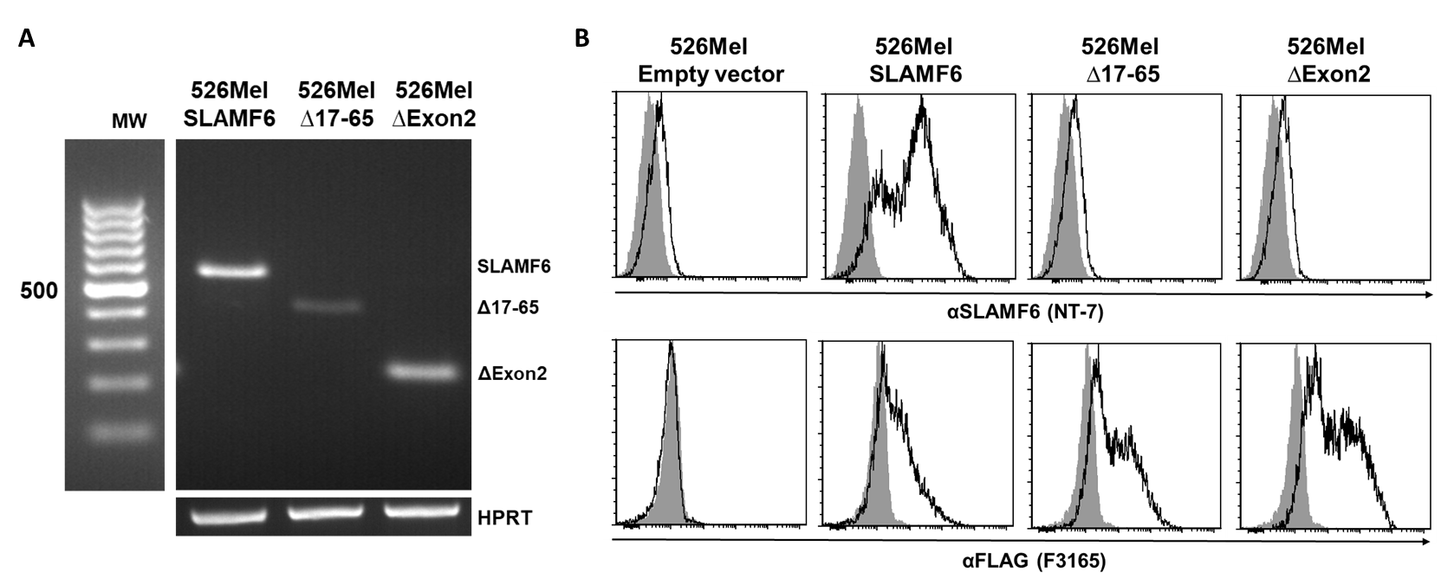
Fig S3 – supplementary for Figure 2:
Validation of SLAMF6 protein expression in modified melanoma cells. A, RNA expression of SLAMF6 isoforms on transfected 526mel melanoma cells. B, Flow cytometry to determine SLAMF6 (MoAb NT-7) or FLAG (MoAb F3165) expression on the transfected 526mel cells.

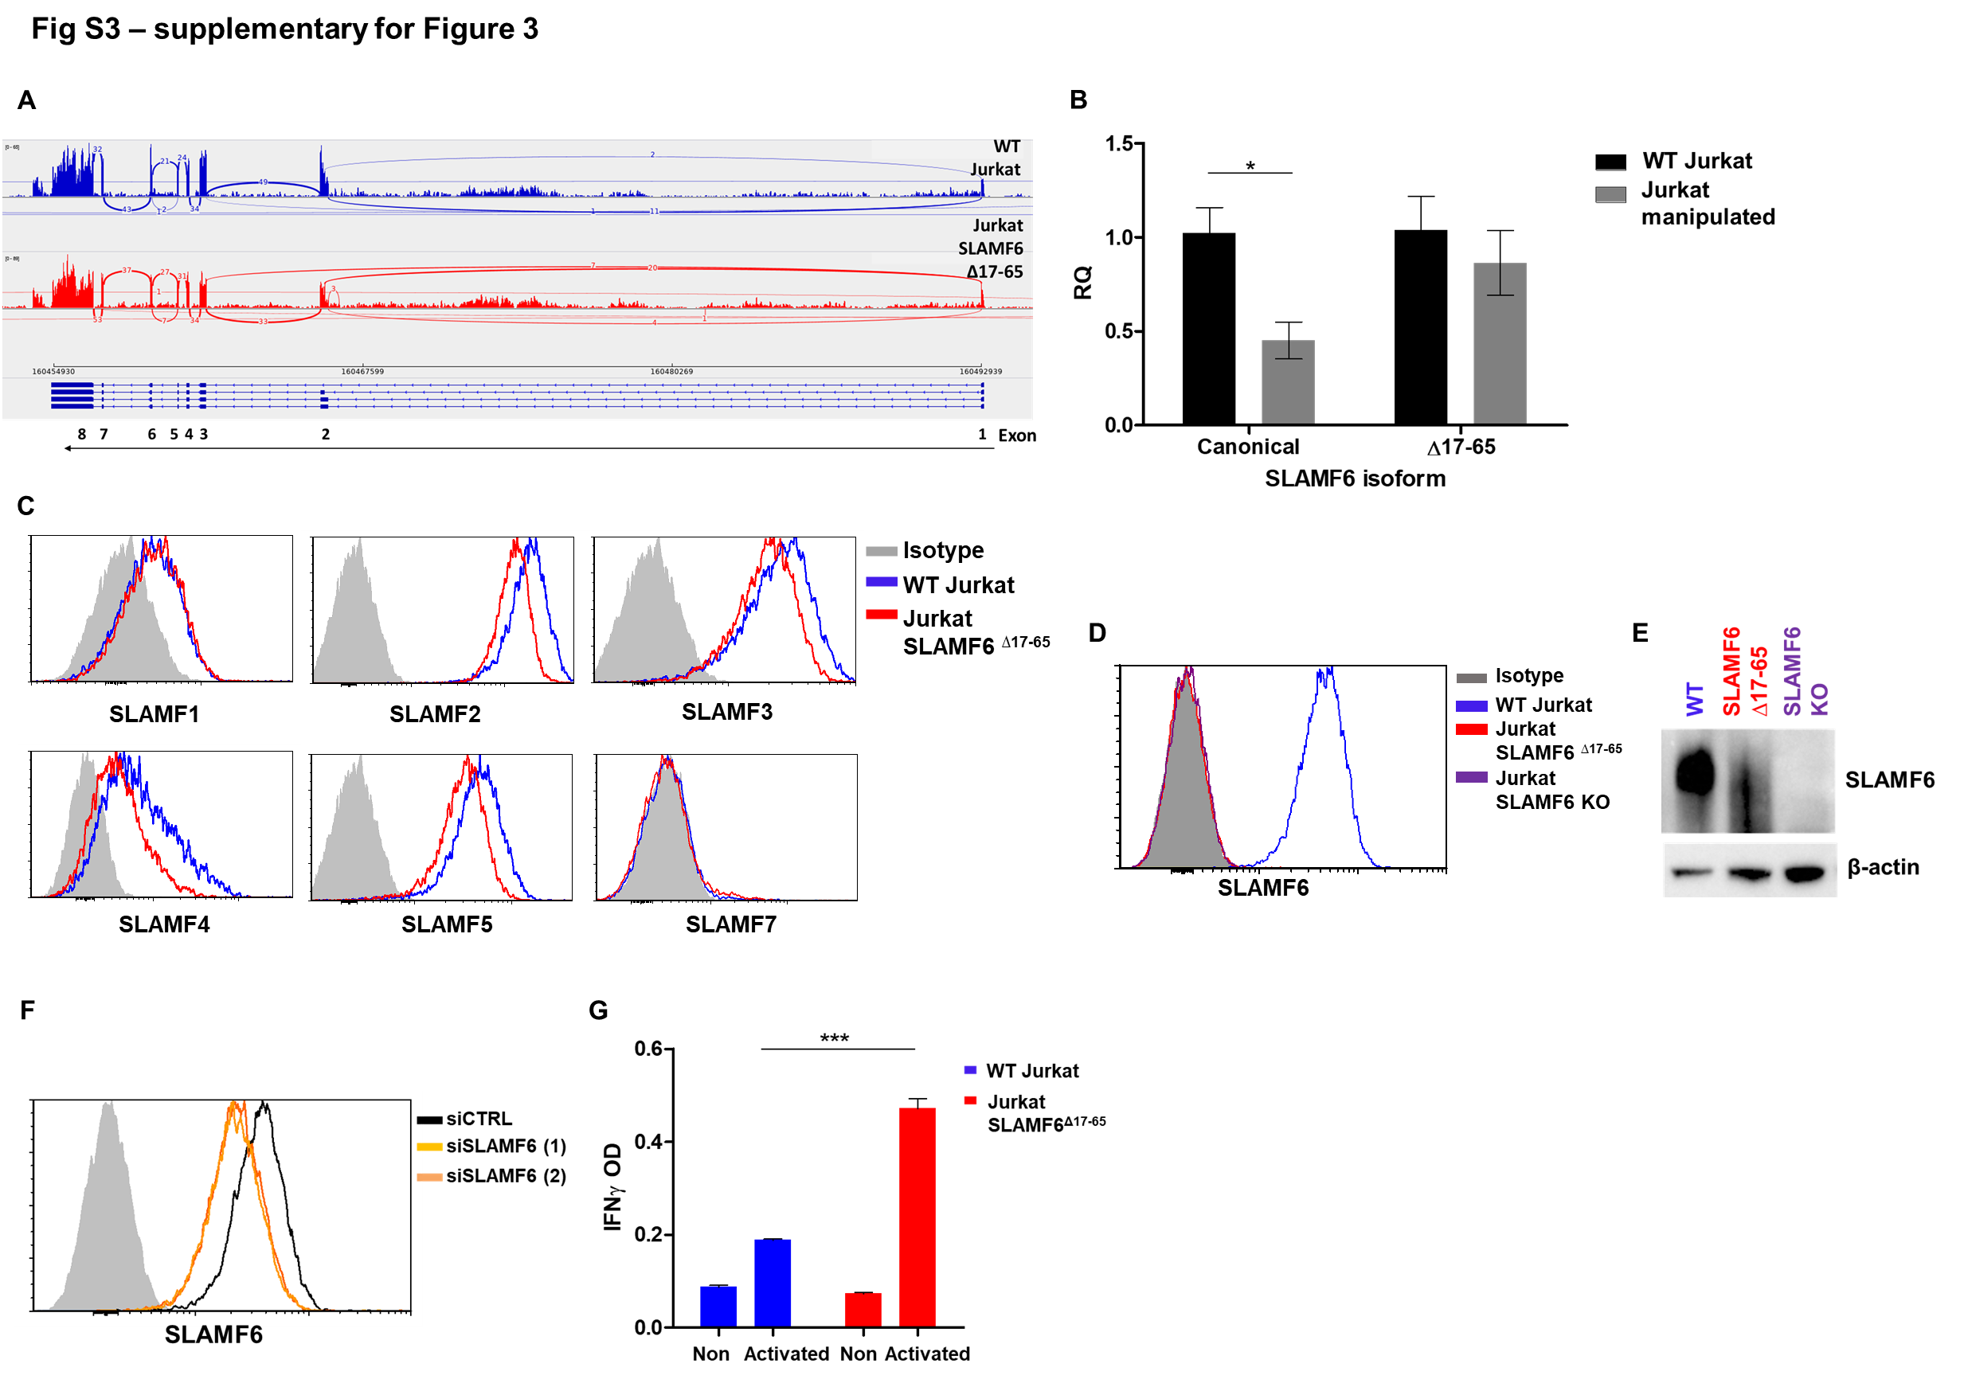
Fig S4 – supplementary for Figure 3:
A, Sashimi plot showing SLAMF6 splice isoforms in WT Jurkat cells and Jurkat-SLAMF6^{∆17-65} cells 36 h post-activation. B, Quantitative RT-PCR for SLAMF6-canonical and SLAMF6^{∆17-65} in relevant Jurkat cells. Data were normalized to HPRT expression and WT Jurkat expression. C, Expression of SLAM family members in WT Jurkat and Jurkat-SLAMF6^{∆17-65} cells. D, SLAMF6 canonical isoform expression in three Jurkat cell lines: WT, SLAMF6^{∆17-65} , and SLAMF6 KO. E, Immunoblot of SLAMF6 using anti-SLAMF6 (AF1908) targeting SLAMF6 C-domain. F, SLAMF6 canonical isoform silencing in WT Jurkat cells electroporated with siSLAMF6. G, ELISA for IFNγ in WT Jurkat and Jurkat-SLAMF6^{∆17-65} cells activated for 48 h. OD, optical density. One-way ANOVA. ***, P < 0.001.

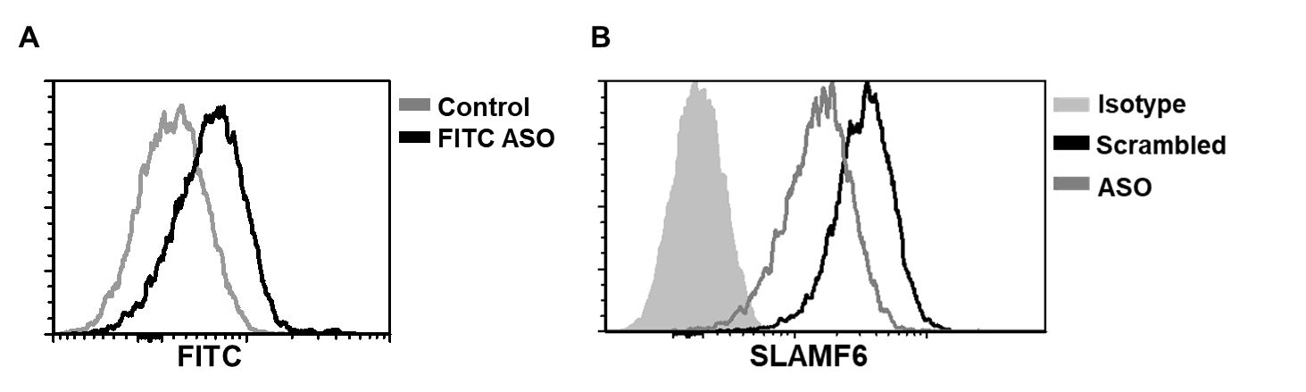
Fig S5 – supplementary for Figure 7:
A, FITC levels measured by flow cytometry 24 h post electroporation of WT Jurkat cells with ASO-FITC or control ASO. B, SLAMF6 expression measured using flow cytometry 24 h post-electroporation of WT Jurkat cells with ASO or control ASO.

